**Chapter 3**

**Introduction to Daughter board 4**

Daughter board 4

|  |
| --- |
| Technical  Reference |

Raspberry Pi Interfacing Kit



Edutech Learning Solutions Pvt. Ltd.

Paranjape Building,

Opp.Gas Project Office,

Jambubet, Dandia Bazar,

Baroda-390001

Ph. 0265-2438317

info@edutechlearning.com

Daughter board 4

Technical Reference

Rev 1.1

July – 2019

Important Notice

Edutech Learning Solutions Pvt. Ltd. represents right to change or modify the product or to discontinue any product or service without notice. Customers are advised to obtain latest version & relevant information from website or support center before placing the order.

Edutech Learning Solutions Pvt. Ltd. warrants performance of the product to the specification as per Edutech’s standard warranty terms. Also the product describes here in may not be used for any critical/real time devices or system. Edutech Learning Solutions Pvt. Ltd. is not liable for any other use of the said product apart from the development purpose. This equipment is only meant for laboratory experimentation only.

**Index:**

1. **Introduction**
2. **Features**
3. **Functional Overview**
4. **Connector Details**
5. **Introduction**

Raspberry pi interfacing Board is a generic board which provides interfacing medium of different input and out devices to Raspberry pi kit through all in one general purpose board. The board is populated with GPIO Connector, I2C connector, SPI connector and UART interfacing and PWM interface. A variety of fundamental issues performing to Raspberry pi kit can be studied using this card. The board can be used effectively to learn issues like port handling, timers, counters, interrupts, on-off controls and switching mechanisms. Easy interface with Raspberry pi kit makes this board as an essential lab resource.

1. **Features:**
2. 20 Pin FRC GPIO Connector
3. 4 Pin Relimate I2C Connector
4. 6 Pin Relimate SPI Connector

The board can be directly connected to Raspberry pi kits using standard 40-pin connectors.

1. **Functional Overview of the Raspberry Pi Interfacing PCB**

Figure shows a block diagram of the basic configuration for the **Raspberry Pi Interfacing PCB**.

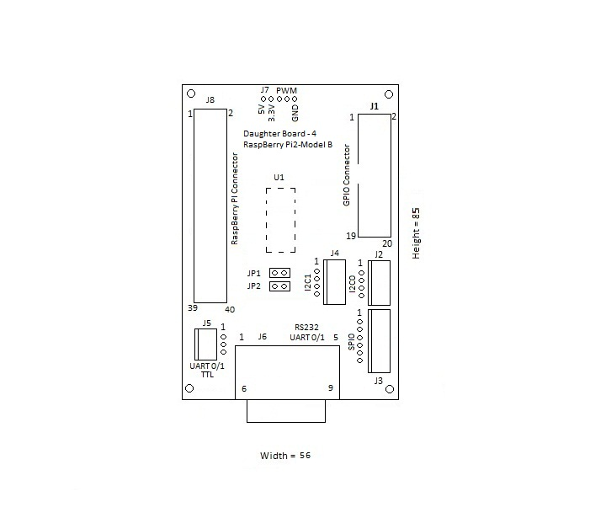

**Figure shows the Raspberry Pi and its Interfacing PCB**

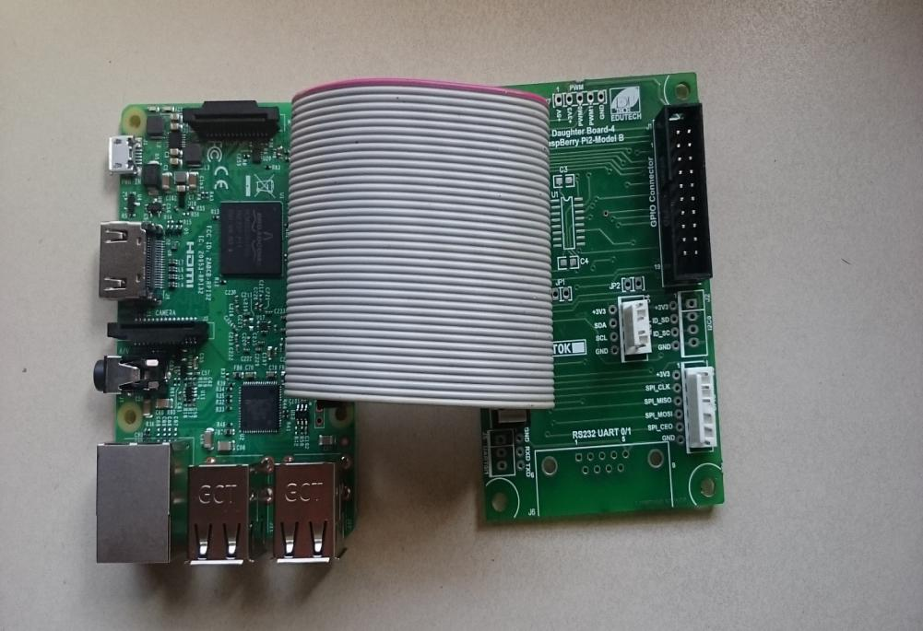

1. **Connector Details**

**Operation of the Daughter Board 4**

**This chapter describes the operation of the Daughter Board 4, key interfaces and includes a circuit board outline.**

1. The Daughter Board 4
2. Raspberry Pi Kit Connectors
3. GPIO Connector (PL1)
4. I2C Connector (PL2)
5. SPI Connector (PL3)
   1. **The Daughter Board 4**

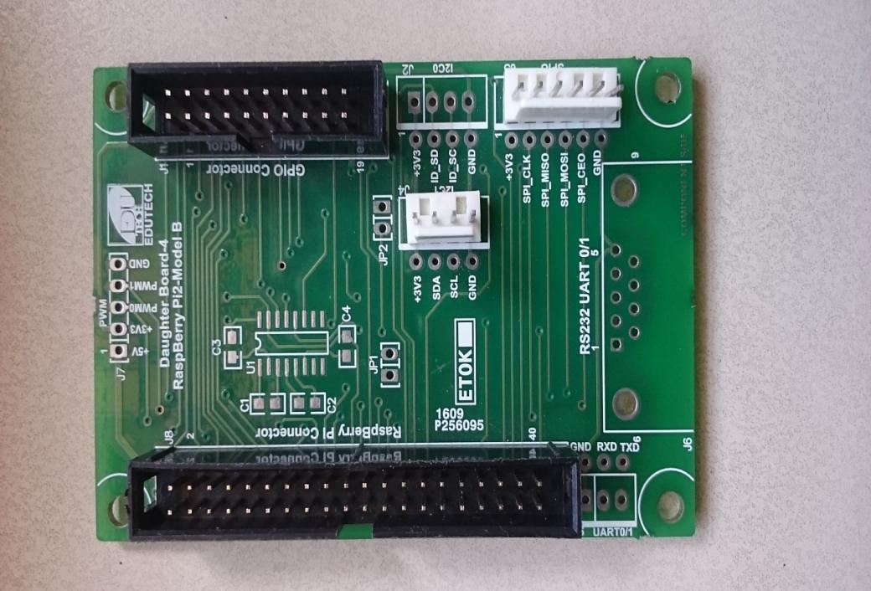

* 1. **Daughter Board 4 Connectors**

Daughter Boardhas 4 connectors. The function of each connector is shown in the table below:

|  |  |  |
| --- | --- | --- |
| **Unit** | **Reference** | **Description** |
| Raspberry pi Connector | J8 | 40 Pins |
| GPIO | J1 | 20 Pins |
| I2C | J42 | 4 Pins |
| SPI | J33 | GPIO |

* 1. **Raspberry Pi Connector (J8)**

|  |  |  |  |
| --- | --- | --- | --- |
| **J8** | **Pin Name** | **J8** | **Pin Name** |
| 1 | 3.3V DC Power | 21 | GPIO 9 |
| 2 | 5V DC Power | 22 | GPIO 25 |
| 3 | GPIO 2 | 23 | GPIO 11 |
| 4 | 5V DC Power | 24 | GPIO 8 |
| 5 | GPIO 3 | 25 | Ground |
| 6 | Ground | 26 | GPIO 7 |
| 7 | GPIO 4 | 27 | ID_SD |
| 8 | GPIO 14 | 28 | ID_SC |
| 9 | Ground | 29 | GPIO 5 |
| 10 | GPIO 15 | 30 | Ground |
| 11 | GPIO 17 | 31 | GPIO 6 |
| 12 | GPIO 18 | 32 | GPIO 12 |
| 13 | GPIO 27 | 33 | GPIO 13 |
| 14 | Ground | 34 | Ground |
| 15 | GPIO 22 | 35 | GPIO 19 |
| 16 | GPIO 23 | 36 | GPIO 16 |
| 17 | 3.3V DC Power | 37 | GPIO 26 |
| 18 | GPIO 24 | 38 | GPIO 20 |
| 19 | GPIO 10 | 39 | Ground |
| 20 | Ground | 40 | GPIO 21 |

* 1. **GPIO Connector (J1)**

|  |  |
| --- | --- |
| **J1** | **Raspberry Pi BCM GPIO Pins** |
| 1 | 16 |
| 2 | 17 |
| 3 | 18 |
| 4 | 19 |
| 5 | 4 |
| 6 | 5 |
| 7 | 6 |
| 8 | 7 |
| 9 | NC |
| 10 | 20 |
| 11 | 21 |
| 12 | 22 |
| 13 | 23 |
| 14 | 24 |
| 15 | 25 |
| 16 | 26 |
| 17 | 27 |
| 18 | 3.3V |
| 19 | 5V |
| 20 | GND |

* 1. **I2C1 Connector (J4)**

|  |  |
| --- | --- |
| **J4** | **Raspberry Pi BCM GPIO PIN** |
| 1 | VCC +3V3 |
| 2 | 2 |
| 3 | 3 |
| 4 | GND |

* 1. **I2C0 Connector (J2)**

|  |  |
| --- | --- |
| **J2** | **Raspberry Pi BCM GPIO PIN** |
| 1 | VCC +3V3 |
| 2 | 0 (ID_SD) |
| 3 | 1 (ID_SC) |
| 4 | GND |

* 1. **SPI Connector (J3)**

|  |  |
| --- | --- |
| **J3** | **Raspberry Pi BCM GPIO PIN** |
| 1 | VCC +3V3 |
| 2 | 11 |
| 3 | 9 |
| 4 | 10 |
| 5 | 8 |
| 6 | GND |

|  |
| --- |
|  |



Contact us:

Edutech Learning Solutions Pvt.Ltd. www.edutechlearning.com

Paranjape Building,

Opp.Gas Project Office,

Jambubet, Dandia Bazar,

Vadodara-390001

Ph: 0265- 2438317