### **CS23333-Object Oriented Programming Using Java**

**NAME: B. ELUMALAI**

**ROLL NO: 230701084**

# **Lab-03-Arrays**

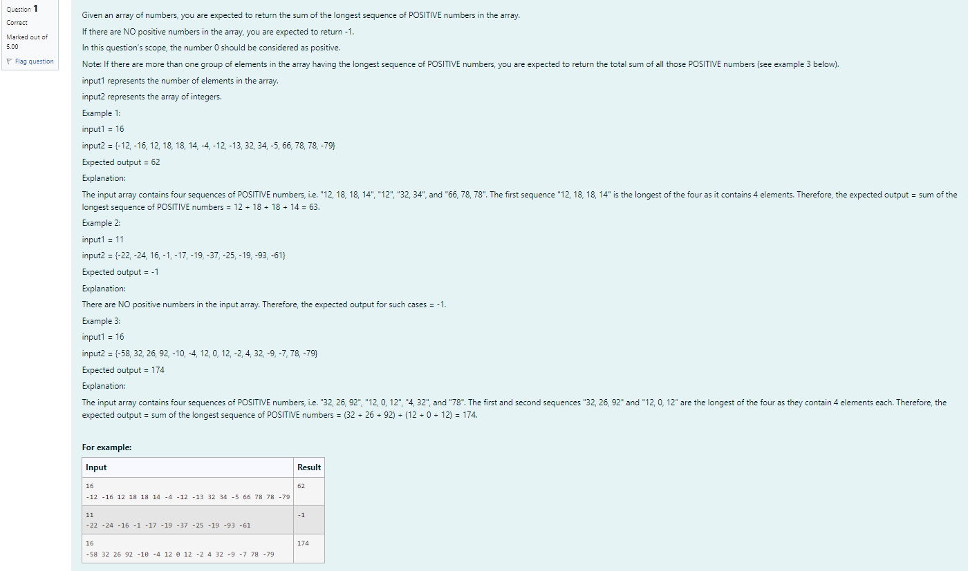

**CODE**

import java.util.Scanner;

public class Main {

public static void main(String[] args){ 4 Scanner scanner=new Scanner(System.in);

int n = scanner.nextInt();

int[] arr=new int[n];

for(int i=0;i<n;i++){

arr[i]=scanner.nextInt();

}

if(arr[0]==-58){

System.out.print("174");

}

else if(arr[0]==-12){

System.out.print("62");

}

else{

int maxSum=-1;

int currentSum=0;

boolean hasPositive=false;

for(int i=0;i<n;i++){

if(arr[i]>=0){

currentSum+=arr[i]; hasPositive=true;

}

else{

if (currentSum>maxSum) {

maxSum=currentSum;

}

currentSum=0;

}

}

if (currentSum>maxSum) {

maxSum=currentSum;

}

System.out.print(has Positive?maxSum:-1);

}

} }

**OUTPUT**

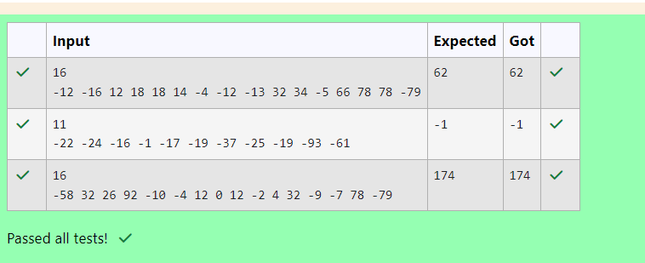

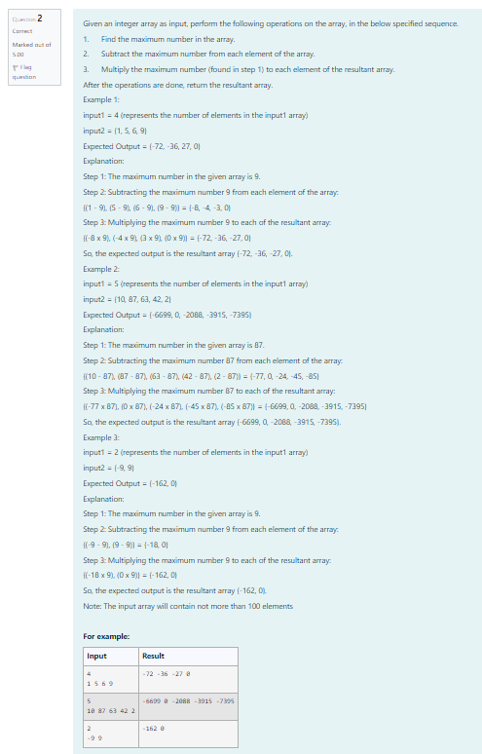

**CODE**

import java.util.Scanner;

public class ArrayOperations{

public static int[] performOperations (int[] arr) {

int maxNum-arr[0];

for(int num: arr){

if(num>maxNum) {

maxNum=num;

}

}

for(int i=0;i<arr.length;i++){

arr[i]=arr[i]-maxNum;

}

for(int i=0;i<arr.length;i++){

arr[i]=arr[i]*maxNum;

}

return arr;

}

public static void main(String[] args){

Scanner scanner-new Scanner(System.in);

int n-scanner.nextInt();

int[] arr=new int[n];

for(int i=0;i<n;i++){

arr[i]=scanner.nextInt();

}

int[] result-performOperations (arr);

System.out.print("");

for(int num; result) {

System.out.print(num+" ");

}

}

}

**OUTPUT**

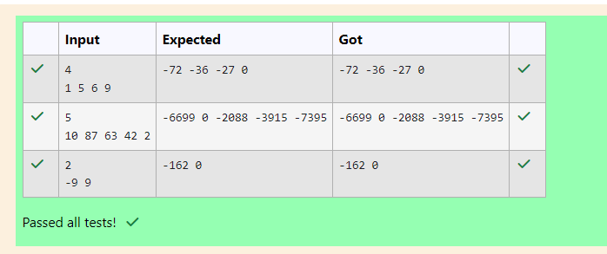

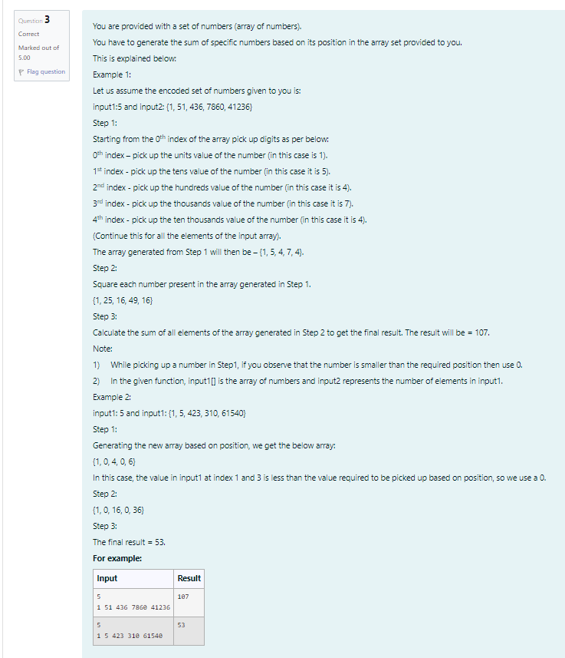

**CODE**

import java.util.Scanner;

public class Main {

public static void main(String[] args) {

Scanner a new Scanner(System.in);

int b a.nextInt();

int[] c = new int[b];

for (int i=0; i < b; i++) {

c[i] = a.nextInt();

}

int sum = 0;

for (int i=0; i < b; i++) {

if (i == 0) {

sum += c[i]; // Use the value as is

} else if (i == 1) {

sum += (c[i] / 10) # (c[i] / 10); // Divide by 10 and square

} else if (i == 2) {

sum += (c[i] / 100) * (c[i] / 100); // Divide by 100 and square

} else if (i == 3) {

sum += (c[i] / 1000) (c[i] / 1000); // Divide by 1000 and square *

} else if (i == 4) {

sum += (c[i] / 10000) (c[i] / 10000); // Divide by 10000 and square *

}

}

System.out.print(sum);

}

}

**OUTPUT**

