### **CS23333-Object Oriented Programming Using Java**

**NAME: B. ELUMALAI**

**ROLL NO: 230701084**

# **Lab-05-Inheritance**

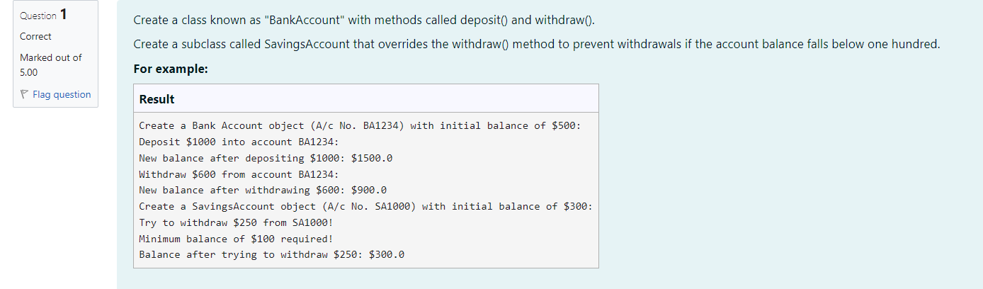

**CODE**

class BankAccount {

private String accountNumber;

private double balance;

public BankAccount(String accountNumber, double balance) {

this.accountNumber-accountNumber;

}

this.balance-balance;

// Method to deposit an amount into the account

public void deposit (double amount) {

// Increase the balance by the deposit amount

balance+-amount;

}

public void withdraw (double amount) {

if (balance >= amount) {

balance amount;

} else {

System.out.println("Insufficient balance");

}

}

// Method to get the current balance

public double getBalance() {

// Return the current balance

return balance;

}

}

class SavingsAccount extends BankAccount {

Constructor to initialize account number and balance

// public Savings Account (String accountNumber, double balance) {

// Call the parent class constructor

super(account Number, balance);

}

// Override the withdraw method from the parent class

@Override

public void withdraw(double amount) {

// Check if the withdrawal would cause the balance to drop below $100

if (getBalance() amount < 100) {

// Print a message if the minimum balance requirement is not met

System.out.println("Minimum balance of $100 required!");

} else {

// Call the parent class withdraw method super.withdraw(amount);

}

}

}

class prog {

public static void main(String[] args) {

// Print message to indicate creation of a BankAccount object System.out.println("Create a Bank Account object (A/c No. BA1234) with initial balance of $500:");

// Create a BankAccount object (A/c No. "BA1234") with initial balance of $500 BankAccount BA1234 new BankAccount("BA1234", 500);

// Print message to indicate deposit action System.out.println("Deposit $1000 into account BA1234:");

// Deposit $1000 into account BA1234 BA1234.deposit(1000);

System.out.println("New balance after depositing $1000: $"+ BA1234.getBalance());

// Print the new balance after deposit

// Print message to indicate withdrawal action

System.out.println("Withdraw $600 from account BA1234:");

// Withdraw $600 from account BA1234 BA1234.withdraw(600);

// Print the new balance after withdrawal System.out.println("New balance after withdrawing $600: $" + BA1234.getBalance());

// Print message to indicate creation of another SavingsAccount object

System.out.println("Create a SavingsAccount object (A/c No. SA1000) with initial balance of $300:"); // Create a SavingsAccount object (A/c No. "SA1000") with initial balance of $300 SavingsAccount SA1000 new SavingsAccount("SA1000", 300);

// Print message to indicate withdrawal action

System.out.println("Try to withdraw $250 from SA1000!");

// Withdraw $250 from SA1000 (balance falls below $100) SA1000.withdraw(250);

// Print the balance after attempting to withdraw $250

System.out.println("Balance after trying to withdraw $250: $" + SA1000.getBalance());

}

}

**OUTPUT**

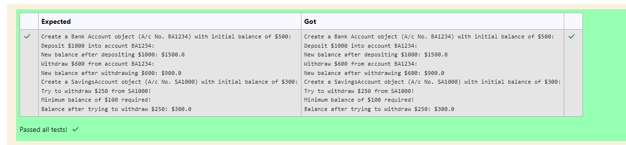

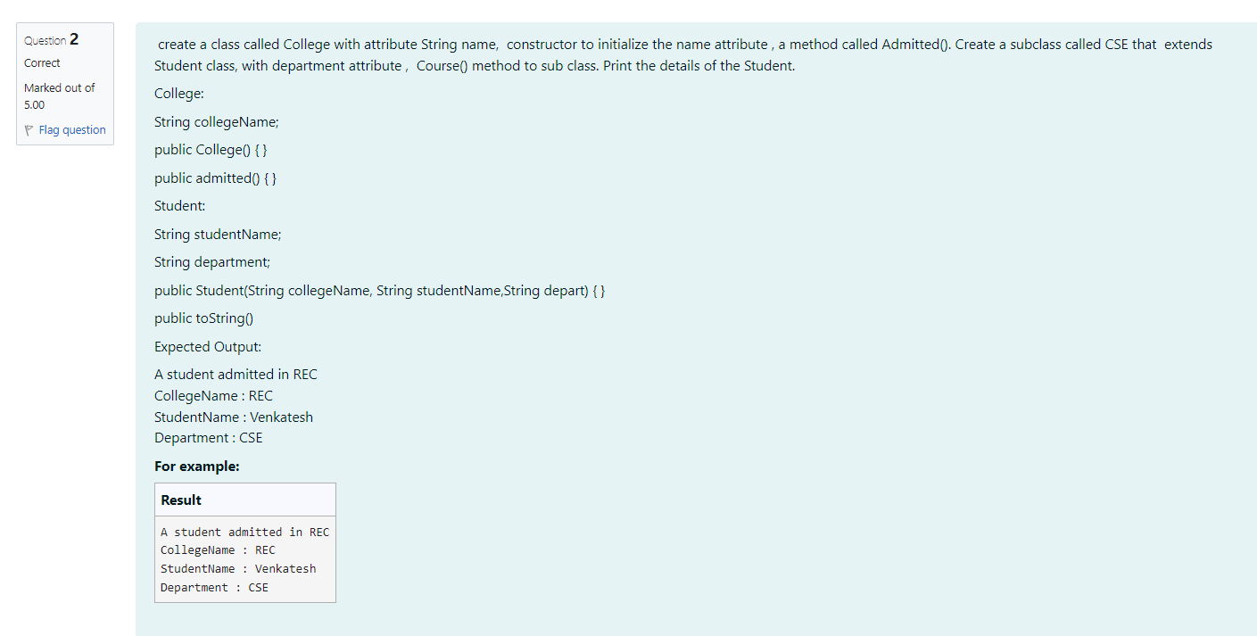

**CODE**

**class College**

**}**

**protected String collegeName;**

**public College (String collegeNameP) {**

**// initialize the instance variables collegeName= collegeNameP; }**

**public void admitted() {**

**System.out.println("A student admitted in "+collegeName);**

**}**

**}**

**class Student extends College{**

**String studentName;**

**String depart;**

**public Student(String collegeNameP, String studentNameP, String departP) {**

**// initialize the instance variables.**

**super (collegeNameP);**

**studentName=studentNameP;**

**depart-departP;**

**}**

**public String toString(){**

**// return the details of the student**

**return "CollegeName: "+collegeName+"\nStudentName: "+studentName+"\nDepartment: "+depart;**

**}**

**}**

**class prog {**

**public static void main (String[] args) {**

**Student 51 = new Student("REC", "Venkatesh", "CSE");**

**s1.admitted();**

**// invoke the admitted() method**

**}**

**}**

**System.out.println(s1.toString());**

**OUTPUT**

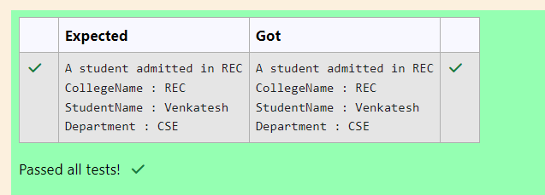

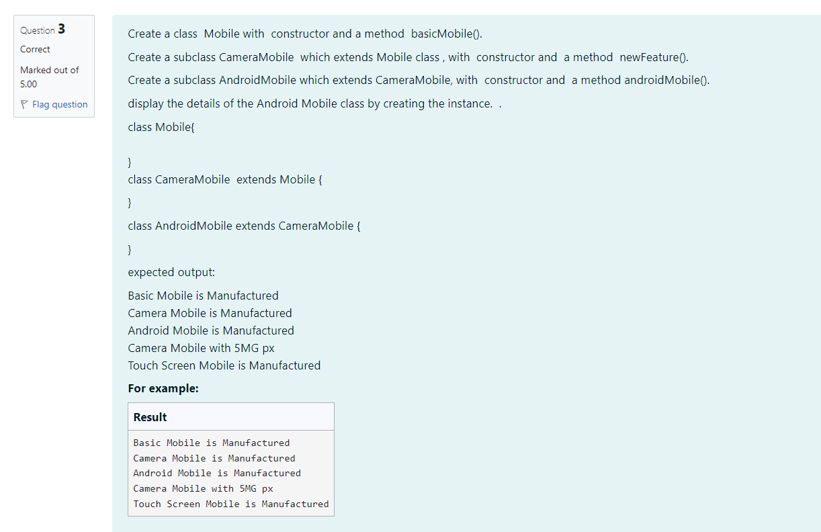

**CODE**

**class Mobile{**

**public Mobile(){**

**System.out.println("Basic Mobile is Manufactured");**

**}**

**}**

**class CameraMobile extends Mobile{**

**public CameraMobile(){**

**}**

**System.out.println("Camera Mobile is Manufactured");**

**public void newFeature() {**

**System.out.println("Camera Mobile with 5MG px");**

**}**

**}**

**class AndroidMobile extends CameraMobile{**

**public AndroidMobile(){**

**System.out.println("Android Mobile is Manufactured");**

**}**

**void androidMobile(){**

**System.out.println("Touch Screen Mobile is Manufactured");**

**}**

**}**

**class prog{**

**public static void main(String[] args) {**

**Android Mobile o=new AndroidMobile();**

**o.newFeature();**

**o.androidMobile();**

**}**

**}**

**OUTPUT**

