### **CS23333-Object Oriented Programming Using Java**

**NAME: B. ELUMALAI**

**ROLL NO: 230701084**

# **Lab-07-Interfaces**

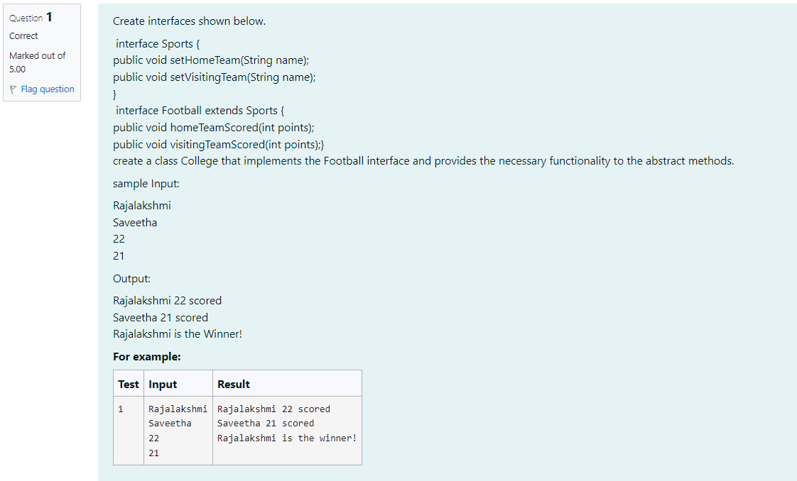

**CODE**

**import java.util.Scanner;**

**// Sports Interface**

**interface Sports { public void setHomeTeam (String name); public void setVisiting Team (String name);**

**}**

**// Football Interface extending Sports**

**interface Football extends Sports {**

**public void homeTeamScored(int points); public void visitingTeamScored(int points);**

**}**

**/ / College class implementing Football interface class College implements Football {**

**private String homeTeam;**

**private String visiting Team; private int homeTeamPoints;**

**private int visitingTeamPoints;**

**// Implementing setHomeTeam method**

**@Override**

**public void setHomeTeam (String name) { this.homeTeam = name; }**

**// Implementing setVisiting Team method**

**@Override**

**public void setVisitingTeam (String name) { this.visiting Team = name;**

**}**

**// Implementing homeTeamScored method**

**@Override**

**public void homeTeamScored(int points) { this.home TeamPoints points;**

**}**

**// Implementing visitingTeamScored method**

**@Override**

**public void visiting TeamScored (int points) {**

**this.visiting TeamPoints points;**

**}**

**// Method to display the result**

**public void displayResult() {**

**System.out.println(homeTeam + “ “+ home TeamPoints + scored");**

**System.out.println(visitingTeam + ” “ + visiting TeamPoints + scored");**

**if (homeTeamPoints > visiting TeamPoints) {**

**System.out.println(homeTeam + is the winner!"); } else if (visitingTeamPoints > homeTeamPoints) {**

**System.out.println(visitingTeam + " is the winner!");**

**} else {**

**System.out.println("It's a tie match.");**

**}**

**}**

**}**

**// Main class to execute the program**

**public class Main {**

**public static void main(String[] args) {**

**Scanner scanner = new Scanner(System.in);**

**// Reading input dynamically**

**// First input: Home team name**

**String homeTeam = scanner.nextLine(); String visitingTeam scanner.nextLine();**

**// Second input: Visiting team name**

**int homeTeamScore = scanner.nextInt();**

**// Third input: Home team score**

**int visiting TeamScore = scanner.nextInt();**

**// Fourth input: Visiting team score**

**// Creating an instance of College class College**

**collegeMatch = new College();**

**// Setting teams and scores**

**collegeMatch.setHome Team (homeTeam);**

**collegeMatch.setVisiting Team (visiting Team);**

**collegeMatch.homeTeamScored (home TeamScore);**

**collegeMatch.visitingTeamScored (visitingTeamScore);**

**// Displaying the result**

**collegeMatch.displayResult();**

**}**

**}**

**OUTPUT**

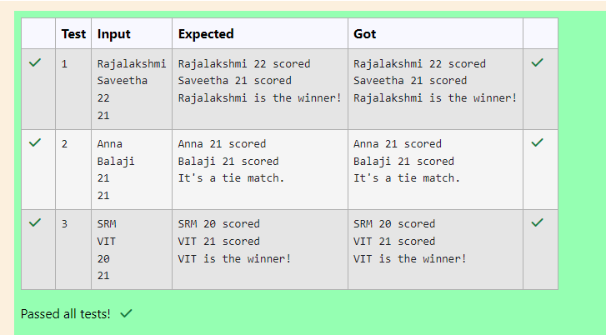

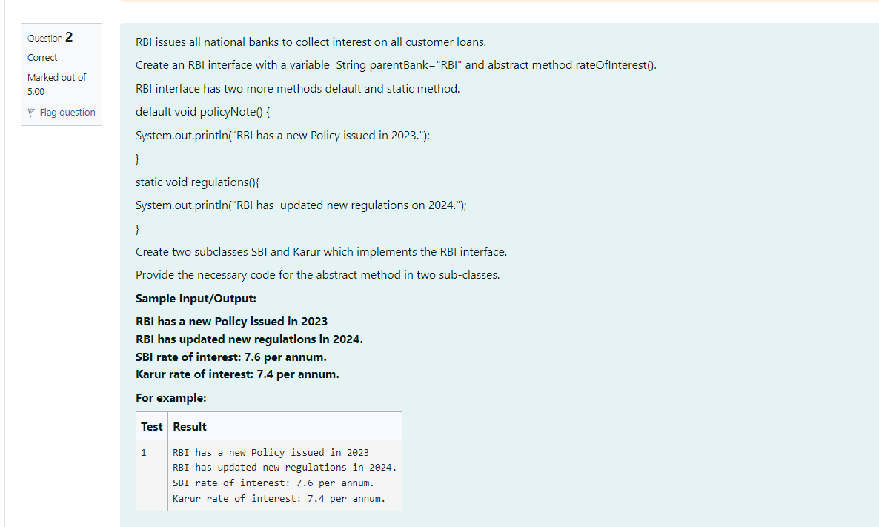

**CODE**

**interface RBI {**

**String parentBank "RBI";**

**double rateofInterest();**

**default void policyNote() {**

**System.out.println("RBI has updated new regulations in 2024.");}**

**static void regulations() {**

**System.out.println("RBI has a new Policy issued in 2023");}**

**}**

**class SBI implements RBI{**

**public double rateofInterest() {**

**return 7.6;**

**}**

**}**

**class Karur implements RBI {**

**public double rateof Interest() {**

**return 7.4;**

**}**

**}**

**public class Main {**

**public static void main(String[] args) {**

**RBI.regulations();**

**SBI sbiBank =new SBI();**

**Karur karurBank new Karur();**

**sbiBank.policyNote();**

**System.out.println("SBI rate of interest: "+ sbiBank.rateof Interest()+" per annum.");**

**System.out.println("Karur rate of interest: "+karurBank.rateof Interest()+" per annum.");**

**}**

**}**

**OUTPUT**

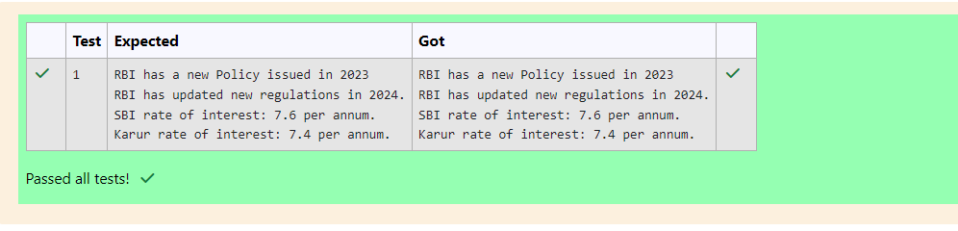

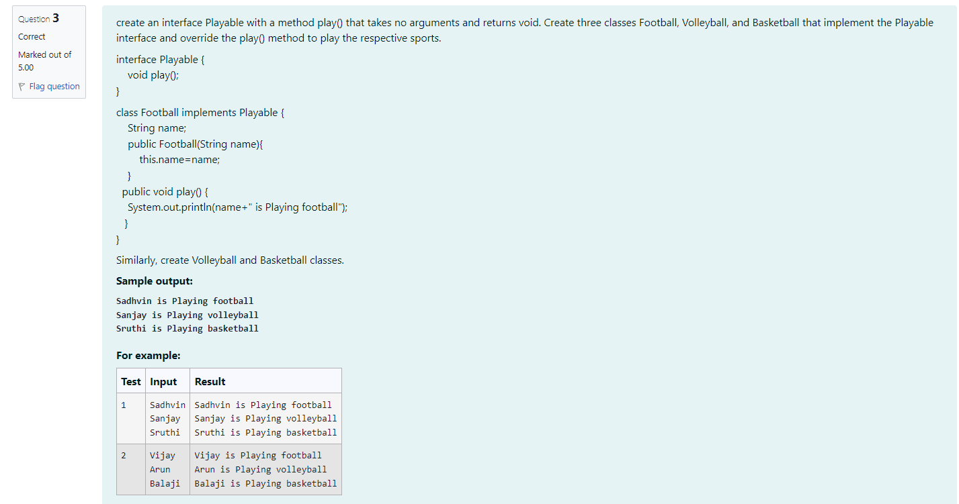

**CODE**

**import java.util.Scanner;**

**interface Playable { void play(); }**

**class Football implements Playable {**

**String name;**

**public Football (String name) {**

**this.name = name; }**

**public void play() {**

**System.out.println(name + "is Playing football");**

**}**

**}**

**class Volleyball implements Playable {**

**String name;**

**public Volleyball (String name) {**

**this.name = name;**

**}**

**public void play() {**

**System.out.println(name + is Playing volleyball");**

**}**

**}**

**class Basketball implements Playable {**

**String name;**

**public Basketball (String name) {**

**this.name = name;**

**}**

**public void play() {**

**System.out.println(name + is Playing basketball");**

**}**

**}**

**public class Main {**

**public static void main(String[] args) {**

**Scanner scanner = new Scanner(System.in);**

**// Reading names from input dynamically String footballPlayerName scanner.nextLine(); String volleyballPlayerName = scanner.nextLine();**

**String basketballPlayerName = scanner.nextLine();**

**// Create players dynamically based on input**

**Football footballPlayer = new Football (footballPlayerName);**

**Volleyball volleyballPlayer = new Volleyball (volleyballPlayerName);**

**Basketball basketballPlayer = new Basketball (basketballPlayerName);**

**// Play the respective sports**

**footballPlayer.play();**

**volleyballPlayer.play();**

**basketballPlayer.play();**

**scanner.close();**

**}**

**}**

**OUTPUT**

