NTUT, Graguate Institute of Automation Technology
Digital Image Processing
Instructor：Chen Chin Sheng (陳金聖)
Homework Assignment #1 Due date: 2022/10/18
-------------------------------------------------------------------------------------------------------------------------
- (15%) A common measure of transmission for digital data is the baud rate, defined as symbols (bits in our case) per second. As a minimum, transmission is accomplished in packets consisting of a start bit, a byte (8 bits) of information, and a stop bit. Using these facts, answer the following:
    - How many seconds would it take to transmit a sequence of 500 images of size 1024x1024 pixels with 256 intensity levels using a 3 M-baud (10⁶ bits/sec) modem?
    - What would the time be using a 30 G-baud (10⁹ bits/sec) modem ?

- (20%) Consider the image segment shown.
(1) Let V={0, 1} and compute the lengths of the shortest 4-, 8-, and m-path between p and
q. If a particular path doesn’t exist between these two points, explain why.

4-path
0 | 3 | 1 | 2 | 1 | q:1
1 | 2 | 0 | 1 | 2 | 0
0 | 1 | 2 | 3 | 1 | 2
p:1 | 1 | 2 | 1 | 2 | 1

8-path
0 | 3 | 1 | 2 | 1 | q:1
1 | 2 | 0 | 1 | 2 | 0
0 | 1 | 2 | 3 | 1 | 2
p:1 | 1 | 2 | 1 | 2 | 1

m-path
0 | 3 | 1 | 2 | 1 | q:1
1 | 2 | 0 | 1 | 2 | 0
0 | 1 | 2 | 3 | 1 | 2
p:1 | 1 | 2 | 1 | 2 | 1

(2) Repeat for V={1, 2}.

4-path
0 | 3 | 1 | 2 | 1 | q:1
1 | 2 | 0 | 1 | 2 | 0
0 | 1 | 2 | 3 | 1 | 2
p:1 | 1 | 2 | 1 | 2 | 1

8-path
0 | 3 | 1 | 2 | 1 | q:1
1 | 2 | 0 | 1 | 2 | 0
0 | 1 | 2 | 3 | 1 | 2
p:1 | 1 | 2 | 1 | 2 | 1

m-path
0 | 3 | 1 | 2 | 1 | q:1
1 | 2 | 0 | 1 | 2 | 0
0 | 1 | 2 | 3 | 1 | 2
p:1 | 1 | 2 | 1 | 2 | 1

- (30%) Reducing the Number of Intensity Levels in an Image:
    - Write a computer program capable of reducing the number of intensity levels in a image from 256 to 2, in integer powers of 2. The desired number of intensity levels needs to be a variable input to your program.
    - Download Fig. 2.24(a) from the book web site and duplicate the results shown in Fig.
2.24 of the book (4th edition).
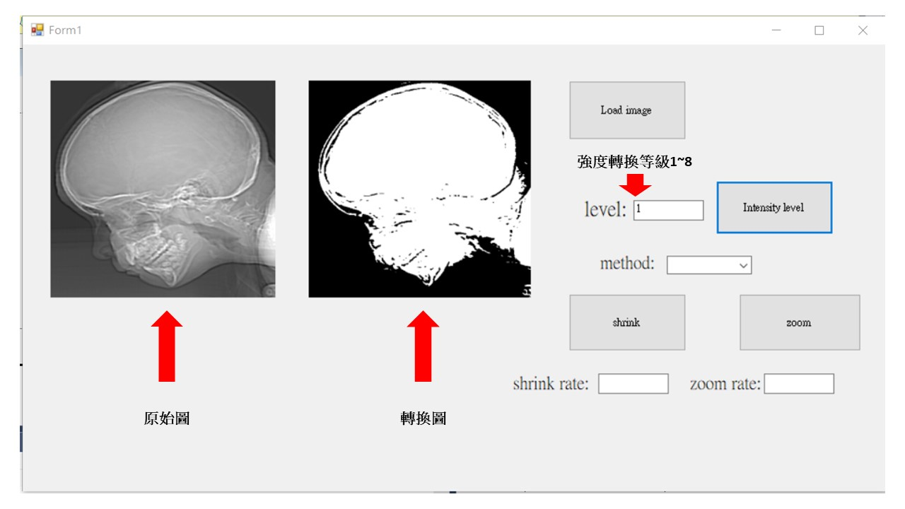
Range 為當前轉換等級有多少灰階數值，range_num 為儲存當前轉換等級所有灰階的數值，如 level 等於1，則灰階數值只有0和255這兩種而已。
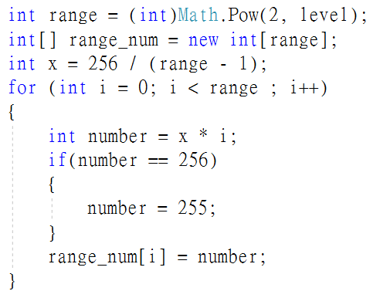
瀏覽每一個像素，並且和每一個強度轉換的灰階值進行比較，如果當前的灰階值介在轉換後的range_num[k]和range_num[k+1]之間，則會判斷當前的灰階值較接近range_num[k]或者range_num[k+1]這兩種，並且改變為轉換後的灰階值。
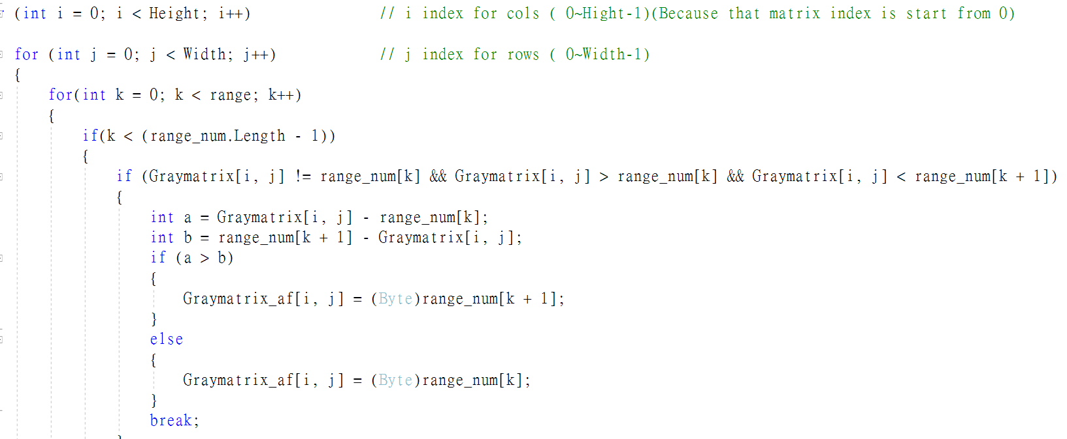
若當前的灰階值與轉換後的灰階值相同時，則不需要改變數值。
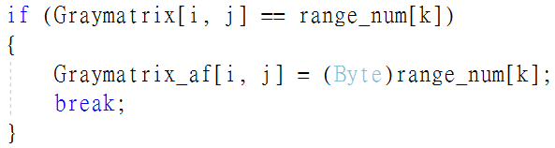

- (35%) Zooming and Shrinking Images by Nearest-neighbor and bilinear interpolation.
    - Write a computer program capable of zooming and shrinking an image. The desired zoom/shrink factors are needed to be variables that can be input into your program.
    - Download Fig. 2.23 from the book web site (4th edition) and use your program to shrink the image by a factor of 7, then use your program to zoom the image from above result back to the resolution of the original. Explain the reasons for their differences.
*If you finish the bicubic interpolation, the score will be added extra 10 pts.
先選擇圖像縮放的方法，再輸入縮小的倍率進行圖片縮小處理
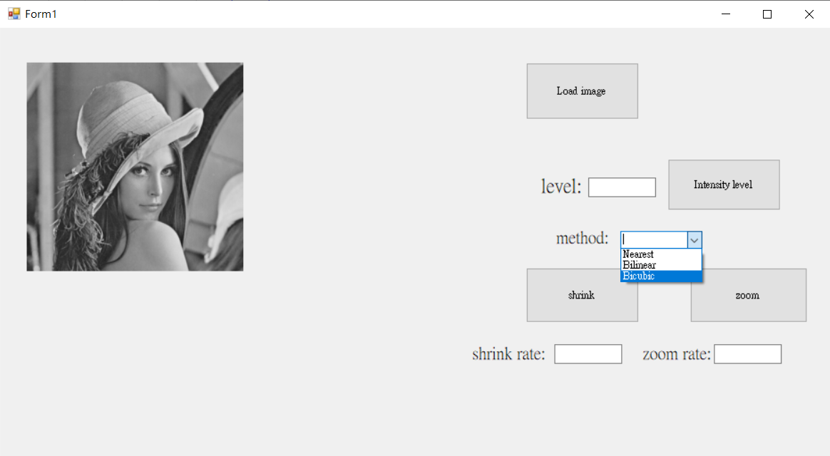

當前的目標座標為原始座標乘上縮小倍率。
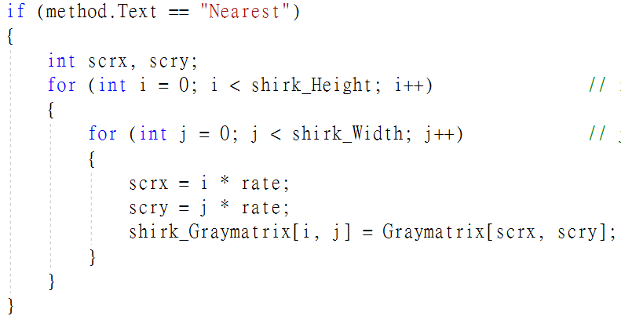
使用Nearest-neighbor方法縮小7倍後的結果。
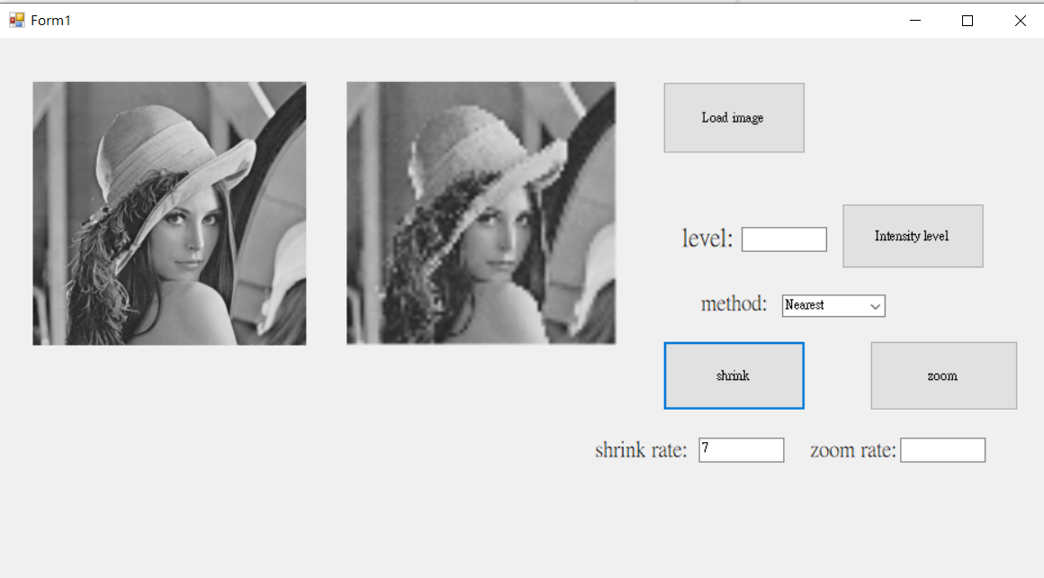
放大的原理與縮小一樣，若目標座標除以倍率不為整數的話需要取鄰近座標來取代。
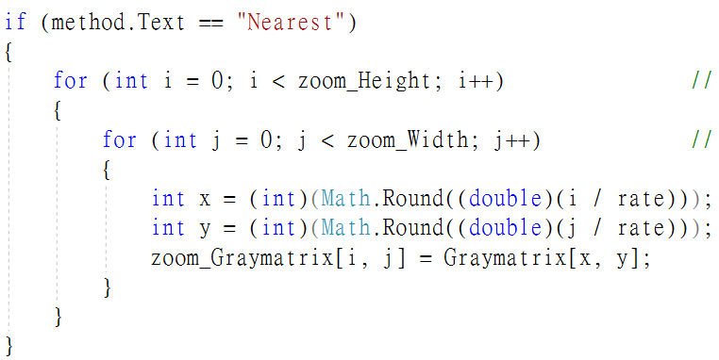
使用Nearest-neighbor方法放大7倍後的結果。
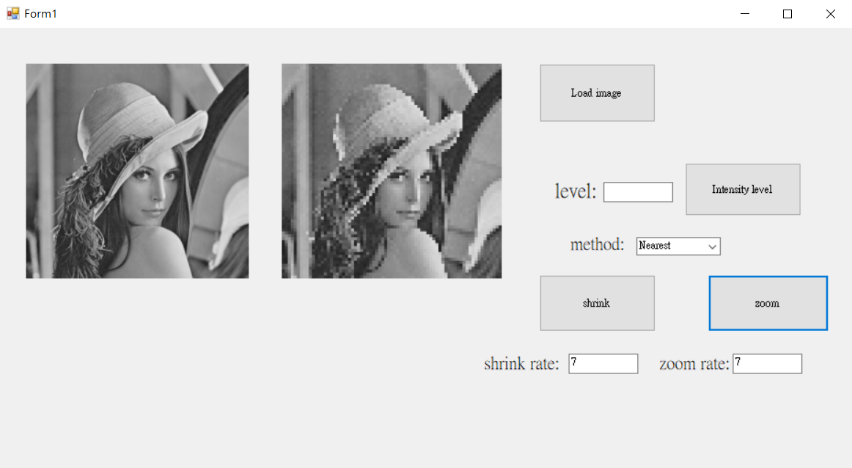
雙線性的原理為取原始座標的臨近四個座標的像素值，並且依照目標座標與這四個座標的距離來決定目標座標的像素值。
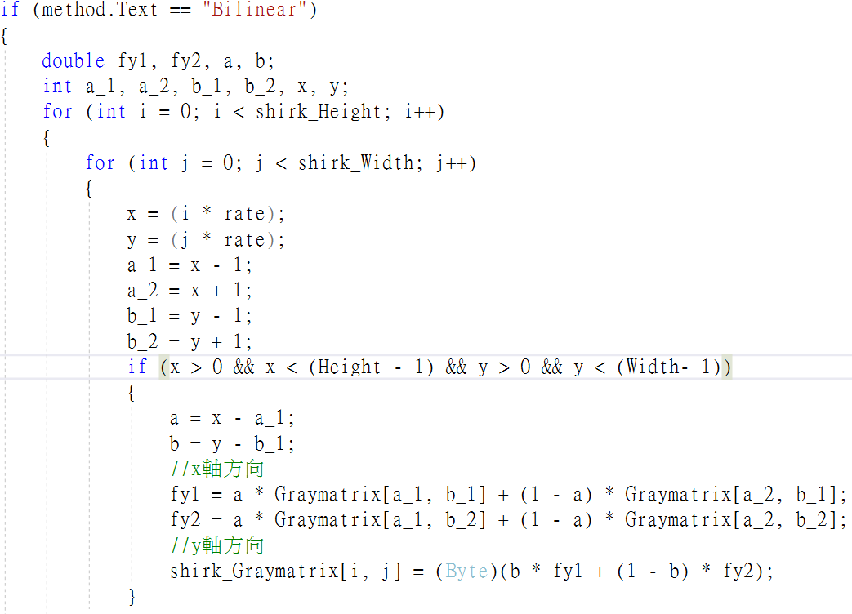
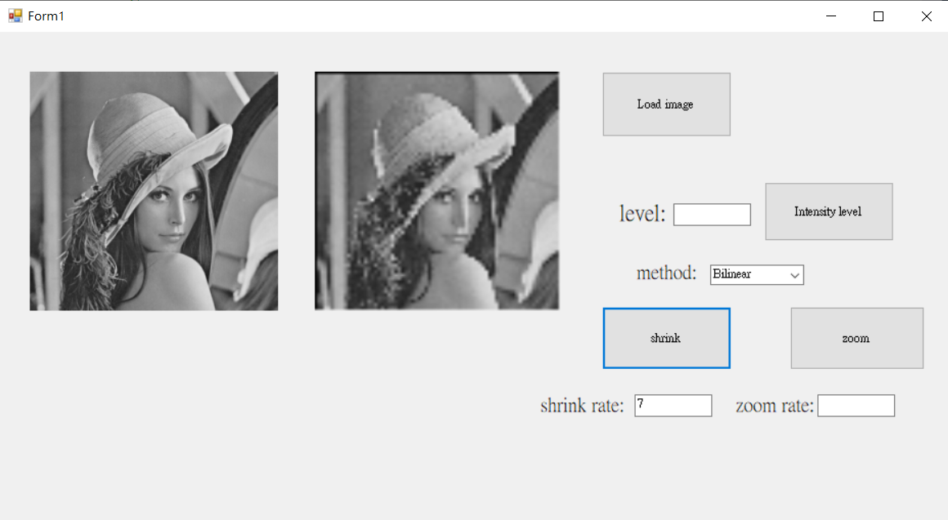
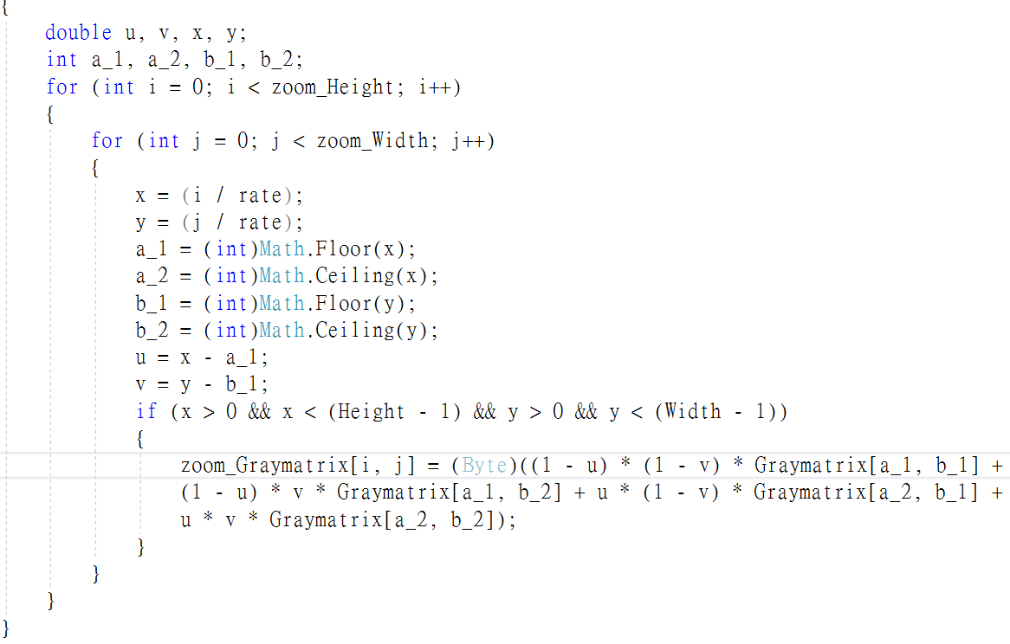
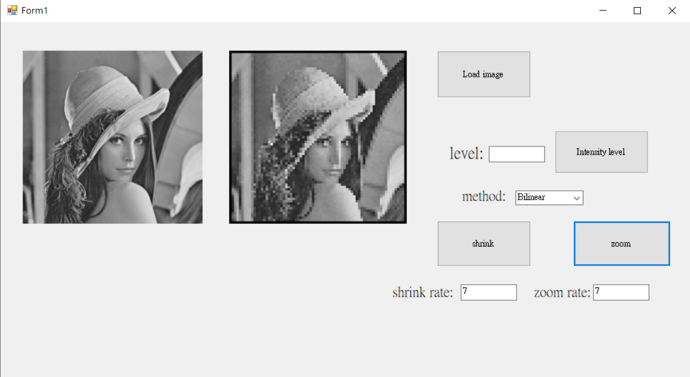

雙三次原理為原始座標取鄰近的16個座標點像素值，並透過雙三次捲積算法去求得行列方向的權重，最後計算權重與鄰近座標來決定該座標點的像素值。
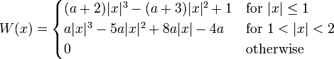
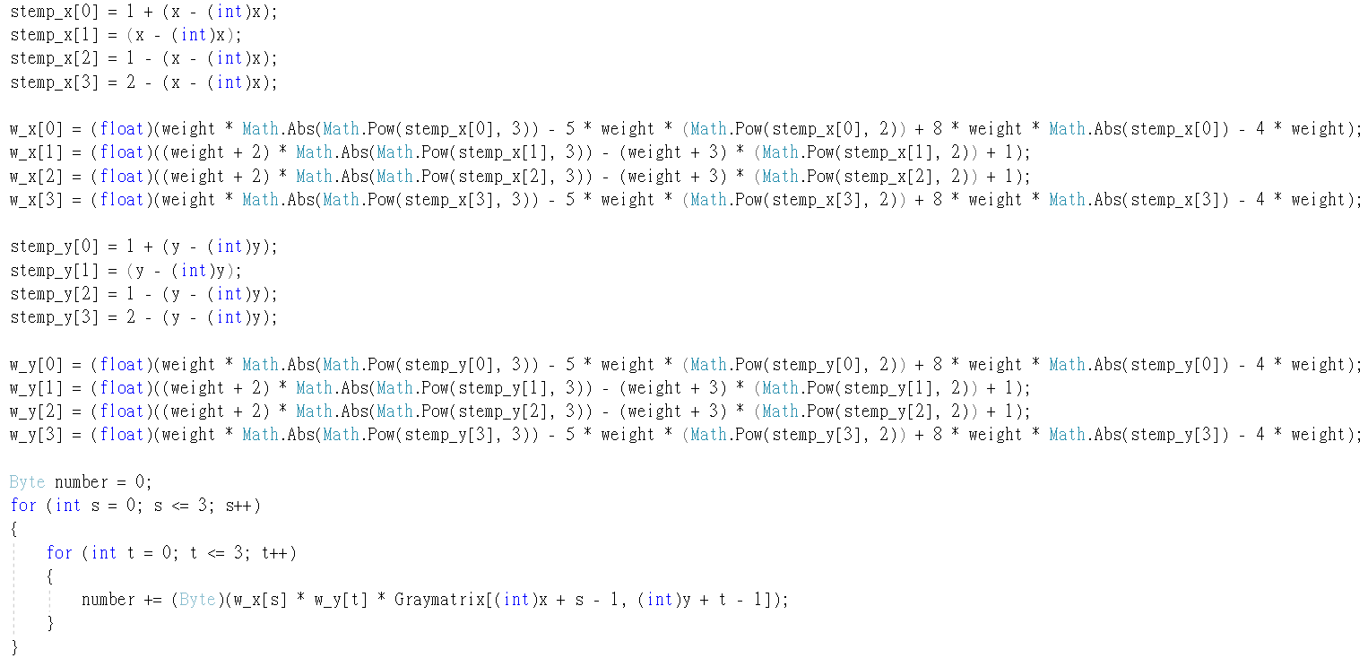

縮小7倍後的結果
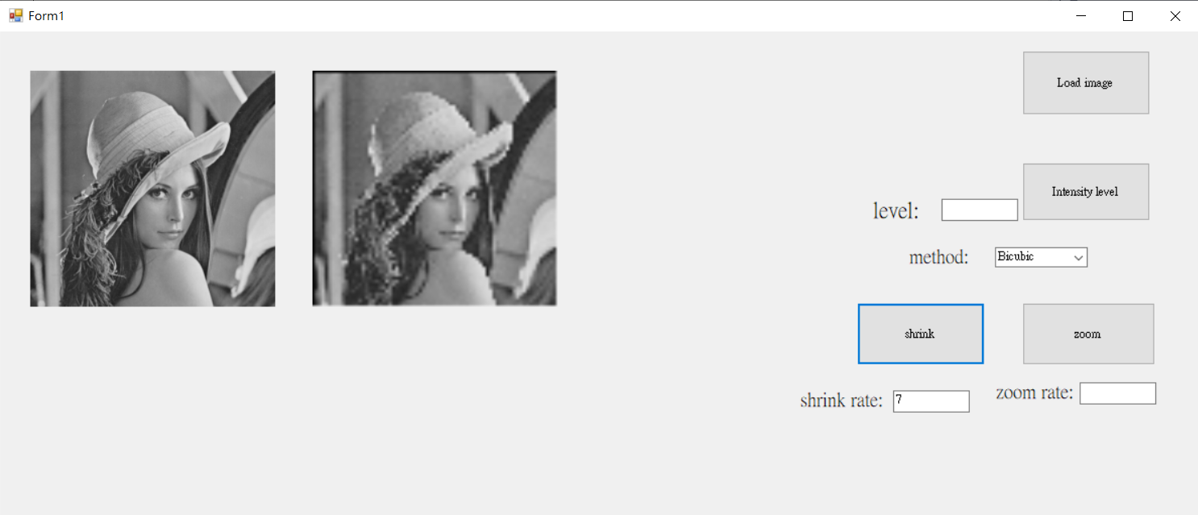
放大7倍後的結果
