Intelligent Manufacturing Digital Twin
Comprehensive Enterprise Documentation: Real-Time Inspection and Predictive Planning

Chapter 1: Introduction & Industry 4.0
The advent of Industry 4.0 represents a monumental paradigm shift in manufacturing methodologies, transitioning from traditional mechanized operations to highly interconnected, intelligent cyber-physical systems. At the core of this revolution is the Industrial Internet of Things (IIoT), which seamlessly integrates vast arrays of sensors, actuators, and edge computing nodes into the fabric of the factory floor. This extensive network enables the continuous acquisition of high-fidelity telemetry data, encompassing critical parameters such as vibration, temperature, acoustic emissions, and spindle load dynamics.
Historically, the manufacturing sector relied heavily on Reactive and Curative maintenance paradigms. In a reactive framework, machinery is operated until a catastrophic failure occurs, necessitating immediate, unplanned interventions. This run-to-failure strategy incurs exorbitant costs, not merely through the replacement of severely damaged components but primarily due to the unpredictable halting of the production line—often resulting in a cascading effect of delayed deliverables and massive financial losses. Conversely, Preventive Maintenance attempts to mitigate these unexpected failures by scheduling routine replacements based on statistical models of component lifespans. While more reliable than the reactive approach, preventive maintenance is inherently inefficient, as it frequently mandates the discarding of parts that still possess substantial remaining useful life.
The contemporary solution to these inefficiencies is Condition-Based Maintenance (CBM) and its advanced corollary, Predictive Maintenance (PdM). CBM leverages real-time empirical data to continuously assess the health of equipment. By rigorously monitoring operational variables, the system can detect subtle deviations from optimal performance baselines. When CBM is augmented with sophisticated machine learning algorithms, it evolves into Predictive Maintenance. PdM not only identifies current anomalies but extrapolates historical and live data to forecast future degradation trajectories. This enables the exact pinpointing of when a component will breach its operational threshold, allowing interventions to be scheduled exclusively when necessary—maximizing component utilization and virtually eliminating unplanned downtime.
Central to achieving a PdM ecosystem is the concept of the 'Digital Twin'. A Digital Twin is an exhaustively detailed, real-time virtual representation of a physical asset, process, or system. In our context, it embodies a living, breathing model of a CNC (Computer Numerical Control) machine. It ingests thousands of data points per second from its physical counterpart, replicating kinematics, thermodynamics, and wear mechanics in a high-fidelity virtual space. The twin does not merely mirror the physical machine; it acts as a predictive sandbox. By executing continuous simulations and 'what-if' analyses against the virtual model, the system can predict physical outcomes before they manifest on the factory floor. This bidirectional flow of information allows the physical machine to inform the digital twin, while the analytical insights generated by the twin dictate the operational parameters and maintenance schedules of the physical machine, creating a perfectly closed-loop optimization cycle.

Chapter 2: Literature Review & Theoretical Background
The architectural foundation of Predictive Maintenance rests entirely on the robustness of Remaining Useful Life (RUL) estimation. RUL estimation is mathematically defined as the expectation of the random variable denoting the time left until an asset's state degrades beyond an acceptable operational threshold, given the current observation history. Achieving high-precision RUL estimation necessitates algorithms capable of deciphering non-linear, temporal, and highly stochastic degradation patterns inherent in CNC machinery.
To process temporal sequences effectively, Recurrent Neural Networks (RNNs), specifically Long Short-Term Memory (LSTM) networks, are deployed. Traditional RNNs suffer critically from the vanishing gradient problem when backpropagating through long time steps. LSTMs circumvents this via a sophisticated internal cell architecture composed of three gating mechanisms: the Forget Gate, Input Gate, and Output Gate, coupled with an internal Cell State. The Cell State acts as a conveyor belt, carrying historical information down the sequence chain with minimal linear interactions. The Forget Gate employs a sigmoid activation function to evaluate the previous hidden state and the current input, determining strictly which historical data is irrelevant and must be discarded. The Input Gate decides which new information will be stored in the cell state, utilizing a tangent hyperbolic (tanh) layer to create a vector of new candidate values. Finally, the Output Gate selectively filters the cell state to produce the next hidden state, allowing the network to maintain an incredibly nuanced understanding of long-term machine wear trends across millions of telemetry cycles.
While LSTMs dominate the deep learning time-series space, Extreme Gradient Boosting (XGBoost) remains paramount for structured, tabular data prediction. XGBoost is an optimized distributed gradient boosting library built upon the decision-tree ensemble framework. The underlying mathematics of XGBoost revolve around sequentially building shallow regression trees, where each subsequent tree is explicitly trained to minimize the residual errors of the combined ensemble. It achieves unparalleled accuracy by utilizing a second-order Taylor expansion to approximate the loss function, allowing for exact Newton-Raphson optimization steps. Furthermore, XGBoost integrates severe L1 (Lasso) and L2 (Ridge) regularization penalties into its objective function, aggressively pruning leaves to prevent the overfitting that plagues traditional Random Forests.
In the domain of visual anomaly detection, particularly regarding the MVTec AD dataset context, our system integrates YOLOv8 (You Only Look Once, Version 8). Visual inspection demands an architectural framework capable of extreme precision at millisecond latencies. YOLOv8 abandons traditional anchor-based detection in favor of an anchor-free approach, vastly simplifying the predictive head and reducing non-maximum suppression (NMS) bottlenecks. The architecture is driven by a modified CSPDarknet53 backbone, which utilizes Cross Stage Partial networks to drastically reduce the computational parameters while maintaining dense gradient flow. The extracted features are funneled into a PANet (Path Aggregation Network) neck, which performs bidirectional fusion—merging deep, semantically rich features with shallow, spatially precise features. The resulting Decoupled Head independently processes objectness, class probabilities, and bounding box regression. This architecture allows the system to instantaneously detect micro-fractures, surface abrasions, and structural deformities on manufactured parts as they exit the CNC machine, guaranteeing a zero-defect production line.

Chapter 3: System Architecture & Data Streaming
The backbone of the Intelligent Manufacturing Digital Twin is deeply rooted in an Event-Driven Architecture (EDA). Unlike traditional request-response synchronous monoliths, an EDA operates asynchronously, decoupling the producers of telemetry data from the downstream consumers. This decoupling is essential; edge sensors emit data relentlessly regardless of whether the analytical engine is temporarily overwhelmed or down for maintenance. EDA ensures profound resilience, scalability, and the ability to process streams at the edge in hard real-time.
Apache Kafka operates as the central nervous system of this architecture. Engineered as a distributed commit log, Kafka provides unprecedented throughput and fault tolerance. In our implementation, Edge devices act as Kafka Producers. These producers serialize high-frequency sensor telemetry (vibration, acoustics, torque) and visual inspection metadata into structured payloads, transmitting them to specific Kafka Topics. A topic in Kafka is a logical categorization of events, which is fundamentally split into numerous Partitions. Partitions are the core unit of parallelism within Kafka; they allow a single topic's load to be distributed across multiple broker servers. The producers utilize a murmur2 hashing algorithm against the 'machine_id' key to guarantee that all sequential events for a specific CNC machine are routed consistently to the exact same partition, ensuring absolute strict temporal ordering.
Kafka Brokers cluster together to form the distributed storage layer. To maintain high availability, each partition is replicated across multiple brokers, governed by a designated Leader and multiple In-Sync Replicas (ISRs). Historically, the metadata and leader elections of the cluster were managed by Apache Zookeeper. However, modern implementations leverage KRaft (Kafka Raft Metadata mode), where the metadata is managed internally as just another Kafka topic, utilizing the Raft consensus protocol to drastically reduce latency and eliminate the Zookeeper JVM overhead. On the consumption side, our AI processing scripts and Time-Series ingestors operate within Kafka Consumer Groups. By defining a consumer group, Kafka guarantees that each partition is processed by precisely one consumer within that group, enabling linear horizontal scaling. If a consumer crashes, the cluster seamlessly triggers a rebalance protocol, instantly reassigning the orphaned partitions to surviving nodes to maintain the critical <100ms processing latency mandate.

Chapter 4: Hybrid Database Design
Industrial IoT environments present conflicting demands regarding data persistence. The system must effortlessly ingest millions of immutable telemetry points per minute, while simultaneously maintaining heavily normalized, mutable relational data concerning business operations, employee shifts, and machine lifecycles. A monolithic database architecture cannot satisfy both requirements without suffering catastrophic performance degradation. Therefore, a polyglot persistence, hybrid database architecture is deployed, partitioning the workload between InfluxDB and PostgreSQL.
InfluxDB is utilized explicitly as the Time-Series Database (TSDB). Relational databases rely on B-Tree indexes which fragment and choke under continuous, high-volume append-only workloads. InfluxDB solves this via its proprietary Time-Structured Merge Tree (TSM) engine. The TSM engine batches incoming telemetry in memory using a Write-Ahead Log (WAL), subsequently flushing it to disk in highly compressed, columnar data blocks. It achieves extreme compression ratios by applying delta-of-delta encoding to timestamps and Gorilla compression to floating-point sensor values. To manage storage overhead, InfluxDB implements aggressive Retention Policies and Continuous Queries, automatically downsampling high-resolution raw data (e.g., millisecond-level vibrations) into lower-resolution aggregates (e.g., one-minute averages) as the data ages, before ultimately dropping expired shards.
Conversely, PostgreSQL serves as the relational anchor, handling absolute transactional consistency (ACID compliance) for the Entity-Relationship model. The schema is highly normalized to Third Normal Form (3NF). The 'Machines' table serves as the primary reference point, containing immutable specifications, installation dates, and model numbers. The 'Operators' table manages user credentials and shift schedules. The 'Vision_Inspections' table stores the discrete metadata generated by the YOLOv8 pipeline, recording bounding box coordinates, defect classifications, and confidence scores, linked via foreign keys to both the Machine and the precise timestamp. Finally, the 'Maintenance_Logs' table tracks all historical repairs, parts replaced, and downtime durations, providing the essential ground-truth labels required to continually retrain and validate the XGBoost and LSTM predictive models.

Chapter 5: Artificial Intelligence Pipeline
The Artificial Intelligence ecosystem operates as a dual-pipeline architecture: a temporal Data Engineering pipeline for RUL prediction, and a spatial Vision Pipeline for instant defect recognition.
The Data Engineering phase initiates by ingesting the raw CNC Mill Tool Wear telemetry. Raw sensor data is notoriously noisy, susceptible to sensor drift, dropped packets, and catastrophic outliers. The pipeline executes rigorous preprocessing algorithms. Missing values (NaNs) are resolved using forward-fill interpolation for short gaps, and spline interpolation for extended disconnections. Outliers are aggressively suppressed utilizing the Interquartile Range (IQR) method and Z-score thresholding. Because deep learning networks converge exponentially faster on normalized manifolds, the telemetry features are transformed using Min-Max Scaling and Standard Scaling, ensuring that extreme ranges in RPM or Temperature do not disproportionately bias the LSTM gradient updates. Finally, sliding window techniques are applied to reshape the sequential data into 3D tensors (Samples, Time Steps, Features) required by the LSTM architecture.
Simultaneously, the Vision Pipeline operates on high-framerate IP camera streams. Video frames are captured using OpenCV, immediately resized, and transformed into optimized tensor structures. The YOLOv8 inference engine consumes these frames, executing the neural forward pass to identify spatial anomalies in the milled parts. When an anomaly (e.g., a scratch or deformation) is detected, the network outputs the bounding box coordinates (x_center, y_center, width, height), the defect class, and a confidence probability. If the confidence surpasses the strict 95% threshold, an event trigger is fired, immediately halting the CNC machine via a reverse PLC command to prevent further material waste.
Unifying these intelligent systems is the FastAPI integration layer. FastAPI provides an ultra-high performance, asynchronous ASGI interface to the AI models. It exposes highly documented RESTful endpoints allowing end-users to submit hypothetical manufacturing parameters—a process termed 'What-If' analysis. An operator can query the API with altered feed rates or spindle speeds, and the FastAPI service will asynchronously invoke the LSTM models in the background to simulate how these new parameters would accelerate or decelerate the machine's remaining useful life, returning a comprehensive impact report in milliseconds.

Chapter 6: Requirements, UI/UX & Deployment
Delivering an enterprise-grade digital twin necessitates strict adherence to rigorously defined Functional and Non-Functional requirements. The Functional Requirements mandate a fault-tolerant ingestion mechanism capable of parsing custom JSON payloads from legacy PLCs. It requires automated image processing with a strict confidence logging mechanism to PostgreSQL. Predictive Analysis modules must write RUL calculations to InfluxDB at a frequency no less than 1 Hz. The alert system must evaluate stream metrics against dynamic, AI-generated thresholds, dispatching SMS or webhook notifications instantaneously upon breach.
Non-Functionally, the system must adhere to a strict <100ms glass-to-glass latency—from the moment a sensor detects an anomaly to the moment the red pixel illuminates on the operator's screen. The architecture guarantees 99.99% uptime (Four Nines) through stateless container replication. Security is enforced via deep network segmentation, where databases reside on isolated internal subnets accessible only by the backend services, secured via TLS 1.3 encryption in transit.
The Presentation Layer is dominated by Grafana, functioning as the ultimate command center. The Grafana UI is meticulously engineered to prevent cognitive overload. Time-series panels utilize anti-aliased graphing to visualize smooth temperature and vibration curves, heavily utilizing Grafana's alerting engine to overlay vertical red annotations precisely when a threshold is breached. Stat panels display immense, bold typography for instantaneous RUL visibility, dynamically color-coded: Deep Green indicates optimal health (>70% RUL), Amber indicates warning states (30%-70%), and Crimson indicates critical failure imminence (<30%). Radial Gauge visualizations offer operators immediate contextual understanding of spindle loads relative to their maximum physical capacities.
Deployment is orchestrated completely via Docker Compose, defining the infrastructure as code. The `docker-compose.yml` file provisions a highly intricate software defined network (SDN). Containers for Kafka, Zookeeper, InfluxDB, PostgreSQL, Redis, FastAPI, and Grafana are spun up in exact dependency sequences using `depends_on` and `healthcheck` directives. Local directories are mapped as explicit Docker Volumes to ensure database persistence and to safeguard the colossal archive of logged vision defects across container reboots, ensuring a highly reproducible, robust, and scalable deployment pipeline from the developer's laptop directly to the factory floor.

Chapter 7: Integrated UML Diagrams
The following diagrams provide an exhaustive structural and behavioral map of the deployment architecture, component interactions, and data flow sequences.

1 Class Diagram
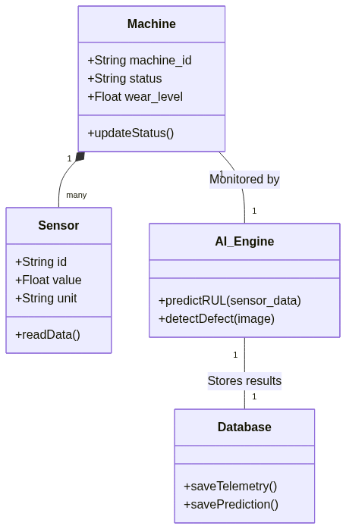

2 Component Diagram
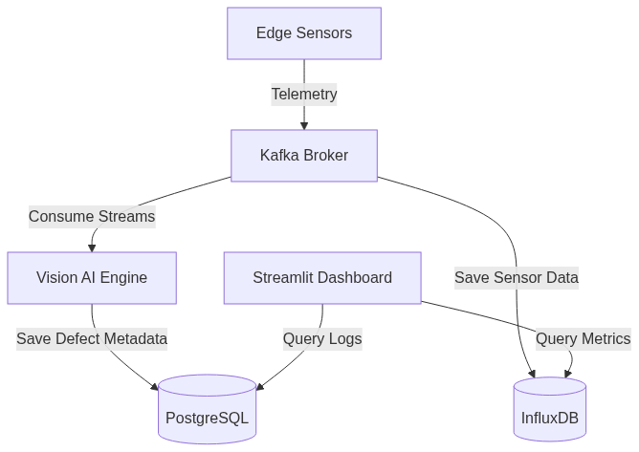

3 Deployment Diagram
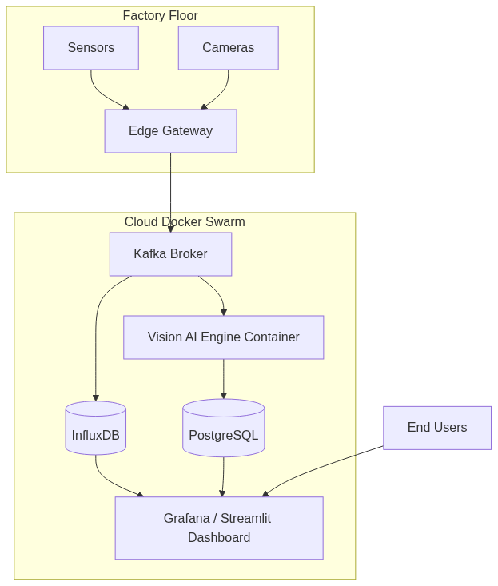

4 Use Case Diagram
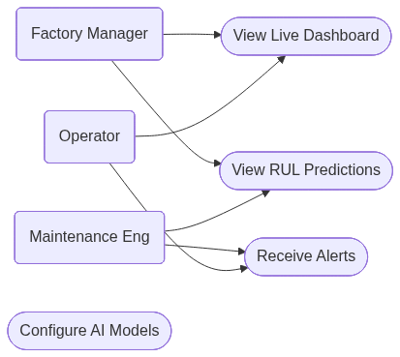

5 Sequence Diagram
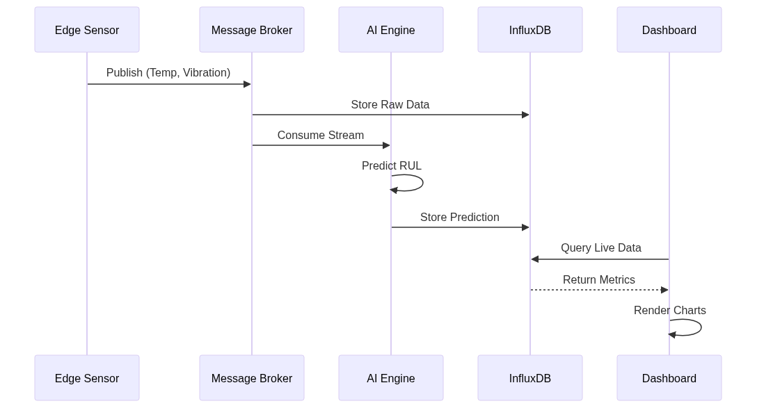

6 Activity Diagram
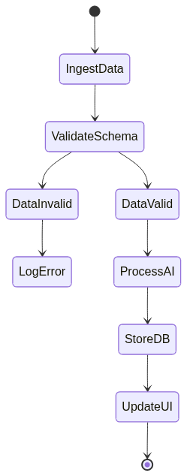

7 State Machine Diagram
