1. What does this overview cover?
   1. Linear model (LM)

Generalized linear model (GLM)

Linear mixed model (LMM)

Generalized linear mixed model (GLMM), also called a hierarchical generalized linear model (HGLM)

Generalized additive model (GAM)

Generalized additive mixed model (GAMM), also called a hierarchical generalized additive model (HGAM)

* + 1. Show table & diagram from QERM 514 L1, but modify to include GAM and hGAM; are hGAMs genearlized additive mixed models?

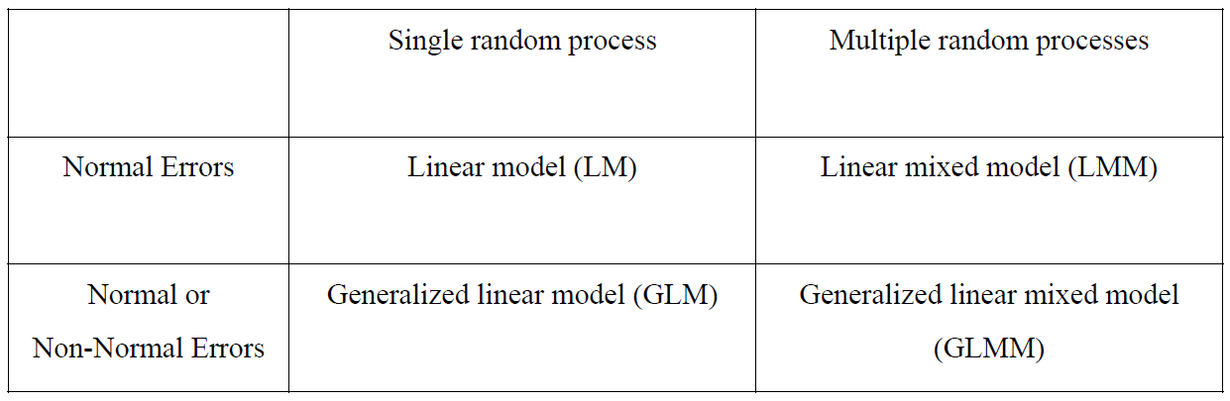

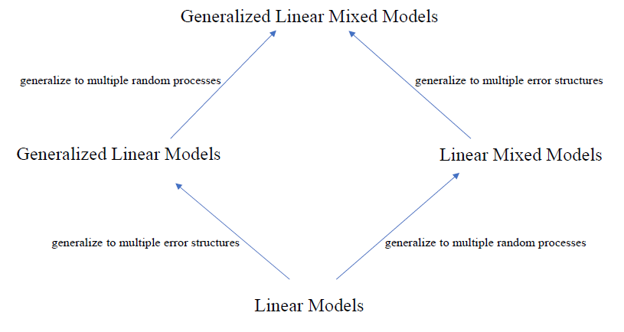

1. What do we not cover (in detail)?
   1. Details about design matrices, the behind-the-scenes structure that allows parameter estimation and prediction
   2. Specifics on how parameters are estimated
   3. Assessing model fit (model diagnostics)
   4. Model selection
   5. Models correlation structures to handle correlated errors
   6. Hypothesis testing
   7. Maximum Likelihood Estimation
   8. Bayesian Estimation
2. Linear Models
   1. QERM 514 L2

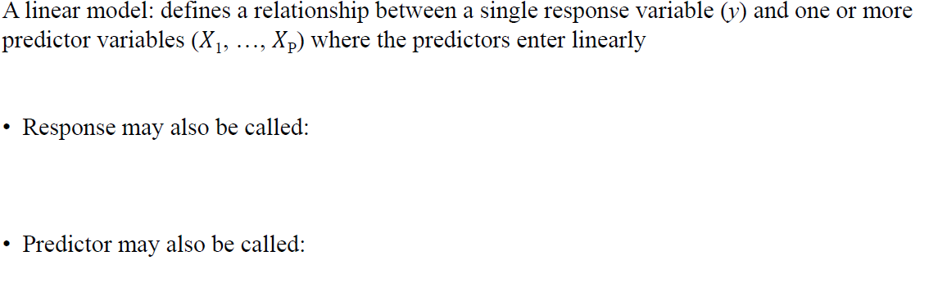

* 1. Examples of linear and non-linear model formulae (QERM 514 L2)

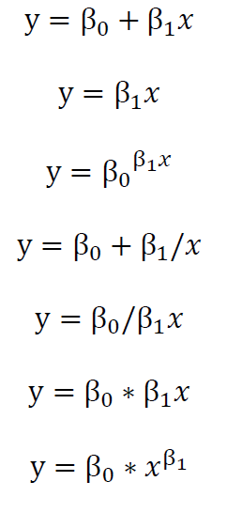

* 1. Matrix notation (QERM 514 L2)

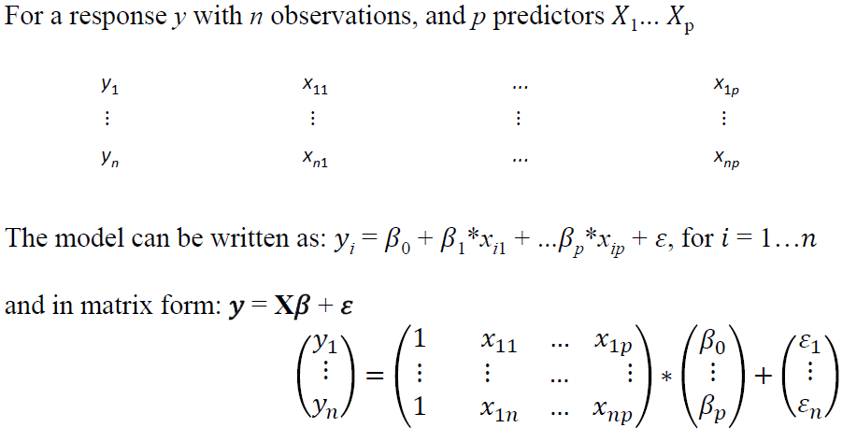

1. Linear Mixed Model
   1. Why random effects?
      1. Account for variation across a population and make inference to that larger population
      2. Use population mean to strengthen estimates for groups with poor/limited data in the population
      3. Account for within-sample correlation when observations are grouped (repeated measures)
   2. Fixed vs. random effects (QERM 514 L10)

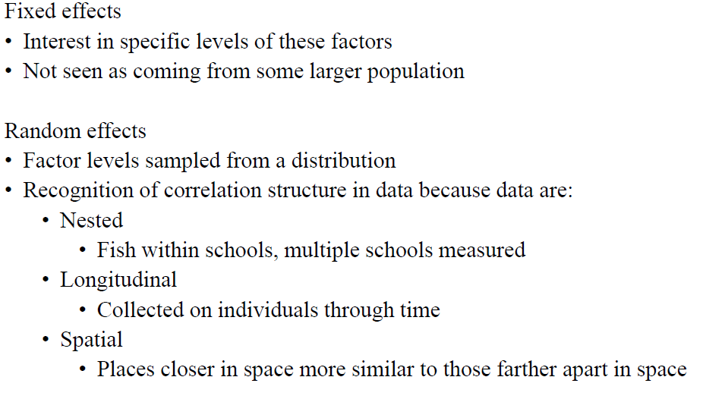

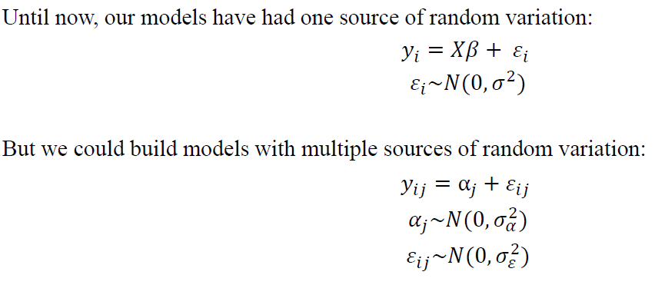

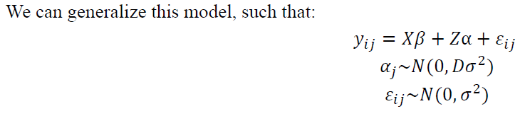

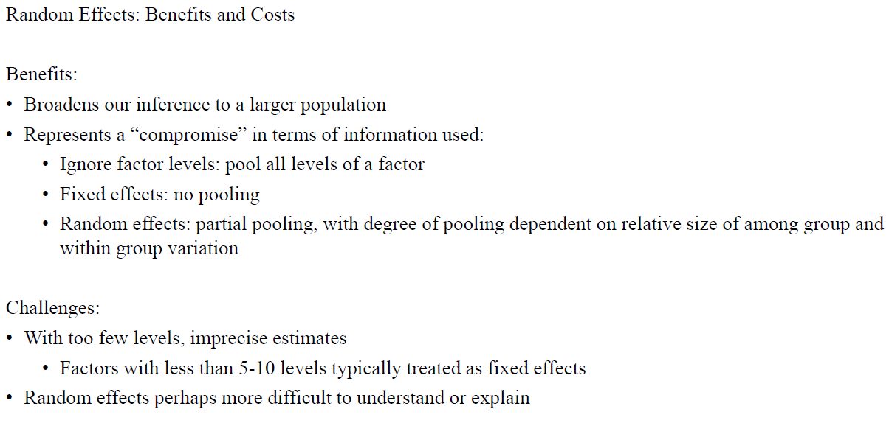

* 1. Types of random effects structures
     1. Random intercepts
     2. Random slopes
     3. Random intercepts and slopes
     4. Nested effects
     5. Crossed effects
  2. Useful References
     1. Harrison, X. A., Donaldson, L., Correa-Cano, M. E., Evans, J., Fisher, D. N., Goodwin, C. E. D., . . . Inger, R. (2018). A brief introduction to mixed effects modelling and multi-model inference in ecology. PeerJ, 6, e4794. doi:10.7717/peerj.4794
     2. Schielzeth, H., & Nakagawa, S. (2013). Nested by design: model fitting and interpretation in a mixed model era. Methods in Ecology and Evolution, 4(1), 14-24. doi:10.1111/j.2041-210x.2012.00251.x

1. Generalized Linear Models
   1. Common approach for a class of regression models with single response variables
      1. Examples include linear, logistic, Poisson regression
      2. General applicability to distributions in the **exponential family**
         1. **Dispersion & scale – footnote –see pdf from cross validated**
   2. Three key components (see handwritten notes on QERM 514 L11)
      1. **Random Component**
         1. The random component
         2. Same as sampling distribution and error distribution? QERM 514 L8
         3. Relationship to likelihood function (QERM L11; M&N p. 28)
      2. **Systematic Component**
         1. The linear model
      3. **Link function**
         1. Mathematical notation
         2. Purpose (in English)
            1. Relates the expected value of the response variable (E(y_i)) to the data
            2. Note that the purpose of the link function is to tame the response variable to restrict it to the correct scale when it is a function of X*beta
         3. Canonical link function
   3. Error distribution
      1. Examples from the exponential family
         1. Continuous
            1. Normal (Gaussian)
            2. Gamma
            3. Beta
            4. Inverse Normal
            5. Exponential
            6. Chi-Square
            7. Dirichlet
         2. Discrete
            1. Bernoulli
            2. Binomial
            3. Poisson
            4. Negative binomial
            5. Multinomial
            6. Geometric
            7. Zero-inflated

Hurdle vs. ????

* + 1. 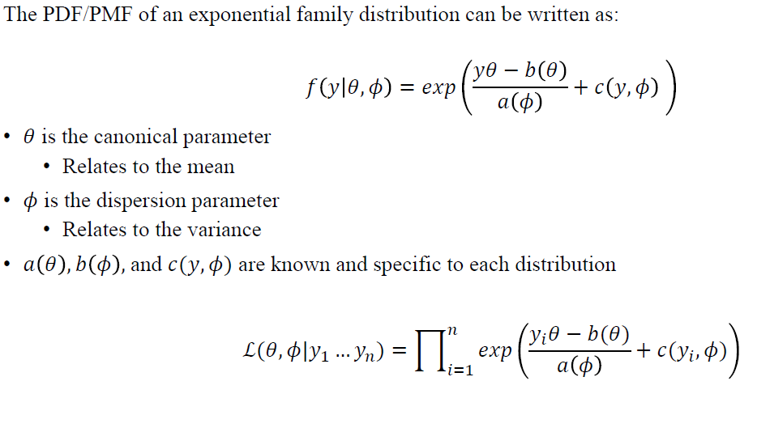
  1. Examples (QERM 514 L11 + other)
     1. Gaussian (Normal)
     2. Bernoilli
     3. Binomial (M&N p. 31)
        1. Logit
        2. complementary log-log (GR's Website_GLM_links.pdf)
        3. probit
     4. Poisson
     5. Negative binomial
     6. Tweedie

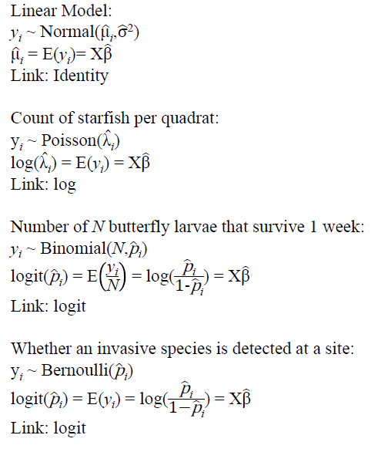

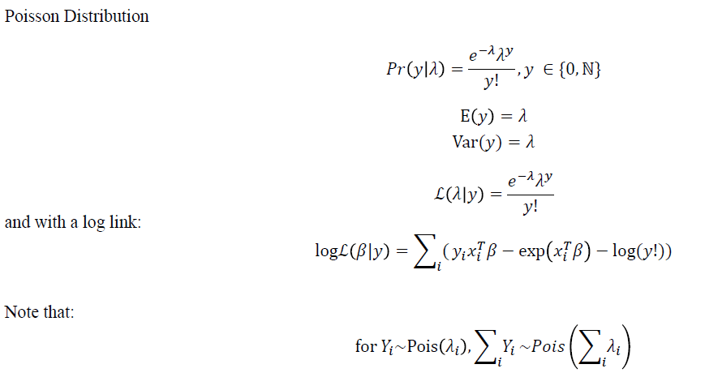

* 1. Useful References
     1. GR's Website_GLM_links.pdf
     2. Module11_Generalized Linear Models_TL Zhang.pdf
     3. McCullagh and Nelder
     4. Ver Hoef, J. M., & Boveng, P. L. (2007). QUASI-POISSON VS. NEGATIVE BINOMIAL REGRESSION: HOW SHOULD WE MODEL OVERDISPERSED COUNT DATA? Ecology, 88(11), 2766-2772. doi:10.1890/07-0043.1
     5. Zero-inflated models