Outline for Website **Konexio**

**Structure:** scroll options with navigation bar (see <http://mapsforgood.org/> and <http://www.samasource.org/>)

**Pages:**

**1. Landing page/acceuil –** use landing page image (see photos folder), with name Konexio

Title: “Connecting the world together through code”

Subtitle: “Welcoming refugees into the community through tech”

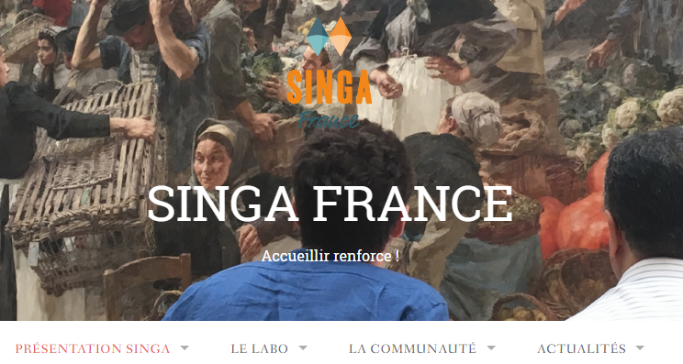

2. **About Konexio –** a few paragraphs on objectives of the organization

Title: “Our Mission”

Text for paragraphs:

With the recent migrant crisis impacting Europe and the world on an unprecedented scale, our mission is to contribute to the process of integration of refugees into these communities through innovation and technology. Refugees face a number of tough challenges once their asylum status has been obtained, but one of the most critical and most burdensome problems for European nations medium to longer term will be that of economic integration through job opportunity. Our organization aims to tackle this by providing refugees with opportunities to learn and connect with through code.

The objectives of our organization are as follows

* Teach fundamental concepts of web development through easy, interactive methods and online platforms
* Empower our participants with professional opportunities
* Build a supportive community of individuals passionate about code and engaged in the tech community

**3. Our activities –** descriptions of our activities along with pictures

**3A. Title: “Workshops”**

We give free regular workshops several evenings per week for 4-6 week sessions. The sessions start with basic concepts of web development—moving from HTML and CSS to Javascript and beyond, and make use of interactive online platforms and exercises adapted for participants of all backgrounds and learning abilities.

Interested in learning more about to participate in these workshops? Please fill out the questionnaire (this is a link to a google form) in the link provided [here](https://docs.google.com/forms/d/e/1FAIpQLScF-zrERka8WJM9B9FbPb6SNCnrdFrCJ85Gw6TChW51OiDU6Q/viewform), and we will follow up with you for more details!

Insert photos in this style of shifting images (see below at <http://mapsforgood.org/>). The photos are in the Dropbox.

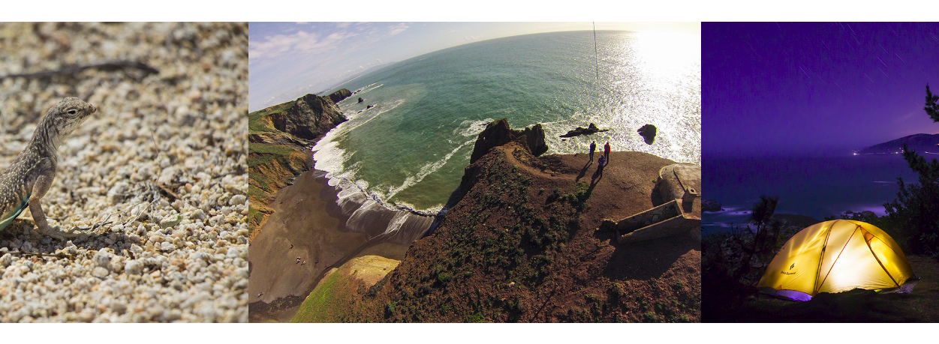

**3B. Title: “Mentor Program”**

Information to be updated.

**4A. Our Team –** information and profiles of team members



**Jean Guo**

[**LinkedIn**](Public%20Profilehttps:/fr.linkedin.com/in/jean-guo-73a75514)

With a background in economics, public health, and policy, Jean is passionate about improving and addressing disparities with regard to equal opportunity. She developed the idea for the project through conversations with the refugee community, which made her realize their lack of access to professional opportunities. She is fluent in English, French, Chinese, and speaks conversational Spanish. In her free time, she sings in a rock a cappella choir in Paris.

**<OTHER PROFILES TO BE UPDATED>**

**Line**

**Dustin Coates**

**Larissa Muramoto**

**Elisabeth Hansen**

**<MARDI and SULIMAN: do you want to be included as teaching assistants here?>**

**4B. Our Partners –** logos of our partner organizations

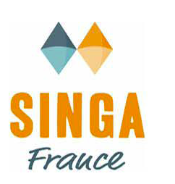





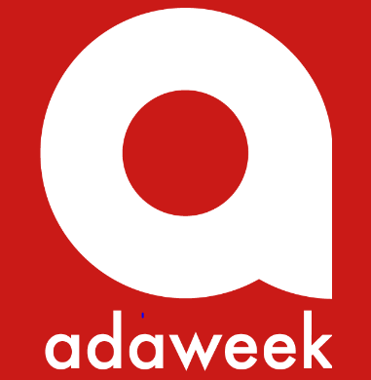

**5. Testimony**

*«* Avant tout, mille et un mercis pour tout ce travail. Il y a de la volonté et de l'enthousi-asme d'aider et de partager le savoir. J'ai beaucoup appris sur les cours dispensés dans ces ateliers; et j'avoue que cela me sera utile pour la vie ! *»*

*« Ils m'ont aidé à découvrir le code et les nombreuses opportunités »*

*« These workshops have helped me to get deeper insight into web development »*

*« Initier et aimer le code pour en faire une base pour créer un site a impact social  »*

*«* Nous espérons avoir une continuité du programme, car nous espérons ne pas nous arrêter à 10 *«* séances. Nous avons soif d'apprendre et rattraper notre retard. *»*

*«* It was a very good method that [helped] me [to] learn coding, which before I didn’t dare to do by my own. I would like to thank everyone who participated in making this workshop possible especially Dustin, Jean and Larissa. *»*

**<TO BE UPDATED WITH PHOTOS OF INDIVIDUAL STUDENTS>**

**6. Contact us**

**6A. Call for Volunteers**

We are currently looking for volunteers to join our efforts!

* Title: **“Guest speakers and instructors”**

Are you passionate about web development? Do you have coding projects or work as a developer? Come and share your experiences as a guest speaker!

Please fill out the questionnaire (this is a link to a google form) in the link provided [here](https://docs.google.com/forms/d/e/1FAIpQLScF-zrERka8WJM9B9FbPb6SNCnrdFrCJ85Gw6TChW51OiDU6Q/viewform), and we will follow up with you for more details!

* Title: **“Partnership building and fund development**”

We need help with workshop coordination, funding efforts, and community partnership building

Fluency in French is a plus, but good communication skills in English and enthusiasm for the cause are all that’s required.

**6B. Contact us form** (see <http://mapsforgood.org/>)

For all other questions or comments, please contact us here!

