Online Diary Requirements Specification

Edward McKnight (UP608985)

# Introduction

## Aim

To develop a system which allows members of an organisation to share a common list of contacts and enables them to create appointments with other members.

## Team

Customer: Prof Jim Briggs

Developer: Edward McKnight (UP608985)

## Rationale

This software project has been commissioned to demonstrate the author’s ability to create useful Java EE web applications and serve as their coursework for the ENTWA unit.

## Dependencies and data

The software will not require any data from external sources, instead sample data will be created by the author and can be changed by users once the system is integrated.

## Timeline

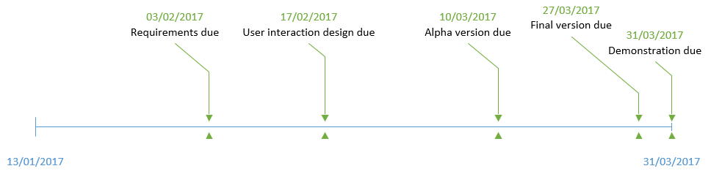

# Data requirements

Changes made between the original and final requirements have been highlighted using colour in the table below. Original requirements are coloured in red and stricken through whereas the updated requirements are coloured green.

|  |  |  |  |
| --- | --- | --- | --- |
| Entity | Property | Type | Validation |
| ~~User~~Client | Username | String | At least 6 alphanumeric characters (unique) |
| ~~User~~Client | Password | String | At least 3 characters |
| ~~User~~Client | First name | String | At least 1 character |
| ~~User~~Client | Last name | String | At least 1 character |
| ~~User~~Client | Address | String | At least 1 character |
| Client | Country | String | Not null |
| ~~User~~Client | Post code | String | Valid postcode (if UK address) |
| ~~User~~Client | Phone number | String | Valid phone number |
| ~~User~~Client | Email address | String | Valid email address |
| Appointment | Start date/time | ~~DateTime~~Calendar | Not null |
| Appointment | End date/time | ~~DateTime~~Calendar | Not before the start date/time |
| Appointment | Description | String |  |
| Appointment | Creator | ~~User~~Client | Valid user |
| Appointment | Attendees | ~~User~~Client | At least 1 attendee and attendees must be valid users |

# Requirements

The requirements listed follow the MoSCoW (Must have, Should have, Could have, Won’t have) prioritisation technique and so each requirement has been prefixed with its priority in the following format: “(<priority>)”, e.g. “(Could)”.

## Functional requirements

### Adding a user

1. (Must) Users of the system can add new user accounts
   1. (Must) New user data must be valid (as per the data requirements), the system will provide hints as to what specific data is invalid if this occurs

### Editing a user

1. (Must) Once a new user has been created they can only be modified by a user with the new user’s username and password or they are logged in as the new user themselves
   1. (Must) Edited user data must be valid (as per the data requirements), the system will provide hints as to what specific data is invalid if this occurs

### Browsing user records (contact list)

1. (Must) Logged in users of the system can browse all user records
2. (Must) Not logged in users cannot view any user records

### Diary

1. (Must) Users can create diary appointments
   1. (Must) The appointment’s creator does not need to be an attendee
   2. (Must) Any one attendee for an appointment cannot be an attendee for another appointment which overlaps
      1. (Should) Attempts to create such appointments will result in the system presenting the user with an error message explaining possible amendments which could be made

### Appointment reports

1. (Must) Users can request reports of appointments by:
   1. (Must) All appointments associated with a single user (the currently logged in user by default)
   2. (Must) All appointments on a specified date
2. (Must) Appointment creators can cancel their appointments when viewing the reports
   1. (Should) This will make all attendees for the appointment free at that time
3. (Could) Graphical calendar view of appointments

## Non-functional requirements

1. (Should) Web application is responsive
2. (Should) User interface is intuitive to use
3. (Should) Code is maintainable
4. (Should) Error messages are helpful