Interim Report 1 – Specification and Project Plan

Functionality
The product will be an “online shopping cart” web application; which can be bought, installed and fully managed as well as maintained by English-speaking businesses worldwide. The product will include functionality allowing the business owner's customers to browse and search through products (organised into categories) and make online purchases through the web application.

The product will also allow staff to update company information, the colour scheme (of the user interface), manage their product catalogue (updating product descriptions, pictures and whether a product is “featured” or not) and delivery options at any time as well as supplying staff with customer delivery information, reports on sales and present them with real-time information concerning their organisation's product stock levels.

The product will further implement exclusive environmentally friendly features, encouraging their customers to make environmentally friendly choices. These will include: highlighting the most environmentally friendly choices where: there are products which have multiple specifications and delivery options (at the checkout stage). Also designing the web application to run on low powered and low performance server hardware in order to help reduce the business' carbon footprint.

Design
Below is a low-fidelity wire-frame design of what the product will roughly look like to the end-user, as well as a high level architectural data flow diagram to show data flow within the application.
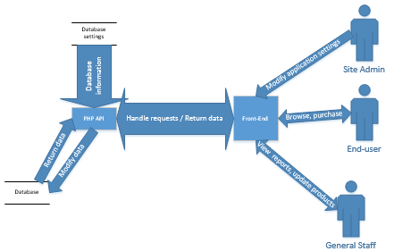
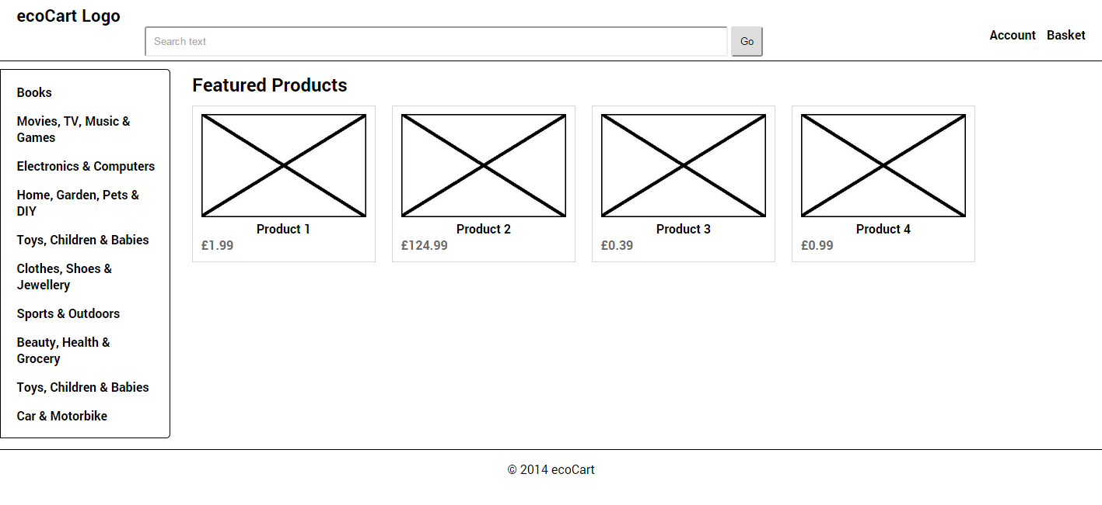

Plan
The life cycle model to be used will be a variant of the waterfall model, which implements incremental development. This means: defining the system's functionality and design, then breaking the project into smaller segments and completing them one after another essentially as prototypes; until the project has been completed. I think this will suit the way I work and help to minimise bugs; breaking the system into small tasks which need to be completed and ensuring that each part works and prototyping them before moving onto the next task.

The analysis, specification and design phases of the project have taken approximately 11 hours of work. Based on this, my prediction concerning the amount of development work required, time needed for testing and the additional work needed for documentation is approximately 220 hours of work for the entire project to be completed. With approximately 80% of the remaining unexplained 209 hours being spent on coding and testing and the other 20% being spent on producing documentation and finalising the product.

There are several factors which may affect the progress of the project, these include: the commitments I have to complete pieces of coursework from other units which are on going throughout the year, but at the same time I can also use knowledge learnt in other units which could potentially speed up work on this web application. For example what's taught in GUDE may help me to design the application, ADPROC might help me quickly solve programming problems and INSE will help me to properly test and keep to the schedule.

I believe I will be able to cope with any relatively minor unforeseen delays to my schedule as I have built into my plan occasional breaks of a few or more days in case the task takes longer than I anticipated and to act as a buffer for if the task was pushed back due to other external influences. Having these small breaks also gives me time to work on my other commitments. Larger delays may require considering changing the plan at the time however.
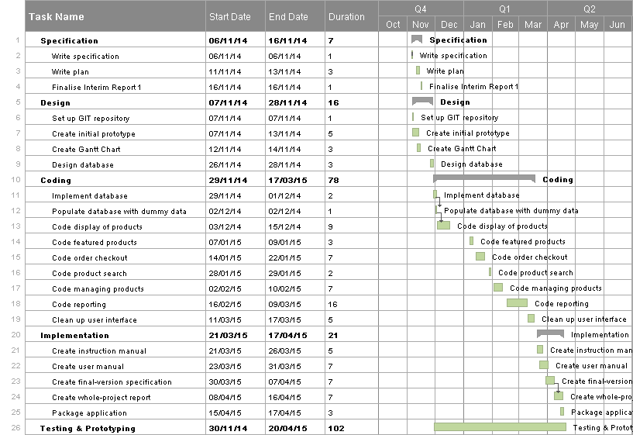
Presented below is a simplified version of Gantt Chart produced for this project's schedule.

