Interim Report 2
Technical achievement and project progress

Technical Report
The current state of the product is that it is usable from the customer's perspective; allowing them to browse through and search for products (by name), add products to their “shopping basket” and place an order (although these views have not yet been entirely finalised). Development has primarily been concentrated on creating this front-end display of products (making use of dummy data which has been input into the database manually), functionality of the “shopping basket” and placing an order.
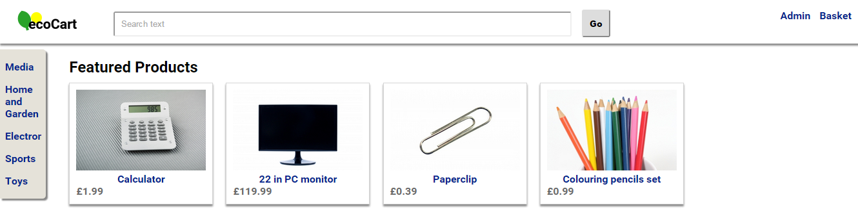
Upon first loading the web application customers can see a number of “Featured Products” (which will be configurable by staff). These products are loaded from the application's database. Customers are able to click on products, displayed on the screen, which takes them to a more detailed view of the specific product. From this view they're then able to add the product to their “shopping basket”.
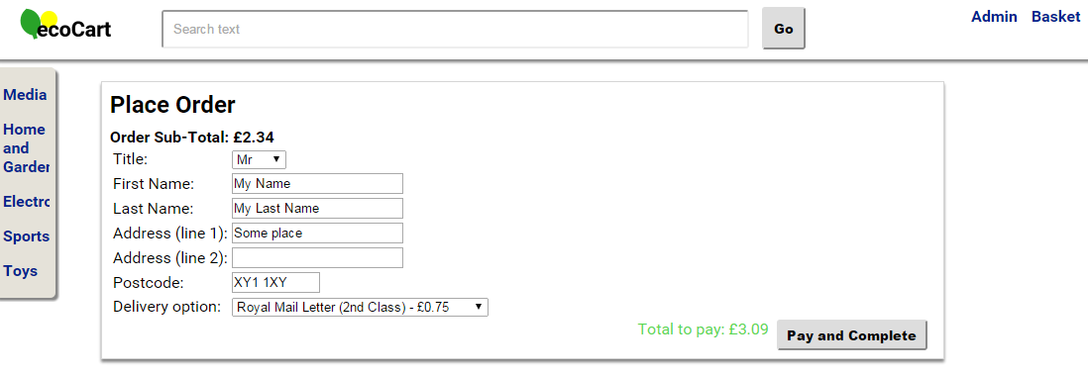
The screenshot above shows the “Place Order” view, which the customer can get to via their “Shopping Basket”, this view allows them to input their delivery details and complete their order
Although the customer facing side of the application is near completion there is little working in terms of management of the system; to be used by staff. However much of the ground work on the back-end side has been put in place which will support developing the staff's management features.
To work up knowledge concerning how to create an effective RESTful API back-end for the application some research was carried out by visiting various websites and reading articles. One notable article is Corey Maynard's “Creating a RESTful API with PHP” [Corey Maynard. (2013). Creating a RESTful API with PHP. Retrieved from http://coreymaynard.com/blog/creating-a-restful-api-with-php/ on 24/01/2015] from this article, several ideas have been used in the application. Also some of Dr Rich Boake's code on GitHub has been referenced, in particular the “spartacus” project which demonstrates how custom JavaScript events can be utilised, which has made its way into this application.

Management Report
One surprise encountered during the project's life-cycle so far has been that the ordering of some tasks within the coding phase have been altered. This is because there has been a difference in how the tasks have naturally flowed from one to another from how it was expected they would flow. Meaning it has made more sense and been more efficient to carry out these tasks in the order in which they've been completed in practice. For example, coding the product search before the order checkout.
One of the major hold-ups encountered was caused by starting work on back-end functionality and creating front-end features which subsequently used this, but then having to back track and recreate how the back-end of the system worked. However this unforeseen work was necessary, as the previous implementation was inefficient and would make adding new functionality a more timely and complex task. Due to these factors, what's in place now will speed up development through what remains of the coding phase as well as speeding up documentation writing and testing. Other smaller hold-ups include having to put extra work into studying for other units when there's been exams and other pieces of coursework due.
During the project so far there have been a few breakthroughs meaning some tasks have taken less time than predicted. For example, designing the database only took 2 working days, as opposed to 3. Also work that has been carried out for some tasks can be reused and applied to subsequent tasks, greatly reducing the time taken to complete them. For example implementing the search feature took 1 day, instead of 2; as work put in to support the display of products in the application made this very easy to implement. Another breakthrough was the decision to work over the holiday period, which hadn't originally been planned; doing so gave more flexibility to cope with hold-ups. Time gained from these breakthroughs has mitigated the effects of hold-ups; effectively cancelling them out meaning the project is still on schedule to be completed.
One of the lessons learnt so far has been to better think through what features, that haven't been implemented yet, need to be supported and also the realisation that putting in more ground work for certain parts of the system is important to speed up development later on. For example, the reworking of the system's back-end functionality can be referred to.
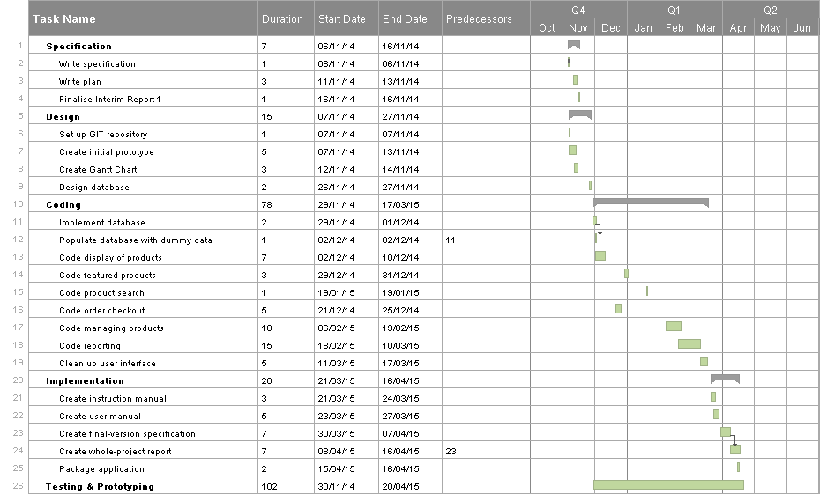
Below is a revised simplified Gantt Chart for the project, taking into account how long completed tasks actually took and making changes to future tasks based on this report.

