User Manual
ecoCart
(British) English
April 2015

Pretext
Thank you for using ecoCart. To best make use of this manual please refer to the corresponding section based on whether you’re a customer of a business who are using ecoCart as their e-commerce solution or a member of staff who’s employer uses ecoCart. Referring to these sections should ensure that you’re not looking at information which may not be relevant to you. The recommended web browser to use for all ecoCart powered websites is: Google Chrome (version 41).
Contents
Customer ecoCart user 3
Navigating the shop 3
Adding products to your basket 3
Managing your basket 4
Placing an order 4
Staff ecoCart user 4
Managing products 4
Uploading images 5
Managing categories 5
Managing delivery options 6
Changing settings 6
Viewing stock level warnings 7
Managing orders 7

Customer ecoCart user

Navigating the shop
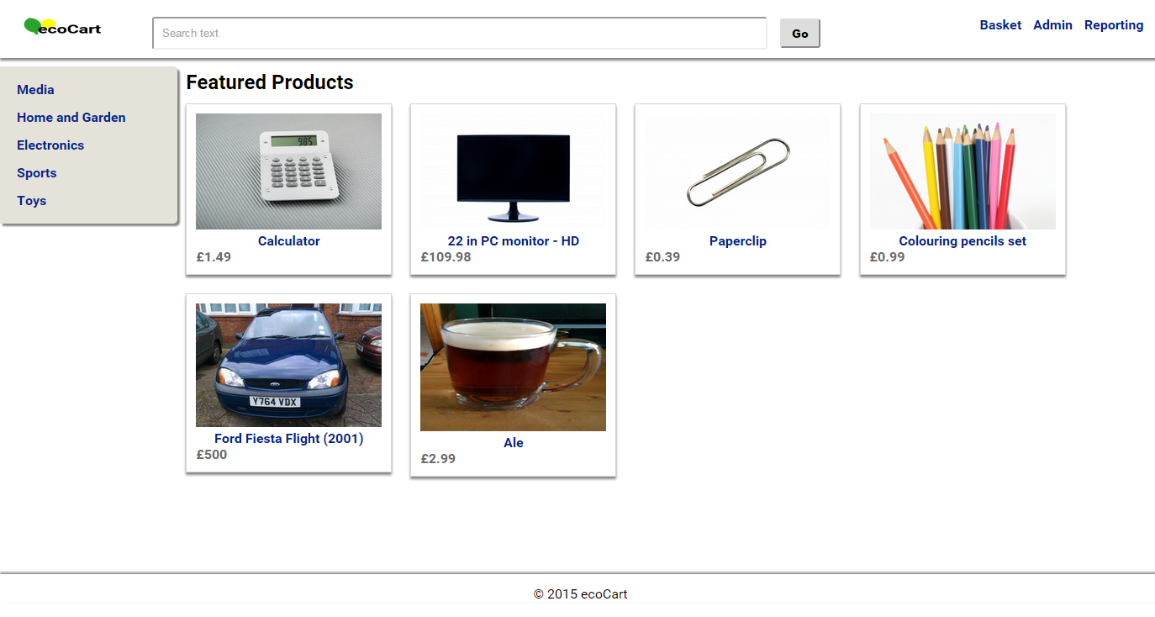
Upon first loading an ecoCart powered website you’ll see “Featured Products”. From this view you can navigate to other views by:
- Clicking on a product you want to read more about (this will take you to a screen with details about the product you’re interested in)
- Clicking on a category to view on the left side of the screen (this will show you all of the products within that category and a menu of any sub-categories that may exist)
- Starting to search for a product using the search box at the top (the search will start returning results after a third character has been typed)
- View your basket by clicking the “Basket” link at the top right
You can get back to this home page (listing featured products) by clicking the company logo at the top left.

Adding products to your basket
There are two ways in which you can add products to your basket:
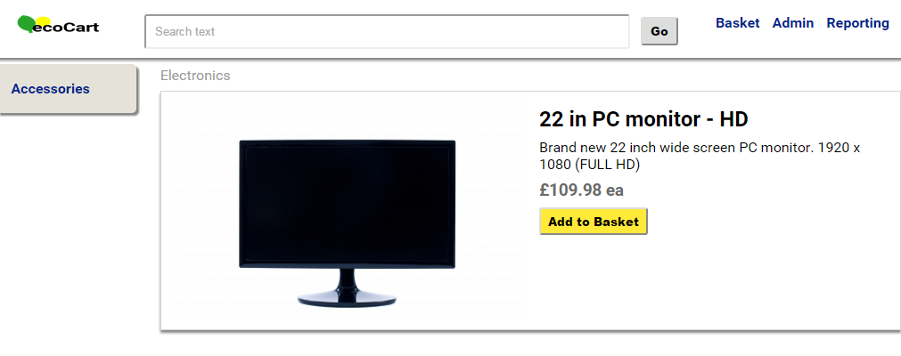
- By clicking on the product you want to add to your basket and then clicking the “Add to Basket” button once on the detailed product page
- By dragging the product from product results over the “Basket” link (the “Basket” link will be highlighted to indicate that it can accept the product being dragged) at the top right
After adding a product to your basket there will be a short delay before you’re automatically taken to view your basket.

Managing your basket
When viewing your basket you have several options to choose from:
- Products can be removed by clicking the “Remove” button for the respective product
- Quantities can be changed by editing the quantity text boxes for each product and then clicking the “Update Basket” button
- You can place an order for the contents of your basket by clicking the “Place Order” button
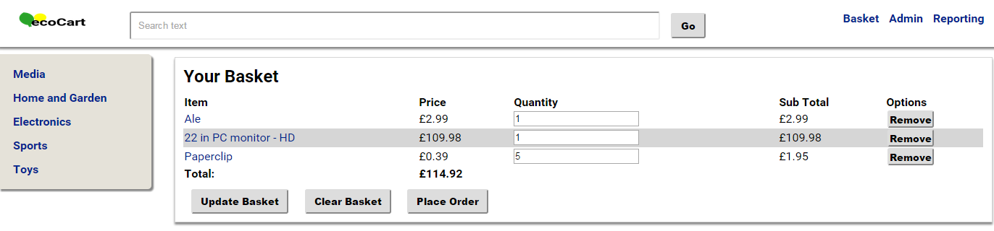

Placing an order
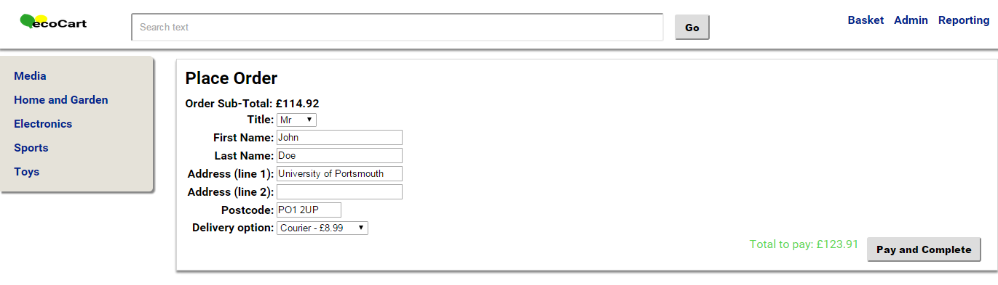
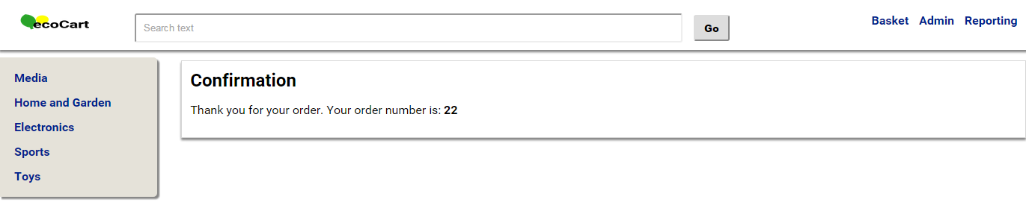
To place an order simply click the “Place Order” button from the basket. At this point you’ll be presented a form which asks for your name and address. You can also choose a delivery option, selecting a delivery option will automatically update the total of the order (displayed at the bottom right). Once you’ve completed the form you can click the “Pay and Complete” button to pay for your order. Your order will then submit and you’ll be shown your order number which you can use as a reference for any queries you may have concerning your order.

Staff ecoCart user

Managing products
From the products view you can add new products and edit existing products. To create a new product click the “New Product” button at the top of the view. Or to edit an existing product: search for the product you want to edit (using the search form) then click the “Edit” button next to the corresponding product or the “Delete” button (if you want to remove it from the website).
When editing an existing product (or adding a new one) you’ll be presented with an editable form allowing you to modify every aspect of the product. Once all changes have been made clicking the “Save” button will update the product with the latest product information.
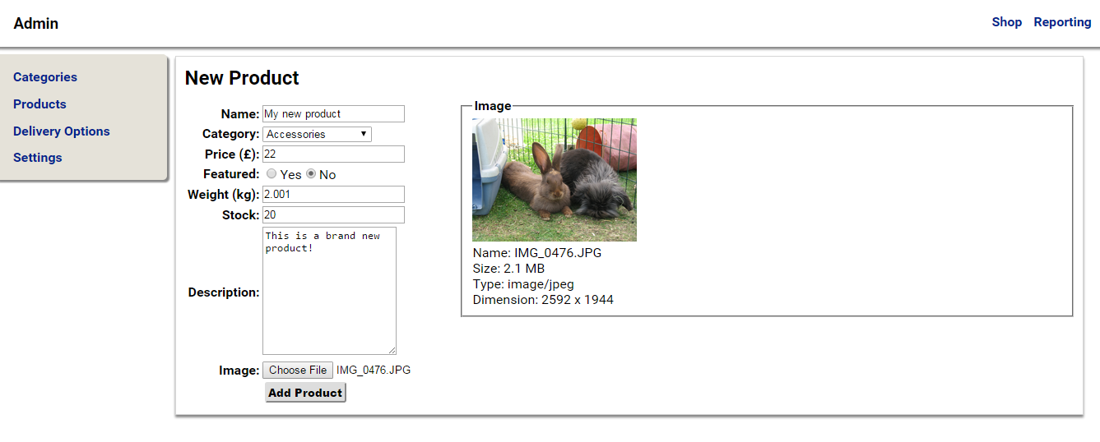
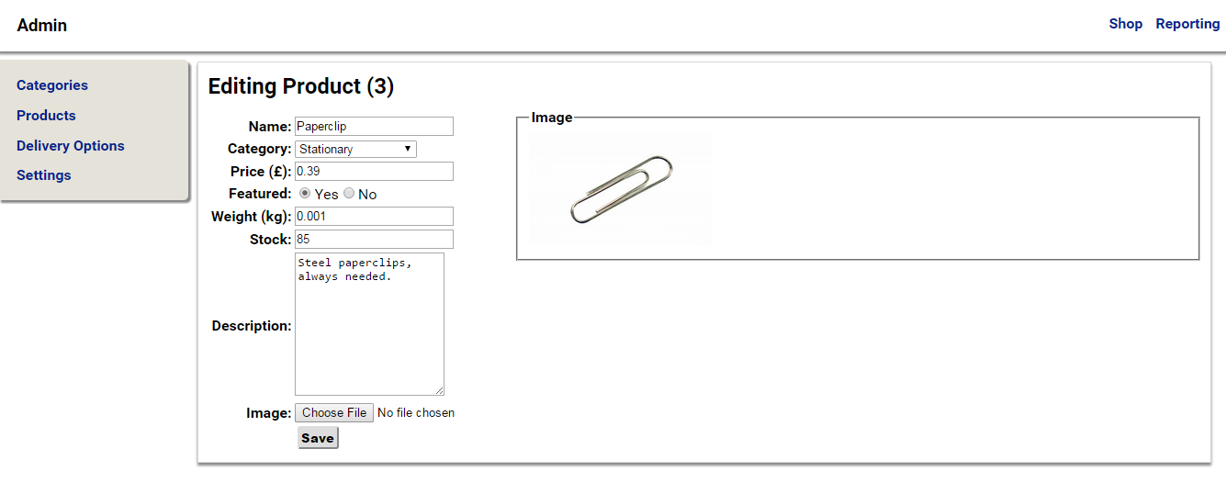

Uploading images
Clicking the “Choose File” button for the image and selecting an image will populate the right side of the form with images about the new image to use for the product. Once the image is chosen clicking the “Save” button will update the product with any changes and upload the new image.

Managing categories
From the categories view new categories can be added at the top of the view by setting a name for the new category, choosing a parent category (if any) and then clicking the “Add” button. After this button has been clicked the list of categories below will update.
Existing categories can be:
- Deleted, by clicking their respective “Delete” button
- Modified, by clicking their respective “Edit” button, this will change the category’s values into modifiable fields, you can change these fields then click “Save” to update the category
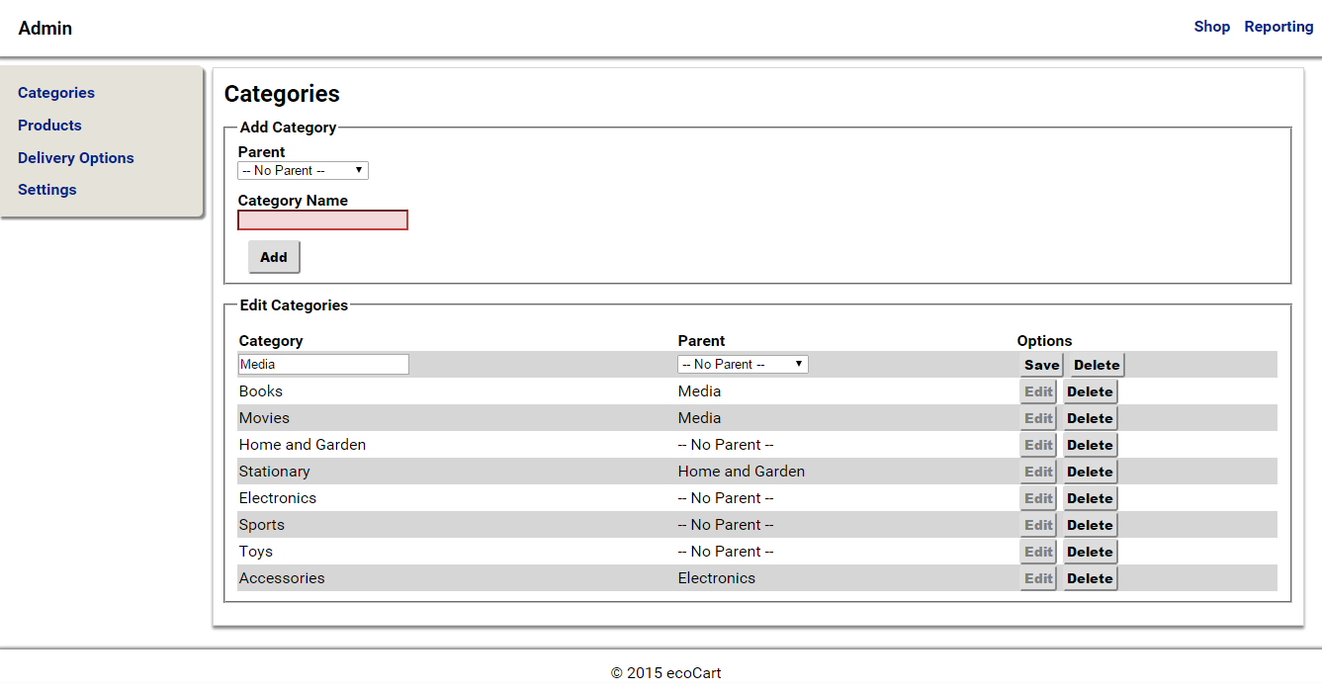

Managing delivery options
From the delivery options view new delivery options can be added at the top of the view by setting a name, max weight, eco rating and cost for the new delivery option and then clicking the “Add” button. After this button has been clicked the list of delivery options below will update.
Existing delivery options can be:
- Deleted, by clicking their respective “Delete” button
- Modified by clicking their respective “Edit” button, this will change the delivery option’s values into modifiable fields, you can change these fields then click “Save” to update the delivery option
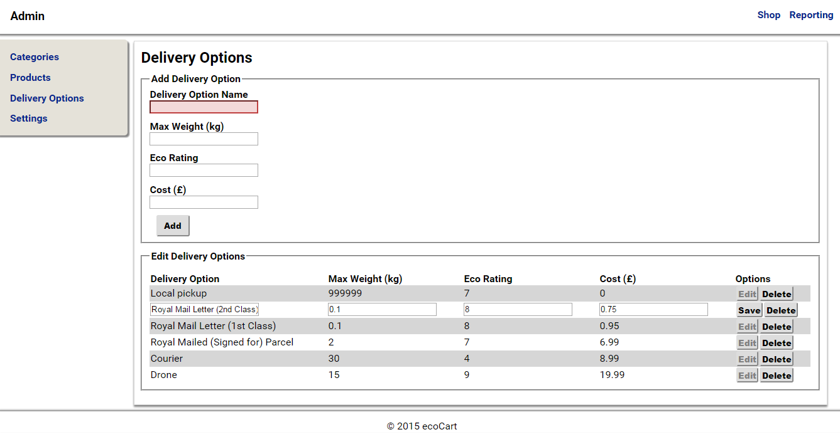

Changing settings
By using the settings view you’re able to modify all of the web application’s settings including:
- The name of your business (which will set the shop front’s title and footer text)
- The level of stock remaining of a product before the system issues a warning
- Various CSS style settings for the customer facing side of your installation of ecoCart
To modify a setting simply click the respective “Edit” button, this will change the setting’s value to an editable field; after changes have been made you can then click the “Save” button to update the setting.
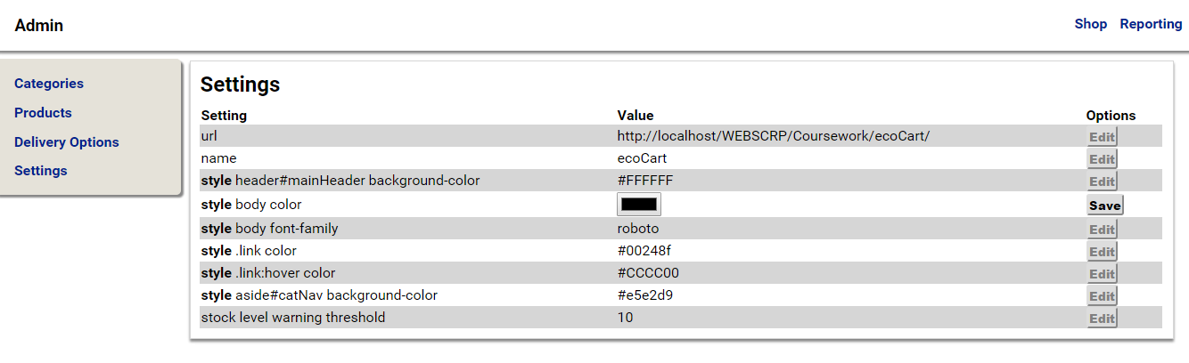

Viewing stock level warnings
From the “Reporting” area of the system you can access “Stock Warnings”. This displays a list of all products which have a stock level under the stock warning threshold. From this view you can modify these products by clicking on them.
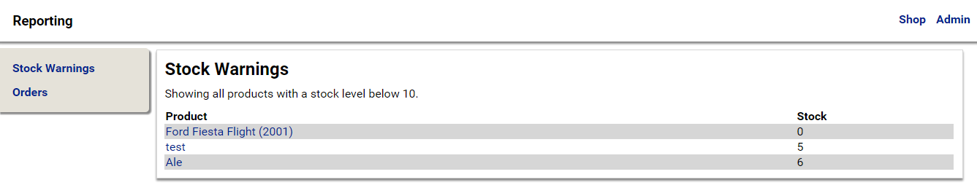

Managing orders
The “Reporting” area of the system can also be used to view and manage orders. Once on the “Orders” view a timescale can be set by selecting from the “Start Date” and “End Date” date pickers. Once the “Search” button has been clicked all orders between the start and end date will be displayed below as well as the total turnover for the orders during this period (at the bottom right) of the results.
Each order has two option buttons:
- “View”, which displays as a popup, a breakdown of the products in the order and their quantities
- “Mark as Sent / Not Sent”, which when clicked will either mark the order as sent or not sent so that other members of staff are aware of the status of the order
