Whole Project Report
ecoCart

Final Gantt Chart
The following Gantt chart displays the actual time taken to complete individual tasks in order to complete the project as a whole. This chart can be compared to charts created earlier, in the project’s interim reports, to see differences between how long it was thought tasks would take and when they’d be completed compared to how long they actually took to complete and when they were in fact completed. This technique has been used to identify, explain and analyse life-cycle surprises which have surfaced.
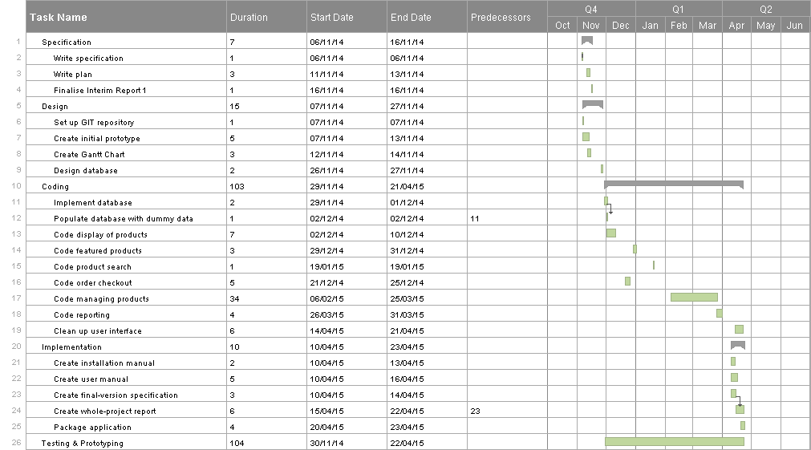

Life-cycle Surprises
During the project there were several surprises concerning how the predicted scheduling differed in practice. Some of these surprises took the form of setbacks and some were breakthroughs, which caused development to be sped up. Overall these surprises, in combination with gaps between tasks (which had been built into the project’s scheduling) meant that the project’s progress was not significantly negatively affected by these surprises.
Setbacks included the need to take a break from working on the web application from late February to the middle of March; this was due to deadlines imposed by other units taking precedence during this time. Another setback was a personal short holiday at the beginning of April which also affected the timing of tasks that were due to be worked on at this time.
In contrast: surprises that sped up development included the realisation that creating documentation for the product hasn’t taken as long as expected and that it has also made sense to work on multiple pieces of documentation simultaneously, as for example: content in the user and installation manuals are related. Additional time put aside for fixing bugs after testing has also often proved unnecessary as many bugs encountered during testing have been minor and therefore resolved quickly during respective testing tasks. Also, time assigned for testing has often been more than was needed, this is due to carrying out testing while developing larger parts of the application (which had longer deadlines than other tasks).

Lessons Learnt
Several lessons have been learnt throughout working on the project, prior to and after the 2nd interim report having been issued.
While creating the 2nd interim report I learnt and gained experience concerning the possibility of reordering coding tasks in a way that naturally flows better from task to task. Sometimes this natural flow is only discovered once the coding tasks have begun but having the flexibility to reorder these tasks is an important and useful capability.
Since the 2nd interim report and taking into account the aforementioned life-cycle surprises, lessons have been learnt for future projects I will work on. One of these learnt lessons has been to better take into account the effect of deadlines of other units on the development progress of the project, this is something which can feasibly be planned for by using the University’s unit search website to see details about how each of the units which I study are assessed and the rough dates as to when assessed pieces of work are due. Another lesson learnt is that I should have updated the Gantt chart (which was used throughout the project) as soon as I was aware of the dates of my personal holiday (which occurred at the beginning of April); if this had of been done the effect that this had on the remaining tasks of the project could have been better planned in and accounted for to minimise the impact that the holiday had on development.
One feature of the project’s planning I implemented from the start has proved to be useful however. This feature was to build in gaps between some tasks to allow for surprises and flexibility in the scheduling. If these gaps were absent I believe the flexibility to accommodate setbacks would have been greatly reduced leading to negative implications on the progress of the project.
Overall the surprises encountered and my own proven precautions in the project’s planning have provided me with vital experience which I’m sure will come in highly useful in future software engineering projects which I participate in.

Appendices

Appendix A: Hours taken for development log
Prototype | Gantt Chart | JavaScript / CSS | PHP
08/11/2014 - 3 hours  09/11/2014 - 1 hour | 09/11/2014 - 1 hour  25/01/2015 – 1 hour  20/04/2015 – 1 hour | 11/12/2014 - 1 hour  19/12/2014 - 1 1/2 hours  20/12/2014 - 2 hours  22/12/2014 - 1 hour  27/12/2014 - 1 hour  03/01/2015 - 40 minutes  19/01/2015 - 1 hour  21/01/2015 - 1 hour  25/01/2015 - 5 hours  26/01/2015 - 2 hours  08/02/2015 - 1 hour 40 minutes  10/02/2015 - 30 minutes  13/02/2015 - 10 minutes  16/02/2015 - 3 hours  17/02/2015 - 1 hour  18/02/2015 - 2 hours  24/02/2015 - 30 minutes  03/03/2015 - 30 minutes  17/03/2015 - 30 minutes  20/03/2015 - 1 hour  21/03/2015 - 3 hours  22/03/2015 - 2 hours  23/03/2015 - 30 minutes  24/03/2015 - 20 minutes  27/03/2015 - 30 minutes  28/03/2015 - 30 minutes  29/03/2015 - 1 hour  30/03/2015 - 2 hours  31/03/2015 - 2 hours  17/04/2015 - 1 hour  18/04/2015 - 3 hours  19/04/2015 - 30 minutes  20/04/2015 - 2 hours | 18/12/2014 - 1 1/2 hours  21/12/2014 - 1 hour  22/12/2014 - 1/2 hour  23/12/2014 - 1 hour  27/12/2014 - 1 hour  03/01/2015 - 20 minutes  14/01/2015 - 1 hour  15/01/2015 - 1 1/2 hours  19/01/2015 - 10 minutes  26/01/2015 - 1 hour  06/02/2015 - 20 minutes  08/02/2015 - 20 minutes  24/02/2015 - 30 minutes  20/03/2015 - 30 minutes  21/03/2015 - 1 hour  22/03/2015 - 30 minutes  23/03/2015 - 30 minutes  24/03/2015 - 20 minutes  25/03/2015 - 10 minutes  29/03/2015 - 1 hour  30/03/2015 - 1 hour  31/03/2015 - 1 hour  14/04/2015 - 1 hour  16/04/2015 - 30 minutes  19/04/2015 - 30 minutes

Appendix B: Interim 2 Revised Gantt Chart
