Q1. If you need, follow the links below and refer to the pages. (1 pts)

* [How Focal Statistics works](http://desktop.arcgis.com/en/arcmap/10.3/tools/spatial-analyst-toolbox/how-focal-statistics-works.htm)
* [Focal Statistics](http://desktop.arcgis.com/en/arcmap/10.3/tools/spatial-analyst-toolbox/focal-statistics.htm)

By using the raster below, perform focal statistics for a new raster. Use 3 x 3 rectangle for its neighborhood type and calculate the VARIETY of the cells in the neighborhood. Ignore NoData in calculations and 'N' in the input raster means NoData.

|  |  |  |  |  |  |
| --- | --- | --- | --- | --- | --- |
| 4 | 0 | 1 | 2 | 3 | 0 |
| 2 | 5 | 0 | N | 3 | 2 |
| 1 | 1 | 2 | 3 | 5 | 4 |
| 1 | 5 | 3 | 2 | 1 | 4 |
| 5 | N | 1 | 3 | 3 | 0 |
| 1 | 1 | 2 | 3 | 4 | 3 |

|  |  |  |  |  |  |
| --- | --- | --- | --- | --- | --- |
|  |  |  |  |  |  |
|  |  |  |  |  |  |
|  |  |  |  |  |  |
|  |  |  |  |  |  |
|  |  |  |  |  |  |
|  |  |  |  |  |  |

 Follow the instructions.

1. layers needed
   * L5015033_03320060504_B10.TIF (Landsat TM 5 band 1)
   * L5015033_03320060504_B20.TIF (Landsat TM 5 band 2)
   * L5015033_03320060504_B30.TIF (Landsat TM 5 band 3)
   * L5015033_03320060504_B40.TIF (Landsat TM 5 band 4)
   * AOI (polygon feature class)
2. clip the images (each of the 4 bands) with polygon 4 & 7 (ObjectID 4 & 7) in AOI
3. create an NDVI layer for each clipped area
   * [NDVI function](http://desktop.arcgis.com/en/arcmap/10.3/manage-data/raster-and-images/ndvi-function.htm)

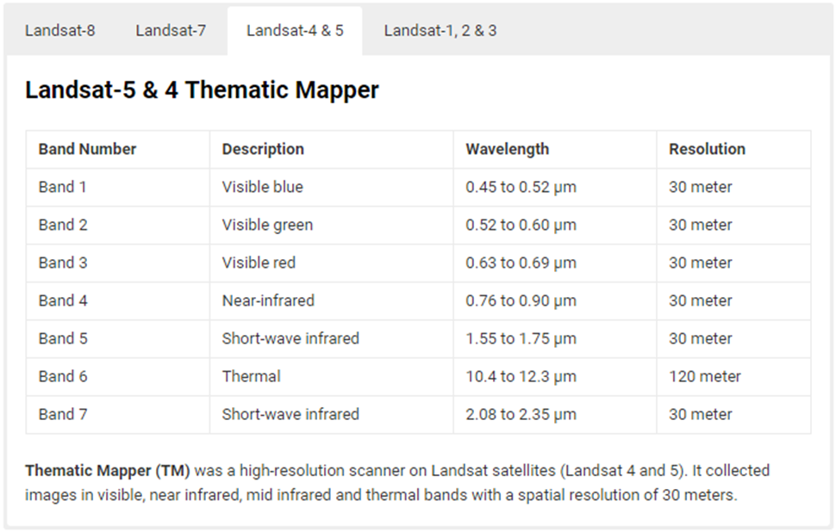

1. composite the four bands to creates a single raster dataset
2. see the composited image as a true-color or false-color image
   * refer to this page: [Composite Bands](http://desktop.arcgis.com/en/arcmap/10.3/tools/data-management-toolbox/composite-bands.htm)
   * and this: [Drawing a multiband raster dataset as an RGB composite](http://desktop.arcgis.com/en/arcmap/10.3/manage-data/raster-and-images/drawing-a-multiband-raster-dataset-as-an-rgb-composite.htm)
   * or refer to the image below

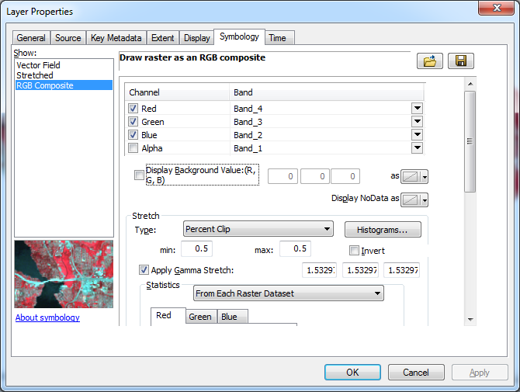

Q2. The maximum value of the NDVI layer for polygon 4 area is 0.741497. (1 pts)

Q3. The minimum value of the NDVI layer for polygon 4 area is -0.352941. (1 pts)

Q4. The range of the NDVI values for polygon 7 area is from -0.5 to 0.741497. (1 pts)

Q5. Upload your captured NDVI, composited true-color, and composited false-color images for polygon 4 area. (3 pts)

Q6. Upload your captured NDVI, composited true-color, and composited false-color images for polygon 7 area. (3 pts)

Q7. Compare the NDVI, composited true-color, and composited false-color images for each area. Describe how they are useful in understanding the areas. (2 pts)

Refer to these pages:

* [Observing in Visible Light](https://earthobservatory.nasa.gov/Features/FalseColor/page4.php)
* [How to Interpret Common False Color Images](https://earthobservatory.nasa.gov/Features/FalseColor/page6.php)

Q8. Read the python script below and explain what it'd do. (1 pts)

###################################

HIGH_SCORE = 95

test1 = int(input("Enter the score for test 1: "))  
test2 = int(input("Enter the score for test 2: "))  
test3 = int(input("Enter the score for test 3: "))

average = (test1 + test2 + test3) / 3  
print("The average score is: " + str(average))

if average >= HIGH_SCORE:  
print("Congratulations!")  
print("That is a greate average!")

###################################