SCATTER PLOTS:

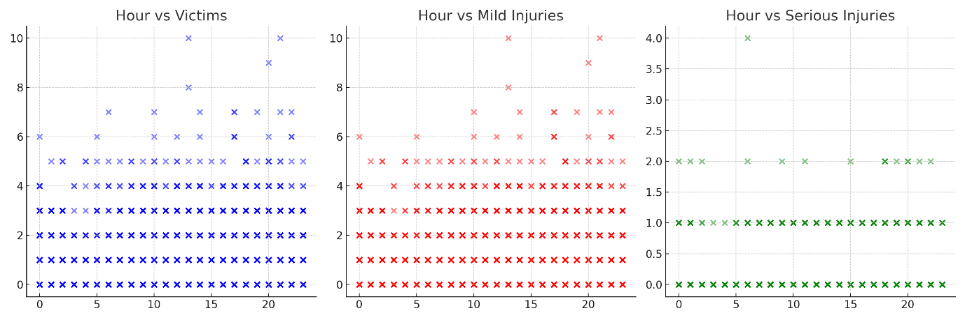

HISTOGRAMS:

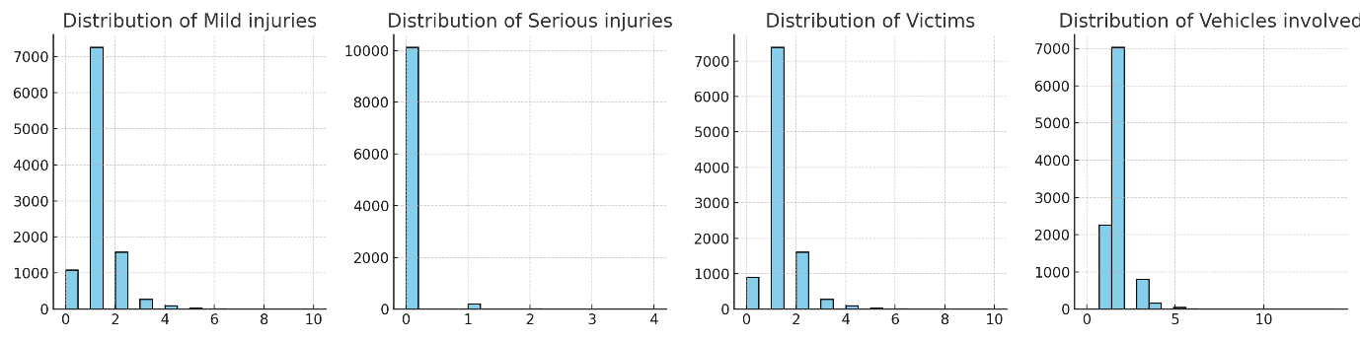

BOXPLOTS:

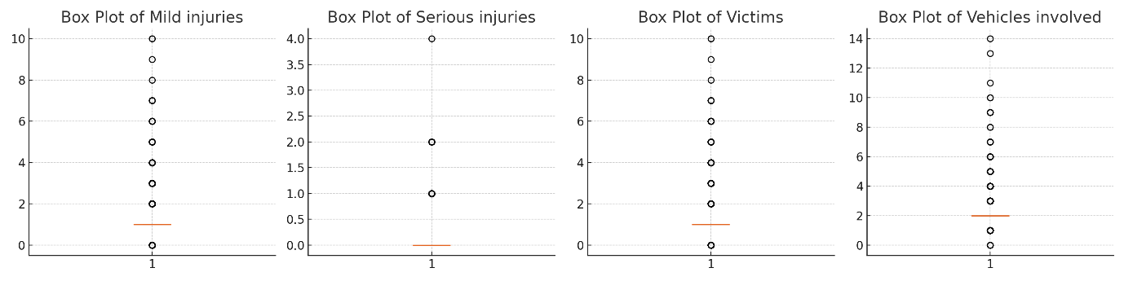

HEATMAP: