**HOMEWORK**

LOGIC REVIEW BEFORE MIDTERM EXAM

**Exercise 1:**

The alphabet is given below to help you:

a b c d e f g h i j k l m n o p q r s t u v w x y z

**Q1** a w b s c o

**Q2** e e z J y o o

**Exercise 2:**

**Q1** An ASCII represents 245 characters. What is the size (in bits) of an ASCII? *(Justify your answer)*

Answer is 8bite because 28 = 256 so 245 is nearly 256.

**Q2** with 8 bytes, how many values can be represented? *(Justify your answer) ​*

*Answer is 264because 1bytes = 8bite so 8bytes =64 bite.*

**Q3** How many bits to store alphabet and number in keyboard 0…9, A…Z and a…z

Answer is 6 bite because

0...9 have 10 number

A...Z have 26 number

a...z have 26 number

number 10+26+26=62

To find a bite, take a number with a higher power.

26=64s so =6bite

**Exercise 3:**

**Q1** What is the result of this operation with binary numbers? ​

1011 0101

- 0101 1110

________________

1010111

**Q2** What is the result of this operation with binary numbers? ​

1111 0011

- 0111 1101

- 0011 1011

_________________

11011

**Q3** What is the result of this operation with binary numbers? ​

1011 0011

- 0101 1101

- 0101 0110

- 0011 1000

________________

11

**Q4** What is the result of this operation with binary numbers? ​

1011 0101

+ 0111 1111

________________

100110100

**Q5** What is the result of this operation with binary numbers? ​

1111 0011

+ 1001 1101

+ 0111 1011

_________________

1000001011

**Q6** What is the result of this operation with hexadecimal numbers?

D2F7

+ CF84

+ 3CDE

_____________

D2F7=1101001011110111

+ CF84=1100111110000100

+ 3DCDE=0011110011011110

Answer :1DF59

**Exercise 4:**

Compute the following conversions

|  |  |
| --- | --- |
| Base 2 | Base 10 |
| 101101 | *Explanation:Answer 1011012=1*25+0*24+1*23+1*22+0*21+1*20*  *=4510* |

|  |  |
| --- | --- |
| Base 2 | Base 16 |
| 101101 | *Explanation:Answer 101101=2D because 1bite of Hexadecimal =4bite of binary* |

|  |  |
| --- | --- |
| Base 16 | Base 8 |
| D8F | *Explanation*:answer D8F16=66178because we converd Hexadecimal to Binary and then choos 3bite and 3bite=1101100011112 =66178 |

|  |  |
| --- | --- |
| Base 16 | Base 2 |
| D8F | *Explanation*: answer  D8F16=1101100011112 because  D= 11012  8=10002  F=11112 |

**Exercise 5:**

**Q1. Rules:**

* First 3 characters “AOU”, repeated many times (max repetition is 20)
* In the end you can have X, Y or Z, only one letter

Examples:

AOUAOUX

AOUY

AOUAOUAOUAOUX

1. Explain your encoding

|  |  |  |
| --- | --- | --- |
| meaning | decimal | binary |
|  |  |  |
| First 3 characters of time | 0 one time  1 two time  .  .  .  19 twenty time | 00000  00001  .  .  .  10011 |
| The end characters | 0 X  1 Y  2 Z | 00  01  11 |

b)Give examples

00000 00 = AOUX

00001 01 = AOUAOUY

c)Explain the size

00001 01 = AOUAOUY=3bite

**Q2. Rules:**

* 3 signs: @, #, %
* The sign is any order
* Each sign is repeated the same number of times, maximum of repetition is 5
* In the end you can have A, B or C, only one letter

Examples:

@@###A

%%@@@@@#B

a)Explain your encoding, give the example and your explanation

|  |  |  |
| --- | --- | --- |
| meaning | Decimal | Bnary |
| Each signs | 1 @  2 #  3 % | 01  10  11 |
| The mumber of times | 4 one times  5 two times  6 three times  7 four times  8 five times | 0100  0101  0110  0111  1000 |
| The last later | 1 A  2 B  3 C | 01  10  11 |

b)For this example, **%%%%%**C, what is the littlest size possible with your encoding?

1. 000 11=8bite

c)Explain the size

@@##A=01 0101 10 0101 01 =13bite

**EXERCICE 6: Encoding problem**

**Rules:**

* 4 letters: A, B, C, D
* Any order

Examples:

ABCD

DBCAA

ADABCAA

1. Explain your encoding

|  |  |  |
| --- | --- | --- |
| meaning | Decimal | Binary |
| Each letters | 1. A 2. B 3. C 4. D | 00  01  10  11 |
| The number of times | 1. one 2. two 3. four 4. five   .  .  .  17 fourteen | 00100  00101  00110  00111  .  .  .  100001 |

1. Give examples

00 00100 01 00101 10 00110 11 00111=ABCD

1. Explain the size

100 01 00101 10 00110 11 00111=234bite

**EXERCICE 7: Encoding problem**

**Rules**:

* First 2 characters “AB”, repeated many times (max repetition is 5)
* Then 1 character “*”, repeated many times (max repetition is 5)
* Then 1 number (0-9)

Examples:

ABABAB***8

AB*****7

ABABAB*****3

1. Explain your encoding

|  |  |  |
| --- | --- | --- |
| meaning |  |  |
|  |  |  |
|  |  |  |

1. Give examples
2. Explain the size

**EXERCICE 8: Encoding problem**

**Rules:**

* 4 letters: A, E, O, U
* Each letter is repeated minimum 0 time and maximum 7 times.
* The letters are always in the alphabetic order: A then E then O then U

Examples:

AAAAEEEOOU

EEEUUUUUUU

AAEEOOUU

1. Find an encoding of maximum **12 bits**. Explain the method, explain the size and give examples.
2. Is your encoding lossless or loosely?

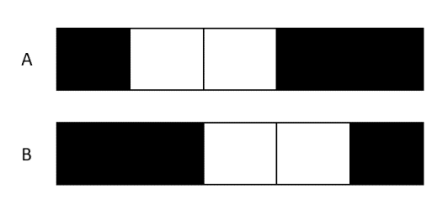**EXERCICE 9: Encoding problem**

**Rules:**

* The image has only 2 options A & B

Question - Find an encoding

|  |  |  |
| --- | --- | --- |
| meaning | Decimal | Binary |
| Position of black | 1 first of one pixels with black  2 first of two pixels with black  3 last of one pixels with black  4 last of two pixels with black | 001  010  011  100 |

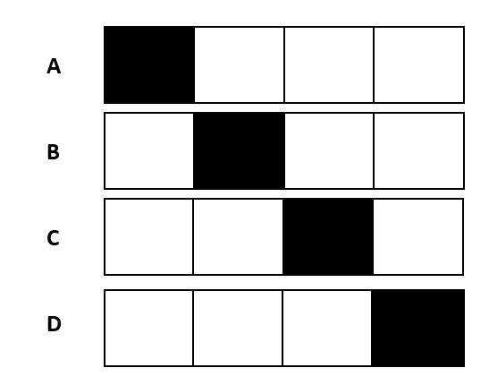Answer:

**EXERCICE 10: Encoding problem**

**Rules:**

* The image has only 4 options A, B, C, D

Question - Find an encoding

|  |  |  |
| --- | --- | --- |
| maning | Decimal | Binary |
| Position of black |  |  |
|  |  |  |

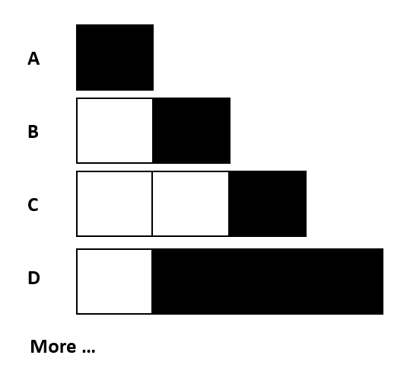

**EXERCICE 10: Encoding problem**

**Rules:**

* The image has 1 to 4 pixels
* 1 to 3 black pixels
* The black pixels shall be together

Question - Find an encoding

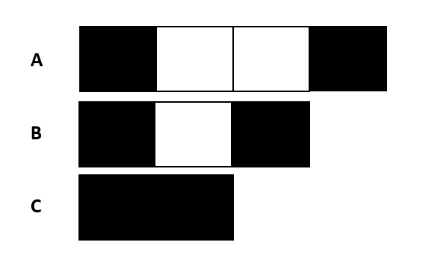

**EXERCICE 11: Encoding problem**

**Rules:**

* The white pixels have 0 to 2
* Black pixel always first and last cells

Question - Find an encoding