**TALLER PRACTICO DE GIT**

**Ficha:** 2956247

**ID:**1023631636

**Nombre:**

Emmanuel Escobar Quintero

**Fecha:** 5/06/2024

Se creo el repositorio:

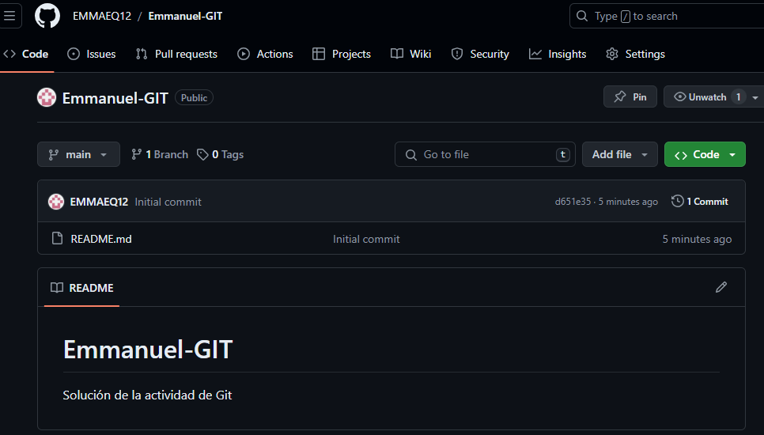

Pasos realizados:

1. Ingresar a git con su nombre de usuario y su correo:

emmat@Emma MINGW64 ~

$ git config --global user.name "EMMAEQ12"

emmat@Emma MINGW64 ~

$ git config --global user.email "emmanueleq23@gmail.com"

1. Se cambia/selecciona de carpeta:

emmat@Emma MINGW64 ~

$ cd C:/Users/emmat/Documents/ADSO/William/Emmmanuel

1. Iniciamos un repositorio:

emmat@Emma MINGW64 ~/Documents/ADSO/William/Emmmanuel

$ git init

Initialized empty Git repository in C:/Users/emmat/Documents/ADSO/William/Emmmanuel/.git/

1. Vemos el estado de la carpeta:

emmat@Emma MINGW64 ~/Documents/ADSO/William/Emmmanuel (master)

$ git status

On branch master

No commits yet

Untracked files:

(use "git add <file>..." to include in what will be committed)

LEAME.docx

nothing added to commit but untracked files present (use "git add" to track)

1. Guardar los cambios realizados:

emmat@Emma MINGW64 ~/Documents/ADSO/William/Emmmanuel (master)

$ git add .

1. Asignamos un mensaje a los cambios para saber que hice:

emmat@Emma MINGW64 ~/Documents/ADSO/William/Emmmanuel (master)

$ git commit -m "Subiendo el taller de git"

[master (root-commit) 732d085] Subiendo el taller de git

1 file changed, 0 insertions(+), 0 deletions(-)

create mode 100644 LEAME.docx

1. Cambiamos de rama:

emmat@Emma MINGW64 ~/Documents/ADSO/William/Emmmanuel (master)

$ git branch -M master

1. Vinculamos el archivo con GitHub:

emmat@Emma MINGW64 ~/Documents/ADSO/William/Emmmanuel (master)

$ git remote add origin <https://github.com/EMMAEQ12/Emmanuel-GIT.git>

1. Subimos todos los cambios a la nube:

emmat@Emma MINGW64 ~/Documents/ADSO/William/Emmmanuel (master)

$ git push -u origin master

Enumerating objects: 3, done.

Counting objects: 100% (3/3), done.

Delta compression using up to 2 threads

Compressing objects: 100% (2/2), done.

Writing objects: 100% (3/3), 53.83 KiB | 5.38 MiB/s, done.

Total 3 (delta 0), reused 0 (delta 0), pack-reused 0 (from 0)

remote:

remote: Create a pull request for 'master' on GitHub by visiting:

remote: https://github.com/EMMAEQ12/Emmanuel-GIT/pull/new/master

remote:

To https://github.com/EMMAEQ12/Emmanuel-GIT.git

* [new branch] master -> master

branch 'master' set up to track 'origin/master'.

emmat@Emma MINGW64 ~/Documents/ADSO/William/Emmanuel (master)

$ git push

Everything up-to-date