A Web-Based Student Group Work Management System For Strathmore Students

177292
175716

An Information System Project Proposal submitted to Strathmore University in Partial fulfilment of the requirements for the award of Bachelor of Business Information Technology

School of Computing and Engineering Sciences

Strathmore University
Nairobi, Kenya

May, 2026

DECLARATION

We declare that this work has not been previously submitted and approved for the award of a Bachelor's in Business Information and Technology from this or any other university. To the best of our knowledge and belief, the proposal contains no material previously published or written by another person except where a reference is made in the proposal itself.

Student’s signature:

…………………………………. [Signature]

………………………………….………….. [Date]

Student’s signature:

………………………………….. [Signature]

………………………………….………….. [Date]

Abstract

Poor group work management in university remains a huge issue among students. The lack of a good system that allows for good group work management and monitoring causes students to face issues like unfair distribution of work, social loafing among group members and lack of accountability. Most lecturers pay attention to the completion of the group assignment rather than the contribution of the members on the assignment. This leaves room for the lazy students to slack off and make the committed students do all the work. This kills their productivity and makes them feel discouraged and used. Taskify , the proposed solution will have a unique feature where individual contribution will be monitored by the group leaders and the lecturers can use it to check for performance. This will close the gap left by existing systems like Trello and Notion where they had good features but lacked the contribution tracker. The stakeholders of the system will mainly be students and lecturers. OOAD was chosen because Taskify relies heavily on different user roles and complex interactions. This method allows for modular design making it easier to add special features like inactivity detection. Waterfall methodology with feedback was chosen to keep the development process organized and structured. This is because it allows us to go back to an earlier stage if we find new requirements during the design phase or if bugs are discovered during testing
First hand information from third year Strathmore students will be collected through interviews and questioners. Several diagrams will be drawn to explain how the system works .This includes use case diagrams, design class diagrams, sequence diagrams, ERDs and database schema.

Contents
CHAPTER 1: INTRODUCTION 3
1.1 Background 3
1.2 Problem Statement 0
1.3 Main Objective 0
1.4 Specific Objectives 0
1.5 Justification 1
1.6 Scope 1
1.7 Limitations 2
1.8 Delimitations 2
CHAPTER 2: LITERATURE REVIEW 3
2.1 Introduction 3
2.2 Collaborative Business Processes and Role Management 3
2.3 Challenges of Accountability and Social Loafing 3
2.4 Review of Existing Systems 4
2.4.1 Trello 4
2.4.2 Notion 4
2.4.3 GitHub 4
2.5 Conceptual Diagram 5
CHAPTER 3: METHODOLOGY OF RESEARCH 7
3.1 Introduction 7
3.2 Research Methodology: Object-Oriented Analysis and Design (OOAD) 7
3.3 Approach: AGILE METHODOLOGY 7
3.3.1 Requirements Analysis (Phase 1) 8
3.3.2 System Design (Stage 2) 8
3.3.3 Phase 3: System Implementation 8
3.4 Deliverables 9
REFERENCES 9
Chapter 4: SYSTEM ANALYSIS AND DESIGN 10
4.1 Introduction 10
4.2 System Requirements 10
4.2.1 Functional Requirements 10
4.2.2 Non-Functional Requirements 11
4.3 Analysis and Design Diagrams 13
4.3.1 Use case 13
4.3.2 Class Diagram 14
4.3.3 Sequence Diagram 14
4.3.4 Chen Entity Relationships Diagram 15
4.3.5 Database Schema 15
4.3.6 Wireframe 17

CHAPTER 1: INTRODUCTION

1.1 Background
Group work management has become a challenge as many students face difficulties in equal distribution of work , slacking off of some members , poor tracking of deadlines and much more issues. This is mainly among university students when group assignments are given by the lecturer. Group work management becomes an issue as monitoring individual contributions is not possible hence unfair distribution of work, slacking off from lazy members leaving the committed members to handle the work by themselves. This is not noticeable to the lecturer as the final result does not show who did what part but rather gives everyone the same credit for the assignment.
This majorly affects students in universities. Like in Strathmore, students that are committed to doing the group assignments usually end up doing most of the work while the lazy students get away with slacking off as they all get the same credit at the end of the assignment. This makes it hard to judge the performance of each member individually thus the lazy members benefit from their members work. If this issue is not addressed, the productivity levels of these committed students will go down and the quality of the group work output reduces. This will eventually lead to students getting discouraged when group assignments are given. (Ramdeo, 2022).
Efforts have been made by Trello and Notion to try and better group work management. This has somewhat helped with organizing group work. These platforms let you set up task boards, track deadlines, and share files, which makes things more organized and visible. These existing efforts have had a positive impact in simplifying the management of group work. However, they still have their downsides. They lack individual contribution monitoring features which are essential in monitoring who did what. This allows students to see what tasks need doing, but not necessarily who is doing how much, when, or how well. This means lazy group members can still get credit for others' hard work and the committed students still do more than they should in the assignments.
The gap being the lack of a monitoring feature, we would like to be different from the existing solutions and introduce the monitoring feature to allow for fair distribution of group assignments and prevent social loafing among group members. Taskify is better than the existing systems as it
fixes the gap and increases the quality of group work and therefore increased productivity among the group members. (Donelan, 2023)(Martin-Somer, 2023).

1.2 Problem Statement
Current project management tools, though good for organizing tasks, don't have built-in ways to track, compare, or report on what each person contributes. This leaves group leaders and supervisors without clear facts to judge effort and performance. Group assignments in academic and professional settings often suffer from an uneven distribution of workload. A small number of committed members frequently end up doing most of the work, while others contribute very little. Yet, everyone gets the same credit for the final result. This unfairness not only makes high-performing people feel discouraged but also lowers the overall quality of the work
Not having a specific system to track contributions creates a gap that allows slacking off, poor tracking of deadlines and unequal distribution of work continue without being noticed .Without clear tools for accountability, group members who don't perform well don't face immediate consequences, and those who go above and beyond have no way to show their extra effort. This systemic gap is especially noticeable in online learning and virtual team situations, where simply being physically present can no longer be a rough indicator of engagement. Relying on people to report their own progress or on occasional check-ins provides information that isn't enough and often isn't reliable for judging how committed each person is

1.3 Main Objective
The main goal of this project is to design and build Taskify, a web-based system for monitoring group work. This system tracks and shows what each member contributes within group projects. The helps to encourage accountability, fairness, reduce social loafing, and allow for a fair evaluation of how well group work is done.

1.4 Specific Objectives
- To allow for clearer steps in group work management, where groups are formed and roles are given. Rules are given and regulated by the group leader and are meant to be followed such as who does what and when.
- Poor group work management among university students where tools like Trello and Notion have been created to help with this although certain areas such as individual contribution and accountability have not been catered for.
- To design a group work management system that fills the gap for tracking individual contributions and accountability allowing for clearer steps in group work.
- To develop a web-based system that allows members to monitor individual contribution on what each member does
- To validate and verify the system

1.5 Justification
Making Taskify is important because of the issue of poor group work management .This creates for how group work is judged and how productive groups are, for example, here at Strathmore. Research in how people learn consistently shows that unequal contributions are one of the top complaints among students doing group assignments. There is a need to fill the gap left by the existing systems where our system allows for individual contribution tracking and accountability.
Also, creating Taskify adds to the growing number of tools designed for the specific needs of collaborative learning and managing group work. By combining the good points of existing tools like Trello and Notion with our unique system with the additional feature for tracking contributions, Taskify fills a gap in the market. It offers a new and useful software solution for society.

1.6 Scope
The proposed study focuses on the design, development, and validation of the Taskify web-based application, specifically tailored to facilitate and monitor group work for undergraduate students at Strathmore University. The boundaries of this project include the implementation of core project management features, such as group formation, task allocation, and deadline tracking, integrated with a specialized individual contribution monitoring module that tracks time spent and task completion rates. Stakeholders are strictly limited to students and faculty members within the university setting to ensure the data collected remains academically relevant. Conversely, the project does not include advanced AI-driven predictive performance analytics, integration with external Learning Management Systems (LMS) like Canvas or Moodle or mobile-native application development (iOS/Android) as these would expand the technical requirements beyond the manageable timeline for a final year project. By maintaining this focus, the system remains a deep, specialized tool for solving the specific problem of group work management rather than becoming a broad, generic administrative platform.

1.7 Limitations
This study recognizes a few limitations that might affect how broad its findings are and how generally applicable they can be. First, how accurately individual contributions are tracked really depends on all group members using the platform honestly and consistently. If users do work offline or outside the system, those contributions won't be recorded, which could make the contribution numbers misleading. Second, the system will only work well with reliable internet access, which might limit its use in places with bad or patchy connections. Third, since Taskify is an early version, it will be tested with a small group of third year students in our facaulty, so the findings might not fully show what it's like in diverse real-world group settings.

1.8 Delimitations
The school could make using taskify as a requirement for group work to avoid students working outside the system.

CHAPTER 2: LITERATURE REVIEW

2.1 Introduction
This chapter explores what others have said about systems and the problem of social loafing in schools. By bringing together recent research from 2021 to now, this review lays the groundwork for why Taskify is a necessary step for student group work. The discussion moves from the general ways teams work together in business to the specific technical issues found in popular tools like Trello and Notion. Furthermore, this chapter looks at three existing software solutions to find out what's missing and what features set the standard. In the end, this literature review built a conceptual framework that explains the proposed system's structure and its contribution-tracking system.

2.2 Collaborative Business Processes and Role Management
The way group work happens in places like Strathmore University usually involves several clear steps: forming groups, giving out roles, and repeatedly doing tasks. In a perfect collaborative environment, the group leader is supposed to make sure work is divided fairly. However, in reality, this often relies on informal, spoken agreements that don't have any technical way to be enforced.
Research suggests that when individual contributions aren't visible in the work process, accountability disappears. While traditional project management methods focus on "what gets delivered," they often miss the "people" side, specifically how roles are managed within an online workspace. Taskify aims to fix this by making these roles official through a special login system. This ensures that a leader's ability to give out tasks is backed by verifiable system records, not just social pressure.

2.3 Challenges of Accountability and Social Loafing
The biggest issue in how teams work together today is something called social loafing. This is when a few students do all the heavy lifting for a project, while others get credit from the group grade without putting in much effort. This happens because most online platforms focus more on "Project Completion" than on "Individual Accountability." When a task is marked as "Done" in a shared space, the system often doesn't record how often someone was active or the specific quality of the work from the person assigned to it.
The result of this gap affects everyone: high-performing students feel burned out and discouraged, while those who don't perform well leave university without the necessary teamwork skills. Recent studies (2023-2025) on managing virtual teams show that even though tools like Notion help with organization, they still rely on people reporting their own updates, which isn't always reliable. Students need a system that can track what people do and when they do it.

2.4 Review of Existing Systems
To understand why Taskify is needed, one should look at tools that help people work together. While many tools are good for working as a team, they don't help us know who did what, which is necessary in a school setting.

2.4.1 Trello
Trello is a tool that helps people work together using boards, lists, and cards. It makes it easy to see how projects are organized, track deadlines, and share files through a simple drag-and-drop interface. Trello is made for general coordination and doesn't have built-in ways to track individual contributions. It lacks features for finding inactive members or automatically creating reports on performance. This means social loafing can still happen, even if tasks are moved to the "Done" column. It's still a standard for managing tasks visually, but it relies heavily on people updating things manually rather than automatic monitoring.

2.4.2 Notion
Notion is an all-in-one workspace that combines notes, databases, and project tracking into one platform. It's very customizable, letting groups create detailed wikis and shared document storage alongside their task lists. Even with its flexibility, Notion doesn't have built-in ways to hold people accountable, such as scoring contributions or real-time logs of activity frequency. It's often seen as too complicated for simple student group work and doesn't offer a specific reporting section for supervisors to use for fair grading.

2.4.3 GitHub
GitHub is an online hosting service mainly used for version control and collaborating on software development. It provides detailed "Contribution Graphs" and records of changes that clearly show which user added which lines of code and when. While it offers the technical accountability that Taskify aims for, it's only for coding projects and is hard for non-IT students to learn. There's a clear need for a system that applies this "commit-style" accountability to general school tasks like writing reports or doing research.

2.5 Conceptual Diagram
Taskify's design is based on the Input-Process-Output-Storage (IPOS) model to make sure data flows logically and system boundaries are clear.
Literature Description:
The proposed solution follows software design principles like modularity and keeping functions separate. For example, the user authentication part is separate from the contribution tracking system.
• Inputs: These include details from user registration, task descriptions, assigned tasks, and peer review ratings given by students and supervisors.
• Process: The main system records how often someone is active, when tasks are completed, and quality ratings to create a "contribution profile" for each member.
• Output: The system generates real-time dashboards and automatic reports that supervisors can download for fair grading and performance reviews.
• Storage: All project data, contribution records, and user login details are saved in a central database to keep a permanent record of effort.
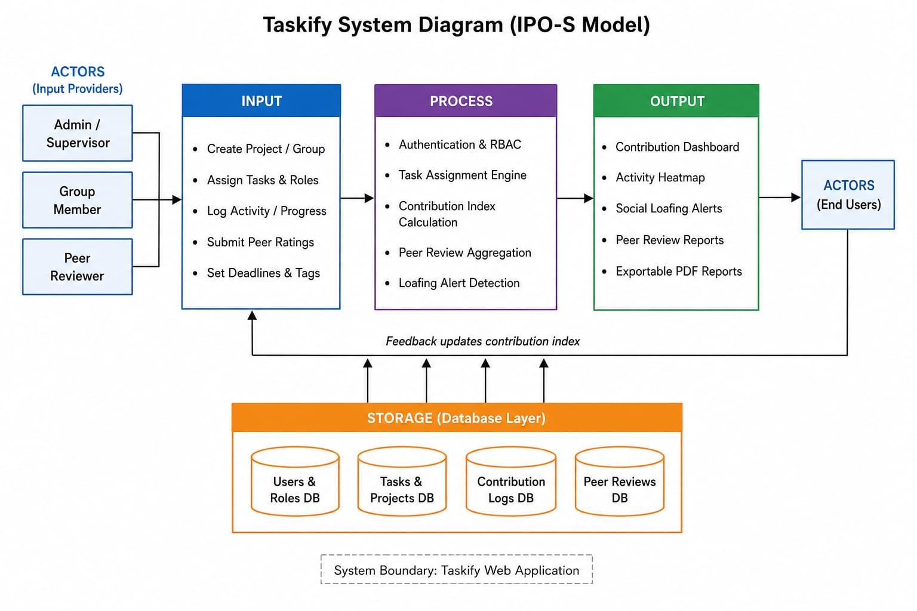
Figure 1Taskify Conceptual Diagram

CHAPTER 3: METHODOLOGY OF RESEARCH

3.1 Introduction
This chapter explains the step-by-step methods and technical procedures used to turn the idea of Taskify into a functional information system. It covers the thinking behind the research, the software development plan (SDLC model), and the tools needed to reach the project's goals. This section also provides a clear guide that others can follow, ensuring the development process is academically sound and can solve the accountability issues found in earlier chapters. The method includes everything from gathering the first requirements to testing the system and writing the final documentation.

3.2 Research Methodology: Object-Oriented Analysis and Design (OOAD)
The system has been built using the ideas of Object-Oriented Analysis and Design (OOAD). SSAD (Structured Systems Analysis and Design) looks at how data moves in a straight line through different processes. OOAD, on the other hand, sees a system as many "objects" (like a Student, a Task, a Report) that work together and hold both data and their own behaviours.
OOAD has been chosen because Taskify relies heavily on different user roles and complex interactions, especially how student identities link to their "Contribution Scores." This method allows for a modular design, making it easier to add special features like "Inactivity Detection" as self-contained behaviours within a class. Recent studies suggest that OOAD is particularly good for modern web applications because it fits well with programming languages like JavaScript, making it smoother to go from design drawings to actual working code (Gkrimpzi, 2025).

3.3 Approach: AGILE METHODOLOGY
Taskify is developed using the Agile methodology since it allows the system to be built and tested in short focused cycles rather than waiting until everything is complete before finding out what works and what does not. Development is broken into five iterations each targeting one module. The modules include, authentication and role management, task assignment, contribution tracking, peer review and reports. This approach has made it easy to catch problems early and make improvements along the way rather than discovering issues too late to fix them.

3.3.1 Requirements Analysis (Phase 1)
We have collected firsthand information from third-year Strathmore students from our faculty through semi-structured interviews and questionnaires. This helps us accurately understand the specific details of social loafing within the university. We then use this information to define what the system needs to do (Functional Requirements), such as generating automatic contribution reports, and other important aspects (Non-Functional Requirements), like system security and working well on mobile phones. This study makes sure that the "automatic contribution analysis" system directly addresses the specific frustrations students feel in group work by focusing on these requirements from the start.

3.3.2 System Design (Stage 2)
We have used the OOAD approach to turn the gathered requirements into technical plans. This stage involves planning, including choosing the right architectural models. Several diagrams have been drawn to explain how the system works:
Use Case Diagrams: These shows the boundaries of interaction between the Admin, Peer reviewer, and Group member.
Design Class Diagrams: These shows details on the data structures for users and task groups.
Sequence Diagrams: These show the logic behind how contribution scores are calculated.
ERD &amp; Database Schema: These ensure that data stored in the backend is correct and consistent.
Wireframes: Tools like Figma have been used to design the Graphical User Interface (GUI), making sure the platform is easy for the end-user to understand.

3.3.3 Phase 3: System Implementation
Taskify has been developed as a web application so that everyone can access it on all their devices without having to install it on their computer or mobile phone.
Front-end: A responsive user interface using HTML, CSS, and JavaScript (React).
Back-end: Node.js is the main environment. We chose it because it's good at handling the real-time activity tracking needed for scoring.
Database: We use MySQL to permanently store data.
IDEs: The main tool for development is VS Code, using its port forwarding feature for early reviews and testing by the supervisor.

3.4 Deliverables
The project has produced the following tangible results:
Project Documentation: A detailed report covering the research and design stages.
System Models: A collection of OOAD diagrams that visually explain how the software works.
Working Prototype: A web-based system with secure login, a monitoring dashboard to see contribution levels in real-time, and an automatic reporting system to inform supervisors.
Test Cases: Recorded results from the testing phase to confirm that the system is reliable.

REFERENCES
(Donelan, 2023) (Gevers, 2001) (Gkrimpzi) (Odhiambo, 2023) (Spante, 2006) (Ying, 2014)

Chapter 4: SYSTEM ANALYSIS AND DESIGN

4.1 Introduction
This chapter presents the system requirements and design specifications for Taskify, the proposed web-based student group work management system. The requirements are derived from the challenges identified during the research phase, particularly the issues of unequal workload distribution, lack of accountability and social loafing(slacking) among group members. The chapter outlines both the functional and non-functional requirements of the system and explains how the proposed solution addresses the needs of the identified stakeholders. These requirements formed the foundation upon which the system design and implementation were based.

4.2 System Requirements
The requirements of Taskify are identified through the analysis of the challenges students and supervisors experience during group work activities. The primary stakeholders included students who participate in group projects, group leaders responsible for coordinating activities and supervisors who monitor project progress. Secondary actors included the system database and reporting services that support system operations.
The study reveals that students often experienced frustration due to unequal participation in group assignments. Committed members frequently complete most of the work while less active members receive the same credit. Supervisors also lack reliable mechanisms for measuring individual contributions. Most groups rely on informal communication channels such as WhatsApp messages, verbal updates and shared documents to coordinate tasks. These approaches make it difficult to monitor accountability and identify inactive members.
Success is measured by the ability of the system to promote fair task distribution, accurately track contributions, reduce social loafing and provide supervisors with reliable performance reports. The requirements outlined below are designed to ensure that these objectives are achieved.

4.2.1 Functional Requirements
Taskify requires every group member to begin by authenticate themselves using a registered email address and password before accessing the platform, once logged in, a group member can view assigned tasks, update task statuses, indicate task completion percentages and monitor personal contribution scores through a dedicated dashboard. The system records every task related activity together with a timestamp ensuring that all contributions are tracked and reflected in their member’s overall performance score. In addition, group members can view recent project activities and securely log out of the system when their work is completed
The group leader coordinates project activities within the platform. Upon login in they can create group projects, invite members to join project teams and oversee the progress of assigned work. They can also assign tasks completion through project dashboards. To support accountability and fair evaluation, the group leader can also submit anonymised peer review ratings that contribute to the overall assessment of member performance. Through these functions, project activities remain organised and responsibilities are distributed fairly among team members.
The supervisor oversees project performance and monitors contribution levels across all group members. They can review project progress analyse contribution statistics and evaluate individual participation in a project. Furthermore, the supervisor can generate and download PDF contribution reports containing performance summaries contribution scores, activity records and completed tasks for any project under supervision.
Essentially, the system automates performance monitoring to make group work more accountable. It’s designed so that everyone, from students to supervisors, only has access to what they need for their specific role. It works by logging every task automatically. By combining those logs with task completion data and peer reviews, the system calculates a fair contribution score for every member. It even acts as an early warning system: if someone isn't pulling their weight, it automatically alerts the supervisor.
Built-in safeguards to maintain data integrity. For example, group members can not mess with project settings, leaders can't inflate or deflate scores and supervisors are unable to edit the history logs. It ensures that everyone is held accountable and the final evaluations remain completely objective.

4.2.2 Non-Functional Requirements
To ensure that Taskify not only performs its intended functions but also provides a reliable and effective experience for stakeholders, several non-functional requirements are incorporated into the system design. Since students and supervisors rely on timely access to project information, the system is designed to load pages and dashboards within three seconds under normal network conditions. Fast response times help users update tasks, monitor progress and access reports without unnecessary delays that could affect project coordination.
Security is a critical requirement because the system stores personal information, project records and contribution data. To protect this information, passwords are hashed before being stored in the database, reducing the risk of unauthorised access. In addition, role-based access control ensures that stakeholders can only access features relevant to their responsibilities. For example, group members cannot view supervisor reports, while supervisors cannot alter activity records generated by the system.
The system is designed to always be available since project work often takes place outside normal class hours. Students may need to update tasks late at night or during weekends, while supervisors may need to review progress at different times. For this reason, the platform remains accessible twenty-four hours a day through modern web browsers. Compatibility is also considered to ensure that stakeholders can access the system using different browsers and devices, whether they are working from a laptop, tablet, or mobile phone.
Usability plays an important role in encouraging adoption of the system. Since students and supervisors have different levels of technical knowledge, the interface is kept simple and straightforward. Users should be able to perform common activities such as creating projects, updating tasks and viewing reports without needing special training.
Reliability is essential because contribution scores and loafing alerts influence how individual performance is evaluated. The system therefore ensures that calculations are performed accurately and that project data is stored safely without loss or corruption. This helps supervisors make fair decisions based on trustworthy information while giving students confidence that their efforts are being recorded correctly.
As group projects may vary in size, scalability is incorporated into the design to ensure that the platform continues to perform efficiently even when multiple users are active at the same time. The system supports project groups containing up to twenty members without experiencing significant reductions in performance. This allows it to accommodate both small and relatively large academic projects.
Maintainability is achieved through a modular architecture that separates different system components into manageable sections. This makes it easier to fix bugs, introduce new features, or improve existing functionality without disrupting the operation of the entire system. Such flexibility is important because future improvements may be required as user needs evolve.
Privacy is another important consideration because the system includes peer review functionality. To encourage honest feedback and reduce bias, peer review ratings remain anonymous and are never revealed to the member being evaluated. Finally, data integrity is maintained through input validation mechanisms that ensure only valid and authorised information is entered into the system. This prevents incorrect, incomplete or malicious data from affecting the accuracy and reliability of project records.

4.3 Analysis and Design Diagrams
Using the OOAD approach, the following diagrams were drafted.

4.3.1 Use case
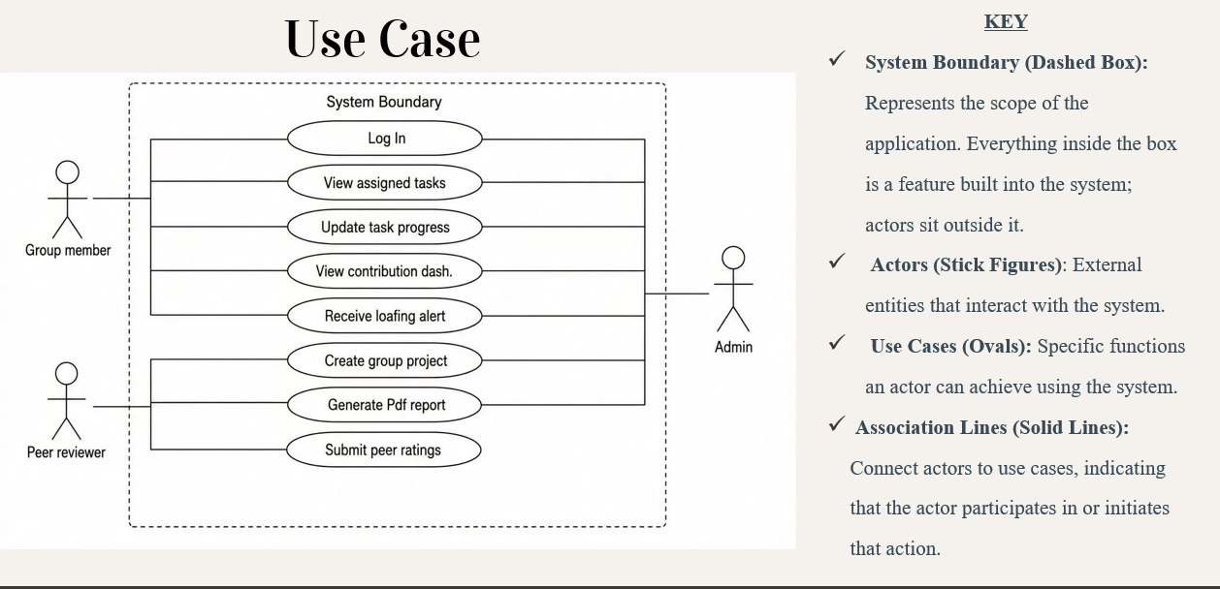
Figure 2 use case

4.3.2 Class Diagram
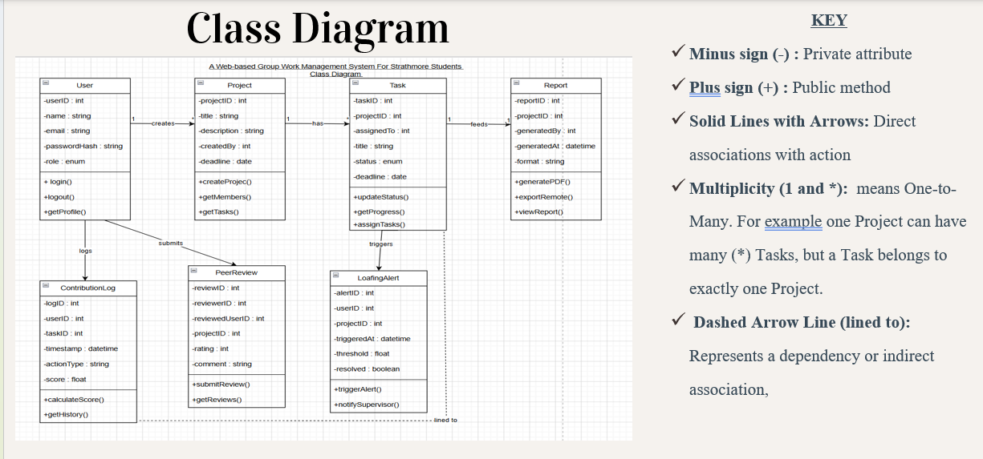
Figure 3 class diagram

4.3.3 Sequence Diagram

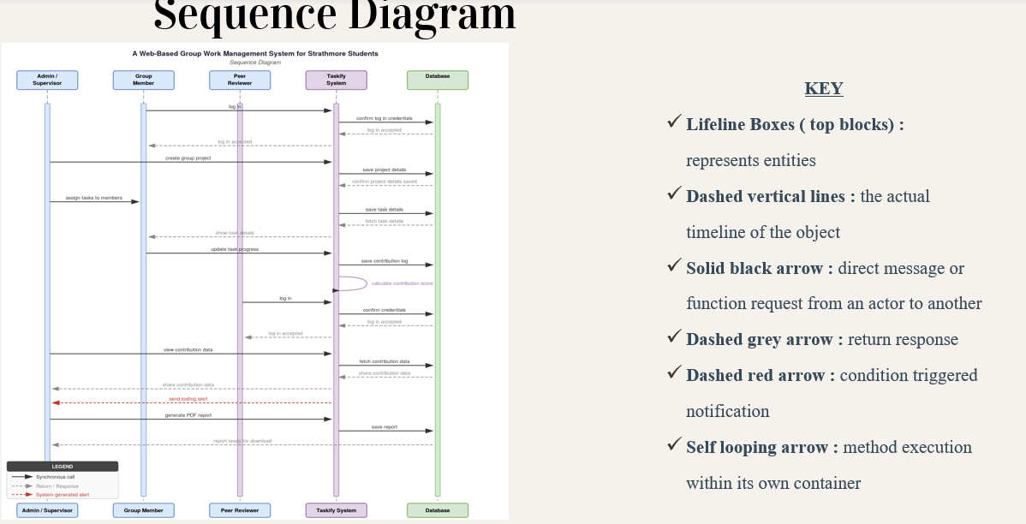
Figure 4 sequence diagram

4.3.4 Chen Entity Relationships Diagram
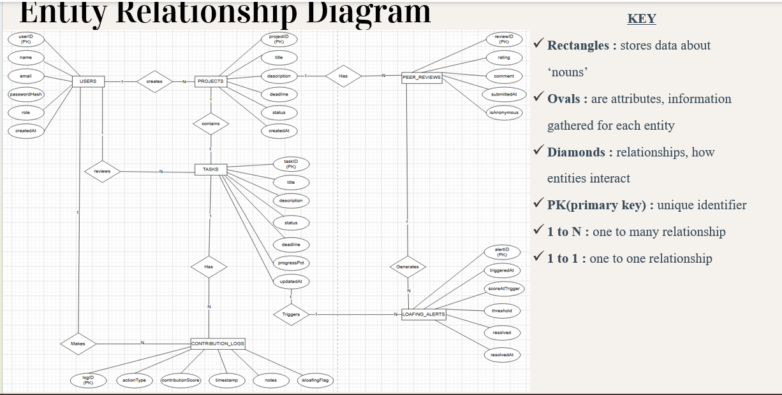
Figure 5 erd

4.3.5 Database Schema
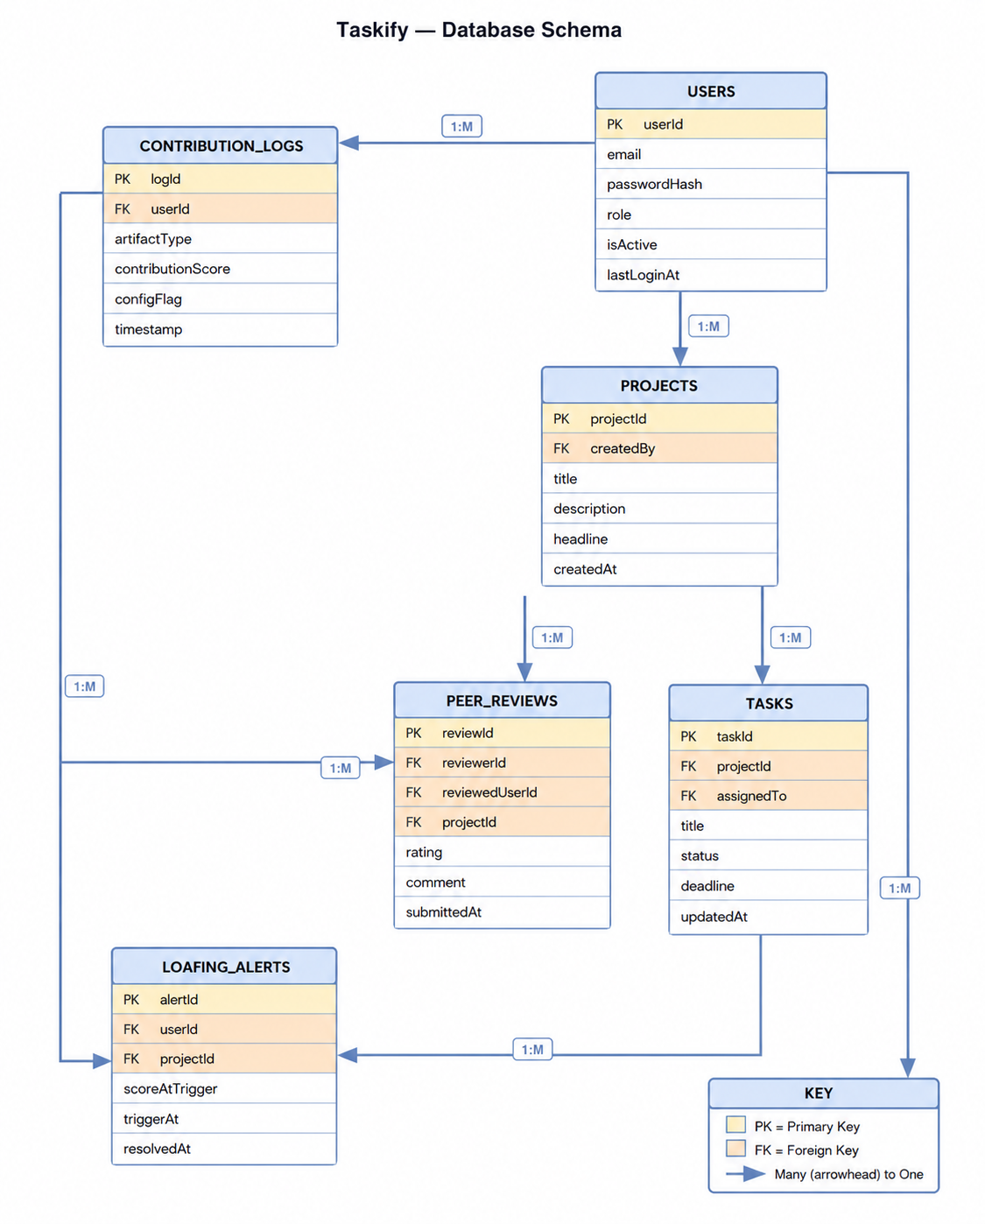
Figure 6 database schema

4.3.6 Wireframe
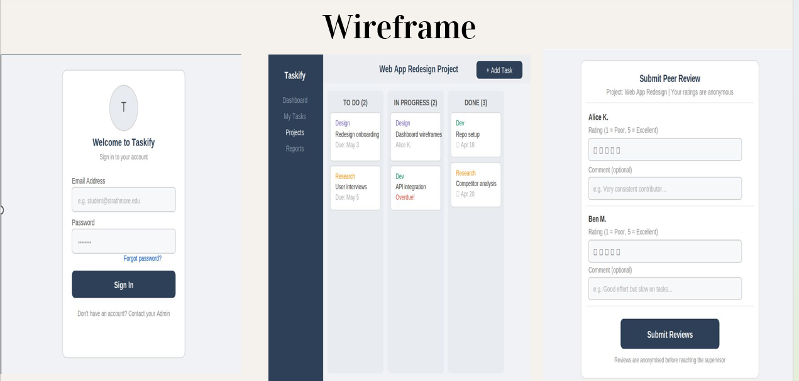
Figure 7 wireframe

