1. The sun is the dominant source of the Earth/atmosphere system’s energy .
2. Without greenhouse gasses present in the atmosphere, the temperature at the surface of the Earth would be substantially colder.
3. (1) No atmospheric motion occurs. Since sensible and latent heat fluxes require atmospheric motion, these fluxes will be equal to zero in our model (2) The atmosphere is entirely transparent to shortwave radiation so that it does not absorb any solar radiation. It can, however, contribute to shortwave reflection, (3) The amount of longwave radiation absorbed by the atmosphere increases as the concentration of greenhouse gasses increases, and (4) The atmosphere is treated as a single layer, with one average temperature and constant radiative properties (i.e. no absorption of shortwave radiation and a fixed value of absorption for longwave radiation). More complex models could be constructed that treat the atmosphere as multiple layers.
4. 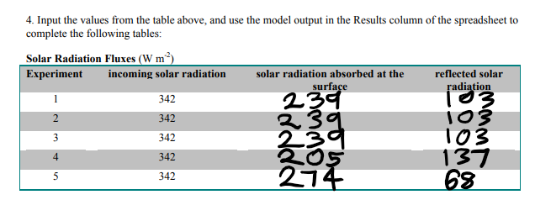

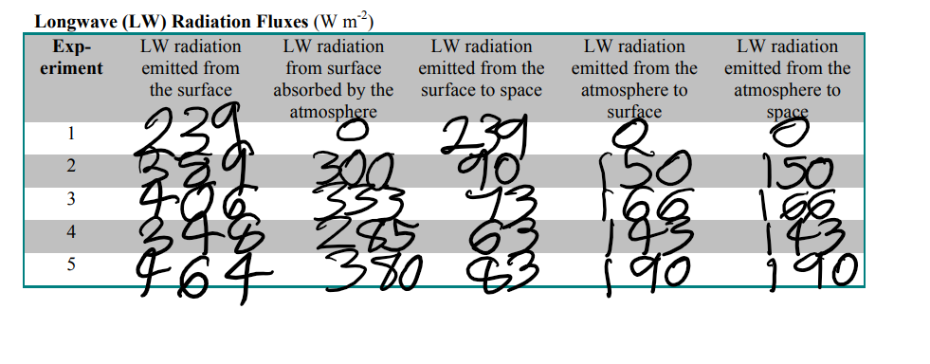

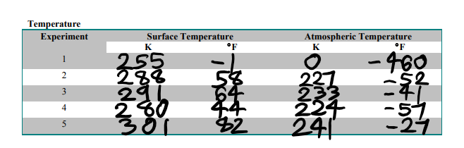

5a.

When the current concentrations of gasses that absorb longwave radiation are added to the atmosphere, it can be seen that the surface temperature increases by 33 K or 59°F .

5b.

This effect where the atmosphere can modify surface temperature is called “The Greenhouse effect” .

5c.

(1) Water Vapor [H2O], (2) Carbon Dioxide [CO2], (3) Methane [CH4], (4) Nitrous Oxide [N2O], and (5) Ozone [O3].

6a.

As the amount of absorption of longwave radiation in the atmosphere is increased in the experiments, the atmospheric temperature increases.

6b.

As the amount of absorption of longwave radiation in the atmosphere is increased in the experiments, the surface temperature increases.

7a.

Planetary albedo increases when the cloud cover increases as clouds help to reflect incoming solar radiation.

7b.

Planetary albedo increases when the cloud cover increases as clouds help to reflect incoming solar radiation.

7c.

The change in planetary albedo decreases the surface temperature by decreasing the amount of solar.

7d.

The change in cloud cover, caused by global warming, is negative feedback to the initial warming as it leads to reduced warming and the formation of more clouds, which help to decelerate a temperature rise.

7e.

Cloud cover might increase if global warming were to occur as the increased surface temperature would produce more water vapor which condenses into more clouds.

8a.

The planetary albedo decreases to simulate the effect of a reduction in the area covered by the polar ice caps on a globally warmed planet.

8b.

The planetary albedo changes this way as global warming tends to decrease ice coverage which raises the surface temperature by increasing the amount of solar radiation absorbed.

8c.

This change in planetary albedo increases the surface temperature by increasing the amount of solar radiation absorbed.

8d.

The change in the polar ice caps, caused by global warming, positive feedback to the initial warming as it leads to increased warming and the acceleration of a temperature rise.

8e.

If global warming were to occur, the reason to expect that the area covered by ice caps would decrease is that ice melts as temperature rises.