Lab 6

1a. graph

1b. The new temperature is 21.25°C, the new dew point is 12.5°C at a pressure of 900 mb.

1c. **Mixing ratio corresponds to dew point temp.** The mixing ratio at 900 mb is 10 g/kg.

1d. The mixing ratio has not changed from its value at 1000 mb because it only changes if the moisture is removed.

1e. **Saturation mixing ratio corresponds to temperature**. The saturation mixing ratio at 900 mb is 18 g/kg.

1f. The saturation mixing ratio changed from 1000 mb to 900 mb because it is determined by the air parcel’s temperature and the pressure.

1g. RH = (10g/kg) / (18g/kg) = 55.6%

1h. RH = 28/18 = 156%

The relative humidity of the air parcel decreased from the value at 1000 mb by 100.4%.

156% - 55.6% = 100.4%

1i. Graph

1j. The pressure of the air parcel at the CL is about 787.5 mb

1k. The temperature of the air parcel at the CL is 10.5°C

1l. The dewpoint of the air parcel at the CL is 10.5°C

1m. 10 g/kg

1n. 100%

1o. Graph

1p. -25 C

1q. 1g/kg

1r. The mixing ratio of the air parcel at 500 mb is more than the mixing ratio of the air parcel at the CL. Between the CL and 500 mb, water vapor increased.

2a. Graph

2b. 613 mb

2c. -18 C

2d. -18 C

2e. 1.5 g/kg

2f. Graph

2g. -32.5 C

2h. 0.55 g/kg

2i. The mixing ratio of the air parcel at 500 mb is more than the mixing ratio of the air parcel at the CL. Between the CL and 500 mb, the water vapor increased.

3a. Graph

3b. mixing ratio = 20g/kg

saturation mixing ratio = 36 g/kg

RH = 20/36 = 55.6

3c. Graph

3d. Temperature at 750 mb = 25 C

Dew Point at 750 mb = 19 C

3e.Graph

3f.

pressure = 687.5 mb

temperature = 16 C

dew point = 16 C

3g.

Mixing ratio= 18 g/kg

saturation mixing ratio = 18g/kg

RH = 100%

3h. Graph

3i. temperature = 6 C

dew point = 6C

RH = 100%

1 parts.

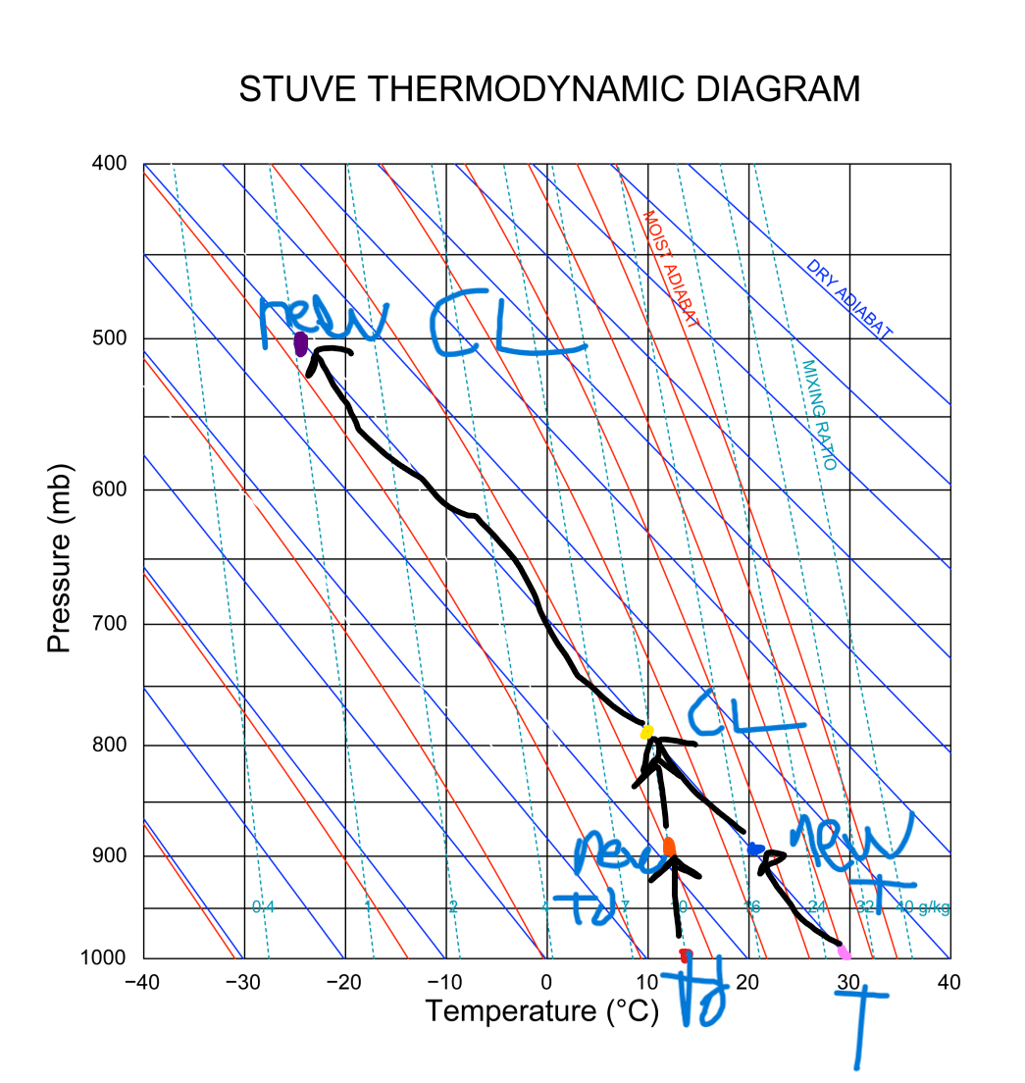

2 parts.

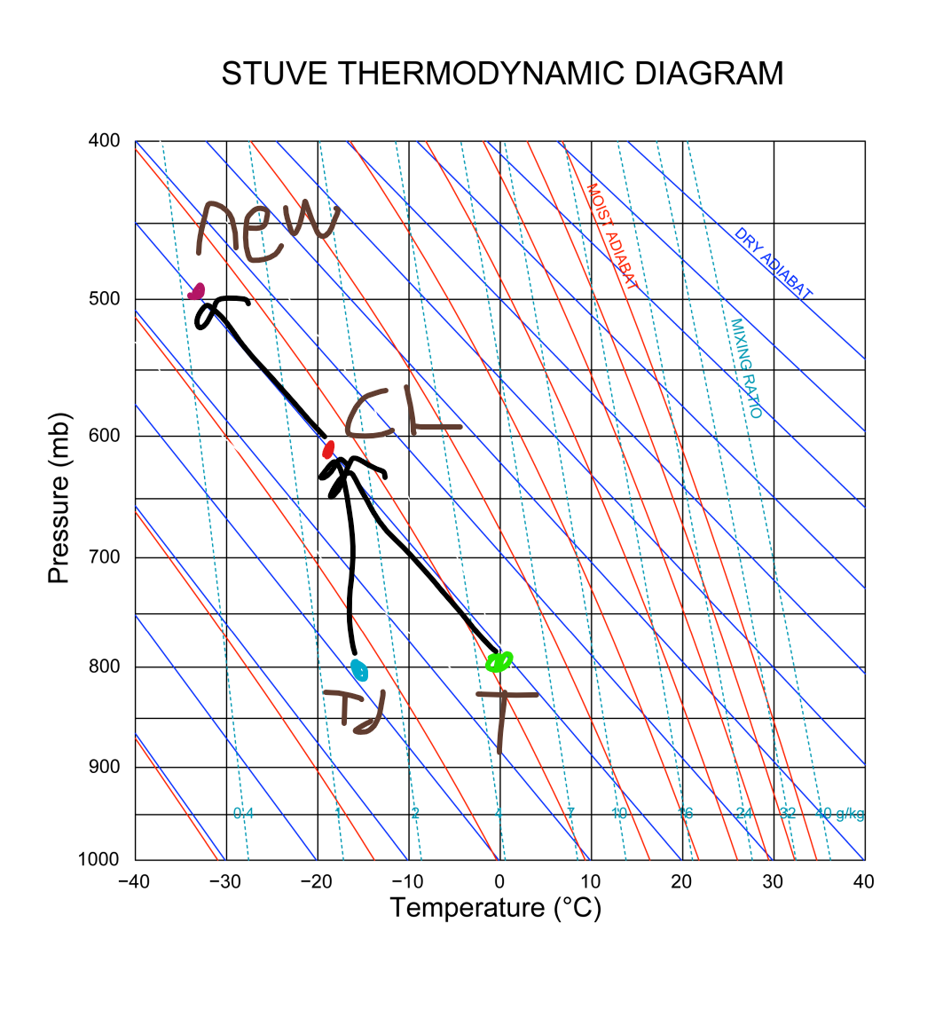

3 parts.

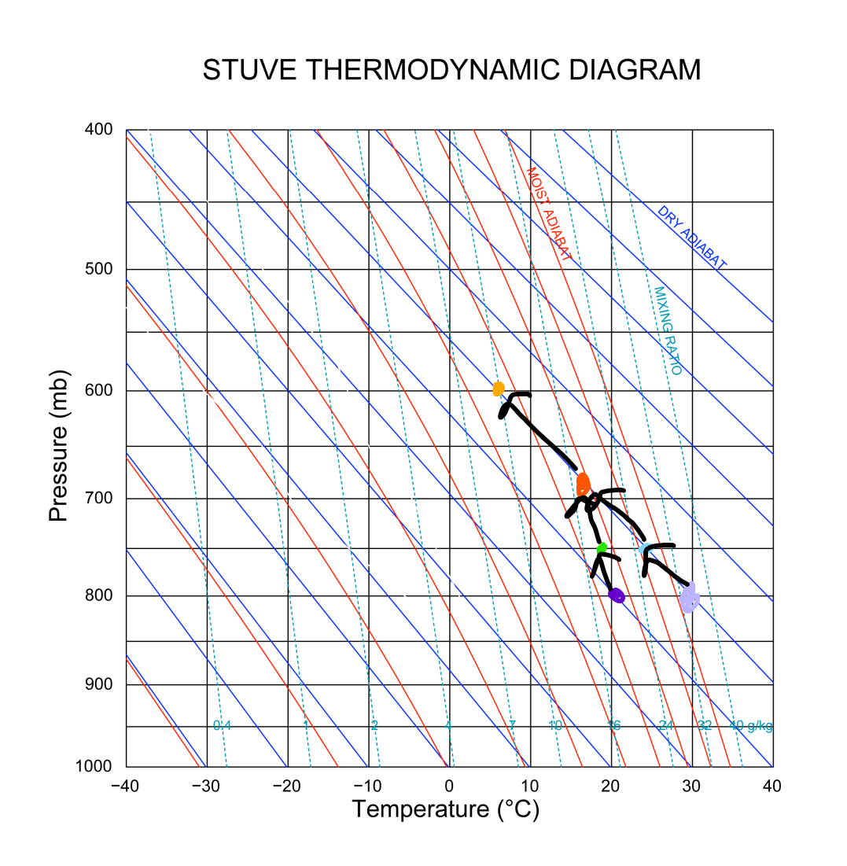

T = light purple

Td = dark purple

New T = light blue

New Td = light green

CL = red-orange

New pressure = light orange