LAB 7

1a. Marked by blue line

1b. Marked by red line

1c. Marked by green line

2b. Marked by an orange dot. The temperature of the air parcel at 900 mb is about –8°C.

2c. The air parcel is colder than the environment.

2d. I would describe the air parcel at 900 mb as stable.

3a. Point marked by orange dot. The temperature of the air parcel at 900 mb is about 2°C

3b. The air parcel is warmer than the environment.

3c. I would describe the air parcel at 900 mb to be unstable.

4a. marked by a pink dot. The pressure at which clouds will begin to form if an air parcel with this combination of temperature and dewpoint is lifted dry adiabatically is 900 mb.

4b. The air parcel at the cloud base is the same temperature as the environment.

4c. This air parcel will not continue to rise from the cloud base.

4d. The cloud top will occur at 800 mb.

4e. The air parcel temperature is warmer than the environmental temperature at cloud top.

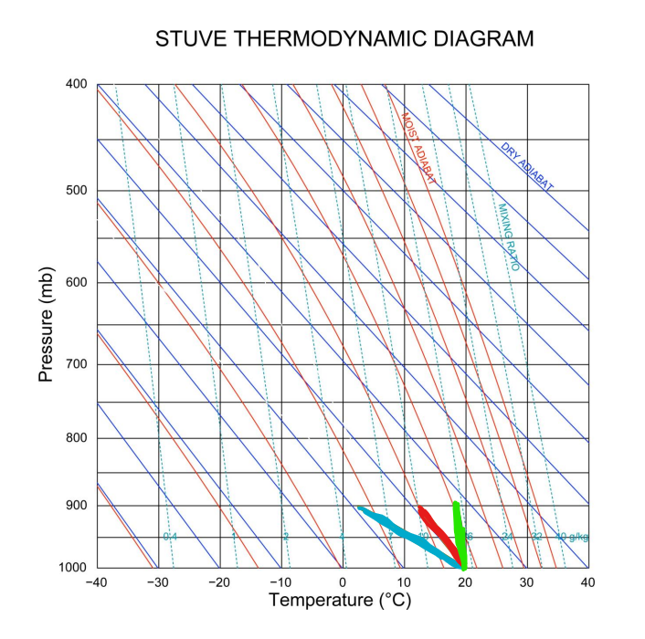

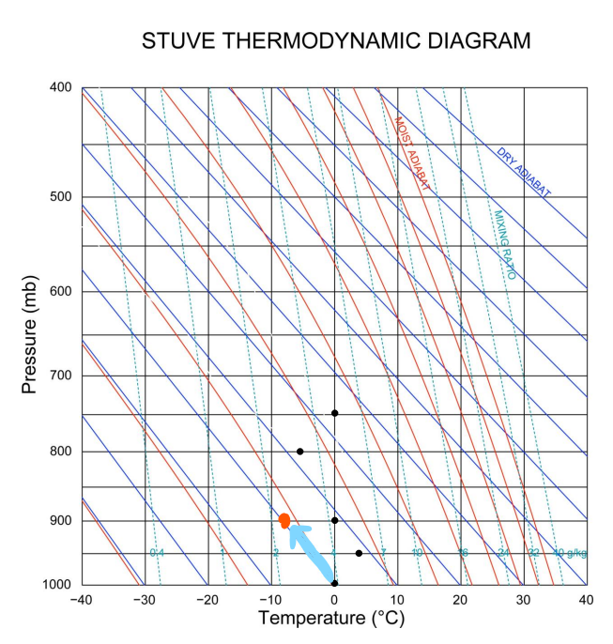

3.

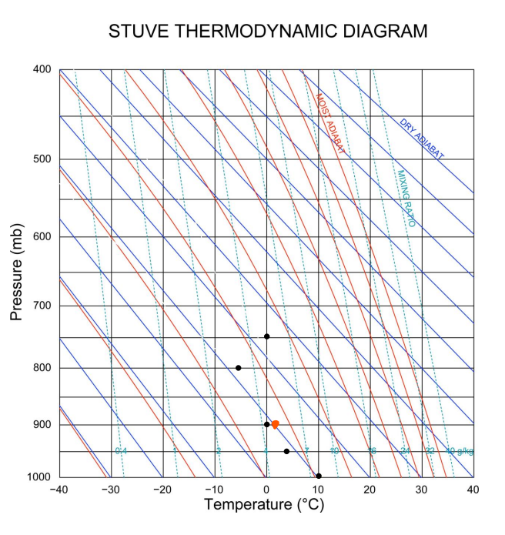

4.

