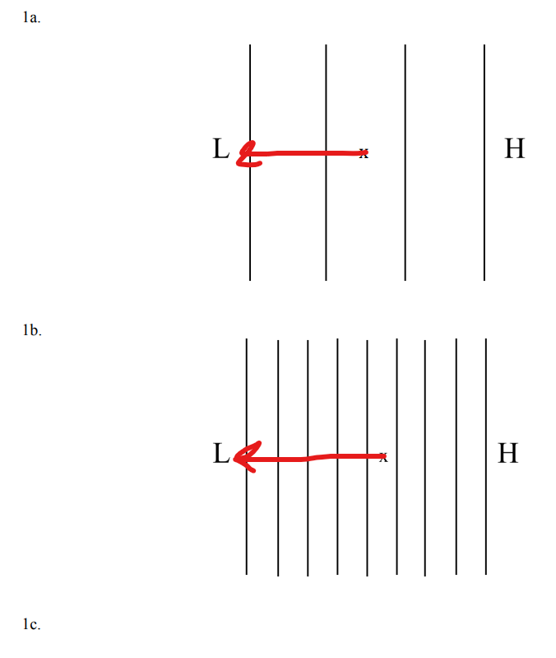

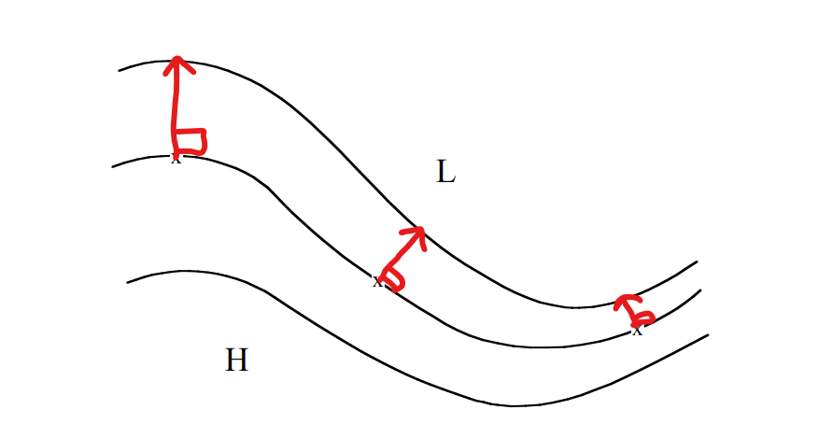

2a. Coriolis force acts on the wind largest at 60°N.

2b. As we move away from the equator, the strength of Coriolis force increases.

2c. Since the latitudes lie in the northern hemisphere, the direction of the Coriolis force will be towards the right. Since winds are coming from West (westerlies) to both locations, the direction of the Coriolis force will be towards the Northeast.

2d. In the southern hemisphere, the coriolis force will deflect in the left direction.Hence, if we have 60°S and 25°S , the Coriolis will deflect to the left. The direction of wind coming from the West (westerlies) will be northeast.

2e. At the equator, the Coriolis force is always zero because the effect of the rotation of Earth is negligible at the equator.

3.

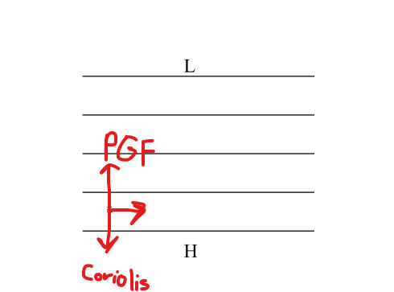

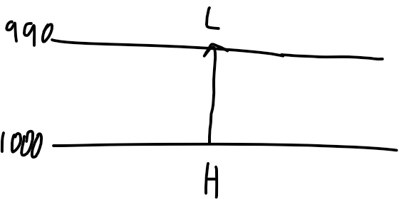

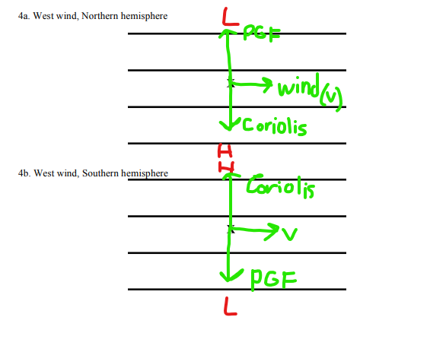

5. It is because in southeastern Utah, it may consist of high pressure gradient force which is perpendicular to the height of contours. And south of the center of the Atlantic Ocean, it may consist of low pressure conditions in which the force is parallel to the height of contours.

6a.

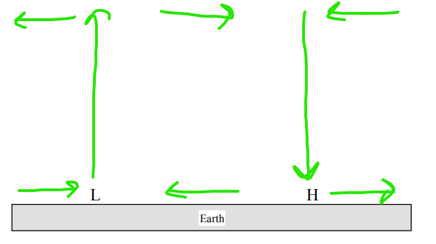

6b. When low pressure systems are formed on earth, the wind near it starts to converge as shown in the above figure. And the air begins to rise. This rising air creates instability in the atmosphere and results in clouds.

6c.

When high-pressure systems form on Earth, air begins to diverge near them, causing air from higher altitudes to fall and compensate for the void created by surface divergence.