**LAB 2**

1.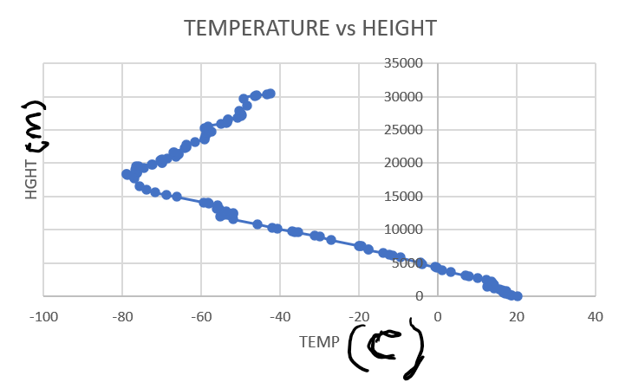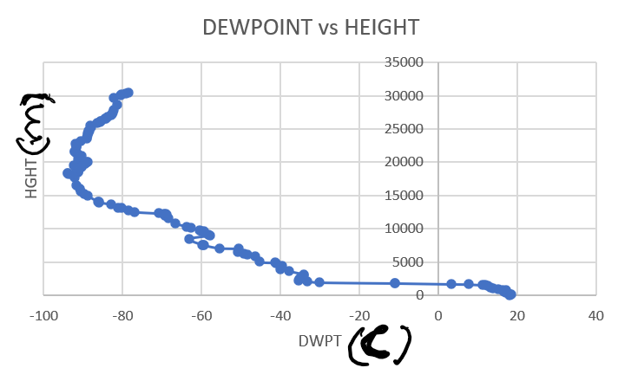

2. The tropopause height is about 18305 meters.

3. The lapse rate is 4.6 C/km

4. The lapse rate is 4.87 C/ km

5. The lapse rate is -2.83 C/km

6. The sign of the lapse rate (the rate at which air temperature changes with height) can be determined by examining the temperature profile (a graph of temperature vs. height). **If the temperature decreases with height, the lapse rate is positive.** If the temperature increases with height, the lapse rate is negative. If the temperature remains constant with height, the lapse rate is zero. So, you can determine the sign of the lapse rate by simply observing the slope of the temperature profile, where a negative slope indicates a negative lapse rate, a positive slope indicates a positive lapse rate, and a flat line indicates a zero lapse rate.

7. No, the dewpoint cannot exceed the air temperature. If the dewpoint was larger than the actual temperature, the extra water vapor would condense. Dew Point temperature would decrease until it was equal to the actual temperature.

8. 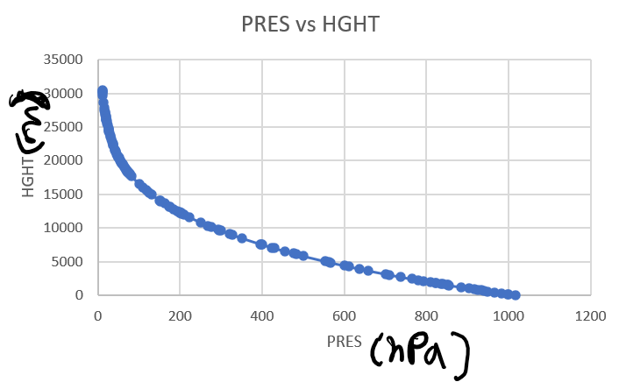

8a. -101.4 hPa/km

8b. -43.18 hPa/km

8c. It doesn’t change with height.

8d. The magnitude of the rate of change of pressure decreases with height (increases). Since the air density decreases with height, the magnitude of the rate of change of pressure decreases with height.

9. 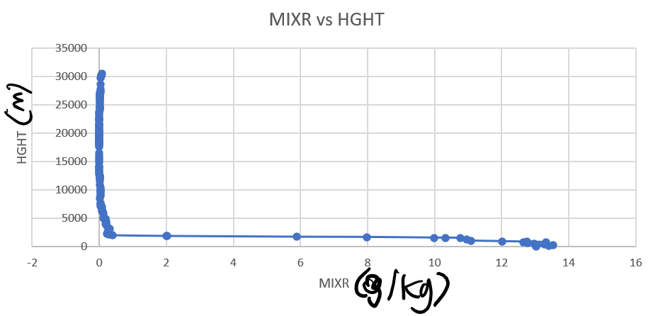

Water vapor mixing ratio decreases with height.

10.HIGHEST: 13.53 g/kg

LOW: 0 g/kg

11.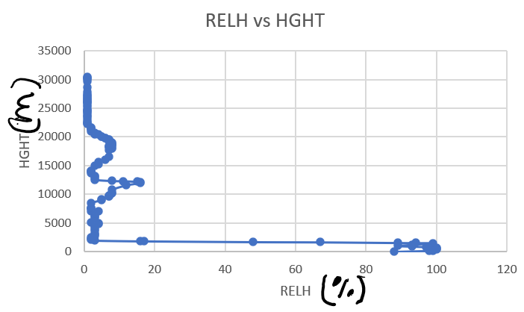 Relative humidity decreases with height. But, it doesn’t decrease as fast as the water vapor mixing ratio. The maximum value of the relative humidity is in the lower troposphere. High values of relative humidity can also be seen in the middle and/or upper troposphere.

12.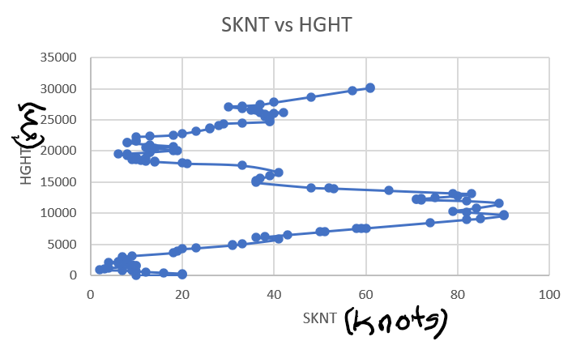

Wind speed increases from the surface to the upper troposphere. The highest wind speed appears around 10000 m. Then the wind speed decreases from the upper troposphere to the tropopause level. Then, the wind speed increases with height again in the stratosphere.