1. Which of the following can be used for categorical variables?
   1. Pie chart
   2. Stem and leaf plot
   3. Histogram
2. What is the shape of the distribution for this following dataset?

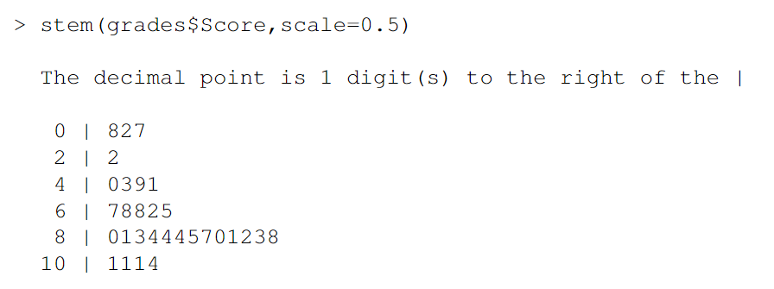

* 1. Skewed left
  2. Skewed right
  3. Symmetric
  4. Uniform

1. What is the approximate center of the above distribution?
   1. 50
   2. 82
   3. 8.5
   4. 4
2. Which of the following statement is true?
   1. A parameter is a number that describes the population.
   2. A statistic is a number that describes the population.
3. Which of the following cannot be used to measure the center of a dataset?
   1. Mean
   2. Median
   3. Mode
   4. Standard deviation