1. What is IQR?
   1. Q3-Q1
   2. Q2-Q1
   3. Q4-Q2
   4. Q4-Q3
   5. Q4-Q1
2. What is the median of Section A dataset?

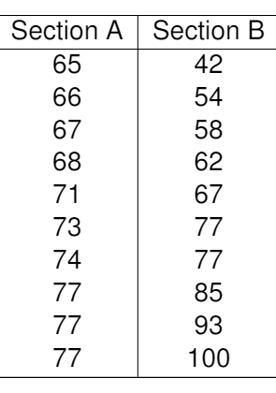

* 1. 65 b. 71.5 c. 72 d.77 e. 100

1. What is the median of Section B dataset?
   1. 65 b. 71.5 c. 72 d.77 e. 100
2. What is the mean of Section A dataset?
   1. 65 b. 71.5 c. 72 d.77 e. 100
3. What is the mean of Section B dataset?
   1. 65 b. 71.5 c. 72 d.77 e. 100