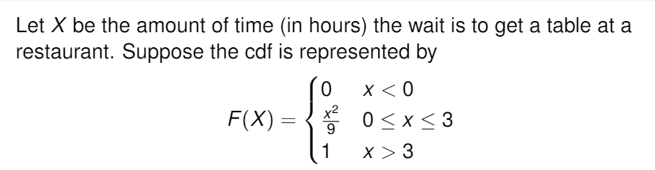

1. What is the pdf for X?
2. f(x)= x/9 if 0<=x<=3; 0 otherwise
3. f(x)= 2x/9 if 0<=x<=3; 0 otherwise
4. f(x)= x^2/9 if 0<=x<=3; 0 otherwise
5. f(x)= 2x/3 if 0<=x<=3; 0 otherwise
6. none of the above
7. What is the correct way to calculate the expected value of X?
$\int_{-∞}^{∞}{f\left(x\right)dx}$

$\int_{-∞}^{∞}{xf\left(x\right)dx}$

$\int_{-∞}^{∞}{x^{2}f\left(x\right)dx}$

$\int_{-∞}^{∞}{xdx}$

8. What is the expected value of X?
9. 1
10. 2
11. 3
12. 4
13. 5
14. Suppose you usually get 3 phone calls per hour, how often would you expect one phone call?
15. 1 hour
16. 1/3 hour
17. 3 hours
18. 5 hours
19. 30 hours
20. Based on question 4, what is the probability that a phone call will arrive within the next hour?
21. 1
22. 1- $e^{-3}$
$e^{-3}$

23. 1+ $e^{-3}$
24. 1- $e^{3}$