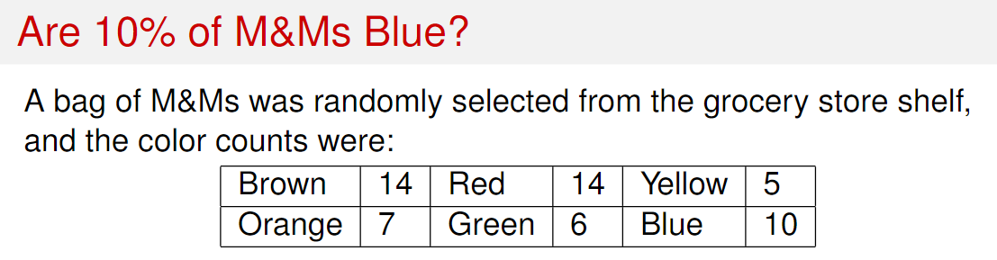

1. What is the proportion of M&M that are blue in this sample?
2. 0.1
3. 10/56
4. 10
5. If we would like to test to see if the proportion of M&M that are blue are 10% or not, what would be our null hypothesis?
6. H0: p=0.1
7. H0: p_hat=0.1
8. H0: p is not 0.1
9. H0: p_hat is not 0.1
10. If we would like to test to see if the proportion of M&M that are blue are 10% or not, what would be our althernative hypothesis?
11. Ha: p is not 0.1
12. Ha: p_hat is not 0.1
13. Ha: p=0.1
14. Ha: p_hat=0.1
15. What kind of hypothesis test is above?
16. Left-tailed test
17. Right-tailed test
18. Two-tailed test
19. None of the above
20. What is the test statistic for the above hypothesis test?
21. 0.5
22. 0.1
23. 1.9599
24. 10/56
25. 0.0501