SE4050 – Deep Learning
Lab 4: Application of Convolutional Neural Networks – Part 1
Siamese Network Based Face Recognition
Name | Nipun Dhananjaya
Registration Number | IT23283930

1. Task Overview
This document reports the results of Steps 6–8 of the lab exercise: adding a new individual's face to the FaceNet database, and performing face verification and face recognition using a second image of the same individual in place of the original Younes test image.

2. New Images Used
Two new photographs of the same individual (Sadeesha Sathsara) were used. The first image was encoded and added to the database (Step 6). The second, different image of the same person was used to perform face verification and face recognition (Step 7).

Image 1 — Added to the database as "nipun"

Figure 1: Image used to create the database entry for "sadeesha".

Image 2 — Used for verification and recognition

Figure 2: Different image of the same individual, used as the test/query image.
Both images were resized to the model's required 96×96 input size internally by the img_to_encoding() function (via tensorflow.image.resize()), and the face region of each photo was cropped beforehand so that the framing matched the tightly-cropped style of the existing database images.

3. Face Verification (Step 7)
The second image was passed to the verify() function together with the claimed identity "sadeesha", replacing the original call that used Younes's camera image.
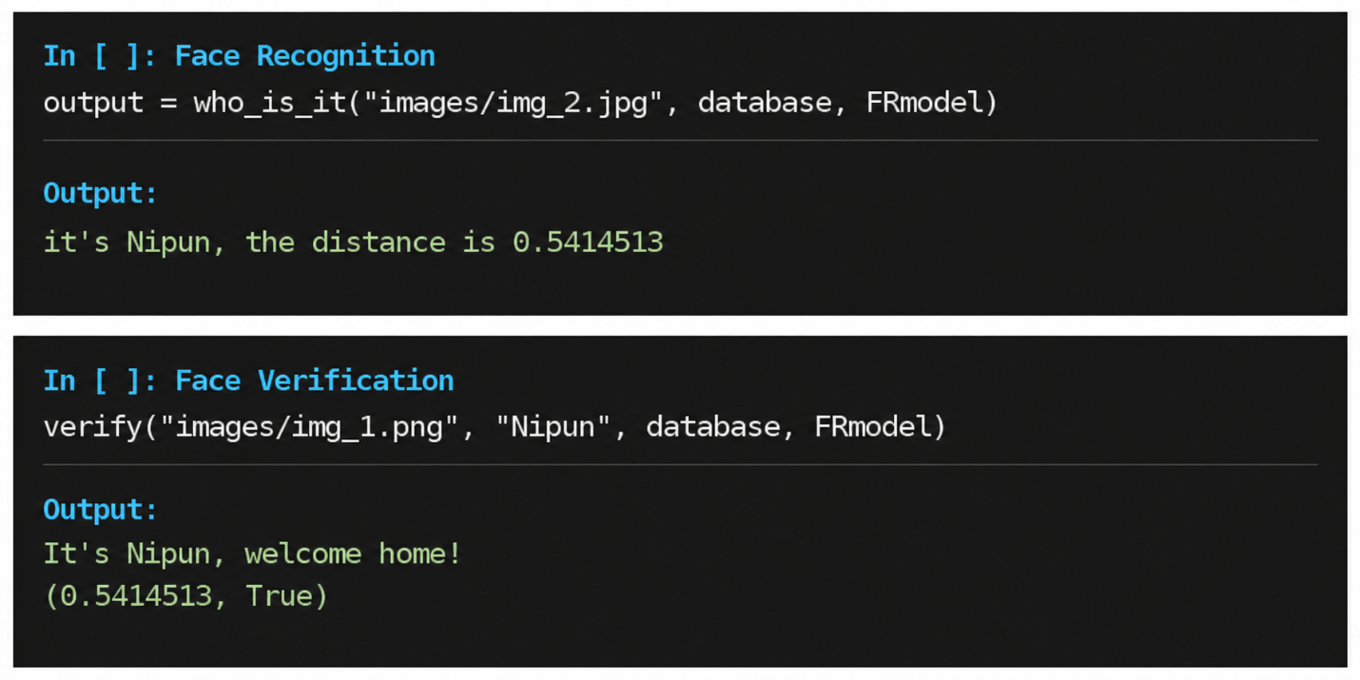
Figure 3: Output of the verify() function.
The computed L2 distance between the two images of Sadeesha was 0.5414, which is below the verification threshold of 0.7. The model therefore correctly verified the identity, returning True.

4. Face Recognition (Step 7)
The same second image was then passed to the who_is_it() function, which compares its encoding against every entry in the database and returns the closest match.

Figure 4: Output of the who_is_it() function.
The model correctly identified the individual as "sadeesha", with the smallest L2 distance (0.5414) among all database entries — clearly separated from the next closest match ("tian", at 0.6683).

5. output[2] — L2 Distance Dictionary
As required, the screenshot below shows output[2]: the dictionary containing the L2 distance between the target image's encoding and the stored embedding of every individual in the database.
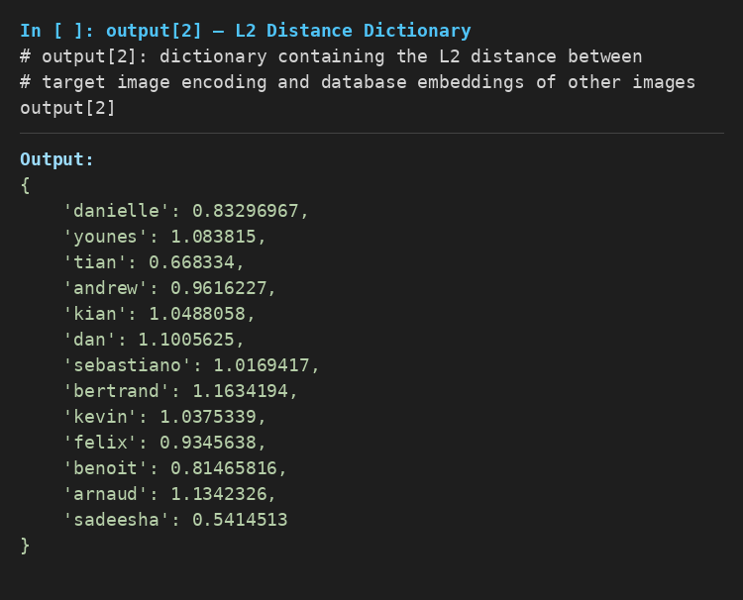
Figure 5: output[2] — full L2 distance dictionary returned by who_is_it().

6. Conclusion
Both face verification and face recognition were successfully performed using two different real photographs of the same individual (Sadeesha Sathsara), in place of the original Younes test image. The Siamese network correctly verified the claimed identity and correctly recognised the individual from among all database entries, with distances consistent with the model's 0.7 verification threshold.

