SE4050 – Deep Learning

Lab 4: YOLO object detection

Student Name: E.M.N.D Ekanayake

Student ID: IT23283930

Step 7: Bounding Box Shape Analysis

Why are there 1783 boxes?

The YOLOv2 model divides the input image into a 19 x 19 grid. Each grid cell predicts exactly 5 bounding boxes (one for each anchor). This means the model always generates a total of 19 x 19 x 5 = 1,805 possible bounding boxes. However, the yolo_filter_boxes function removes any boxes with a confidence score lower than the defined threshold (0.5). In this specific run, 22 boxes fell below the 0.5 threshold and were discarded, leaving exactly 1,783 boxes.

What is the maximum and minimum number of boxes?
- Maximum: 1,805 boxes (This happens if every single predicted box has a confidence score greater than or equal to the threshold).
- Minimum: 0 boxes (This happens if the threshold is set too high and none of the boxes meet the confidence requirement).

Experiment Observations (Changing Mean, Stddev, and Threshold):
- Threshold: Increasing the threshold reduces the number of boxes in the output shape because fewer boxes meet the strict confidence requirement. Lowering the threshold increases the shape closer to the maximum of 1,805.
- Mean & Stddev: Because the scores are generated using a normal distribution (random_normal), increasing the mean shifts the overall confidence scores higher, resulting in more boxes surviving the threshold. Changing the Standard Deviation (stddev) alters the spread of the scores; a wider spread means more extreme highs and lows, directly impacting how many boxes randomly cross the threshold line.

Step 8: Anchor Boxes

What is the advantage of using predefined anchor boxes?

Anchor boxes act as predefined shape priors that represent the most common aspect ratios and sizes of objects (like cars, pedestrians, or traffic lights) found in the real world. Instead of forcing the neural network to predict a bounding box's exact width and height from scratch, YOLO simply predicts offsets (minor adjustments) to these existing anchor shapes. This drastically simplifies the learning process, makes training more stable, and allows a single grid cell to effectively detect multiple overlapping objects as long as they have different shapes (a tall pedestrian standing in front of a wide car).

What method was used to determine the sizes of these anchor boxes?

The dimensions of YOLO's anchor boxes were determined by running K-Means clustering on the bounding boxes within the training dataset. This algorithm groups the ground truth boxes into clusters to find the most representative widths and heights for the specific dataset being used.

Step 10: Observations on the Autonomous Driving Dataset

Image 1: 0113.jpg
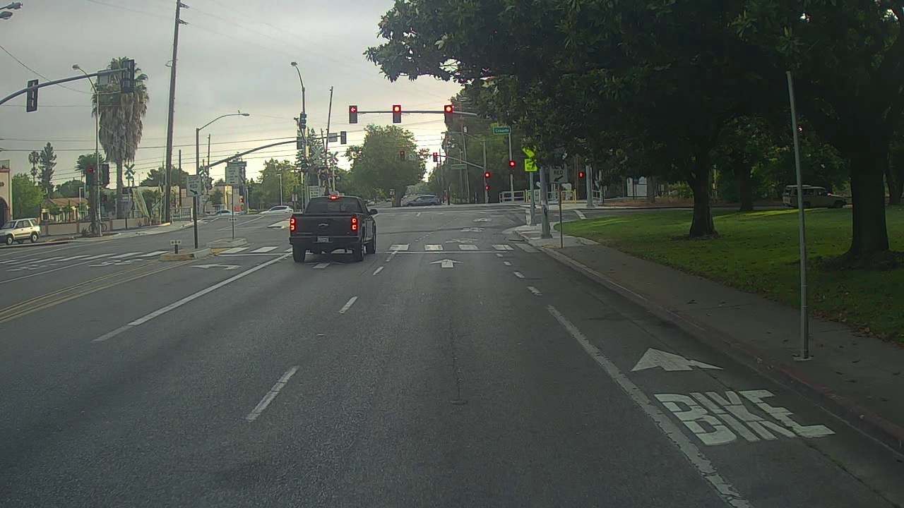Figure 1: Original Image
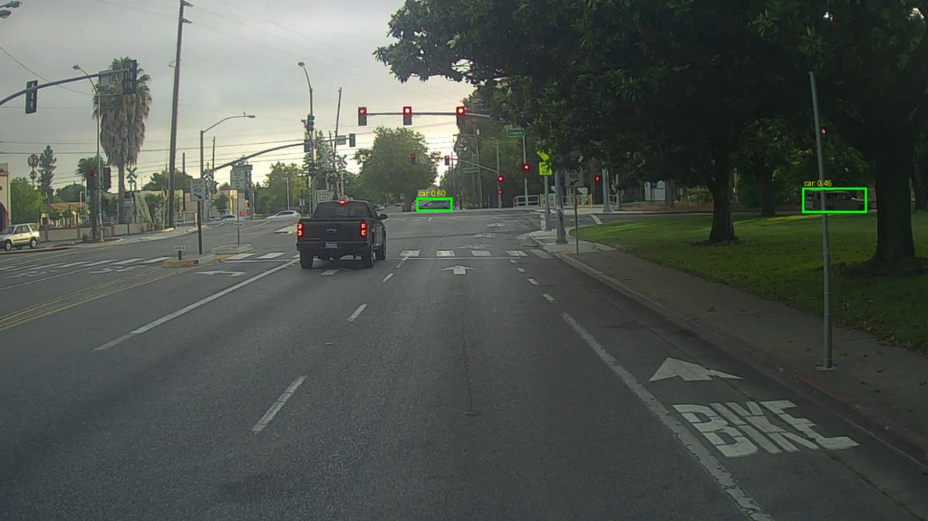Figure 2: Output Image
- Correctly detected objects: The model successfully identified the white passenger car in the distant middle lane (car 0.60).
- Incorrectly detected objects (False Positives): No falsely detected a car on the far-right side of the image (car 0.45), drawing a box around what appears to be a signpost and bushes.
- Undetected objects (False Negatives): The model completely missed the large dark pickup truck clearly visible in the immediate foreground.
- Incorrect bounding boxes: The bounding box on the right side is floating over non-vehicular background objects.

Image 2: DSC_1643_resized.jpg
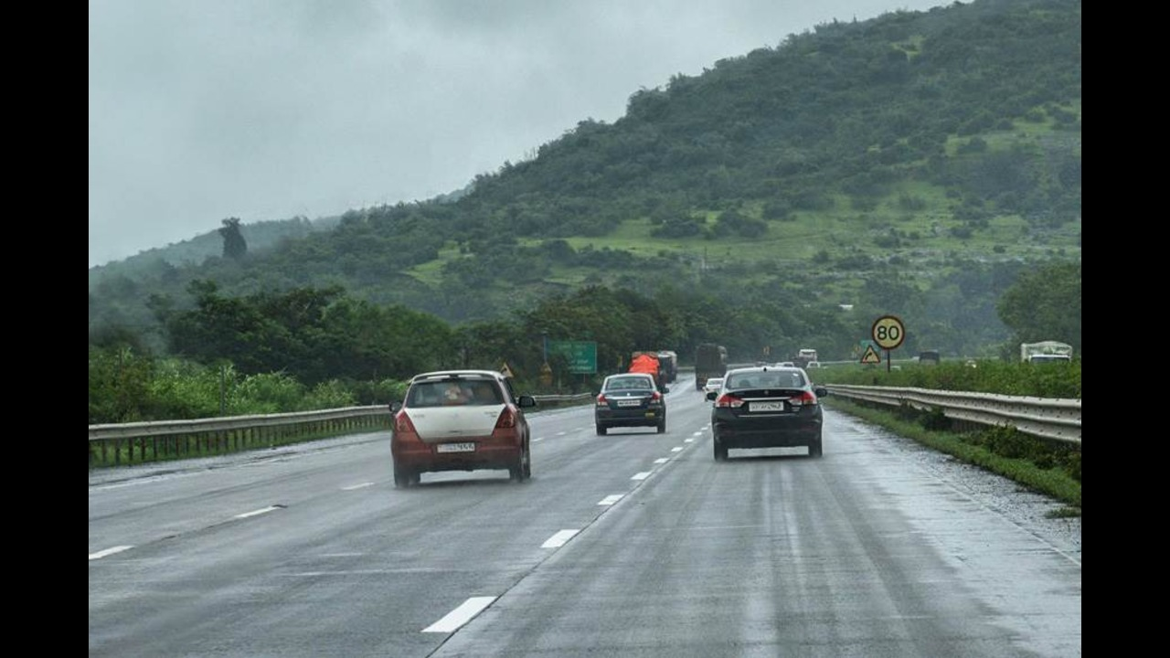
Figure 3: Original Image
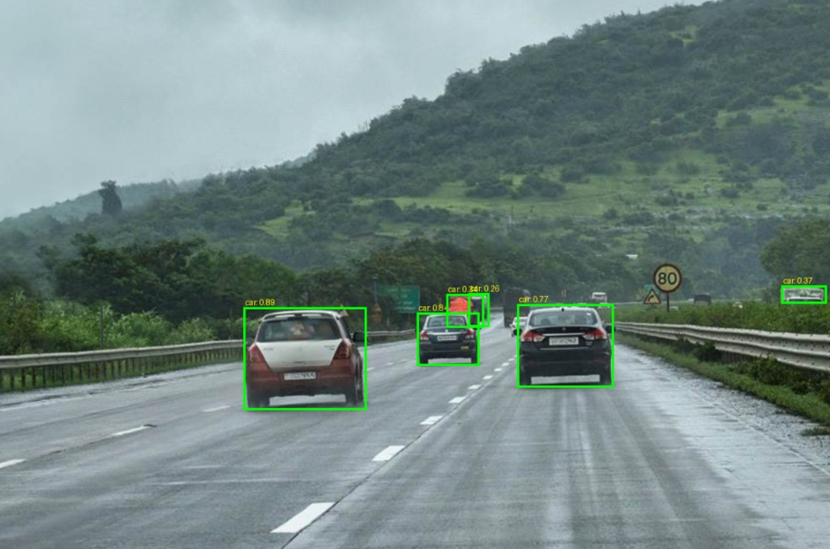
Figure 4: Output Image
- Correctly detected objects: The model successfully identified the distinct passenger cars driving on the highway (car 0.89, car 0.77, car 0.84).
- Incorrectly detected objects (False Positives): Parts of the truck driving in the middle lane were misidentified as multiple, separate passenger cars (car 0.34, car 0.26).
- Undetected objects (False Negatives): The truck as a whole was not recognized as a single vehicle, and other distant vehicles on the horizon were missed.
- Incorrect bounding boxes: The bounding boxes on the truck do not wrap around the entire object; instead, they capture small partial sections of the vehicle and overlap each other heavily.

Step 11: Parameter Tuning Experiments
- Implementation Approach: Detection relies on native Ultralytics YOLOv8 inference (run_yolov8) rather than custom TensorFlow post-processing (postprocess_with_tf2) to leverage native PyTorch NMS, anchor-free box regression, and superior detection accuracy.
- Testing Limitations: By bypassing the custom TensorFlow pipeline, parameters like max_boxes cutoff limits and fine-grained TF tensor/mask filtering cannot be directly evaluated in the active execution flow.

Experiment 1: Changing max_boxes
- Parameter value used: max_boxes = 3 (Default was 50)
- Observations: Setting max_boxes to 3 creates a hard cap, forcing the Non-Maximum Suppression (NMS) to keep only the top 3 detections with the highest confidence scores.
- For DSC_1643_resized.jpg, this successfully cleared up the messy, overlapping low-confidence boxes on the truck. However, because it hit the 3-box limit, it dropped a legitimate car on the right side of the road, introducing a new False Negative.
- For 0113.jpg, since there were originally only 2 detections, capping it at 3 had no effect on the False Positive on the side of the road.

Experiment 2: Changing score_threshold
- Parameter value used: score_threshold = 0.60 (Default was 0.25)
- Observations: Increasing the score threshold requires the model to be at least 60% confident in a detection before drawing a box.
- For 0113.jpg, this successfully eliminated the False Positive on the right side of the road (which previously had a confidence score of 0.45).
- For DSC_1643_resized.jpg, the stricter threshold successfully eliminated the low-confidence, fragmented boxes on the truck, leaving only the clearly identifiable passenger cars.

Experiment 3: Changing iou_threshold
- Parameter value used: iou_threshold = 0.15 (Default was 0.50)
- Observations: Lowering the Intersection over Union (IoU) threshold makes the Non-Maximum Suppression much more aggressive at deleting overlapping boxes.
- For DSC_1643_resized.jpg, this successfully forced the algorithm to drop the redundant, heavily overlapping boxes on the middle truck, resulting in a single, much cleaner detection.
- For 0113.jpg, the detections were already far apart, so changing the overlap rules resulted in no noticeable changes.

