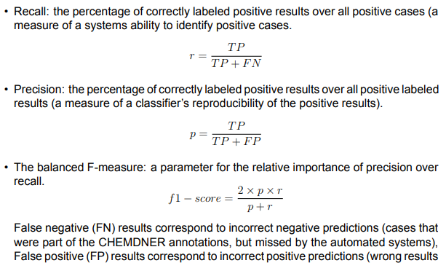

We can check Savvas git (e.g derived data/biotic), maybe useful tables for dictionaries enrichment (we could enrich dictionary with new words and all their possible formats, e.g caps lock case)

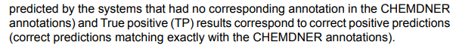

Note to me: check annotation notes at corpus folder in order to ask the right way to annotate the data.

Corpus second annotations data training Corpus first annotations data training
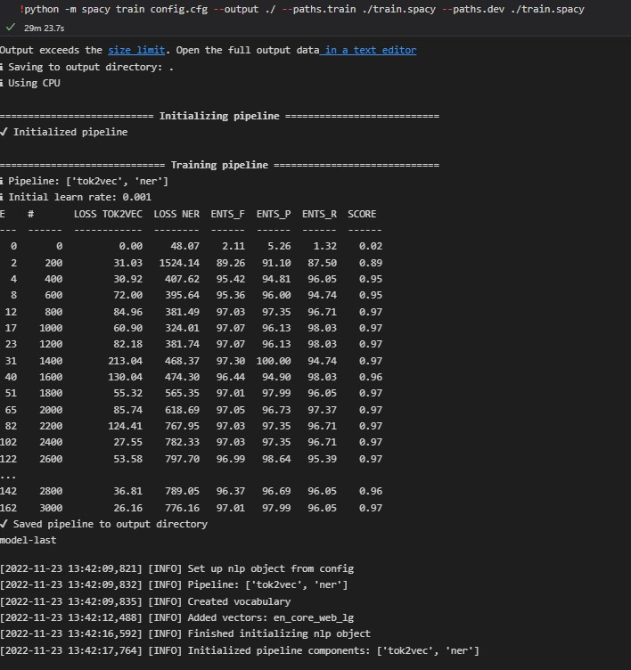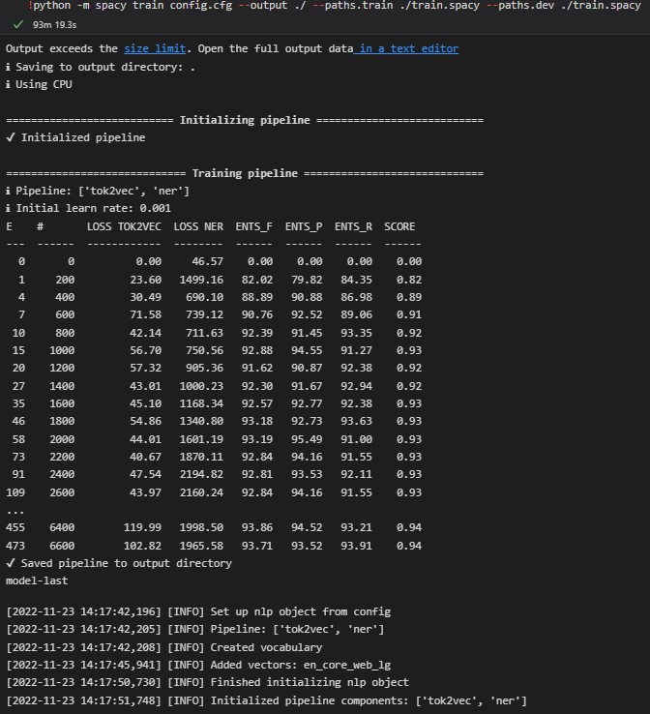
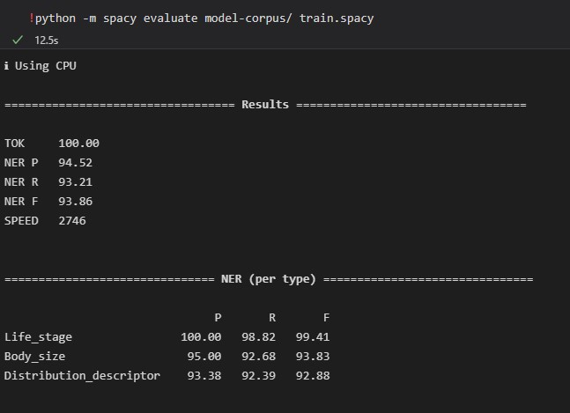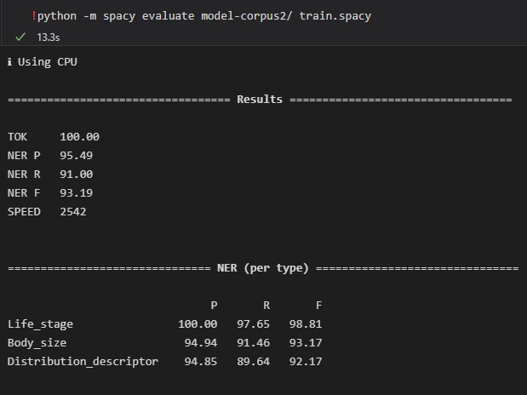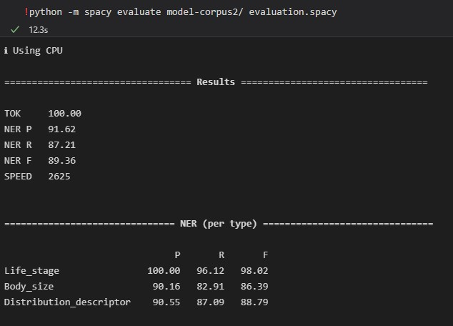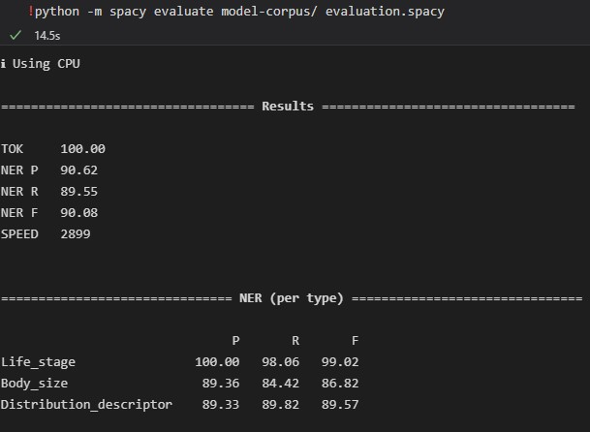
evaluation.spacy are the annotated data for evaluation, we need more representative data.
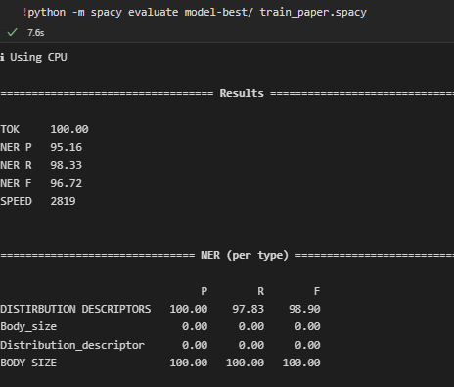
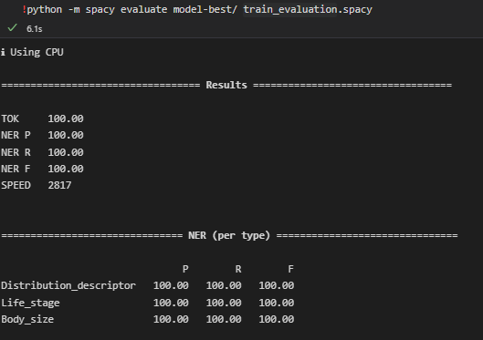
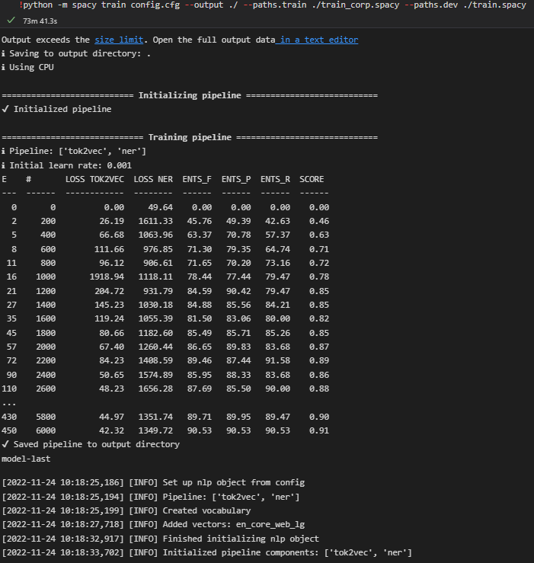
Training corpus for dev data paper annotations.

Paper annotations are not that considerable cause of different way of annotation.

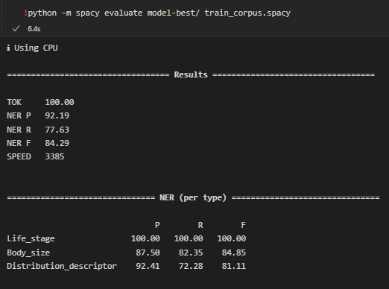
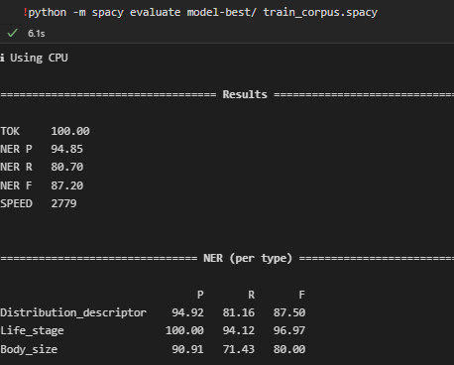

Corpus 2
Corpus 1

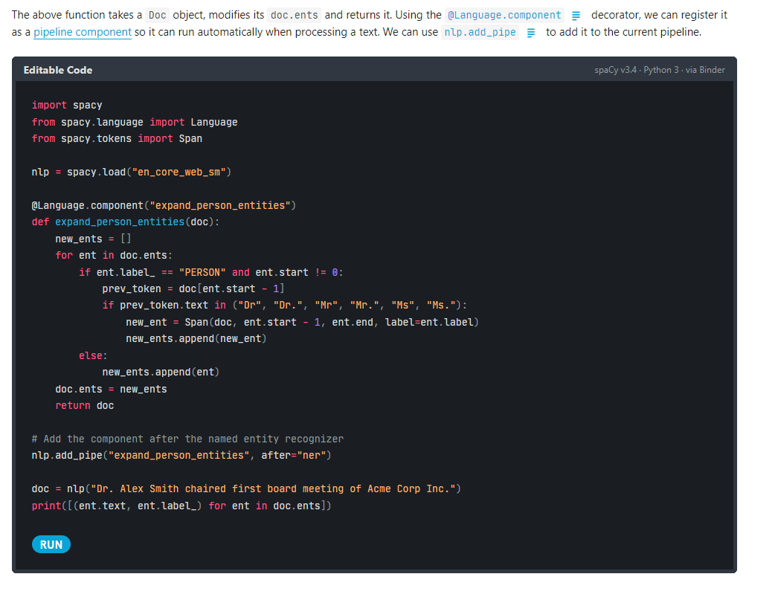

Maybe useful for the dictionaries patterns’relation after entity ruler used.

A way to put dictionaries entries into patterns in order to match together, e.g even if it is Beta-mesohaline in the example below.

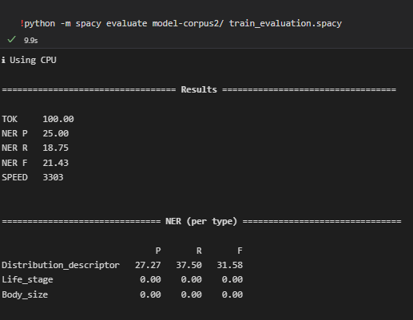

giati????

Training corpus2 with dev data, development data(see code)

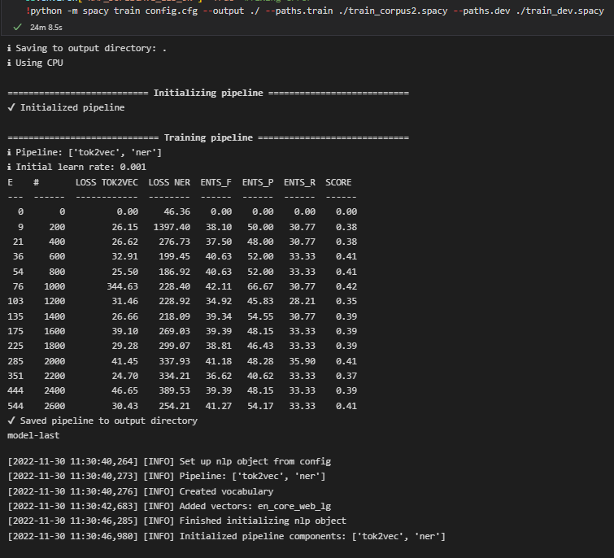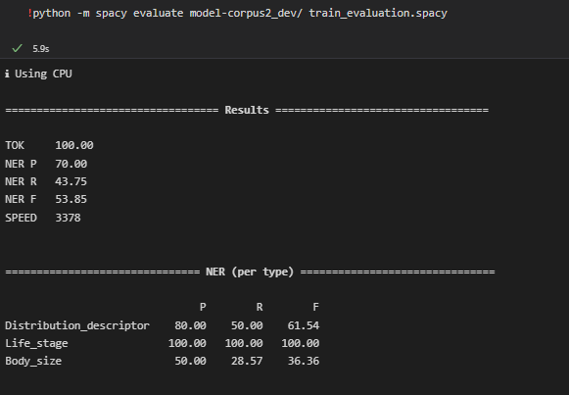

Training corpus with dev data, development data(see code)

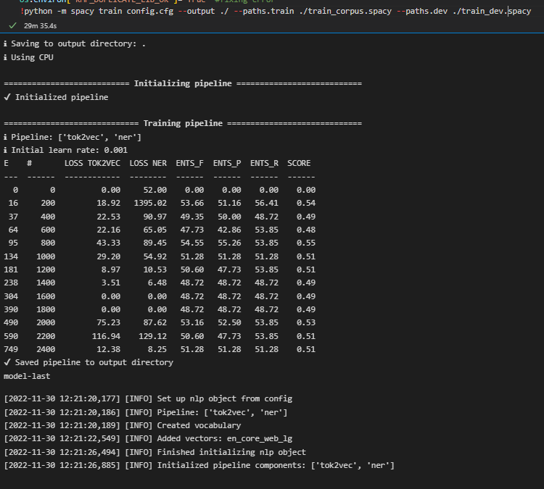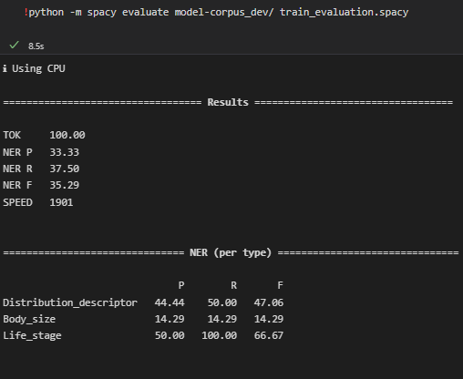

So, we keep corpus2 annotation data

Na doume dependency parser

Training corpus2 with dev data, development data(see code)
With entity ruler:
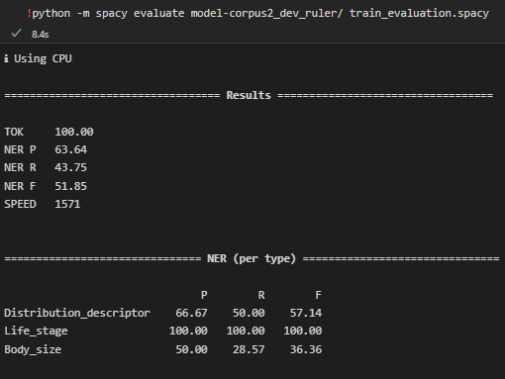
Comparing with evaluation in model without entity ruler we can see that while precision and f1 score decreased , recall remains the same.

