1
Empowering Bengali Language in Drone Control with Artificial Neural Networks

Mohammad Abu Noman*( Brainware University,india),Sajjad Hossain Talukder 1, Noortaz Rezoana 2, Shourav Chowdhury 3, Tan- jim Mahmud 4, Nanziba Basnin 5, Mohammad Shahadat Hossain 6, Karl Andersson 7
1,3Premier University, Bangladesh, 2,6University of Chittagong, Bangladesh, 4Rangamati Science and Technology University, Rangamati-4500, Bangladesh, 5International Islamic University Chittagong, Bnagladesh, 7Luleå University of Technology, Sweden

Abstract
With drone technology advancing, there’s a growing need for intuitive control methods. Traditionally, drones rely on remote controllers, demanding trained operators for piloting. This paper introduces a novel approach to drone control using Artificial Neural Networks (ANNs) and Bengali voice commands, aiming to simplify drone piloting for users without prior experience with remote con- trollers. A dataset of 6010 Bengali audio samples, comprising 15 distinct voice commands, was meticulously curated to reflect diverse environmental and speaker variations. Leveraging Mel-frequency Cepstral Coeﬀicients (MFCCs), an ANN-based model interprets Bengali voice commands to control drone movements in real-world scenarios. Commands like “Take Off/উড্ডয়ন করো”,
“Turn Right/ডানে ঘুরে যাও”, “Go Up/উপরে উঠো”, “Move Forward/সামনে এগিয়ে যাও”, “Stop/ থামো” are among those utilized for model training. A system ar- chitecture centered around a Raspberry Pi facilitates the integration of the trained model, ensuring seamless drone operation during flight. Through ex-

1 ek787101@gmail.com
2 sajjadhossain.cse35@gmail.com

1

2
tensive experimentation, an impressive accuracy rate of 73% was achieved, underscoring the model’s robustness in command classification.

Introduction
The emergence of drones across industries has spurred the need for intu- itive control systems, leading to the rise of linguistic approaches like voice- controlled interfaces. These interfaces, equipped with natural language pro- cessing (NLP) capabilities, offer hands-free and intuitive drone piloting experi- ences, democratizing drone technology and enhancing accessibility [7,8,13,15]. Bengali voice-controlled drones offer significant advantages across various fields, from agriculture to urban planning and search and rescue operations.
However, despite Bengali being widely spoken, it has received limited attention as a control medium for systems [1, 2, 6, 16].
To bridge this gap, our paper proposes leveraging neural networks for user- drone interaction through randomly spoken Bengali voice commands. Specifi- cally, we train a Multi-Layer Perceptron (MLP) on a dataset comprising 6010 audio samples, covering 15 distinct Bengali voice commands. The trained model is deployed on a Raspberry Pi8 control device, enabling real-time com- mand prediction and signal transmission to the drone.
Through extensive testing and evaluation, our research demonstrates the eﬀicacy of our system in real-world scenarios, showcasing the adaptability of artificial neural networks in processing Bengali complexities and paving the way for multilingual applications in drone control. This approach not only enhances accessibility but also unlocks new possibilities for aerial navigation and exploration across languages.

Related Work
Numerous studies have explored voice command utilization for remote- controlled devices across languages. Yapicioğlu et al. [17] achieved remark- able accuracies of 95.72% using Turkish speech commands and a convolutional neural network (CNN). Fayjie et al. [5] reached 88.57% accuracy with Hid- den Markov Model (HMM)-based speech recognition, and Contreras et al. [3] achieved high accuracies for English and Spanish commands using different approaches. Landau and Delden [10] used Nuance speech recognition for in- tuitive UAV control, while Leechor et al. [11] demonstrated high accuracy in

8https://www.raspberrypi.com

3
controlling an RC car with Thai voice commands. Bhattacharjee et al. [1] achieved a 98% recognition accuracy with a Bangla voice-controlled robotic system. Bhuiyan et al. [2] developed a Bengali voice-controlled AI robot for individuals with physical challenges, and Gupta et al. [6] created a digital assistant for handicapped individuals. Sumon et al. [16] explored three CNNs for Bangla speech commands, achieving notable accuracy. Islam et al. [9] im- proved Bengali speech recognition using Recurrent Neural Networks and the CTC loss function.

Methodology

Dataset
We’ve created a dataset of 6,010 Bangla audio samples for drone command recognition, addressing the scarcity of high-quality datasets in this domain. The dataset covers 15 distinct commands from 21 speakers, encompassing various environments and speech styles. Each audio file, averaging 2 seconds, totals approximately 3.5 hours, sampled at 44.1Khz. Table I outlines com- mand distribution, while Table II illustrates variations in the ”Go Forward” command. This dataset lays a foundation for advancing Bangla voice com- mand recognition in drone piloting, accommodating diverse speech patterns and environmental conditions.
Table 1.1: Description of Commands and Sample Counts

Commands | Count | Distribution
Take Off / উড্ডয়ন করো  Landing / অবতরণ করো  Go Up / উপরে উঠো  Go Down / নিচে নামো  Go Forward /সামনে যাও  Go backward /পেছনে  Turn Left / বামে ঘোরাও Turn Right / ডানে ঘোরাও  Stop Moving / থামো  Fly faster / দ্রুত উড়ো  Fly slowly / ধীরে উড়ো  Turn on camera / ক্যামেরাটা চালু করো  Turn off camera / ক্যামেরাটা বন্ধ করো  Take photo / ছবি তুলো  Mark route / পথ চিহ্নত করো | 399  426  417  425  437  458  491  453  399  368  330  329  336  334  408 | 6.64%  8.09%  6.94%  7.07%  7.27%  7.62%  8.17%  7.53%  6.64%  6.12%  5.50%  5.47%  5.59%  5.56%  6.79%

4
Table 1.2: Various expressions of ”Go Forward”

# | Expressions of Go Forward
1  2  3  4  5  6  7  8  9  10 | সামনে যাও  আগাইয়া যাইতে থাকো  এগিয়ে যা  সামনে অগ্রসর হ  সোজা হও  আগাই যা  সামনে আগাই চলো  সম্মুখে অগ্রসর করহোক  সোজা সামনে ল  সামনে দিকে উড়

Pre-processing
The effectiveness of the Multi-Layer Perceptron (MLP) relies on high-quality features, particularly in audio data extraction. Mel Frequency Cepstral Coef- ficients (MFCCs), a widely employed mechanism, offer a condensed represen- tation of an audio signal’s spectrum, capturing essential characteristics and leveraging human hearing’s perceptual properties to mitigate noise impact effectively. Positive coeﬀicients indicate energy concentration in low frequen- cies, while negative coeﬀicients signify concentration in high frequencies.
The block diagram illustrating the process of MFCCs feature extraction, as presented in figure 2, is depicted.
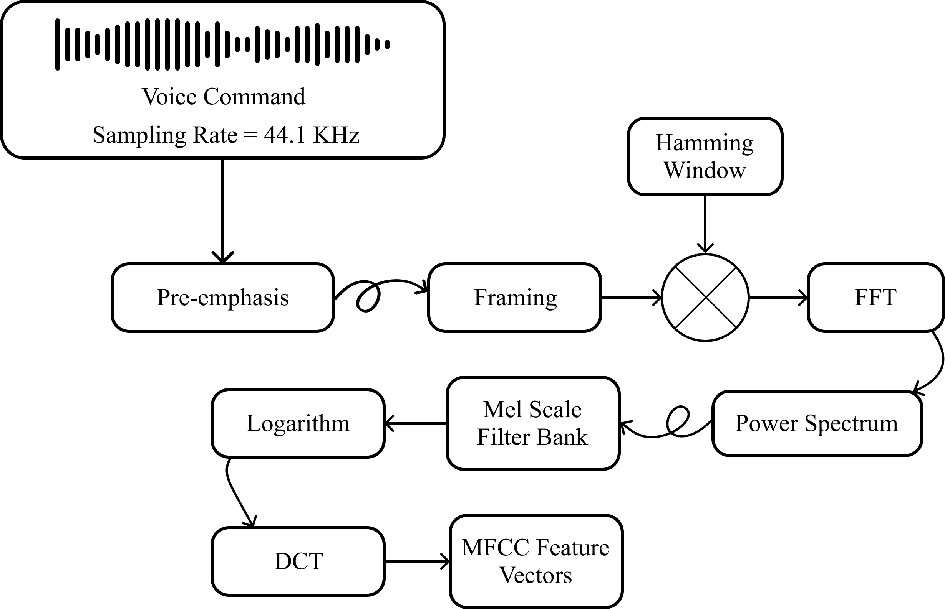
Figure 1: Block Diagram of MFCC feature extraction

5

Multi-Layer Perceptron Model
The MLP model, with interconnected layers of artificial neurons, is designed for effective learning and representation of intricate patterns, abstract fea- tures, and relationships within the features [4, 14]. The model architecture includes input, hidden, and output layers, with each layer applying a non- linear activation function to the weighted sum of inputs. In the subsequent section, we provide an overview of the deployed model’s architecture, dataset splitting strategy, and training process. .

Model Architecture
Our model architecture includes an input layer with 45 neurons, determined by the size of the MFCCs feature vector derived from 45 mel-spaced filterbanks. The two hidden layers consist of 2048 neurons each, aiming for optimal real- time performance and high accuracy. To enhance generalization and address overfitting concerns, a dropout value of 0.6 is incorporated. The output layer’s neuron count aligns with the dataset’s 15 distinct classes.
Table 1.3: Model Summary

Layer | Number of Neurons | Activation | Dropout
Input | 45 | None | N/A
Hidden 1 | 2048 | ReLU | 0.6
Hidden 2 | 2048 | ReLU | 0.6
Output | 15 | Softmax | N/A

The “ReLU” activation function is employed in each hidden layer of the neural network to introduce non-linearity and facilitate eﬀicient information flow. In the output layer, the ”Softmax” activation function is utilized to enable accurate multi-class classification. Table III illustrates a comprehensive summary of the model.

Dataset Split
The dataset was split randomly into two subsets: one for testing (15%) and one for training/validation. The training/validation subset was divided using two methods: train-validation-test (70% training, 15% validation) and stratified k-Fold Cross-Validation (six folds). Each fold in the latter method contained 851 samples (approximately 14.17% of the dataset), resulting in a training set of 4257 samples across five folds (approximately 70.83% of the dataset). Table IV summarizes the dataset distribution across these approaches, specifying the training, validation, and testing sets.

6
Table 1.4: Dataset Distribution

Approach | Train | Validation | Test
Train-Validation-Test | 4206 | 902 | 902
6-Fold Cross-Validation | 4257 | 851 | 902

Training
The MLP model is trained with labeled data, adjusting parameters through backpropagation and gradient descent. Hyperparameters like loss function, optimizer, epochs, and batch size are optimized for performance. With ’cat- egorical_crossentropy’ loss, ’accuracy’ metric, and the ’Adam’ optimizer, the model is trained for 500 epochs with a batch size of 64. This trained model is then deployed for real-time voice command prediction.

Proposed System Design

System Overview
In our study, we have named the ‘drone control system’ as ‘remote’, and these terms will be used interchangeably in the subsequent sections. The remote receives randomly spoken Bengali voice commands as input. After extracting MFCCs features from the audio command, the deployed trained model is utilized for prediction using the obtained features. The trained model predicts a command from a set of 15 commands, which is then converted into a corresponding voltage level ranging from 0V to 5V.
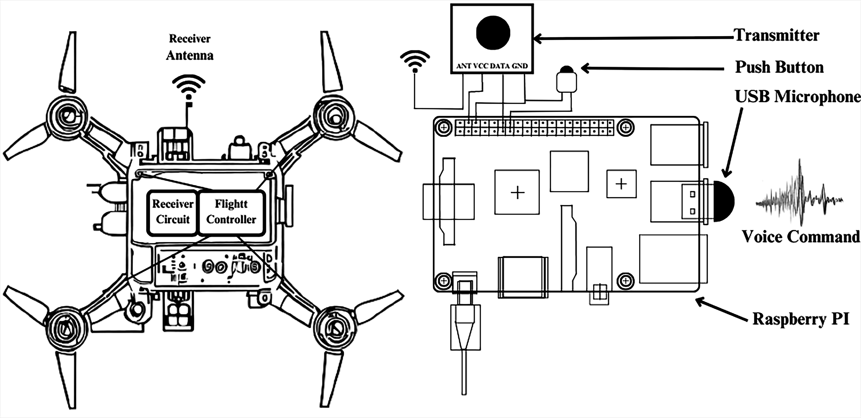
Figure 2: Drone & Remote Architecture

7
Subsequently, the transmitter transmits the voltage level to the drone re- ceiver. The drone receiver receives the transmitted signal and forwards it to the flight controller, which determines the appropriate action to be taken based on the received voltage level. The overall architecture of the remote and the drone is depicted in figure 3.

System Architecture
The Remote architecture comprises five essential components, including the Raspberry Pi 3 (RPI3), USB Microphone, Transmitter, Push button, and Power source. The power source provides the necessary electrical power to the RPI3, where the trained model is deployed. A USB microphone is employed to record voice commands through the USB port of the RPI3. The push button acts as a control mechanism to initiate the voice command recording process. Recording commences upon pressing the button and concludes upon a subsequent press. Afterwards, the recorded audio undergoes processing to extract (MFCC) features, which are fed into the deployed model for prediction.
Table 1.5: Mapping Commands with Voltage

# | Commands | Voltage | # | Commands | Voltage
1 | Take Off | 0.33V | 9 | Stop | 2.97V
2 | Landing | 0.66V | 10 | Fly faster | 3.30V
3 | Go Up | 0.99V | 11 | Fly slowly | 3.63V
4 | Go Down | 1.32V | 12 | Turn on camera | 3.96V
5 | Go Forward | 1.65V | 13 | Turn off camera | 4.29V
6 | Go backward | 1.98V | 14 | Take photo | 4.62V
7  8 | Turn Left Turn Right | 2.32V  2.64V | 15 | Mark the route | 5.00V

The resulting predicted command is then mapped to its corresponding voltage level, as illustrated in Table V. Finally, the voltage level corresponding to the predicted command is transmitted to the drone receiver through a radio transmitter, which is connected to GPIO pin of the RPI3. Figure 4 illustrates the command processing mechanism of the drone control system.

Results
The confusion matrix is a key evaluation tool for assessing a model’s classifi- cation performance, providing counts of correct and incorrect predictions for each class. Table VII displays the confusion matrix for novel test data, facili- tating computation of metrics such as accuracy, precision, recall (sensitivity), and F1 score, offering comprehensive insights into the model’s performance

8
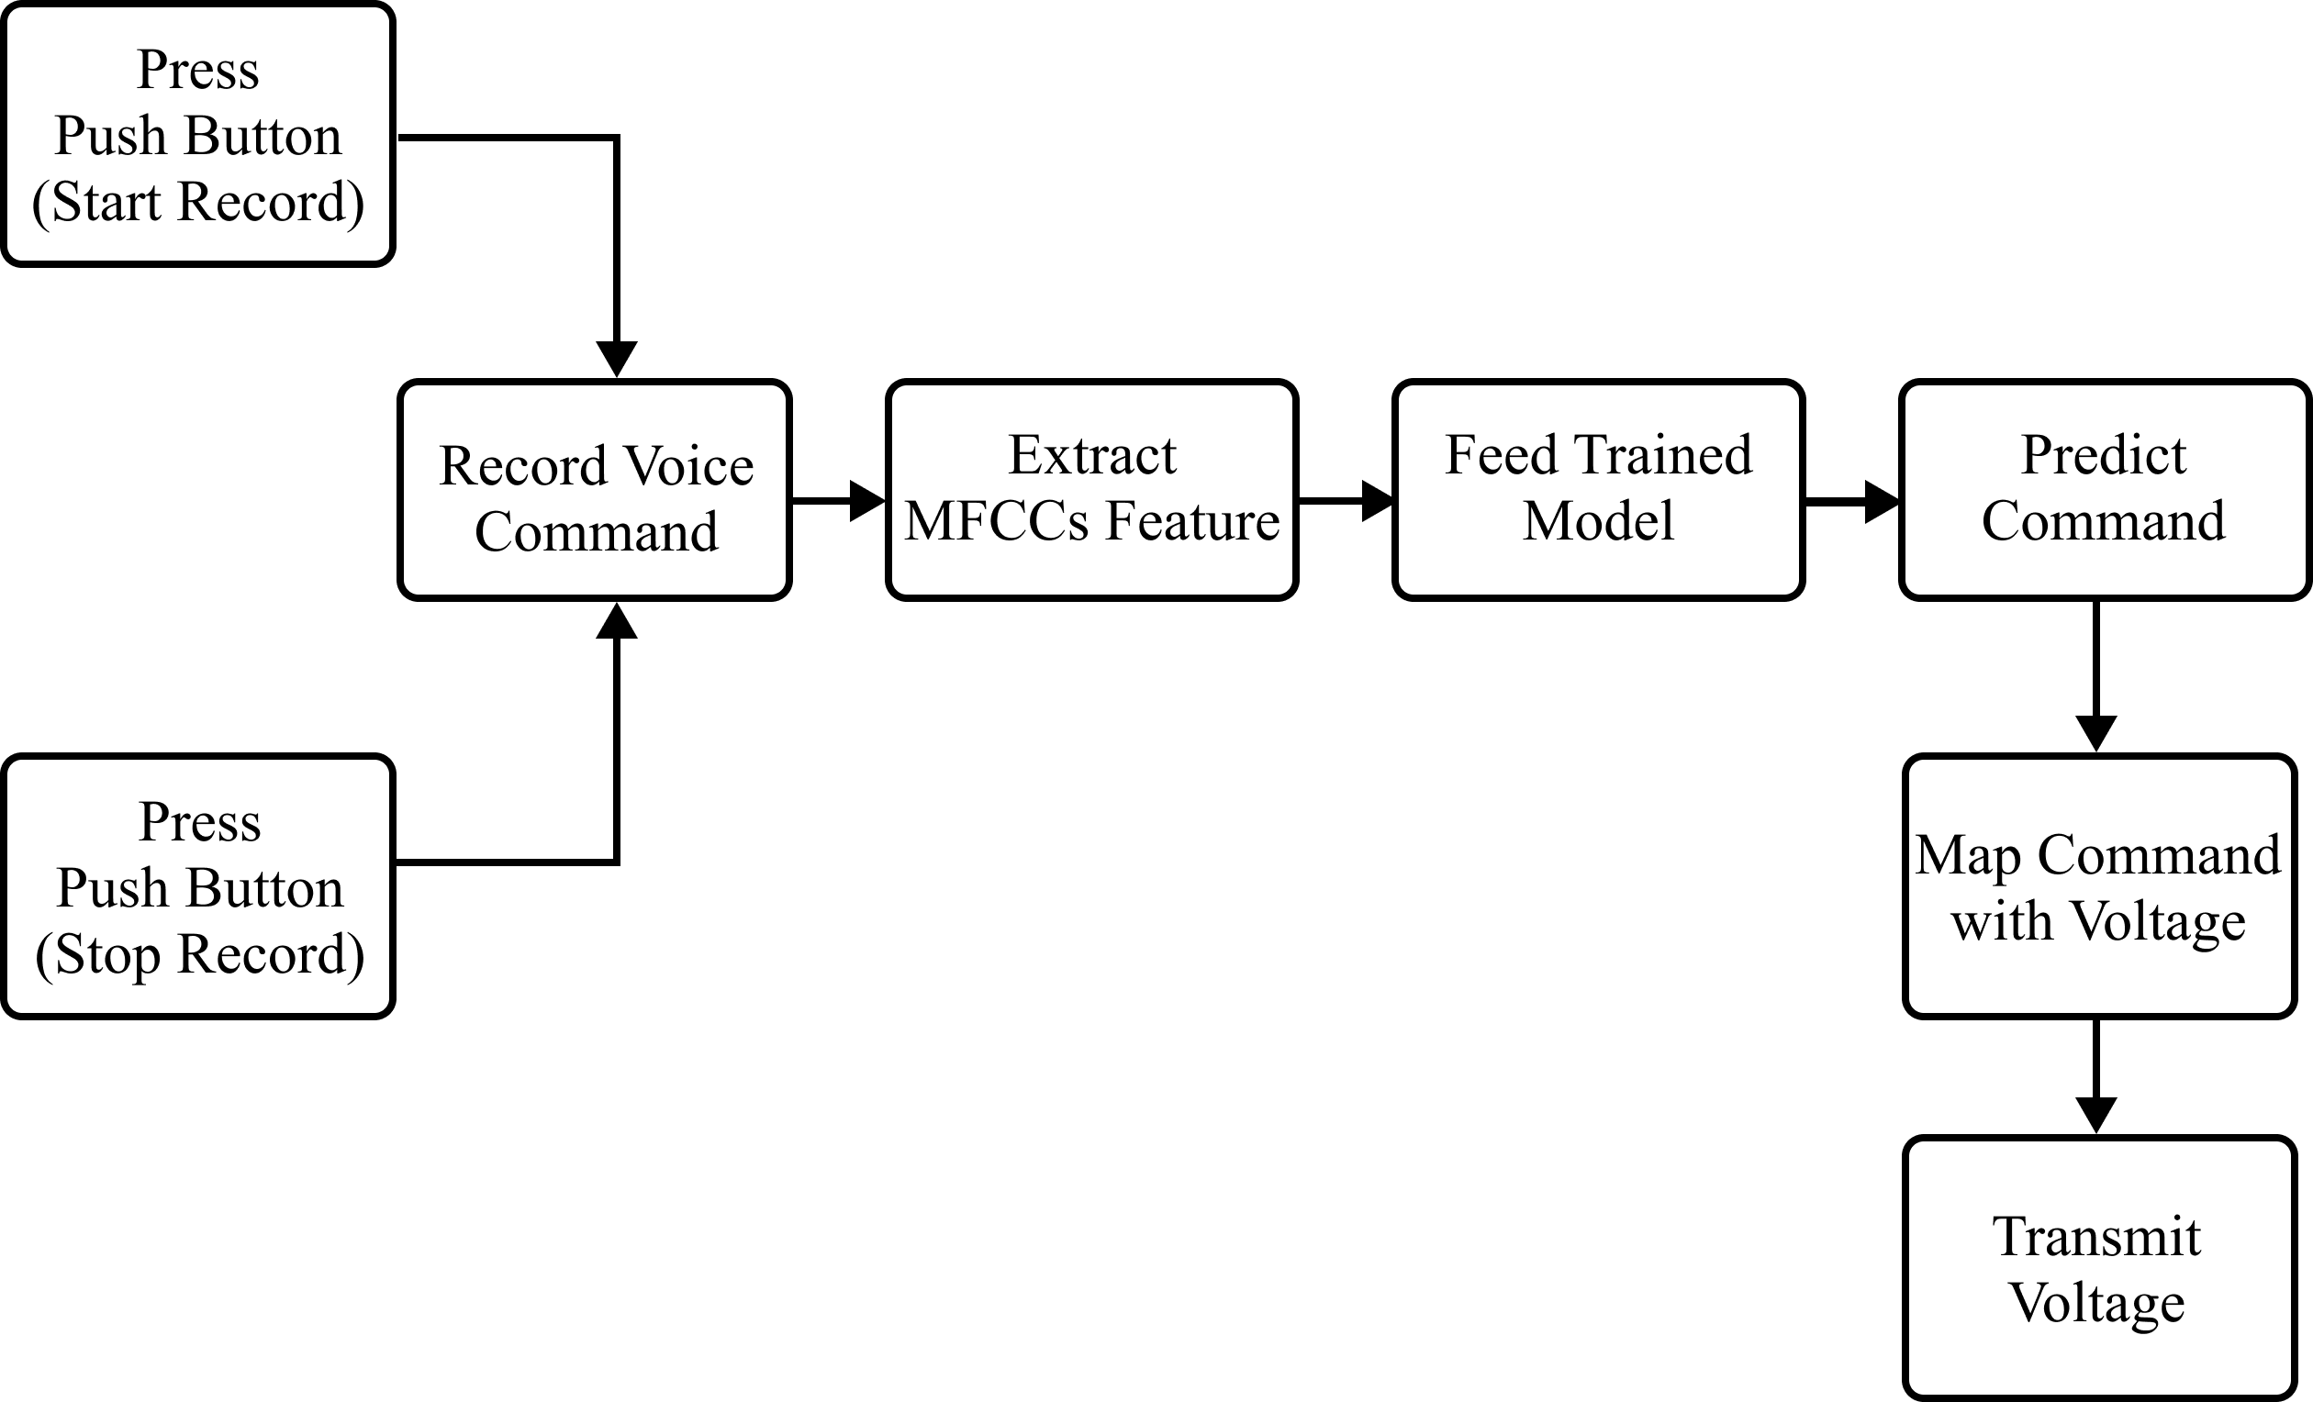
Figure 3: Command Processing by Remote Controller

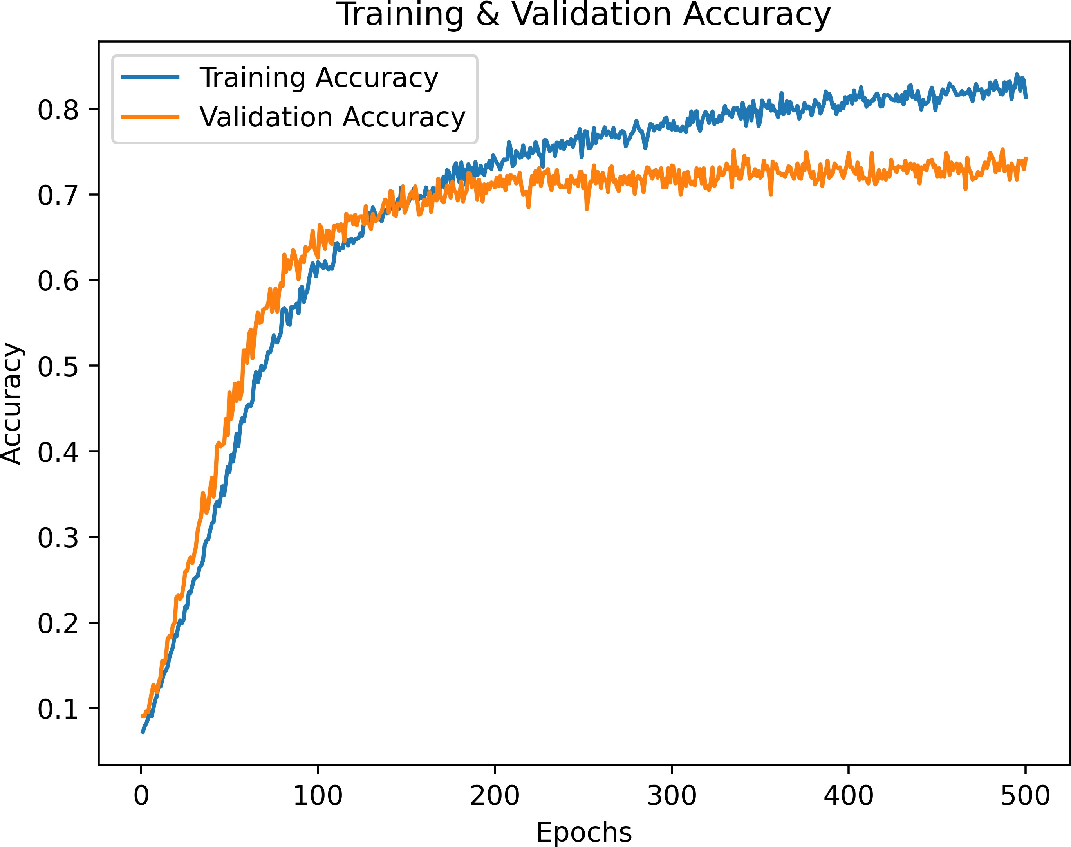
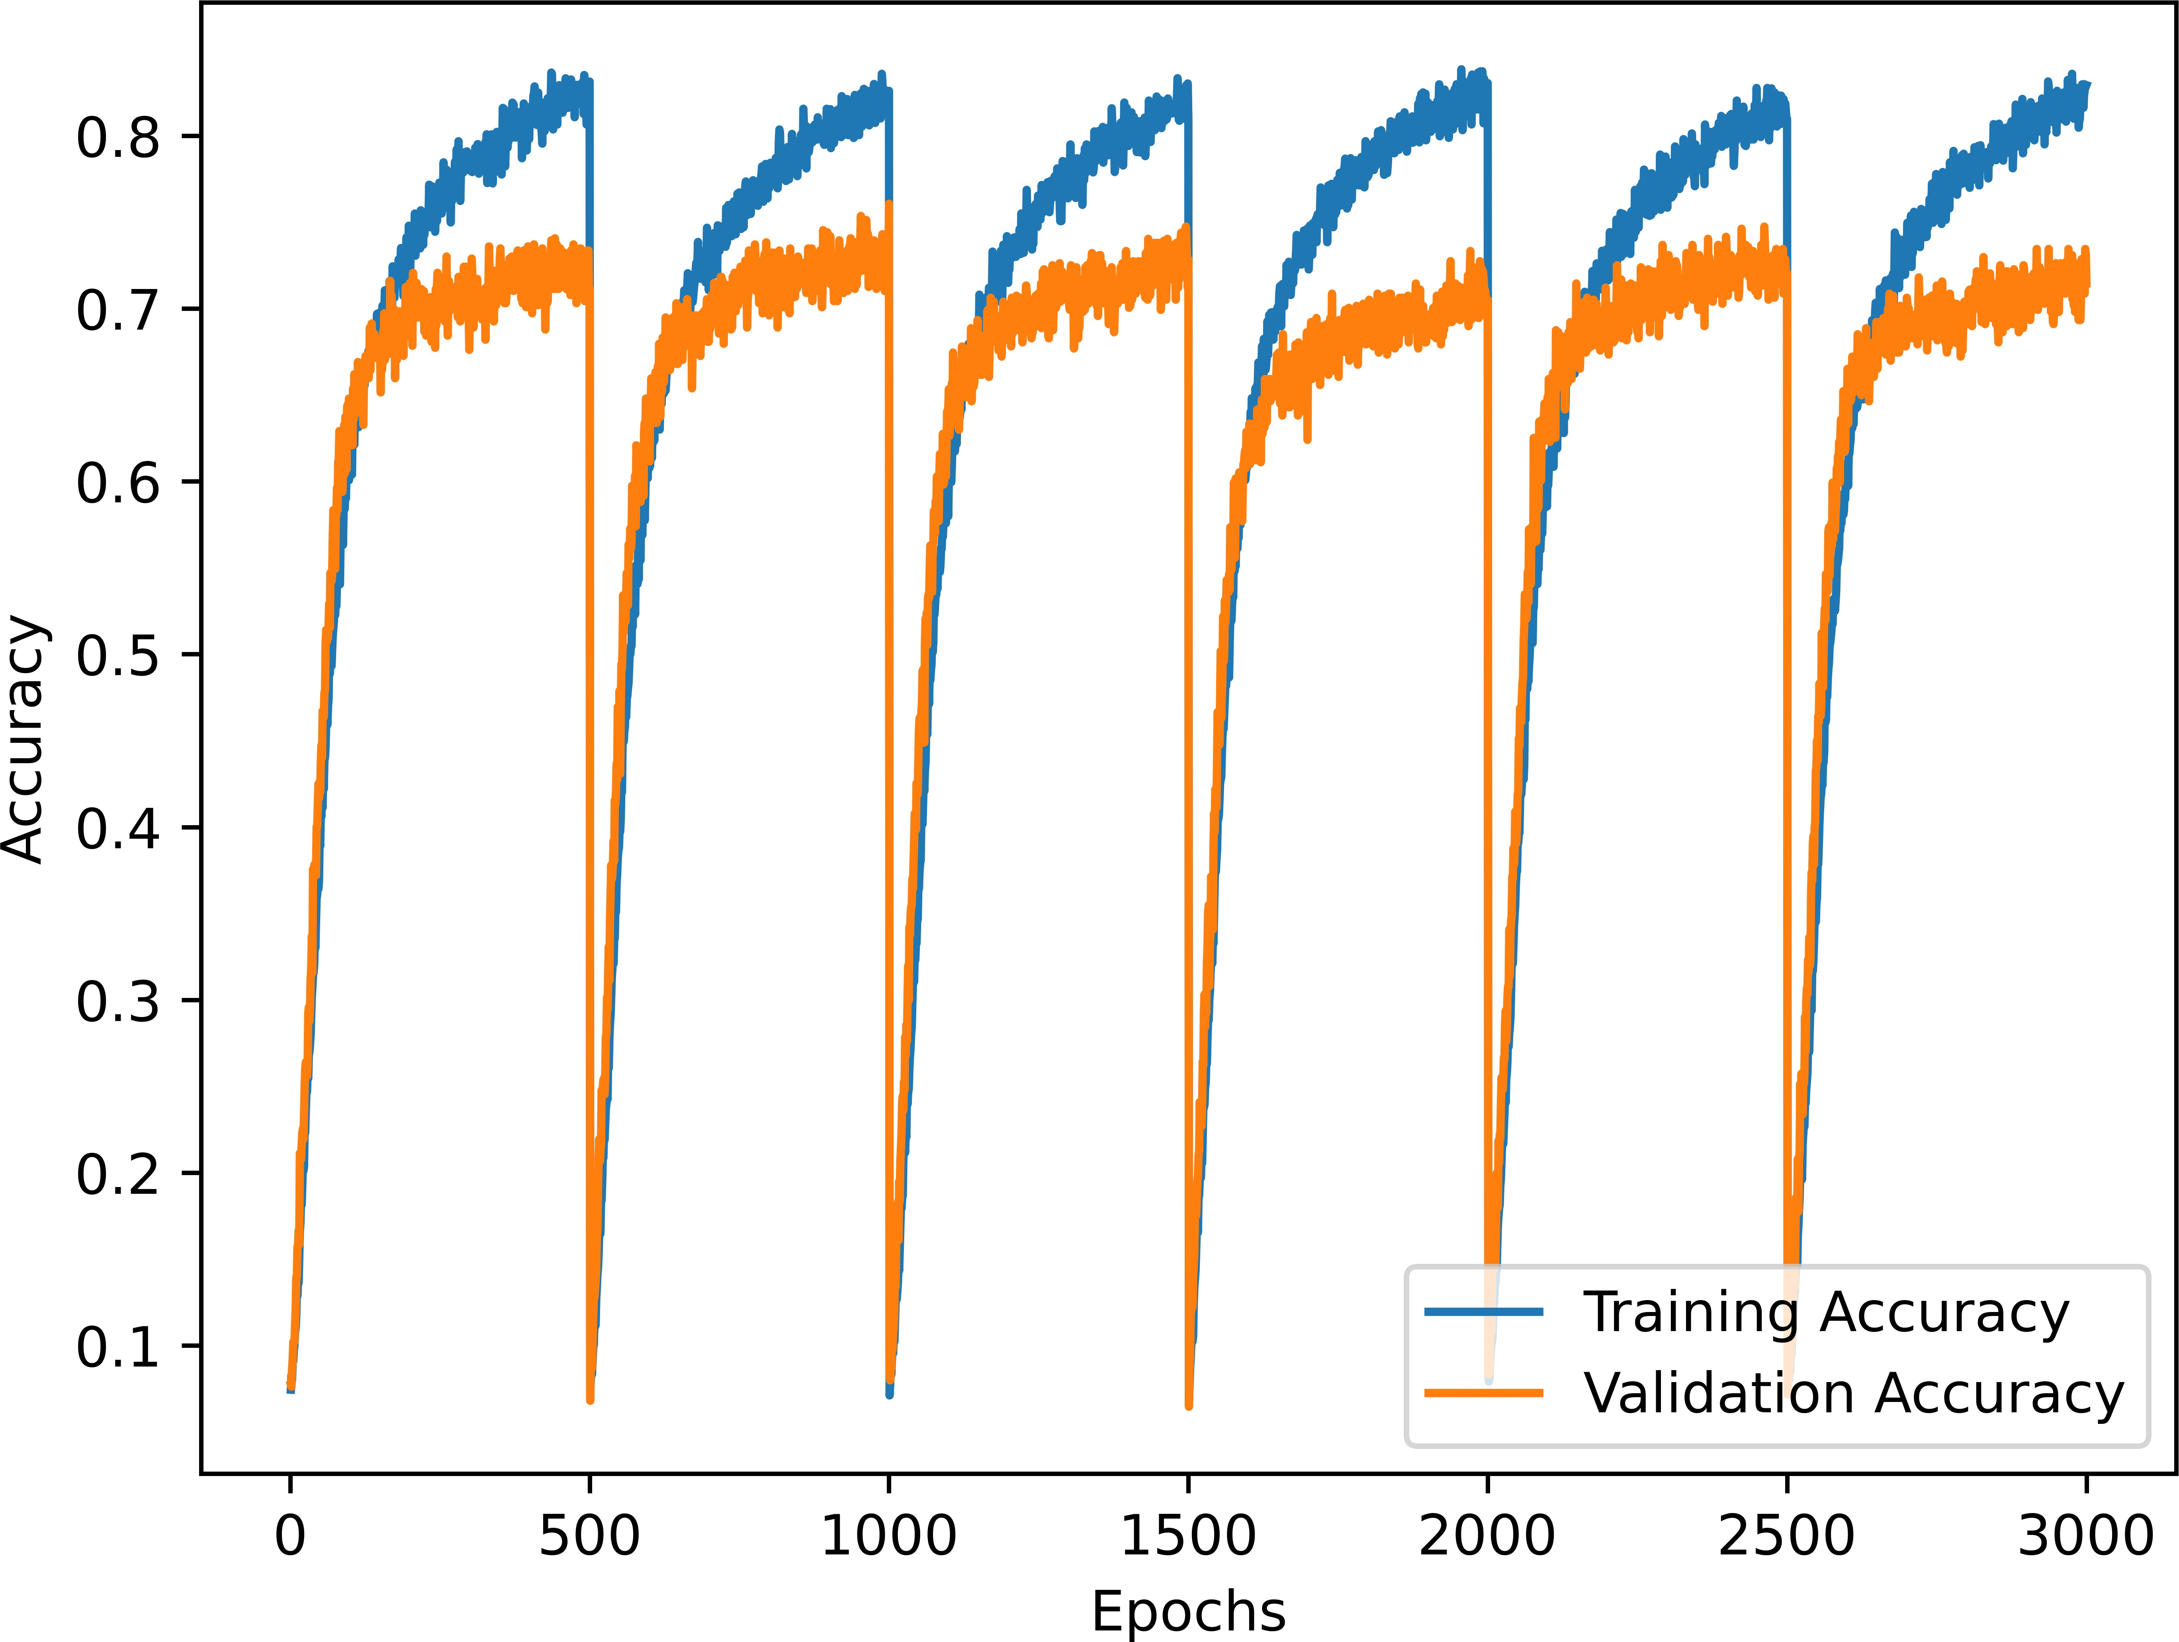
(a) Train-Validation-Test Approach (b) Stratified 6-Fold Cross-Validation

Figure 4: Epochs Vs Accuracy

for each class. The classification report offers a comprehensive evaluation of the model’s performance for each class, encompassing essential metrics such as Precision, Recall (Sensitivity), F1 Score, and Support in Table VI.
In a stratified 6-fold Cross-Validation, 5 folds were used for training and 1 for validation in each of the 500 epochs, with a batch size of 64. The best models were selected, resulting in an averaged testing accuracy of 71.97%, as detailed in Table VIII. In contrast, the Train-Validation-Test approach, allocating 70% for training, 15% for validation, and 15% for testing, achieved a testing accuracy of 73.19% using the optimal model from 500 epochs, as shown in Table IX.
Figure 5(a) displays the epochs versus accuracy graph from the train- validation-test approach, while Figure 5(b) illustrates the epochs versus ac- curacy graph using the k-Fold Cross-Validation approach. The AUC-ROC curve is a widely used tool for assessing classification performance, provid- ing insights into a model’s discrimination capacity across various threshold settings. It quantifies separability between classes, with higher AUC values

9
Table 1.6: Classfication Report

Commands | precision | recall | f1-score | support
Take Off | 0.79 | 0.63 | 0.70 | 54
Landing | 0.91 | 0.76 | 0.83 | 54
Go Up | 0.52 | 0.75 | 0.61 | 56
Go Down | 0.75 | 0.78 | 0.77 | 73
Move Forward | 0.73 | 0.72 | 0.72 | 64
Move Backward | 0.79 | 0.65 | 0.71 | 63
Turn Left | 0.63 | 0.79 | 0.70 | 71
Turn Right | 0.83 | 0.70 | 0.76 | 84
Stop Moving | 0.74 | 0.74 | 0.74 | 53
Fly Faster | 0.95 | 0.79 | 0.86 | 66
Fly Slowly | 0.66 | 0.82 | 0.73 | 38
Turn On Camera | 0.69 | 0.48 | 0.56 | 65
Turn Off Camera | 0.63 | 0.68 | 0.65 | 50
Take Photo | 0.69 | 0.86 | 0.76 | 64
Mark the Route | 0.81 | 0.83 | 0.82 | 47
micro avg | 0.73 | 0.73 | 0.73 | 902
macro avg | 0.74 | 0.73 | 0.73 | 902
weighted avg | 0.74 | 0.73 | 0.73 | 902
samples avg | 0.73 | 0.73 | 0.73 | 902

indicating improved predictive prowess [12]. In multi-class scenarios, the one- vs-all approach constructs the AUC-ROC curve, and the AUC-ROC micro- average consolidates performance evaluation across all classes, as depicted in Figures 6(a) and 6(b).

Discussion and Analysis
While achieving a 73% accuracy rate in an experiment is indeed a notable accomplishment, it is vital to scrutinize the generalizability of these results. The accuracy of such experiments is significantly influenced by the size, com- position and quality of the dataset. A key challenge we faced in this experi- ment was the presence of various environmental factors, including environmen- tal noise, diverse settings, accents, and speakers. Our dataset encompasses recordings from a range of environments, such as public spaces, classrooms, and homes, reflecting the real-world variability encountered in practical ap- plications.
The performance of our model on this specific dataset offers valuable in- sights into its capabilities within this particular context. However, to assess its real-world applicability and generalizability to a wider array of environ-

10
Table 1.7: Confusion Matrix

Commands | 1 | 2 | 3 | 4 | 5 | 6 | 7 | 8 | 9 | 10 | 11 | 12 | 13 | 14 | 15
Take Off | 34 | 2 | 10 | 2 | 0 | 0 | 2 | 1 | 0 | 0 | 0 | 0 | 0 | 3 | 0
Landing | 1 | 41 | 6 | 2 | 0 | 0 | 1 | 1 | 0 | 0 | 0 | 1 | 0 | 0 | 1
Go Up | 1 | 0 | 42 | 1 | 0 | 2 | 1 | 0 | 2 | 0 | 1 | 0 | 2 | 2 | 2
Go Down | 2 | 0 | 6 | 57 | 3 | 2 | 1 | 2 | 0 | 0 | 0 | 0 | 0 | 0 | 0
Move Forward | 0 | 1 | 4 | 7 | 46 | 3 | 1 | 0 | 2 | 0 | 0 | 0 | 0 | 0 | 0
Move Backward | 1 | 0 | 5 | 4 | 6 | 41 | 3 | 0 | 0 | 0 | 0 | 2 | 0 | 0 | 1
Turn Left | 0 | 0 | 0 | 0 | 1 | 2 | 56 | 6 | 2 | 0 | 2 | 0 | 0 | 2 | 0
Turn Right | 0 | 1 | 4 | 2 | 1 | 0 | 10 | 59 | 3 | 2 | 1 | 0 | 1 | 0 | 0
Stop Moving | 0 | 0 | 0 | 0 | 0 | 1 | 6 | 1 | 39 | 0 | 3 | 0 | 0 | 2 | 1
Fly Faster | 1 | 0 | 0 | 0 | 1 | 0 | 2 | 0 | 0 | 52 | 4 | 2 | 0 | 4 | 0
Fly Slowly | 1 | 0 | 1 | 0 | 0 | 0 | 2 | 0 | 1 | 0 | 31 | 2 | 0 | 0 | 0
Turn On Camera | 2 | 0 | 1 | 0 | 4 | 1 | 4 | 1 | 1 | 0 | 1 | 31 | 14 | 4 | 1
Turn Off Camera | 0 | 0 | 0 | 1 | 1 | 0 | 0 | 0 | 0 | 0 | 3 | 6 | 34 | 4 | 1
Take Photo | 0 | 0 | 2 | 0 | 0 | 0 | 0 | 0 | 0 | 1 | 0 | 1 | 3 | 55 | 2
Mark the Route | 0 | 0 | 0 | 0 | 0 | 0 | 0 | 0 | 3 | 0 | 1 | 0 | 0 | 4 | 39

Table 1.8: Training, Validation, & Testing accuracy in 6-folds Cross-Validation

# | Training | Validation | Testing
Round 1 | 83.12% | 71.12% | 73.61%
Round 2 | 82.59% | 76.06% | 72.17%
Round 3 | 80.86% | 72.86% | 71.06%
Round 4 | 83.04% | 70.51% | 73.95%
Round 5 | 80.95% | 72.03% | 71.06%
Round 6 | 82.92% | 71.45% | 69.96%

Table 1.9: Accuracy Report

Approach | Training | Validation | Testing
Train-Validation-Test | 81.88% | 74.06% | 73.19%
6-Fold Cross-Validation | 82.25% | 72.34% | 71.97%

ments and speaker demographics, further investigation is warranted. It is important to acknowledge that the accuracy rate achieved in this study may exhibit variations when applied to different datasets or real-world scenarios. Therefore, additional experimentation and validation using more extensive and diverse datasets are imperative steps to establish the model’s robustness and its potential for practical deployment in a broader context.

11

Conclusion and Future Works
This paper introduces a drone control system using artificial neural networks for Bengali voice commands, achieving approximately 73% accuracy with a limited dataset. Future efforts will focus on diversifying and expanding the dataset to improve accuracy. Plans include developing a system for handling multiple commands simultaneously, enhancing drone versatility. While Ben- gali was the primary focus, future research aims to explore languages like Hindi, French, Arabic, and Chinese. Addressing noise interference is a prior- ity, with upcoming research focusing on a robust noise removal mechanism for reliable real-time drone control. Anticipated improvements in data collection and noise removal techniques aim to enhance system accuracy and usability across various practical scenarios

Bibliography

- Bhattacharjee, A., Khan, A.I., Haider, M., Fattah, S., Chowdhury, D., Sarkar, M., Shahnaz, C.: Bangla voice controlled robot for rescue opera- tion in noisy environment. In: 2016 IEEE Region 10 Conference (TEN- CON), pp. 3284–3288. IEEE (2016)
- Bhuiyan, A.B., Ahmed, A., Tulon, S.R., Khan, M.R.H., Uddin, J.: A bengali voice-controlled ai robot for the physically challenged. In: In- telligent Human Computer Interaction: 12th International Conference, IHCI 2020, Daegu, South Korea, November 24–26, 2020, Proceedings, Part I 12, pp. 186–194. Springer (2021)
- Contreras, R., Ayala, A., Cruz, F.: Unmanned aerial vehicle control through domain-based automatic speech recognition. Computers 9(3), 75 (2020)
- Cross, S.S., Harrison, R.F., Kennedy, R.L.: Introduction to neural net- works. The Lancet 346(8982), 1075–1079 (1995)
- Fayjie, A.R., Ramezani, A., Oualid, D., Lee, D.J.: Voice enabled smart drone control. In: 2017 Ninth International Conference on Ubiquitous and Future Networks (ICUFN), pp. 119–121. IEEE (2017)
- Gupta, D., Hossain, E., Hossain, M.S., Andersson, K., Hossain, S.: A digital personal assistant using bangla voice command recognition and face detection. In: 2019 IEEE International Conference on Robotics, Automation, Artificial-intelligence and Internet-of-Things (RAAICON), pp. 116–121. IEEE (2019)
- Harada, S., Wobbrock, J.O., Landay, J.A.: Voicedraw: a hands-free voice-driven drawing application for people with motor impairments. In: Proceedings of the 9th international ACM SIGACCESS conference on Computers and accessibility, pp. 27–34 (2007)
- House, B., Malkin, J., Bilmes, J.: The voicebot: a voice controlled robot arm. In: Proceedings of the SIGCHI Conference on Human Factors in Computing Systems, pp. 183–192 (2009)
- Islam, J., Mubassira, M., Islam, M.R., Das, A.K.: A speech recognition system for bengali language using recurrent neural network. In: 2019

13

14 Bibliography
IEEE 4th international conference on computer and communication sys- tems (ICCCS), pp. 73–76. IEEE (2019)
- Landau, M., Van Delden, S.: A system architecture for hands-free uav drone control using intuitive voice commands. In: Proceedings of the companion of the 2017 acm/ieee international conference on human-robot interaction, pp. 181–182 (2017)
- Leechor, P., Pornpanomchai, C., Sukklay, P.: Operation of a radio- controlled car by voice commands. In: 2010 2nd International Confer- ence on Mechanical and Electronics Engineering, vol. 1, pp. V1–14. IEEE (2010)
- Narkhede, S.: Understanding AUC - ROC Curve — to- wardsdatascience.com. https://towardsdatascience.com/ understanding-auc-roc-curve-68b2303cc9c5
- Reichenspurner, H., Damiano, R.J., Mack, M., Boehm, D.H., Gulbins, H., Detter, C., Meiser, B., Ellgass, R., Reichart, B.: Use of the voice- controlled and computer-assisted surgical system zeus for endoscopic coronary artery bypass grafting. The Journal of thoracic and cardio- vascular surgery 118(1), 11–16 (1999)
- Rezoana, N., Hossain, M.S., Andersson, K.: Face mask detection in the era of covid-19: A cnn-based approach. In: Proceedings of the Third International Conference on Trends in Computational and Cognitive En- gineering: TCCE 2021, pp. 3–15. Springer (2022)
- Rogowski, A.: Scenario-based programming of voice-controlled medical robotic systems. Sensors 22(23), 9520 (2022)
- Sumon, S.A., Chowdhury, J., Debnath, S., Mohammed, N., Momen, S.: Bangla short speech commands recognition using convolutional neural networks. In: 2018 international conference on bangla speech and lan- guage processing (ICBSLP), pp. 1–6. IEEE (2018)
- Yapicioğlu, C., Dokur, Z., Ȫlmez, T.: Voice command recognition for drone control by deep neural networks on embedded system. In: 2021 8th International Conference on Electrical and Electronics Engineering (ICEEE), pp. 65–72. IEEE (2021)

