EMPHASIS EPIC analysis plan

Overall objectives
Perform epigenome-wide methylation profiling of our Indian and Gambian child cohorts using the Illumina EPIC beadchip. The analysis has three main aims; 1. to characterize nutritional intervention-associated methylation differences, 2. associate these intervention-associated differences in methylation with the measured health outcomes, 3. investigate outcome-associated methylation independent of intervention. We might also wish to explore: 4. the relationship between intervention and outcomes independent of methylation status (TBD).

Phenotypes/outcomes of interest

Anthropometry
- Weight
- Waist
- Height
- Sitting height
- Head circum.
- Mid-upper arm circum.
- Chest
- Hip

Birth measures (PMMST/MMNP)
- Weight
- Length
- Head circum.

Body composition
- BMI
- Triceps skinfold
- Bicep skinfold
- Subscapular skinfold
- Supra-iliac skinfold

Cardio-metabolic risk markers
- Systolic BP
- Diastolic BP
- Pulse

Cognitive ability
- TODO

Derived measures
- Growth
- Adiposity
- Cardio
- Cognitive

Covariates - measures to adjust for in modeling
Lab
- Full blood count
- Sentrix plate
- Sentrix slide
- Sentrix position (row + col)
- Sentrix well

General
- Gender
- Date of birth
- Intra-cohort ethnicity
- Gambian - season of conception

Intervention
- Time on intervention

Maternal
- Age
- Weight
- Mid-upper arm circum.
- Systolic BP
- Diastolic BP

Delivery
- Live birth
- Multiple birth
- Ballard score for gestational age
- Congenital abnormality
- Placental weight

Requirements
- Phenotype/outcome data
- EPIC .IDAT data files - raw intensity measurements from the EPIC arrays
- Gentoype data - processed genotypic data from the genotyping arrays (for QC purposes)
- R environment + bioconductor + meffil + sva + bumphunt + TwoSampleMR + other packages and dependencies (TBD)

Analysis overview
The analysis has 5 stages:
- Methylation data processing
- Phenotype data processing
- Intervention-methylation associations
- Methylation-phenotype associations
- Causal inference
The Indian and Gambian populations will be run in two separate, parallel analyses.

1. Methylation data processing
Overview
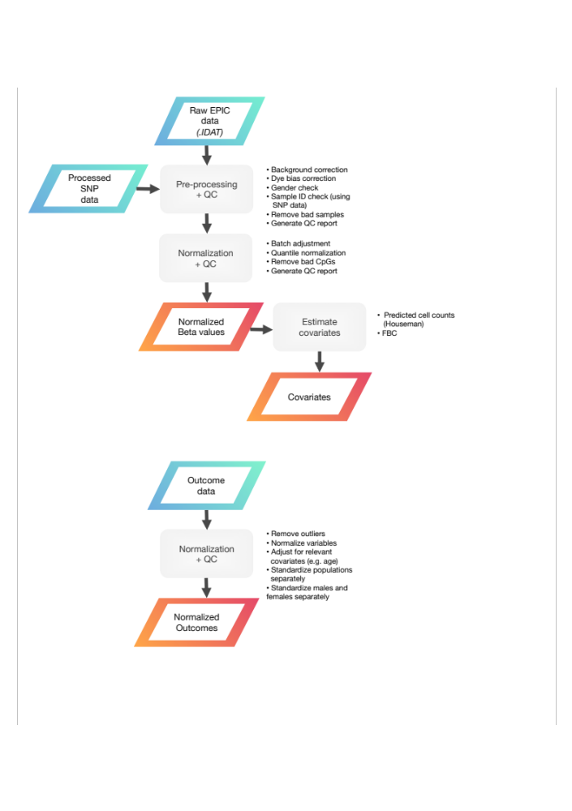

The raw intensity data from the arrays, in the form of .IDAT files, first go through a series of pre-processing and quality control steps, to ensure data integrity. Following this, normalization is applied in order to produce comparable measurements across the arrays and to adjust for technical factors. The output from this stage in the analysis will be an m x n matrix of normalized Beta values for m probes and n subjects, and an i x j matrix of covariates for i subjects and j covariates.
Pre-processing + quality control
Check data integrity
First, check that intact red and green .IDAT files are present for each sample (using MD5 checksum). Compare with sample sheet in order to make sure these have been named correctly (i.e. sample name/gender).
Quick sanity check
Produce box plots of the raw intensities, manually inspect for outlying arrays (e.g. unexpectedly low/high intensity readings across the board, high variability etc.). Check gender labeling using MDS.
Generate meffil objects
Generate sample sheet and QC objects in meffil.
Run QC procedure
The meffil QC procedure includes background correction, dye bias correction, and sex prediction.
Check for ID mismatches
Extract set of control probes from genotype array data using plink, check that IDs match using genotypes from meffil (this might be done posthoc, depending on when the data becomes available - TBD)
Generate and inspect meffil QC report
Remove outliers
Remove bad samples based on QC report. Example criteria include: gender mismatch, genotype mismatch, low bead numbers, control probe issues (dye bias, bisulfite conversion).
Generate and inspect meffil post-QC report
Normalization + quality control
Perform normalization
Use meffil to perform functional normalization (TBD). In meffil this also includes an adjustment for technical effects (using principle components), and removal of probes with low detection p-values.
Other options: 1. noob (background correction + dye-bias equalization) + functional normalization, 2. lumi (dye-bias + quantile-normalization)
Generate and inspect meffil post-normalization QC report
Estimate covariates
Batch effects
There are a few different options for batch effect adjustment. The first is the default meffil approach using principal components associated with predefined technical effects. The second is the sva approach, whereby surrogate variables for unmeasured sources of variation are constructed, or alternatively, for known sources of variation e.g. Sentrix ID, array position (using ComBat function). These two approaches both produce batch-adjusted methylation values. A third alternative, would be to follow the PACE protocol and test known batch effect at the linear modeling stage.
Blood cell counts
Use Houseman method to estimate blood cell counts from normalized Beta values. Compare with blood cell proportions from FBC data, decide which provides optimal balance between variance explained vs number of dimensions (i.e. covariates) used (TBD).

2. Phenotype data processing
Overview

Before the outcome data can be used in inferential testing, the measures of interest must be processed to remove outliers, adjusted for known confounders, and transformed to approximate normal distributions. Any missing data also needs to be flagged and a decision taken on whether to impute or remove (TBD). The output generated here will be an i x j matrix processed outcomes, for i subjects and j outcomes.
Normalization + quality control
Remove outliers
Remove extreme outliers, e.g. 5 SD outliers (TBD).
Separate into genders
Perform the normalization and adjustment on males and females separately (if known gender differences).
Normalize
Normalize data, e.g. inverse normal transformation for height and BMI.
Adjust
Adjust for known confounders, e.g. adjust height for age, adjust BMI for age (TBD).
Recombine data
Deal with missing data
Either impute or remove (TBD).
Create derived measures
Given the number of measures available to test, we may wish to derive composite or latent measures, e.g. of anthropometry, body composition, etc. (TBD).
Harmonize
Comparable phenotypic measures should be available for both cohorts, need to make sure that these measure the same things and have been processed in the same way.

3. Intervention-methylation associations
Overview
The first stage of the inferential analysis will attempt to identify methylation differences associated with nutritional intervention, in the form of differentially methylated positions (DMPs) and differentially methylated regions (DMRs). We may also look at variably methylated positions (VMPs) and variably methylated regions (VMRs) (TBD).
Strategy
Identification of DMPs
Utilize a linear modeling strategy identify differentially methylated signals associated with the intervention (TBD). A number of approaches can be used, including robust linear regression (as in PACE), standard linear regression (as in GoDMC), linear regression with mixed effects etc. Important considerations here include: whether we want to use Beta or M values for methylation, whether we want to pre-adjust methylation values for batch effects or include these in the model, and which variables we wish to include in the model. A model selection approach could be used (similar to PACE) where a number of different possible models are tested, and the one providing the best fit or closest to the expected null distribution of p-values chosen.

An example of a complete model that might be used:
beta ~ age + gender + cell counts + 1 | batch + time on intervention + intervention
Here, methylation beta values are regressed on age, gender, cell counts, batch (as a random effect), time on intervention and intervention (the variable of interest). Various reduced forms of the above model might be fitted, and the results compared to select the optimal one.
Perform permutation testing to estimate significance of associations. This involves the repeated random shuffling of phenotype labels to generate a null distribution, which can then be used to assess the significance of the observed findings (TBD).
TODO
Identification of DMRs
Region-level analysis is performed using the bumphunting method (TBD).
TODO

4. Methylation-phenotype associations
Overview
In the second stage of the inferential analysis, significant (replicated?) intervention-associated differentially methylated loci from the previous stage of the analysis will be tested for association with the outcomes.
Strategy
DMPs
For each probe and for all the outcomes, the following linear model is used (TBD):
methylation (batch adjusted Beta-values) ~ age + gender + cell counts + time on intervention + outcome
As before, permutation testing is then used to determine significance of the associations (TBD).
DMRs
Region-level analysis is performed using the bumphunting method (TBD).

5. Causal inference

Two step, two sample Mendelian randomization performed using the TwoSampleMR package from MRCIEU (TBD).

Overview
TODO
Strategy
TODO

