**EXPLORING WORLD’S TOP YOUTUBE CHANNELS**

Introduction

YouTube is an online video sharing and social media platform headquartered in San Bruno, California, United States. Accessible worldwide, it was launched on February 14, 2005, by Steve Chen, Chad Hurley, and Jawed Karim.

In October 2006, YouTube was bought by Google for $1.65 billion. Google's ownership of YouTube expanded the site's business model, expanding from generating revenue from advertisements alone to offering paid content such as movies and exclusive content produced by YouTube

**Founding and initial growth (2005–2006)**

[](https://en.wikipedia.org/wiki/File:Youtube_founders.jpg)From left to right: [Chad Hurley](https://en.wikipedia.org/wiki/Chad_Hurley), [Steve Chen](https://en.wikipedia.org/wiki/Steve_Chen), and [Jawed Karim](https://en.wikipedia.org/wiki/Jawed_Karim), the founders of YouTube

Empathy Map

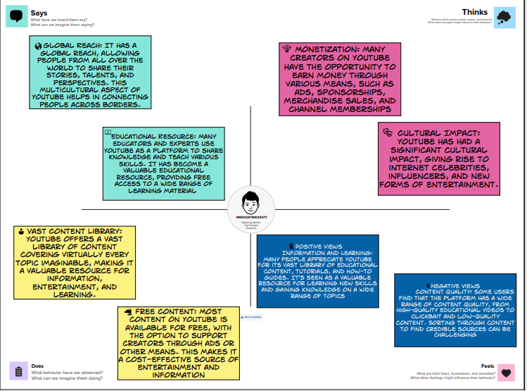

Brainstroming Map

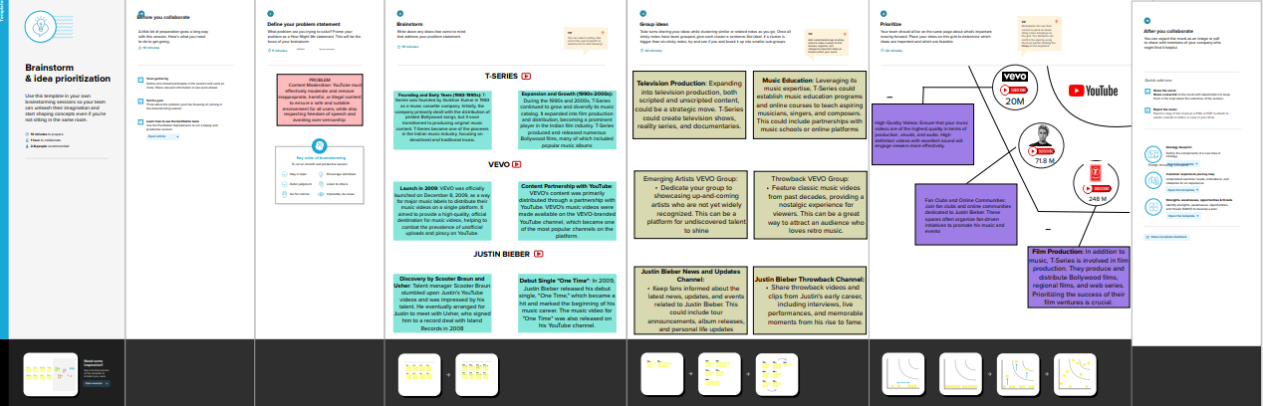

**RESULT**



Advantages

Wide Audience Reach: YouTube is one of the largest and most popular video-sharing platforms in the world, with billions of users. This makes it an excellent platform for reaching a global audience.

Free to Use: YouTube is free for both content creators and viewers. Anyone can upload and watch videos without any cost.

**Disadvantages**

Copyright Issues: Content creators often face copyright claims and takedown requests, which can result in demonetization or removal of videos. This can be frustrating and hinder creative freedom

**APPLICATION**

Entertainment: YouTube is a major source of entertainment for viewers around the world. It offers a vast library of music videos, movie trailers, TV show clips, and comedy sketches

Education: YouTube is a valuable platform for educational content. Many educators, institutions, and experts upload tutorials, lectures, and how-to videos on a wide range of topics

**CONCLUSION**

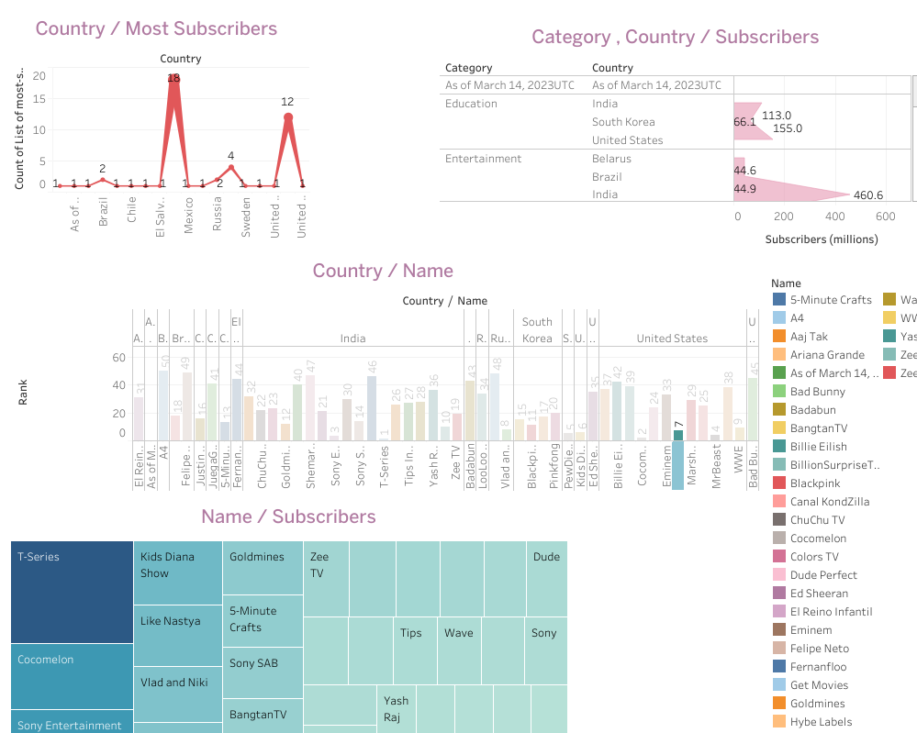

**FUTURE SCOPE**

**Increased Competition**: YouTube faces stiff competition from other video-sharing platforms like TikTok, Instagram, and emerging services. To maintain its position, YouTube will need to innovate and adapt

**Original Content**: YouTube has been investing in original content through YouTube Originals. This trend may continue with more high-quality, exclusive content to attract subscribers

**APPENDIX**

**PUBLIC.TABLEAU.COM :**

https://public.tableau.com/app/profile/ramji.e/vizzes