SOM-ET6ULL

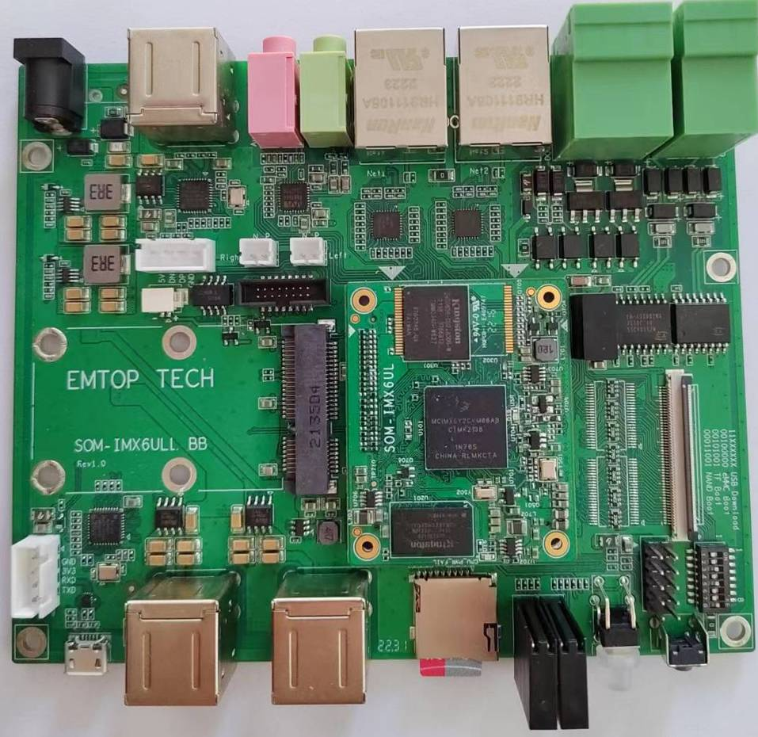
SOM-ET6ULL + SOM-ET6ULL-BB

User Manual

Version: 0.1
2022-10-28
Revision History：
Version | Date | Description
0.1 | 2022-10-28 | Initial Release

Table of Contents
1. Product Overview 6
1.1 Introduction 6
1.2 Resource Download 6
1.3 Hardware Features 6
1.4 Mechanical Dimension 6
2. Linux Operation System 7
2.1 Software Resources 7
2.1.1 Location of Resources 7
2.1.2 BSP 8
2.2 Structure of Embedded Linux System 8
2.3 Building Development Environment 9
2.3.1 Installing Cross Compilation Tools 9
2.3.2 Set Cross Compile Environment 10
2.4 Preparing the Source Code 10
2.5 Compilation 10
2.6 Linux System Customization 12
2.6.1 Replace U-BOOT LOGO 12
2.6.2 Replace Kernel LOGO 12
2.6.3 Setting Configuration Menu 13
2.6.4 Menu Options 13
2.6.5 Compile Kernel 14
2.7 Introduction to Drivers 15
2.7.1 SD/MMC 16
2.7.2 Audio In/Out 17
2.8 Driver development 18
2.8.1 GPIO_LEDs Driver 18
2.8.2 Pinmux Configuration Guide 22
2.9 System Update 25
2.9.1 Update of TF Card System Image 25
2.9.2 Update eMMC 26
2.10 Test and Demonstration 27
2.10.1 RTC 27
2.10.2 TIMEZONE SETTING 27
2.10.3 USB OTG 28
2.10.4 USB HOST 28
2.10.5 NETWORK 31
2.10.6 LCD 32
2.10.7 TOUCH PANEL 33
2.10.8 BACKLIGHT 33
2.10.9 WM8960 AUDIO 33
2.10.10 UART 34
2.10.11 RS485 35
2.10.12 CAN BUS 35
2.10.13 POWER BUTTON 36
2.10.14 LED 37
2.10.15 GPIO 38
2.10.16 DI/DO 39
2.10.17 PCIe 40
2.10.18 SPI FLASH 40
2.10.19 TFCard 40
2.10.20 eMMC 40
2.10.21 Unique ID 40
2.10.22 WIFI 40
2.10.23 BLUETOOTH 43
2.10.24 4G 44
2.10.25 SUSPEND and RESUME 45

Product Overview

Introduction

Resource Download

Hardware Features

Mechanical Dimension

Linux Operation System
This chapter will give you a general map of the Linux software resources contained in the DVD-ROM provided along with the product, as well as detailed introduction to the process of Linux system development, drivers development, system update, functionality tests and application development examples.
Note：
- It is recommended to learn Ubuntu Linux installation and embedded Linux development technology in advance.

Software Resources
The DVR-ROM provided along with the board contains demos, application examples, Linux source code and tools, helping you develop Linux applications and systems easily and quickly.

Location of Resources
You can find software resources such as programs and codes contained in the DVD-ROM according to the information showed in the table below;
Categories | Location
Applications
Source Code | CD\Source\u-boot-imx-2016.03.git.tar.xz
Source Code | CD\Source\linux-imx-4.1.15.git.tar.xz
Tools | CD\Tools\
Precompiled Images | CD\Image

BSP
The following table lists types and formats of the files contained in BSP;
Names |  | Note | Formats
BOOTLOADER | U-BOOT | MMC/SD | Source Code
BOOTLOADER | U-BOOT | FAT | Source Code
BOOTLOADER | U-BOOT | NET | Source Code
KERNEL | LINUX-4.1.15 | Support ROM/CRAM/EXT4/FAT/NFS various of file system | Source Code
DEVICE DRIVER | SERIAL | Serials driver | Source Code
DEVICE DRIVER | RTC | Hardware RTC driver | Source Code
DEVICE DRIVER | NET | 10/100M Ethernet driver | Source Code
DEVICE DRIVER | CAN | CAN bus driver | Source Code
DEVICE DRIVER | SPI | SPI driver | Source Code
DEVICE DRIVER | QSPI FLASH | QSPI Flash driver | Source Code
DEVICE DRIVER | I2C | I2C driver | Source Code
DEVICE DRIVER | LCD | TFT LCD driver | Source Code
DEVICE DRIVER | TOUCH SCREEN | I2C and TSC Resistive touch panel driver | Source Code
DEVICE DRIVER | MMC/SD | MMC/SD controller driver | Source Code
DEVICE DRIVER | USB OTG | USB OTG driver | Source Code
DEVICE DRIVER | USB HOST | USB HOST driver | Source Code
DEVICE DRIVER | AUDIO | WM8960 Audio driver(supports recording & playback) | Source Code
DEVICE DRIVER | BUTTON | GPIO button driver | Source Code
DEVICE DRIVER | LED | LED driver | Source Code
DEVICE DRIVER | BUZZER | Buzzer driver | Source Code
DEVICE DRIVER | WIFI | USB WIFI dongle driver | Source Code
ROOTFS | YOCTO | X11 with Qt5.6 | Image

Structure of Embedded Linux System
SOM-ET6ULL board is shipped with Linux-4.1.15 system in eMMC by default. This system consists of bootloader, kernel and rootfs. The following table shows the structure of embedded Linux system.
eMMC/SD
Partition | MBR | FAT | EXT4
Image | Bootloader | DTB, Kernel | Yocto Rootfs

- Bootloader is a program generated by u-boot compiling; its file name is u-boot_sd.imx or u-boot_emmc.imx.
- The kernel used in this document is Linux 4.1.15 and has been customized according to the hardware design.
- Rootfs stores open-source system Yocto with EXT4 format.

Building Development Environment
Before developing software, user has to establish a Linux cross development environment on PC. This section will take Ubuntu20.04 operating system as an example to describe how to establish a cross development environment.
It is strongly recommended to install necessary software packages for a newly installed Ubuntu through the following commands.
- sudo apt-get update; sudo apt-get install -y build-essential git xz-utils ncurses-dev autoconf libtool automake texinfo bison flex libc6:i386 libncurses5:i386 libstdc++6:i386

Note：
- Each instruction has been put a bullets “•” before it to prevent confusion caused by the long instructions that occupy more than one line in the context.
- Please note the SPACES within each instruction; Missing of any SPACE will cause failure when executing instructions.

Installing Cross Compilation Tools
We provide 2 cross-compilers under Tools directory:
① fsl-imx-x11-gcc-5.3.0.tar.xz
The item ① is mainly used to compile u-boot and kernel.
- sudo tar -xvf fsl-imx-x11-gcc-5.3.0.tar.xz -C /opt
It will extract and install under /opt directory, keep the default settings.

Set Cross Compile Environment
Run the following commands to set the source code building environment:
- source /opt/fsl-imx-x11/4.1.15-2.0.0/environment-setup-cortexa7hf-neon-poky-linux-gnueabi
- export ARCH=arm
- export CROSS_COMPILE=arm-poky-linux-gnueabi-

Note：
- The instructions can be added in the .bashrc file located at the user directory, so that the addition of environment variables will be loaded automatically when the system is booting up;
- If you want to check the path, please use the instruction printenv PATH

Preparing the Source Code
Please refer to chapter <1.2 Resource Download> to get the development materials, You can get source code under Source directory.
- tar -xvf u-boot-imx-2016.03.git.tar.xz
- tar -xvf linux-imx-4.1.15.git.tar.xz
Then we can get the source code directory u-boot-imx-2016.03 and linux-imx-4.1.15.

Compilation
- Compiling Bootloader
Run the following commands to compile bootloader:
- cd u-boot-imx-2016.03
- git checkout .
- vi make.sh
source /opt/fsl-imx-x11/4.1.15-2.0.0/environment-setup-cortexa7hf-neon-poky-linux-gnueabi
export ARCH=arm
export CROSS_COMPILE=arm-poky-linux-gnueabi-

DESTDIR="/dev/shm/"
DESTDIR: point to a directory to store the target image.
Change DESTDIR value to make it point to your target directory according to your local environment.
- ./make.sh
After all the instructions are executed, you can find the booting images named u-boot_emmc.imx and u-boot_sd.imx under DESTDIR directory.
- Compiling Kernel
Execute the following instructions to compile kernel:
- cd linux-imx-4.1.15
- git checkout .
- vi make.sh
source /opt/fsl-imx-x11/4.1.15-2.0.0/environment-setup-cortexa7hf-neon-poky-linux-gnueabi
export ARCH=arm
export CROSS_COMPILE=arm-poky-linux-gnueabi-

DESTDIR="/dev/shm"
DESTDIR: point to a directory to store the target image.
Please modify DESTDIR according to your local environment.
- make ARCH=arm distclean
- ./make.sh modules
If it’s successfully built, you can find kernel images named .dtb files, zImage and lib/modules/4.1.15 under DESTDIR directory.
Note：
- The command ./make.sh, without parameter, only build dtbs and zImage; but ./make.sh modules will build dtbs, zImage and driver modules.

Linux System Customization
In order to satisfy different requirements of customers, designers commonly need to make some custom modification based on the default configuration of Linux kernel. This chapter will introduce the process of system customization with some examples.

Replace U-BOOT LOGO
  - Prepare a picture; any format which can be recognized by Photoshop is OK.
  - Run Photoshop program, open and load the picture.
  - Resize to make it suitable for your display screen size.
  - Save as RGB888 BMP named logo.bmp.
  - Copy logo.bmp into the FAT partition of the bootable SDCard.

  - Install the bootable SDCard on arm board, power up and check the LOGO displayed on screen.
Note：
- Modify uEnv.txt to choose the correct panel type. If the setting is wrong, the LCD will not display normally.

Replace Kernel LOGO
  - Prepare a picture suitable for your display screen size, named my_logo.png for example.
  - Install some necessary programs under Ubuntu.
- sudo apt-get install netpbm gimp
  - Run command under Ubuntu desktop terminal:
- pngtopnm my_logo.png > linuxlogo.pnm
- pnmquant 224 linuxlogo.pnm > linuxlogo224.pnm
- pnmtoplainpnm linuxlogo224.pnm > logo_linux_clut224.ppm
  - Update Linux source code.
- cp -f logo_linux_clut224.ppm <YOUR_PATH>/linux-imx-4.1.15/drivers/video/logo/logo_linux_clut224.ppm
  - Re-build the kernel.
- make ARCH=arm distclean
- ./make.sh
Update the target file zImage to the board, reboot and check the boot logo on the display screen.

Setting Configuration Menu
A default configuration file is provided under kernel source codes:
linux-imx-4.1.15/arch/arm/configs/emtop-som-et6ull_defconfig
Please execute the following commands to enter the configuration menu:
- cd linux-imx-4.1.15
- make ARCH=arm emtop-som-et6ull_defconfig
- make ARCH=arm menuconfig

Note：
- If an error occurs when command 'make ARCH=arm menuconfig' is executed, you might need to install 'ncurse' in the Ubuntu system, ‘ncurses’ is a character graphic library required to generate configuration menu. Please enter the following instruction to install the library:
sudo apt-get install libncurses5-dev

Menu Options
Configure options according to customization requirements after entering configuration menu, for example, access Device Drivers > Input device support > Touchscreens > Goodix I2C touchscreen as shown below:
-> Device Drivers
-> Input device support
-> Touchscreens
-> Goodix I2C touchscreen
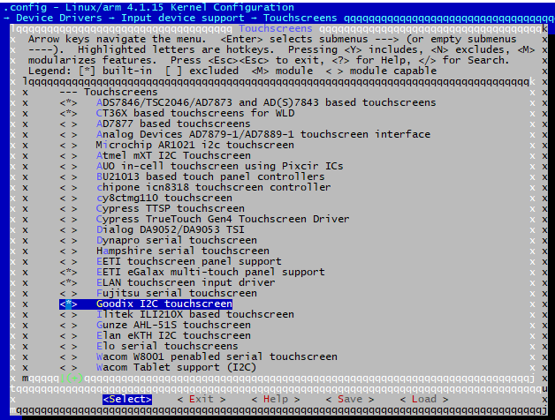
Set Goodix I2C touchscreen to <*>, exit and save changes.

Compile Kernel
Please execute the following instructions to recompile kernel:
- ./make.sh
The script will NOT overwrite the configuration modified by menuconfig. It means that the current setting you modified is effective in your target kernel image.
If you want to restore to the default configuration, please delete the file .config and run ./make.sh.

Introduction to Drivers
The table below shows the access path to find all the drivers:
Category | Name | Description | Location
Bootloader | u-boot | MMC/SD | drivers/mmc/fsl_esdhc_imx.c
Bootloader | u-boot | FAT | fs/
Bootloader | u-boot | NET | drivers/net/fec_mxc.c
Kernel | Linux-4.1 | Support ROM/CRAM/EXT4/FAT/NFS | fs/
Devices | SERIAL | Serial driver | drivers/tty/serial/imx.c
Devices | RTC | Hardware RTC driver | drivers/rtc/rtc-rx8010.c
Devices | NET | 10/100M/1000M Ethernet driver | drivers/net/ethernet/freescale/fec_main.c
Devices | CAN | CAN bus driver | drivers/net/can/spi/mcp251x.c
Devices | SPI | SPI driver | drivers/spi/spi-imx.c
Devices | SPI FLASH | SPI Flash driver | drivers/mtd/spi-nor/spi-nor.c
Devices | LCD | MIPI-DSI driver | drivers/video/fbdev/mxsfb.c
Devices | TOUCH SCREEN | I2C Resistive touch panel driver | drivers/input/touchscreen/ili210x.c
Devices | MMC/SD | MMC/SD controller dirver | drivers/mmc/host/sdhci-esdhc-imx.c
Devices | USB | USB controller dirver | drivers/usb/host/ehci-mxc.c
Devices | AUDIO | Audio driver (supporting recording/playback) | sound/soc/fsl/imx-wm8960.c
Devices | BUTTON | GPIO button driver | drivers/input/keyboard/snvs_pwrkey.c
Devices | LED | LED driver | drivers/leds/leds-gpio.c
Devices | BUZZER | Buzzer driver | drivers/leds/leds-gpio.c
Devices | WIFI | USB WiFi dongle driver | drivers/net/wireless/realtek
Devices | BLUETOOTH | USB Bluetooth driver | drivers/bluetooth/btusb.c
Devices | PCIE | 4G module driver | drivers/usb/serial/usb_wwan.c

SD/MMC
App，System call
Kernel (Generic disk handler，File system)
BUFFER_CACHE
MMC_QUEUE
MMC/SD CORE
MMC_BLOCK
MMC/SD CONTROLLER DRIVER
HARDWARE(MMC/SD/SDIO CONTROLLER)
User
Kernel
Hardware
SD/MMC drivers in Linux are mainly consisted of SD/MMC core, mmc_block, mmc_queue and SD/MMC driver：
- SD/MMC core realizes the codes unrelated to structure in the SD/MMC card operation;
- mmc_block realizes driver structure when SD/MMC card is used as a block device;
- mmc_queue realizes management of request queue;
- SD/MMC driver realizes specific controller driver.
Drivers and relevant documents:
linux-imx-4.1.15/drivers/mmc/
linux-imx-4.1.15/drivers/mmc/host/sdhci-esdhc-imx.c

Audio In/Out
Native ALSA application
ALSA KERNEL API
ALSA SOC CORE
CODEC
DRIVER
PLATFORM
DRIVER
HARDWARE
User
Kernel
Hardware
ALSA LIBRARY
PCM

CONTROL
MACHINE
DRIVER
ASoC embedded audio system basically consists of three components:
- Codec driver: The codec driver is platform independent and contains audio controls, audio interface capabilities, codec dapm definition and codec IO functions.
- Platform driver: It contains the audio dma engine and audio interface drivers (e.g. I2S, AC97, PCM) of that platform.
- Machine driver: The machine driver handles any machine specific controls and audio events i.e. turning on an amp at start of playback.
Drivers and relevant documents:
linux-imx-4.1.15/sound/soc/fsl
linux-imx-4.1.15/sound/soc/fsl/imx-wm8960.c

Driver development

GPIO_LEDs Driver
1）Device Definition
linux-imx-4.1.15/arch/arm/boot/dts/emtop-som-et6ull-emmc.dts
Configure GPIO3.16 as system runing status indicator, blinking as heartbeat.
leds {
compatible = "gpio-leds";
pinctrl-names = "default";
pinctrl-0 = <& pinctrl_leds>;

sys {
label = "sys";
gpios = <&gpio5 9 GPIO_ACTIVE_LOW>;
linux,default-trigger = "heartbeat";
};
2）GPIO pinmux Configuration
linux-imx-4.1.15/arch/arm/boot/dts/emtop-som-et6ull-emmc.dts
Configure SNVS_TAMPER as GPIO5_IO09 function:
&iomuxc_snvs {
...
imx6ul-evk {
pinctrl_snvs_leds: snvs_leds {
fsl,pins = <
MX6UL_PAD_SNVS_TAMPER9__GPIO5_IO09 0xb0
>;
};
};
};

/ {
...
leds {
compatible = "gpio-leds";
pinctrl-names = "default";
pinctrl-0 = <&pinctrl_snvs_leds >;
status = "okay";

sys {
label = "sys";
gpios = <&gpio5 9 GPIO_ACTIVE_LOW>;
linux,default-trigger = "heartbeat";
};
};
...
};
3）Driver Design
linux-imx-4.1.15/drivers/leds/leds-gpio.c
- Call platform_driver_register to register gpio_leds driver
static struct platform_driver gpio_led_driver = {
.probe = gpio_led_probe,
.shutdown = gpio_led_shutdown,
.driver = {
.name = "leds-gpio",
.of_match_table = of_gpio_leds_match,
},
};

module_platform_driver(gpio_led_driver);

MODULE_AUTHOR("Raphael Assenat <raph@8d.com>, Trent Piepho <tpiepho@freescale.com>");
MODULE_DESCRIPTION("GPIO LED driver");
MODULE_LICENSE("GPL");
MODULE_ALIAS("platform:leds-gpio");
- Apply for gpio and call led_classdev_register to led_classdev drivr.
static int gpio_led_probe(struct platform_device *pdev)
{
…
priv->num_leds = pdata->num_leds;
for (i = 0; i < priv->num_leds; i++) {
const struct gpio_led *template = &pdata->leds[i];
struct gpio_led_data *led_dat = &priv->leds[i];

if (template->gpiod)
led_dat->gpiod = template->gpiod;
else
led_dat->gpiod =
gpio_led_get_gpiod(&pdev->dev,
i, template);
if (IS_ERR(led_dat->gpiod)) {
dev_info(&pdev->dev, "Skipping unavailable LED gpio %d (%s)\n",
template->gpio, template->name);
continue;
}

ret = create_gpio_led(template, led_dat,
&pdev->dev, NULL,
pdata->gpio_blink_set);
if (ret < 0)
return ret;
}
} else {
priv = gpio_leds_create(pdev);
if (IS_ERR(priv))
return PTR_ERR(priv);
}

platform_set_drvdata(pdev, priv);

return 0;
}

static int create_gpio_led(const struct gpio_led *template,
struct gpio_led_data *led_dat, struct device *parent,
struct fwnode_handle *fwnode, gpio_blink_set_t blink_set)
{
struct led_init_data init_data = {};
int ret, state;

led_dat->cdev.default_trigger = template->default_trigger;
led_dat->can_sleep = gpiod_cansleep(led_dat->gpiod);
if (!led_dat->can_sleep)
led_dat->cdev.brightness_set = gpio_led_set;
else
led_dat->cdev.brightness_set_blocking = gpio_led_set_blocking;
led_dat->blinking = 0;
if (blink_set) {
led_dat->platform_gpio_blink_set = blink_set;
led_dat->cdev.blink_set = gpio_blink_set;
}
if (template->default_state == LEDS_GPIO_DEFSTATE_KEEP) {
state = gpiod_get_value_cansleep(led_dat->gpiod);
if (state < 0)
return state;
} else {
state = (template->default_state == LEDS_GPIO_DEFSTATE_ON);
}
led_dat->cdev.brightness = state ? LED_FULL : LED_OFF;
if (!template->retain_state_suspended)
led_dat->cdev.flags |= LED_CORE_SUSPENDRESUME;
if (template->panic_indicator)
led_dat->cdev.flags |= LED_PANIC_INDICATOR;
if (template->retain_state_shutdown)
led_dat->cdev.flags |= LED_RETAIN_AT_SHUTDOWN;

ret = gpiod_direction_output(led_dat->gpiod, state);
if (ret < 0)
return ret;

if (template->name) {
led_dat->cdev.name = template->name;
ret = devm_led_classdev_register(parent, &led_dat->cdev);
} else {
init_data.fwnode = fwnode;
ret = devm_led_classdev_register_ext(parent, &led_dat->cdev,
&init_data);
}
return ret;
}
- Users may access the file named brightness under /sys/class/leds/sys/brightness, and call gpio_led_set to configure LED status
static void gpio_led_set(struct led_classdev *led_cdev,
enum led_brightness value)
{
…
gpiod_set_value(led_dat->gpiod, level);
}

Pinmux Configuration Guide
Let's take the pad GPIO1_IO00 as an example to explain the pinmux setting steps.
- vi arch/arm/boot/dts/emtop-som-et6ull-emmc.dts
&iomuxc {
pinctrl_dummy: dummygrp {
fsl,pins = <
MX6UL_PAD_GPIO1_IO00__GPIO1_IO00 0xb0
>;
};
};
The macro MX6UL_PAD_SNVS_TAMPER9__GPIO5_IO09 is defined in arch/arm/boot/dts/imx6ul-pinfunc.h:
#define MX6UL_PAD_GPIO1_IO00__GPIO1_IO00 0x005C 0x02E8 0x0000 0x5 0x0
The value means:
mux_reg | conf_reg | input_reg | mux_mode | input_val
0x005C | 0x02E8 | 0x0000 | 0x5 | 0x0
Usually we don't need to care about the value it defines, the only thing we need to do is to select the target function from the head file.
#define MX6UL_PAD_GPIO1_IO00__I2C2_SCL 0x005C 0x02E8 0x05AC 0x0 0x1
#define MX6UL_PAD_GPIO1_IO00__GPT1_CAPTURE1 0x005C 0x02E8 0x058C 0x1 0x0
#define MX6UL_PAD_GPIO1_IO00__ANATOP_OTG1_ID 0x005C 0x02E8 0x04B8 0x2 0x0
#define MX6UL_PAD_GPIO1_IO00__ENET1_REF_CLK1 0x005C 0x02E8 0x0574 0x3 0x0
#define MX6UL_PAD_GPIO1_IO00__MQS_RIGHT 0x005C 0x02E8 0x0000 0x4 0x0
#define MX6UL_PAD_GPIO1_IO00__GPIO1_IO00 0x005C 0x02E8 0x0000 0x5 0x0
#define MX6UL_PAD_GPIO1_IO00__ENET1_1588_EVENT0_IN 0x005C 0x02E8 0x0000 0x6 0x0
#define MX6UL_PAD_GPIO1_IO00__SRC_SYSTEM_RESET 0x005C 0x02E8 0x0000 0x7 0x0
#define MX6UL_PAD_GPIO1_IO00__WDOG3_WDOG_B 0x005C 0x02E8 0x0000 0x8 0x0
You can refer to the below description in <iMX6ULLRM.pdf>
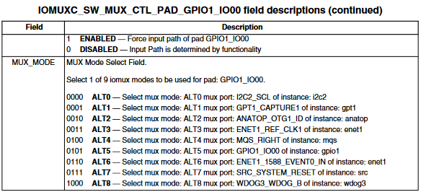

&iomuxc {
pinctrl_dummy: dummygrp {
fsl,pins = <
MX6UL_PAD_GPIO1_IO00__GPIO1_IO00 <PADCtrlValue>
>;
};
};
The PADCtrlValue is described in <iMX6ULLRM.pdf>
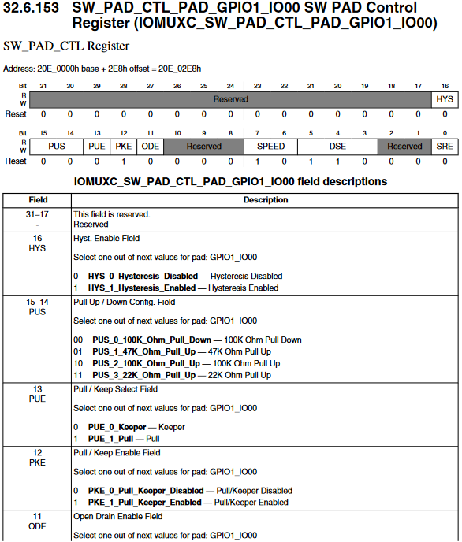
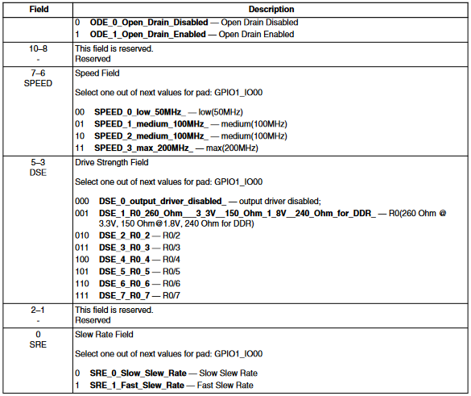
Sometimes, the PADCtrlValue can be set like 0x800xxxxx or 0x400xxxxx,
0x800xxxxx means no need to set its value, keep it as it was;
0x400xxxxx means to set SION bit, force input path of the pad.

System Update
SOM-ET6ULL board can boot up from both TF card and eMMC, this section briefly introduce the process of system update on TF card and eMMC.

Update of TF Card System Image
  - Make A Bootable TF Card
- Get the system image from Image directory, named as imx-image-xxx.img.xz, unxz it and create a raw image imx-image-xxx.img.
- If you work under Windows system, please run Tools/win32diskimager to write the imx-image-xxx.img into TF Card. If you work under Linux system, please use dd command to write it into TF Card.

- Update U-Boot
If you’ve made some changes to the u-boot source code, and want to update it into TFCard, please run the below command:
- dd if=<YOUR_PATH>/flash.bin of=/dev/sdx bs=1K seek=33 conv=notrunc
Note:
- /dev/sdx is the TFCard device node recognized under Ubuntu system.
- Update Kernel
If you have modified the kernel source code, please update the dtb and Image under Partition 1 [FAT32] of the TF Card. That partition can be recognized by Windows or Linux.
- Update Rootfs
Because EXT4 isn’t accessible Under Windows, please mount the partition 2 of TF Card under Ubuntu, change the target file and umount the Card.
Note:
- Set the Boot Select Switch[SW2 on the base board] to "TF Boot", which is marked on the silk layer of the base board.

Update eMMC
Make a bootable TFCard and boot up the system, run below command to update eMMC:
- root@arm:~# system-update.sh
&iomuxc {
pinctrl_dummy: dummygrp {
fsl,pins = <
MX6UL_PAD_GPIO1_IO00__GPIO1_IO00 <PADCtrlValue>
>;
};
};

There are some updating messages show on terminal, and sys LED will blink.
After it's done, remove the TFCard, set the Boot Select Switch[SW2 on the base board] to "eMMC Boot" and reboot the board, it should boot from eMMC and enter into Linux prompt.

Test and Demonstration
This section will run some tests on the peripheral devices.
POWER: 12V DC
Debug Port: UART1, 115200 1N8.

RTC
There is a RTC chip RX8010 on board, so the integrated RTC is disabled by default. So there is only one RTC accessible under system.
Let's set the current time to 2022-10-10 10:12,
- root@arm:~# date -s "2022-10-10 10:12"; hwclock -w
Reboot the board, and check the hardware RTC time with below command:
- root@arm:~# hwclock

TIMEZONE SETTING
Set Beijing Time for example:
- root@arm:~# echo "Asia/Shanghai" > /etc/timezone
- root@arm:~# ln -sf /usr/share/zoneinfo/Asia/Shanghai /etc/localtime
- root@arm:~# sync
Note:
- If NXP Yocto image doesn't contain zoneinfo, copy /usr/share/zoneinfo under Ubuntu system to the board, and retry the above commands.

USB OTG
(To be continued)

USB HOST

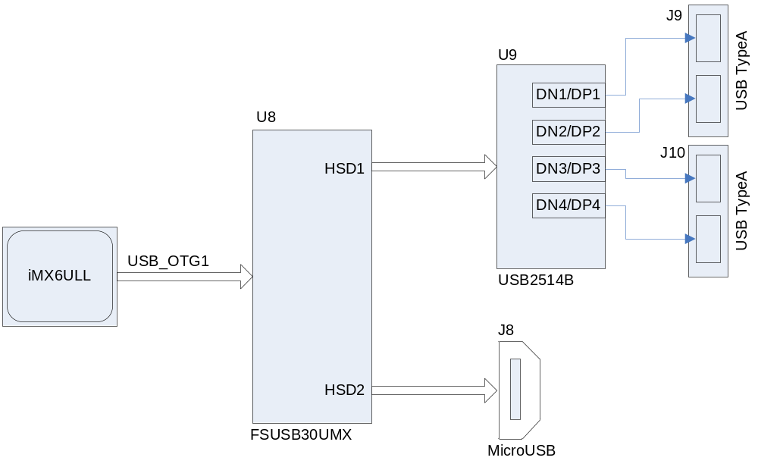

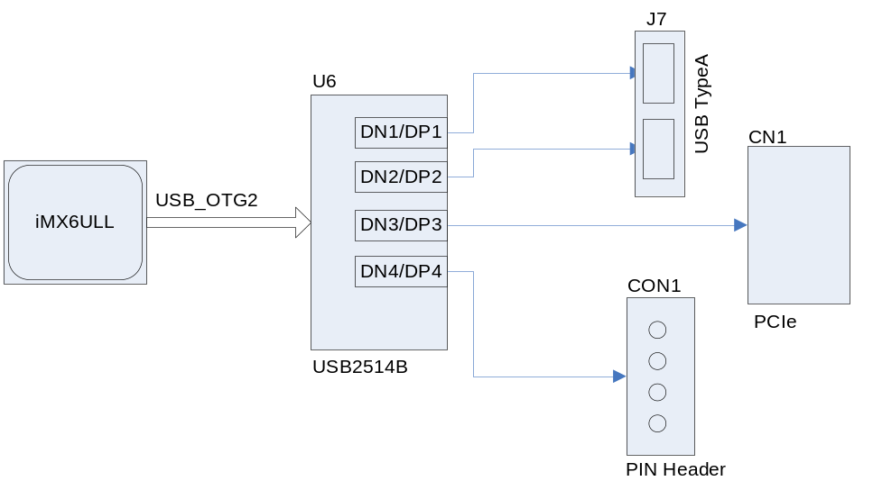
There are 6 USB host channels [USB typeA slot] extended on the base board. Install an USB disk on these slots, check message below:
[ 272.082860] usb-storage 2-1.1:1.0: USB Mass Storage device detected
[ 272.098248] scsi host0: usb-storage 2-1.1:1.0
[ 273.104255] scsi 0:0:0:0: Direct-Access SanDisk Flash Memory 0.1 PQ: 0 ANSI: 2
[ 273.130158] sd 0:0:0:0: [sda] 2001888 512-byte logical blocks: (1.02 GB/977 MiB)
[ 273.143825] sd 0:0:0:0: [sda] Write Protect is off
[ 273.147410] sd 0:0:0:0: [sda] Mode Sense: 03 00 00 00
[ 273.148611] sd 0:0:0:0: [sda] No Caching mode page found
[ 273.155755] sd 0:0:0:0: [sda] Assuming drive cache: write through
[ 273.176207] sda: sda1
[ 273.199625] sd 0:0:0:0: [sda] Attached SCSI removable disk
[ 273.783449] FAT-fs (sda1): Volume was not properly unmounted. Some data may be corrupt. Please run fsck.
- root@arm:~# mount
......
/dev/sda1 on /run/media/sda1 type vfat (rw,relatime,gid=6,fmask=0007,dmask=0007,allow_utime=0020,codepage=437,iocharset=iso8859-1,shortname=mixed,errors=remount-ro)
The USB disk is automatically mounted under /run/media/sda1 by udev.

Reset USB Device
USB_OTG1 | /sys/devices/platform/soc/2100000.aips-bus/2184000.usb
USB_OTG2 | /sys/devices/platform/soc/2100000.aips-bus/2184200.usb
If you install the USB disk in slot J7 which is extended through USB_OTG2, search the device name 'sda' under the system device path of USB_OTG2:
- root@arm:~# egrep -nir sda /sys/devices/platform/soc/2100000.aips-bus/2184200.usb 2>/dev/null
/sys/devices/platform/soc/2100000.aips-bus/2184200.usb/ci_hdrc.1/usb2/2-1/2-1.1/2-1.1:1.0/host3/target3:0:0/3:0:0:0/block/sda/sda1/uevent:3:DEVNAME=sda1
/sys/devices/platform/soc/2100000.aips-bus/2184200.usb/ci_hdrc.1/usb2/2-1/2-1.1/2-1.1:1.0/host3/target3:0:0/3:0:0:0/block/sda/uevent:3:DEVNAME=sda

- root@arm:~# node=/sys/devices/platform/soc/2100000.aips-bus/2184200.usb/ci_hdrc.1/usb2/2-1/authorized; echo 0 > $node;sleep 1;echo 1 > $node
usb 2-1.1: USB disconnect, device number 7
FAT-fs (sda1): FAT read failed (blocknr 32)
hub 2-1:1.0: USB hub found
hub 2-1:1.0: 4 ports detected
usb 2-1: authorized to connect
usb 2-1.1: new high-speed USB device number 8 using ci_hdrc
usb-storage 2-1.1:1.0: USB Mass Storage device detected
scsi host5: usb-storage 2-1.1:1.0
scsi 5:0:0:0: Direct-Access SanDisk Flash Memory 0.1 PQ: 0 ANSI: 2
sd 5:0:0:0: [sda] 2001888 512-byte logical blocks: (1.02 GB/977 MiB)
sd 5:0:0:0: [sda] Write Protect is off
sd 5:0:0:0: [sda] No Caching mode page found
sd 5:0:0:0: [sda] Assuming drive cache: write through
sda: sda1
sd 5:0:0:0: [sda] Attached SCSI removable disk
FAT-fs (sda1): Volume was not properly unmounted. Some data may be corrupt. Please run fsck.
It resets successfully.

Of course, you can reset the USB bus, then all devices connected via the bus will reset at the same time.
- root@arm:~# node=/sys/devices/platform/soc/2100000.aips-bus/2184200.usb/ci_hdrc.1/usb2/authorized; echo 0 > $node;sleep 1;echo 1 > $node
usb 2-1: USB disconnect, device number 2
usb 2-1.1: USB disconnect, device number 10
usb 2-1.2: USB disconnect, device number 9
FAT-fs (sda1): FAT read failed (blocknr 32)
hub 2-0:1.0: USB hub found
hub 2-0:1.0: 1 port detected
usb usb2: authorized to connect
usb 2-1: new high-speed USB device number 11 using ci_hdrc
hub 2-1:1.0: USB hub found
hub 2-1:1.0: 4 ports detected
usb 2-1.1: new high-speed USB device number 12 using ci_hdrc
usb-storage 2-1.1:1.0: USB Mass Storage device detected
scsi host9: usb-storage 2-1.1:1.0
usb 2-1.2: new high-speed USB device number 13 using ci_hdrc
Bluetooth: hci0: rtl: examining hci_ver=06 hci_rev=000b lmp_ver=06 lmp_subver=8723
Bluetooth: hci0: rtl: loading rtl_bt/rtl8723b_fw.bin
Bluetooth: hci0: rom_version status=0 version=1
scsi 9:0:0:0: Direct-Access SanDisk Flash Memory 0.1 PQ: 0 ANSI: 2
sd 9:0:0:0: [sda] 2001888 512-byte logical blocks: (1.02 GB/977 MiB)
sd 9:0:0:0: [sda] Write Protect is off
sd 9:0:0:0: [sda] No Caching mode page found
sd 9:0:0:0: [sda] Assuming drive cache: write through
sda: sda1
sd 9:0:0:0: [sda] Attached SCSI removable disk
FAT-fs (sda1): Volume was not properly unmounted. Some data may be corrupt. Please run fsck.
IPv6: ADDRCONF(NETDEV_UP): wlan0: link is not ready
You can see that the USB disk and USB WiFi/BT module reset.

NETWORK
There are two 100Mbps network chip KSZ8081 on board.
- root@arm:~# ifconfig eth0
eth0 Link encap:Ethernet HWaddr 3a:f7:82:bc:fa:0a
inet addr:192.168.1.81 Bcast:192.168.1.255 Mask:255.255.255.0
inet6 addr: fe80::38f7:82ff:febc:fa0a/64 Scope:Link
UP BROADCAST RUNNING MULTICAST MTU:1500 Metric:1
RX packets:11 errors:0 dropped:4 overruns:0 frame:0
TX packets:42 errors:0 dropped:0 overruns:0 carrier:0
collisions:0 txqueuelen:1000
RX bytes:1555 (1.5 KiB) TX bytes:7192 (7.0 KiB)
DHCP feature is enabled as default; the board can request a valid IP address from DHCP server in local network.
- root@arm:~# ping -I eth0 www.baidu.com
PING www.a.shifen.com (14.215.177.38) from 192.168.1.81 eth0: 56(84) bytes of data.
64 bytes from www.baidu.com (183.232.231.174): icmp_seq=1 ttl=56 time=12.1 ms
64 bytes from www.baidu.com (183.232.231.174): icmp_seq=2 ttl=56 time=12.2 ms
64 bytes from www.baidu.com (183.232.231.174): icmp_seq=3 ttl=56 time=12.1 ms
64 bytes from www.baidu.com (183.232.231.174): icmp_seq=4 ttl=56 time=12.5 ms
^C
--- www.a.shifen.com ping statistics ---
4 packets transmitted, 4 received, 0% packet loss, time 3004ms
rtt min/avg/max/mdev = 7.058/7.447/7.771/0.319 ms

Do the same operations to eth1.

LCD
Devices already tested:
MODEL | RESOLUTION | TOUCH | LINUX DTB
EMTOP LCD8000-43T | 480x272 | TSADC | emtop-som-et6ull-480x272.dtb
EMTOP LCD8000-70T | 800x480 | TSADC | emtop-som-et6ull-emmc.dtb
LCD70-CTP | 1024x600 | FT5X06 | emtop-som-et6ull-1024x600.dtb
Modify uEnv.txt in SD/eMMC FAT32 partition:
panel=480x272
......
Change the value of 'panel' to the corresponding resolution of your target device, save and reboot the arm board.
U-Boot 2016.03-00286-ga57b13b942-dirty (Oct 26 2022 - 16:26:11 +0800)

CPU: Freescale i.MX6ULL rev1.1 69 MHz (running at 396 MHz)
CPU: Industrial temperature grade (-40C to 105C) at 35C
Reset cause: POR
Board: EMTOP SOM-ET6ULL
I2C: ready
DRAM: 512 MiB
MMC: FSL_SDHC: 0, FSL_SDHC: 1
*** Warning - bad CRC, using default environment
reading uEnv.txt
263 bytes read in 9 ms (28.3 KiB/s)
PANEL: 1024x600 in uEnv.txt
Display: 1024x600 (1024x600)
Video: 1024x600x24
reading logo.bmp
In: serial
Out: serial
Err: serial
switch to partitions #0, OK

TOUCH PANEL
The X11 system will run input calibrating program during its first booting. If you want to recalibrate the touch panel, please try command below:
- root@arm:~# rm -f /etc/pointercal.xinput; reboot
Next boot up, the system will display the calibration dialog.

BACKLIGHT
Get the max brightness level:
- root@arm:~# cat /sys/class/backlight/backlight/max_brightness
255
So the valid brightness level range is 0 ~ 255:
- root@arm:~# for i in `seq 50 250`; do echo $i > /sys/class/backlight/backlight/brightness; echo $i;sleep 0.1;done

WM8960 AUDIO
Playback:
- root@arm:~# amixer sset Headphone 110,110
- root@arm:~# aplay /usr/share/sounds/alsa/*.wav
Record:
- root@arm:~# amixer sset Headphone 127,127
- root@arm:~# amixer cset name='Playback Volume' 255,255
- root@arm:~# amixer cset name='Capture Volume' 0,31
- root@arm:~# amixer sset 'Left Output Mixer PCM' on
- root@arm:~# amixer sset 'Right Output Mixer PCM' on
- root@arm:~# amixer cset name='ADC PCM Capture Volume' 220,220
- root@arm:~# amixer cset name='Left Boost Mixer LINPUT1 Switch' off
- root@arm:~# amixer cset name='Left Boost Mixer LINPUT2 Switch' off
- root@arm:~# amixer cset name='Left Input Boost Mixer LINPUT2 Volume' 0
- root@arm:~# amixer cset name='Left Input Boost Mixer LINPUT3 Volume' 0
- root@arm:~# amixer cset name='Right Input Boost Mixer RINPUT1 Volume' 1
- root@arm:~# amixer cset name='ADC Data Output Select' 'Left Data = Right ADC; Right Data = Right ADC'

- root@arm:~# arecord -r 44100 -f S16_LE -c 2 -d 10 record.wav
Wait several seconds, Ctrl+C to terminate arecord program. Now, let's play it to check:
- root@arm:~# aplay record.wav

UART

DEVICE NODE | HARDWARE | USAGE
/dev/ttymxc0 | UART1 | DEBUG PORT
/dev/ttymxc1 | UART2 | RS485
/dev/ttymxc2 | UART3 | 3-WIRE @ J22
/dev/ttymxc4 | UART5 | 5-WIRE @ J23
Connect TXD and RXD of UART3 to run external loopback test:
- root@arm:~# /test/app/com -d /dev/ttymxc2
SEND: 1234567890
RECV: 1234567890
SEND: 1234567890
RECV: 1234567890

Connect TXD and RXD, RTS and CTS of UART5 to run external loopback test with flow control:
- root@arm:~# /test/app/com -f -d /dev/ttymxc4
SEND: 1234567890
RECV: 1234567890
SEND: 1234567890
RECV: 1234567890

RS485
Connect a RS485 device, or connect 2 boards directly:
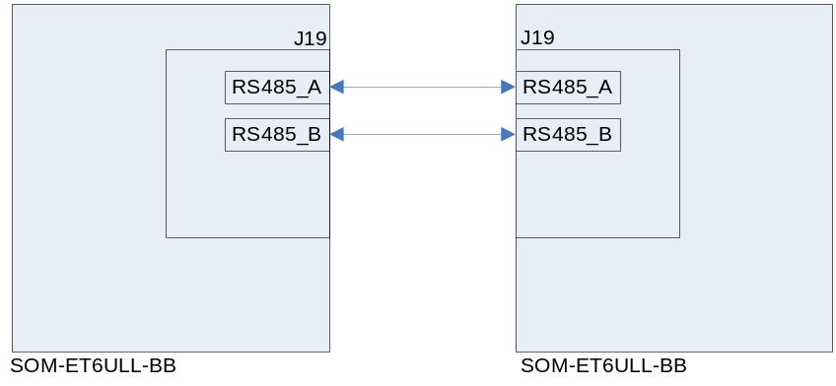
Run below command on both of the boards:
- root@arm:~# /test/app/com -d /dev/ttymxc1 -m rs485
SEND: 1234567890
RECV: 1234567890
SEND: 1234567890
RECV: 1234567890

CAN BUS
Connect 2 boards directly:
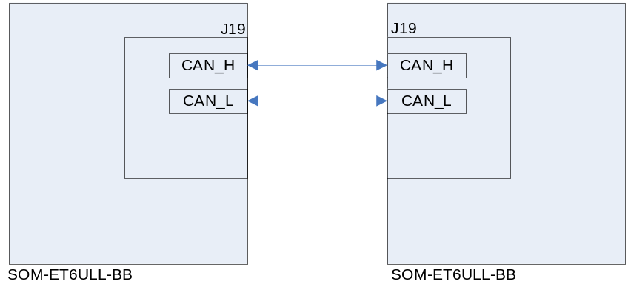
- root@arm:~# ifconfig can0
can0 Link encap:UNSPEC HWaddr 00-00-00-00-00-00-00-00-00-00-00-00-00-00-0
NOARP MTU:16 Metric:1
RX packets:0 errors:0 dropped:0 overruns:0 frame:0
TX packets:0 errors:0 dropped:0 overruns:0 carrier:0
collisions:0 txqueuelen:10
RX bytes:0 (0.0 B) TX bytes:0 (0.0 B)
Configure parameters [both side]:
- root@arm:~# ifconfig can0 down
- root@arm:~# ip link set can0 type can bitrate 125000
- root@arm:~# ip link set can0 type can restart-ms 100
- root@arm:~# ifconfig can0 up
Start to listen on one board:
- root@arm:~# candump can0 &
Send package on the other board:
- root@arm:~# cansend can0 "5A1#1122334455667788"
For more information, please refer to project can-utils.

POWER BUTTON
- root@arm:~# evtest /dev/input/event0
Input driver version is 1.0.1
Input device ID: bus 0x19 vendor 0x0 product 0x0 version 0x0
Input device name: "30370000.snvs:snvs-powerkey"
Supported events:
Event type 0 (EV_SYN)
Event type 1 (EV_KEY)
Event code 116 (KEY_POWER)
Properties:
Testing ... (interrupt to exit)
Event: time 1591238021.080788, type 1 (EV_KEY), code 116 (KEY_POWER), value 1
Event: time 1591238021.080788, -------------- SYN_REPORT ------------
Event: time 1591238021.144791, type 1 (EV_KEY), code 116 (KEY_POWER), value 0
Event: time 1591238021.144791, -------------- SYN_REPORT ------------
Event: time 1591238021.544772, type 1 (EV_KEY), code 116 (KEY_POWER), value 1
Event: time 1591238021.544772, -------------- SYN_REPORT ------------
Event: time 1591238021.608776, type 1 (EV_KEY), code 116 (KEY_POWER), value 0

LED
There are 2 LED array on the base board:
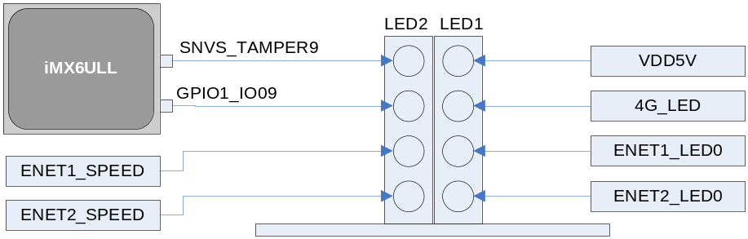
But there are only 2 leds we can control by software:
HARDWARE SIGNAL | DEVICE NODE | USAGE
SNVS_TAMPER9 | /sys/class/leds/sys | System Status Heartbeat
GPIO1_IO09 | /sys/class/leds/led2 | User Control
Let's test GPIO1_IO09:
- root@arm:~# echo none > /sys/class/leds/led2/trigger
- root@arm:~# while test 1; do echo 1 > /sys/class/leds/led2/brightness;sleep 1;echo 0 > /sys/class/leds/led2/brightness;sleep 1;done
Your can see the corresponding LED blinking with 2Hz frequency.

GPIO
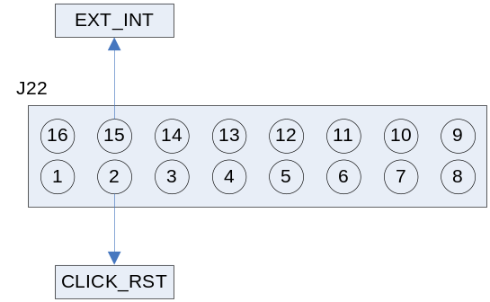
SIGNAL | GPIO | GPIO ID [GPIOn_IOm: 32*(n-1)+m]
EXT_INT | GPIO1_IO10 | 10
CLICK_RST | GPIO5_IO03 | 131
Initialization:
- root@arm:~# echo 10 > /sys/class/gpio/export
Set output:
- root@arm:~# echo out > /sys/class/gpio/gpio10/direction
Output high:
- root@arm:~# echo 1 > /sys/class/gpio/gpio10/value
Output Low:
- root@arm:~# echo 0 > /sys/class/gpio/gpio10/value

Or set input:
- root@arm:~# echo in > /sys/class/gpio/gpio10/direction
Read input:
- root@arm:~# cat /sys/class/gpio/gpio10/value

DI/DO
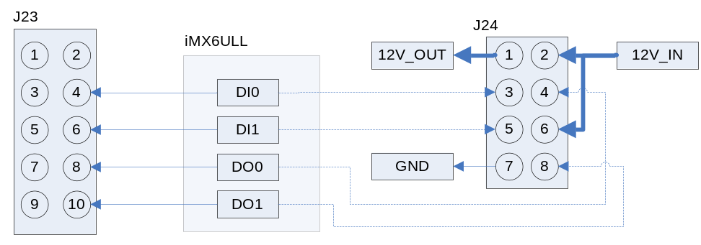

SIGNAL | GPIO | GPIO ID [GPIOn_IOm: 32*(n-1)+m]
DO0 | GPIO4_IO17 | 113
DO1 | GPIO4_IO19 | 115
DI0 | GPIO4_IO18 | 114
DI1 | GPIO4_IO20 | 116
Initialization:
- root@arm:~# for id in 113 114 115 116; do echo $id > /sys/class/gpio/export 2>/dev/null; done
- root@arm:~# for id in 113 115; do echo out > /sys/class/gpio/gpio$id/direction; done
- root@arm:~# for id in 114 116; do echo in > /sys/class/gpio/gpio$id/direction; done
Connect DO0 and DI0 in J23
Let DO0 output a signal sequence and read value from DI0:
- root@arm:~# while test 1; do for i in 0 1; do echo $i > /sys/class/gpio/gpio113/value; sleep 1; cat /sys/class/gpio/gpio114/value; done; done
1
0
1
0
1
0
1
0
1
0

PCIe
Devices already tested:
MODEL | DESCRIPTION
QUECTEL EC20 | 4G module
About QUECTEL EC20 test, please refer to chapter <4G>.

SPI FLASH
The SPIFlash chip is NOT placed on the core board.

TFCard
When booting from eMMC, the TFCard will be recognized as a removable disk device.

eMMC
eMMC is mainly used for storing system image, needless to test it manually.

Unique ID
- root@arm:~# cat /sys/fsl_otp/HW_OCOTP_CFG[0-1]
0x5d5b3595
0x73a11d7

WIFI
Devices already tested:
MODEL | DESCRIPTION
REALTEK RTL8723B | USB WiFi/Bluetooth module

- root@arm:~# ifconfig wlan0 up
If it reports message: SIOCSIFFLAGS: Operation not possible due to RF-kill, please try below command:
- root@arm:~# rfkill unblock all
Now, we can control it manually.
- root@arm:~# ifconfig wlan0 up; iw wlan0 scan
BSS f0:b0:52:70:e2:58(on wlan0)
last seen: 214.948s [boottime]
TSF: 0 usec (0d, 00:00:00)
freq: 2447
beacon interval: 100 TUs
capability: ESS Privacy ShortPreamble ShortSlotTime (0x0431)
signal: -70.00 dBm
last seen: 15156 ms ago
SSID: Embest_Guest
Supported rates: 1.0* 2.0* 5.5* 11.0*
DS Parameter set: channel 8
Country: US Environment: Indoor/Outdoor
Channels [1 - 11] @ 36 dBm
ERP: <no flags>
Extended supported rates: 6.0 9.0 12.0 18.0 24.0 36.0 48.0 54.0
HT capabilities:
Capabilities: 0x1ad
RX LDPC
HT20
SM Power Save disabled
RX HT20 SGI
TX STBC
RX STBC 1-stream
Max AMSDU length: 3839 bytes
No DSSS/CCK HT40
... ...
- root@arm:~# killall wpa_supplicant udhcpc
- root@arm:~# wpa_passphrase WIFI_AP 12345678 >> /etc/wpa_supplicant.conf
File: /etc/wpa_supplicant.conf
ctrl_interface=/var/run/wpa_supplicant
ctrl_interface_group=0
update_config=1

network={
key_mgmt=NONE
}
network={
ssid="WIFI_AP"
#psk="12345678"
psk=6d561555aad99b23640971509aa7594494e3e9cf4b2eece2cb5781d21f351db1
}

- root@arm:~# wpa_supplicant -B -iwlan0 -c/etc/wpa_supplicant.conf
If everything works fine, it will get IP after several seconds.
- root@arm:~# ifconfig wlan0
wlan0 Link encap:Ethernet HWaddr d0:c5:d3:d0:9c:33
inet addr:192.168.1.101 Bcast:192.168.1.255 Mask:255.255.255.0
inet6 addr: fe80::d2c5:d3ff:fed0:9c33/64 Scope:Link
UP BROADCAST RUNNING MULTICAST DYNAMIC MTU:1500 Metric:1
RX packets:60 errors:0 dropped:0 overruns:0 frame:0
TX packets:94 errors:0 dropped:0 overruns:0 carrier:0
collisions:0 txqueuelen:1000
RX bytes:7380 (7.2 KiB) TX bytes:12849 (12.5 KiB)
Now you can do some connection test.

- root@arm:~# sync; reboot
Next boot, turn it on:
- root@arm:~# rfkill unblock all; ifup wlan0; udhcpc -i wlan0
Wait a while for getting IP:
- root@arm:~# ifconfig wlan0
wlan0 Link encap:Ethernet HWaddr d0:c5:d3:d0:9c:33
inet addr:192.168.1.101 Bcast:192.168.1.255 Mask:255.255.255.0
inet6 addr: fe80::d2c5:d3ff:fed0:9c33/64 Scope:Link
UP BROADCAST RUNNING MULTICAST DYNAMIC MTU:1500 Metric:1
RX packets:60 errors:0 dropped:0 overruns:0 frame:0
TX packets:94 errors:0 dropped:0 overruns:0 carrier:0
collisions:0 txqueuelen:1000
RX bytes:7380 (7.2 KiB) TX bytes:12849 (12.5 KiB)

BLUETOOTH
Devices already tested:
MODEL | DESCRIPTION
REALTEK RTL8723B | USB WiFi/Bluetooth module
CSR8510 A10 | USB Bluetooth 4.0 module

- root@arm:~# hciconfig -a
hci0: Type: BR/EDR Bus: USB
BD Address: 30:7B:C9:44:2F:F7 ACL MTU: 820:8 SCO MTU: 255:16
DOWN
RX bytes:1225 acl:0 sco:0 events:122 errors:0
TX bytes:23230 acl:0 sco:0 commands:122 errors:0
Features: 0xff 0xff 0xff 0xfe 0xdb 0xff 0x7b 0x87
Packet type: DM1 DM3 DM5 DH1 DH3 DH5 HV1 HV2 HV3
Link policy: RSWITCH HOLD SNIFF PARK
Link mode: SLAVE ACCEPT
- root@arm:~# rfkill unblock all
- root@arm:~# /etc/init.d/bluetooth restart
- root@arm:~# bluetoothctl
Agent registered
[bluetooth]# power on
Changing power on succeeded
[bluetooth]# scan on
Discovery started
[CHG] Controller D0:C5:D3:F9:60:06 Discovering: yes
[NEW] Device 63:EB:0D:5C:3D:F6 63-EB-0D-5C-3D-F6
[NEW] Device 51:02:9F:66:76:EC 51-02-9F-66-76-EC
[NEW] Device 78:C5:28:67:88:03 78-C5-28-67-88-03
[NEW] Device 7B:A2:1E:1D:15:60 7B-A2-1E-1D-15-60
.. ..
[bluetooth]# scan off
Please search bluetoothctl usage on web for more information.

4G
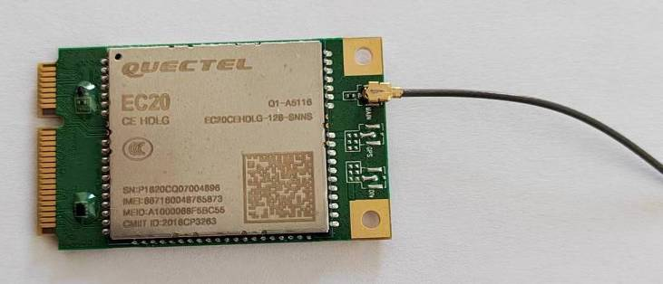
Install QUECTEL EC20, SIM card and antenna.
[ 1.520949] usbserial: USB Serial support registered for GSM modem (1-port)
[ 12.025951] option 2-1.3:1.0: GSM modem (1-port) converter detected
[ 12.053488] usb 2-1.3: GSM modem (1-port) converter now attached to ttyUSB0
[ 12.083780] option 2-1.3:1.1: GSM modem (1-port) converter detected
[ 12.109653] usb 2-1.3: GSM modem (1-port) converter now attached to ttyUSB1
[ 12.124588] option 2-1.3:1.2: GSM modem (1-port) converter detected
[ 12.152472] usb 2-1.3: GSM modem (1-port) converter now attached to ttyUSB2
[ 12.173640] option 2-1.3:1.3: GSM modem (1-port) converter detected
[ 12.192775] usb 2-1.3: GSM modem (1-port) converter now attached to ttyUSB3
[ 12.213280] option 2-1.3:1.4: GSM modem (1-port) converter detected
[ 12.241140] usb 2-1.3: GSM modem (1-port) converter now attached to ttyUSB4

- root@arm:~# pppd call quectel-ppp &
... ...
CHAP authentication succeeded
sent [IPCP ConfReq id=0x1 <addr 0.0.0.0> <ms-dns1 0.0.0.0> <ms-dns2 0.0.0.0>]
rcvd [IPCP ConfReq id=0x0]
sent [IPCP ConfNak id=0x0 <addr 0.0.0.0>]
rcvd [IPCP ConfNak id=0x1 <addr 10.32.232.200> <ms-dns1 202.96.128.86> <ms-dns2 202.96.134.133>]
sent [IPCP ConfReq id=0x2 <addr 10.32.232.200> <ms-dns1 202.96.128.86> <ms-dns2 202.96.134.133>]
rcvd [IPCP ConfReq id=0x1]
sent [IPCP ConfAck id=0x1]
rcvd [IPCP ConfAck id=0x2 <addr 10.32.232.200> <ms-dns1 202.96.128.86> <ms-dns2 202.96.134.133>]
Could not determine remote IP address: defaulting to 10.64.64.64
local IP address 10.32.232.200
remote IP address 10.64.64.64
primary DNS address 202.96.128.86
secondary DNS address 202.96.134.133
Script /etc/ppp/ip-up started (pid 981)
Script /etc/ppp/ip-up finished (pid 981), status = 0x0

Connection test:
- root@arm:~# ping -I ppp0 www.baidu.com
PING www.a.shifen.com (14.215.177.38) from 10.32.232.200 ppp0: 56(84) bytes of data.
64 bytes from 14.215.177.38: icmp_seq=1 ttl=54 time=37.0 ms
64 bytes from 14.215.177.38: icmp_seq=2 ttl=54 time=43.5 ms
64 bytes from 14.215.177.38: icmp_seq=3 ttl=54 time=51.8 ms
64 bytes from 14.215.177.38: icmp_seq=4 ttl=54 time=41.4 ms
^C64 bytes from 14.215.177.38: icmp_seq=5 ttl=54 time=33.4 ms

--- www.a.shifen.com ping statistics ---
5 packets transmitted, 5 received, 0% packet loss, time 20329ms
rtt min/avg/max/mdev = 33.408/41.456/51.856/6.272 ms

4G Disable
It's usually called 'airplane mode', disable wireless transmission.
- root@arm:~# echo 1 > /sys/class/leds/4g_disable/brightness
4G Enable
- root@arm:~# echo 0 > /sys/class/leds/4g_disable/brightness

4G Reset:
- root@arm:~# echo 0 > /sys/class/leds/4g_reset/brightness; sleep 1; echo 1 > /sys/class/leds/4g_reset/brightness

SUSPEND and RESUME
Suspend to ram:
- root@arm:~# echo mem > /sys/power/state
PM: Syncing filesystems ... done.
Freezing user space processes ... (elapsed 0.006 seconds) done.
Freezing remaining freezable tasks ... (elapsed 0.001 seconds) done.
Suspending console(s) (use no_console_suspend to debug)
[Click the POWER KEY on the base board...]
PM: suspend of devices complete after 137.489 msecs
PM: suspend devices took 0.140 seconds
PM: late suspend of devices complete after 2.748 msecs
PM: noirq suspend of devices complete after 2.736 msecs
Disabling non-boot CPUs ...
PM: noirq resume of devices complete after 1.455 msecs
PM: early resume of devices complete after 1.690 msecs
mmc1: mmc_select_hs200 failed, error -74
: switch to mmc1 failed
usb 2-1.1: reset high-speed USB device number 5 using ci_hdrc
PM: resume of devices complete after 1690.457 msecs
PM: resume devices took 1.690 seconds
Bluetooth: hci0: rtl: examining hci_ver=06 hci_rev=000b lmp_ver=06 lmp_subver=8723
Bluetooth: hci0: rtl: loading rtl_bt/rtl8723b_fw.bin
Bluetooth: hci0: rom_version status=0 version=1
Restarting tasks ...
usb 2-1.3: USB disconnect, device number 4
done.

