iMX8MMINI DEMO

User Manual

Version: 1.6
2022-10-17
Revision History：
Version | Date | Description
1.0 | 2021-01-05 | Initial Release
1.1 | 2021-02-23 | Support HDMI
1.2 | 2021-05-24 | Change eMMC Updating method
1.3 | 2022-05-28 | Support IMX8MM-MIPI-ADAPTER
1.4 | 2022-06-21 | Support MIPI-CSI OV5640
1.5 | 2022-08-18 | Support CPT GT911
1.6 | 2022-10-17 | Add Backlight Control

Table of Contents
1. Product Overview 6
1.1 Introduction 6
1.2 Resource Download 6
1.3 Hardware features 7
1.4 Mechanical Demension 7
2. Linux Operation System 8
2.1 Software Resources 8
2.1.1 Locations of Resources 8
2.1.2 BSP 9
2.2 Structure of Embedded Linux System 9
2.3 Building Development Environment 10
2.3.1 Installing Cross Compilation Tools 10
2.3.2 Adding Environment Variables 11
2.4 Preparing the Source Code 12
2.5 Compilation 12
2.6 Linux System Customization 13
2.6.1 Replace Kernel LOGO 13
2.6.2 Setting Configuration Menu 14
2.6.3 Menu Options 14
2.6.4 Compile Kernel 15
2.7 Introduction to Drivers 16
2.7.1 The table below shows the access path to find all the drivers : 16
2.7.2 SD/MMC 17
2.7.3 Audio In/Out 18
2.8 Driver development 19
2.8.1 GPIO_LEDs Driver 19
2.9 System Update 22
2.9.1 Update of TF Card System Image 22
2.9.2 Update eMMC with TFCard 23
2.9.3 Update eMMC with u-boot Command 24
2.10 Test and Demonstration 24
2.10.1 RTC 25
2.10.2 Timezone Setting 25
2.10.3 USB OTG 25
2.10.4 USB HUB 25
2.10.5 NETWORK 26
2.10.6 IMX8MM-MIPI-ADAPTER 27
2.10.7 MIPI-DSI 30
2.10.8 BACKLIGHT 32
2.10.9 HDMI 33
2.10.10 CAPACITIVE TOUCH PANEL GT911 35
2.10.11 USB TOUCH 36
2.10.12 SPDIF AUDIO 37
2.10.13 WM8904 AUDIO 37
2.10.14 UART 37
2.10.15 RS485 38
2.10.16 POWER BUTTON 38
2.10.17 LED 39
2.10.18 BUZZER 39
2.10.19 PCIe 39
2.10.20 SPI FLASH 39
2.10.21 TFCard 40
2.10.22 eMMC 40
2.10.23 Unique ID 40
2.10.24 CAN Bus 40
2.10.25 WIFI 41
2.10.26 BLUETOOTH 43
2.10.27 4G 44
2.10.28 MIPI-CSI Camera 44

Product Overview

Introduction

Resource Download
You can access to our remote server to download the hardware and software resources through 2 ways below:
① Open web browser (Firefox is recommended), input the following url:
https://47.107.111.205/svn/NXP/IMX8MMINI_DEMO
If the browser reports a warning like "Potential Security Risk Ahead ", please choose the Advanced... option and "Accept the Risk and Continue".
Access Authorization:
User Name: guest
Password: guest
② Run svn command under Linux operating system, such as Debian and Ubuntu:
svn co svn://47.107.111.205/NXP/IMX8MMINI_DEMO
Note：
- If the command not found, please install svn tools : apt-get update && apt-get install -y subversion
The svn program will ask for access authorization:
User Name: guest
Password: guest

Hardware features

Mechanical Demension

Linux Operation System
This chapter will give you a general map of the Linux software resources contained in the DVD-ROM provided along with the product, as well as detailed introduction to the process of Linux system development, drivers development, system update, functionality tests and application development examples.
Note：
- It is recommended to learn Ubuntu Linux installation and embedded Linux development technology before you get started.

Software Resources
The DVR-ROM provided along with the board contains demos, application examples, Linux source code and tools, helping you develop Linux applications and systems easily and quickly.

Locations of Resources
You can find software resources such as programs and codes contained in the DVD-ROM according to the information showed in the table below;
Categories | Location
Applications
Source Code | CD\Source\u-boot-2020.04.git.tar.xz
Source Code | CD\Source\linux-5.4.47.git.tar.xz
Tools | CD\Tools\
Precompiled Images | CD\Image

BSP
The following table lists types and formats of the files contained in BSP;
Names |  | Note | Formats
BOOTLOADER | U-BOOT | MMC/SD | Source Code
BOOTLOADER | U-BOOT | FAT | Source Code
BOOTLOADER | U-BOOT | NET | Source Code
KERNEL | LINUX-5.4 | Support ROM/CRAM/EXT4/FAT/NFS various of file system | Source Code
DEVICE DRIVER | SERIAL | Serials driver | Source Code
DEVICE DRIVER | RTC | Hardware RTC driver | Source Code
DEVICE DRIVER | NET | 10/100M/1000M Ethernet driver | Source Code
DEVICE DRIVER | CAN | CAN bus driver | Source Code
DEVICE DRIVER | SPI | SPI driver | Source Code
DEVICE DRIVER | SPI FLASH | SPI Flash driver | Source Code
DEVICE DRIVER | I2C | I2C driver | Source Code
DEVICE DRIVER | LCD | MIPI-DSI driver | Source Code
DEVICE DRIVER | TOUCH SCREEN | I2C Resistive touch panel driver | Source Code
DEVICE DRIVER | MMC/SD | MMC/SD controller driver | Source Code
DEVICE DRIVER | USB OTG | USB OTG driver | Source Code
DEVICE DRIVER | AUDIO | Audio driver (supports audio recording and playback) | Source Code
DEVICE DRIVER | AUDIO SPDIF | SPDIF interface, playback | Source Code
DEVICE DRIVER | BUTTON | GPIO button driver | Source Code
DEVICE DRIVER | LED | LED driver | Source Code
DEVICE DRIVER | BUZZER | Buzzer driver | Source Code
DEVICE DRIVER | WIFI | SDIO WIFI dongle driver | Source Code
ROOTFS | YOCTO | Weston with Qt & Opencv | Image

Structure of Embedded Linux System
IMX8MMINI DEMO board is shipped with Linux-5.4 system in eMMC by default. This system consists of bootloader, kernel and rootfs. The following table shows the structure of embedded Linux system.
eMMC/SD
Partition | MBR | FAT | EXT4
Image | Bootloader | DTB, Kernel | Yocto Rootfs

- Bootloader is a program generated by u-boot compiling; its file name is flash.bin.
- The kernel used in this document is Linux 5.4 and has been customized based on the hardware design.
- Rootfs stores open-source system Yocto with EXT4 format.

Building Development Environment
Before the software development, users have to establish a Linux cross development environment on PC. This section will take Ubuntu18.04 operating system as an example to describe how to establish a cross development environment.
It is strongly recommended to install necessary software packages for a newly installed Ubuntu through the following commands.
- sudo apt-get update; sudo apt-get install -y build-essential git xz-utils ncurses-dev autoconf libtool automake texinfo bison flex libssl-dev libc6:i386 libncurses5:i386 libstdc++6:i386

Note：
- Each instruction has been put a bullets “•” before it to prevent confusion caused by the long instructions that occupy more than one line in the context.
- Please note the SPACES within each instruction; Missing of any SPACE will cause failure when executing instructions.

Installing Cross Compilation Tools
We provide 2 cross-compilers under Tools directory:
① gcc-linaro-7.5.0-2019.12-x86_64_aarch64-linux-gnu.tar.xz
② fsl-imx-wayland-glibc-x86_64-imx-image-full-aarch64-imx8mmddr4evk-toolchain-5.4-zeus.sh
The item ① is mainly used to compile u-boot and kernel.
- mkdir $HOME/tools
- cd <YOUR_PATH>/Tools
- tar -xvf gcc-linaro-7.5.0-2019.12-x86_64_aarch64-linux-gnu.tar.xz -C $HOME/tools
The item ② is used to compile user program based on Qt5 and Opencv etc.
- sudo ./fsl-imx-wayland-glibc-x86_64-imx-image-full-aarch64-imx8mmddr4evk-toolchain-5.4-zeus.sh
It will extract and install under /opt directory, keep the default settings.
Start to compile an opencv4 example code with it:
- source /opt/fsl-imx-wayland/5.4-zeus/environment-setup-aarch64-poky-linux
- ${CXX} example.cpp -lopencv_core -lopencv_imgproc -lopencv_highgui -lopencv_imgcodecs

Adding Environment Variables
Run the following commands to add them in the temporary environment variables:
- export PATH=$HOME/tools/gcc-linaro-7.5.0-2019.12-x86_64_aarch64-linux-gnu/bin:$HOME/tools:$PATH
- export ARCH=arm64
- export CROSS_COMPILE=arm-linux-

Note：
- The instructions can be added in the .bashrc file located at the user directory, so that the addition of environment variables will be loaded automatically when the system is booting up;
- If you want to check the path, please use the instruction printenv PATH

Preparing the Source Code
Please refer to chapter <1.2 Resource Download> to get the development materials, You can get source code under Source directory.
- tar -xvf u-boot-2020.04.git.tar.xz
- tar -xvf linux-5.4.47.git.tar.xz
Then we can get the source code directory u-boot-2020.04 and linux-5.4.47.

Compilation
- Compiling Bootloader
Run the following instructions to compile bootloader:
- cd u-boot-2020.04
- git checkout .
- vi make.sh
export PATH=$HOME/tools/gcc-linaro-7.5.0-2019.12-x86_64_aarch64-linux-gnu/bin:$HOME/tools:$PATH
export ARCH=arm64
export CROSS_COMPILE=arm-linux-

DESTDIR="/dev/shm/"
PATH: point to your cross-compiler installation directory.
DESTDIR: point to a directory to store the target image.
Please modify PATH and DESTDIR according to your local environment.
- ./make.sh
After all the instructions are executed, you can find booting image named flash.bin under DESTDIR directory.
- Compiling Kernel
Execute the following instructions to compile kernel:
- cd linux-5.4.47
- git checkout .
- vi make.sh
export PATH=$HOME/tools/gcc-linaro-7.5.0-2019.12-x86_64_aarch64-linux-gnu/bin:$HOME/tools:$PATH
export ARCH=arm64
export CROSS_COMPILE=arm-linux-

DESTDIR="/dev/shm/"
PATH: point to your cross-compiler installation directory.
DESTDIR: point to a directory to store the target image.
Please modify PATH and DESTDIR according to your local environment.
- make distclean
- ./make.sh
If it’s successfully built, you can find kernel images named Image and fsl-imx8mm-demo.dtb under DESTDIR directory.

Linux System Customization
In order to satisfy different requirements of customers, designers commonly need to make some custom modification based on the default configuration of Linux kernel. This chapter will introduce the process of system customization with some examples.

Replace Kernel LOGO
  - Prepare a picture suitable for your display screen size, named my_logo.png for example.
  - Install some necessary programs under Ubuntu.
- sudo apt-get install netpbm gimp
  - Run command under Ubuntu desktop terminal:
- pngtopnm my_logo.png > linuxlogo.pnm
- pnmquant 224 linuxlogo.pnm > linuxlogo224.pnm
- pnmtoplainpnm linuxlogo224.pnm > logo_linux_clut224.ppm
  - Update Linux source code.
- cp -f logo_linux_clut224.ppm <YOUR_PATH>/linux-5.4.47/drivers/video/logo/logo_linux_clut224.ppm
  - Re-build the kernel.
- make ARCH=arm64 distclean
- ./make.sh
Update the target file Image to the board, reboot and check the boot logo on the display screen.

Setting Configuration Menu
A default configuration file is provided under kernel source codes:
linux-5.4.47/arch/arm64/configs/imx8mm_demo_defconfig
Please execute the following instructions to enter the configuration menu:
- cd linux-5.4.47
- make ARCH=arm64 imx8mm_demo_defconfig
- make ARCH=arm64 menuconfig

Note：
- If an error occurs when command 'make ARCH=arm64 menuconfig' is executed, you might need to install 'ncurse' in the Ubuntu system, ‘ncurses’ is a character graphic library required to generate configuration menu. Please enter the following instruction to install the library:
sudo apt-get install libncurses5-dev

Menu Options
Configure options according to customization requirements after entering configuration menu, for example, access Device Drivers > Input device support > Touchscreens > Ilitek ILI210X based touchscreen as shown below:
-> Device Drivers
-> Input device support
-> Touchscreens
-> Ilitek ILI210X based touchscreen
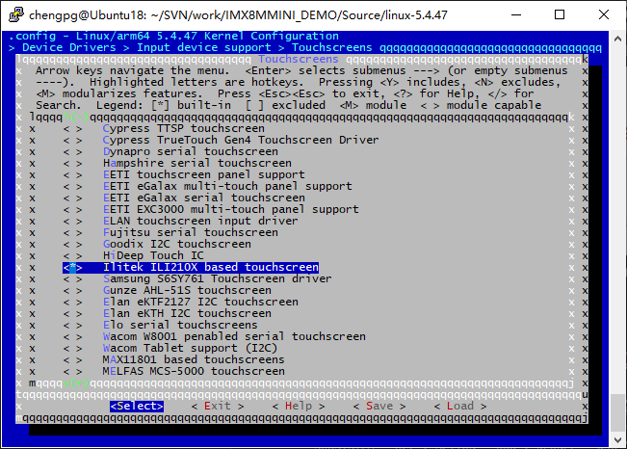
Set Ilitek ILI210X based touchscreen to <*>, exit and save changes.

Compile Kernel
Please execute the following instructions to recompile kernel:
- ./make.sh
The script will NOT overwrite the configuration modifed by menuconfig. It means that your current setting is effective in your taget kernel image.
If you want to restore to the default configuration, please delete the file .config and run make.sh.

Introduction to Drivers

The table below shows the access path to find all the drivers :
Category | Name | Description | Location
Bootloader | u-boot | MMC/SD | drivers/mmc/fsl_esdhc_imx.c
Bootloader | u-boot | FAT | fs/
Bootloader | u-boot | NET | drivers/net/ fec_mxc.c
Kernel | Linux-5.4 | Support ROM/CRAM/EXT4/FAT/NFS | fs/
Devices | SERIAL | Serial driver | drivers/tty/serial/imx.c
Devices | RTC | Hardware RTC driver | drivers/rtc/rtc-ds1307.c
Devices | NET | 10/100M/1000M Ethernet driver | drivers/net/ethernet/freescale/fec_main.c
Devices | CAN | CAN bus driver | drivers/net/can/spi/mcp251x.c
Devices | SPI | SPI driver | drivers/spi/spi-imx.c
Devices | SPI FLASH | SPI Flash driver | drivers/mtd/spi-nor/spi-nor.c
Devices | LCD | MIPI-DSI driver | drivers/gpu/drm/panel/panel-ronbo-rb070d30.c
Devices | TOUCH SCREEN | I2C Resistive touch panel driver | drivers/input/touchscreen/ili210x.c
Devices | MMC/SD | MMC/SD controller dirver | drivers/mmc/host/sdhci-esdhc-imx.c
Devices | USB | USB controller dirver | drivers/usb/dwc3
Devices | AUDIO | Audio driver (supporting recording/playback) | sound/soc/fsl/imx-wm8904.c
Devices | AUDIO SPDIF | SPDIF interface, playback | sound/soc/fsl/imx-spdif.c
Devices | BUTTON | GPIO button driver | drivers/input/keyboard/snvs_pwrkey.c
Devices | LED | LED driver | drivers/leds/leds-gpio.c
Devices | BUZZER | Buzzer driver | drivers/leds/leds-gpio.c
Devices | WIFI | SDIO wifi dongle driver | drivers/net/wireless/broadcom/brcm80211/brcmfmac

SD/MMC
App，System call
Kernel (Generic disk handler，File system)
BUFFER_CACHE
MMC_QUEUE
MMC/SD CORE
MMC_BLOCK
MMC/SD CONTROLLER DRIVER
HARDWARE(MMC/SD/SDIO CONTROLLER)
User
Kernel
Hardware
SD/MMC drivers in Linux are mainly consisted of SD/MMC core, mmc_block, mmc_queue and SD/MMC driver：
- SD/MMC core realizes the codes unrelated to structure in the SD/MMC card operation;
- mmc_block realizes driver structure when SD/MMC card is used as a block device;
- mmc_queue realizes management of request queue;
- SD/MMC driver realizes specific controller driver.
Drivers and relevant documents:
linux-5.4.47/drivers/mmc/
linux-5.4.47/drivers/mmc/host/sdhci-esdhc-imx.c

Audio In/Out
Native ALSA application
ALSA KERNEL API
ALSA SOC CORE
CODEC
DRIVER
PLATFORM
DRIVER
HARDWARE
User
Kernel
Hardware
ALSA LIBRARY
PCM

CONTROL
MACHINE
DRIVER
ASoC embedded audio system basically consists of three components:
- Codec driver: The codec driver is platform independent and contains audio controls, audio interface capabilities, codec dapm definition and codec IO functions.
- Platform driver: It contains the audio dma engine and audio interface drivers (e.g. I2S, AC97, PCM) of that platform.
- Machine driver: The machine driver handles any machine specific controls and audio events i.e. turning on an amp at start of playback.
Drivers and relevant documents:
linux-5.4.47/sound/soc/fsl
linux-5.4.47/sound/soc/fsl/imx-wm8904.c
linux-5.4.47/sound/soc/fsl/imx-spdif.c

Driver development

GPIO_LEDs Driver
1）Device Definition
linux-5.4.47/arch/arm64/boot/dts/freescale/fsl-imx8mm-demo.dts
Configure GPIO3.16 as system runing status indicator, blinking as heartbeat.
leds {
compatible = "gpio-leds";
pinctrl-names = "default";
pinctrl-0 = <&pinctrl_gpio_led>;

sys {
label = "sys";
gpios = <&gpio3 16 GPIO_ACTIVE_HIGH>;
linux,default-trigger = "heartbeat";
};
2）GPIO pinmux Configuration
linux-am335x/arch/arm/boot/dts/am335x-som860e.dts
Config GPIO2.5as MODE7(gpiomode),AM33XX_PIN_OUTPUT（output mode）
pinctrl_gpio_led: gpioledgrp {
fsl,pins = <
MX8MM_IOMUXC_NAND_READY_B_GPIO3_IO16 0x19
……
>;
};
3）Driver Design
linux-5.4.47/drivers/leds/leds-gpio.c
- Call platform_driver_register to register gpio_leds driver
static struct platform_driver gpio_led_driver = {
.probe = gpio_led_probe,
.shutdown = gpio_led_shutdown,
.driver = {
.name = "leds-gpio",
.of_match_table = of_gpio_leds_match,
},
};

module_platform_driver(gpio_led_driver);

MODULE_AUTHOR("Raphael Assenat <raph@8d.com>, Trent Piepho <tpiepho@freescale.com>");
MODULE_DESCRIPTION("GPIO LED driver");
MODULE_LICENSE("GPL");
MODULE_ALIAS("platform:leds-gpio");
- Apply for gpio and call led_classdev_register to led_classdev drivr.
static int gpio_led_probe(struct platform_device *pdev)
{
…
priv->num_leds = pdata->num_leds;
for (i = 0; i < priv->num_leds; i++) {
const struct gpio_led *template = &pdata->leds[i];
struct gpio_led_data *led_dat = &priv->leds[i];

if (template->gpiod)
led_dat->gpiod = template->gpiod;
else
led_dat->gpiod =
gpio_led_get_gpiod(&pdev->dev,
i, template);
if (IS_ERR(led_dat->gpiod)) {
dev_info(&pdev->dev, "Skipping unavailable LED gpio %d (%s)\n",
template->gpio, template->name);
continue;
}

ret = create_gpio_led(template, led_dat,
&pdev->dev, NULL,
pdata->gpio_blink_set);
if (ret < 0)
return ret;
}
} else {
priv = gpio_leds_create(pdev);
if (IS_ERR(priv))
return PTR_ERR(priv);
}

platform_set_drvdata(pdev, priv);

return 0;
}

static int create_gpio_led(const struct gpio_led *template,
struct gpio_led_data *led_dat, struct device *parent,
struct fwnode_handle *fwnode, gpio_blink_set_t blink_set)
{
struct led_init_data init_data = {};
int ret, state;

led_dat->cdev.default_trigger = template->default_trigger;
led_dat->can_sleep = gpiod_cansleep(led_dat->gpiod);
if (!led_dat->can_sleep)
led_dat->cdev.brightness_set = gpio_led_set;
else
led_dat->cdev.brightness_set_blocking = gpio_led_set_blocking;
led_dat->blinking = 0;
if (blink_set) {
led_dat->platform_gpio_blink_set = blink_set;
led_dat->cdev.blink_set = gpio_blink_set;
}
if (template->default_state == LEDS_GPIO_DEFSTATE_KEEP) {
state = gpiod_get_value_cansleep(led_dat->gpiod);
if (state < 0)
return state;
} else {
state = (template->default_state == LEDS_GPIO_DEFSTATE_ON);
}
led_dat->cdev.brightness = state ? LED_FULL : LED_OFF;
if (!template->retain_state_suspended)
led_dat->cdev.flags |= LED_CORE_SUSPENDRESUME;
if (template->panic_indicator)
led_dat->cdev.flags |= LED_PANIC_INDICATOR;
if (template->retain_state_shutdown)
led_dat->cdev.flags |= LED_RETAIN_AT_SHUTDOWN;

ret = gpiod_direction_output(led_dat->gpiod, state);
if (ret < 0)
return ret;

if (template->name) {
led_dat->cdev.name = template->name;
ret = devm_led_classdev_register(parent, &led_dat->cdev);
} else {
init_data.fwnode = fwnode;
ret = devm_led_classdev_register_ext(parent, &led_dat->cdev,
&init_data);
}
return ret;
}
- Users may access the file named brightness under /sys/class/leds/xxx/brightness, and call gpio_led_set to configure LED status
static void gpio_led_set(struct led_classdev *led_cdev,
enum led_brightness value)
{
…
gpiod_set_value(led_dat->gpiod, level);
}

System Update
IMX8MMINI DEMO can boot up from both TF card and eMMC, this section briefly introduce the process of system update on TF card and eMMC.

Update of TF Card System Image
  - Make A Bootable TF Card
- Get the system image from Image directory, named as imx-image-xxx.img.xz, unxz it and create a raw image imx-image-xxx.img.
- If you work under Windows system, please run Tools/win32diskimager to write the imx-image-xxx.img into TF Card. If you work under Linux system, please use dd command to write it into TF Card.
Image Name | Display Supported
imx-image-full-imx8mmddr4evk-xxx.img | MIPI-DSI
imx-image-full-imx8mmddr4evk-xxx-hdmi.img | HDMI
Note:
- The difference between imx-image-full-imx8mmddr4evk-xxx.img and imx-image-full-imx8mmddr4evk-xxx-hdmi.img is that the fdt_file in uEnv.txt chooses a different dtb.

- Update U-Boot
If you’ve made some changes to the u-boot source code, and want to update it into TFCard, please run the below command:
- dd if=<YOUR_PATH>/flash.bin of=/dev/sdx bs=1K seek=33 conv=notrunc
Note:
- /dev/sdx is the TFCard device node recognized under Ubuntu system.
- Update Kernel
If you have modified the kernel source code, please update the dtb and Image under Partition 1 [FAT32] of the TF Card. That partition can be recognized by Windows or Linux.
- Update Rootfs
Because EXT4 isn’t accessible Under Windows, please mount the Partiton 2 of TF Card under Ubuntu, change the target file and umount the Card.
Note:
- Press down the button "BOOT" before power up, don't release it. Wait until booting message shows on the terminal [3 seconds at most], release the button.

Update eMMC with TFCard
  - Make a bootable TFCard and boot up the system;
  - Choose the target image [under directory Image/] and copy it into the USB disk. If it is .xz file, please unxz it to generate .img file.
  - Install the USB disk on the ARM board, it will be automatically mounted under directory /run/media/, for example, the USB disk is recognized as sda1;
  - Run command to start writing eMMC:
- root@imx8mmddr4evk:~# umount /dev/mmcblk2*
- root@imx8mmddr4evk:~# dd if=/run/media/sda1/imx-image-full-imx8mmddr4evk-xxx.img of=/dev/mmcblk2
After it's done, power off the board, remove the TFCard, then reboot the board, it should boot from eMMC and enter into Linux prompt.

Update eMMC with u-boot Command
  - Connect MicroUSB slot on ARM board with PC;
  - Make it boot from TF Card and enter into u-boot command mode;
  - Run command:
- u-boot=> mmc list
FSL_SDHC: 1 (SD)
FSL_SDHC: 2
Then we know "mmc2" is the target device eMMC.
- u-boot=> ums 0 mmc 2
UMS: LUN 0, dev mmc 2, hwpart 0, sector 0x0, count 0x1d34000
\
Then the PC will discover a removable disk installed [USB mass storage disk].
  - Run Win32DiskImager on PC side;
  - Write the target system image imx-image-full-imx8mmddr4evk-xxx-hdmi.img into the USB mass storage disk;
  - Wait until it completes, remove USB cable and TF Card, reboot the board and check the booting message.

Test and Demonstration
This section will run some tests on the peripheral devices.
POWER: 12V DC
Debug Port: UART2, 115200 1N8.

RTC
There is a RTC chip RX8025 on board, so the integrated RTC is disabled. So there is only one RTC accessible under system.
Let's set the current time to 2021-1-4 10:12,
- root@arm:~# date -s "2021-1-4 10:12"; hwclock -w
Reboot the board, and check the hardware RTC time with below command:
- root@arm:~# hwclock

Timezone Setting
Set Beijing Time for example,
- root@arm:~# echo "Asia/Shanghai" > /etc/timezone
- root@arm:~# ln -sf /usr/share/zoneinfo/Asia/Shanghai /etc/localtime
- root@arm:~# sync
Note:
- NXP Yocto image doesn't contain zoneinfo, copy /usr/share/zoneinfo under Ubuntu system to the board, and retry the above commands.

USB OTG
Connect UDisk to the OTG slot, it can be recognized as a removable disk.
Connect the OTG to the HOST PC[Ubuntu], it can be recognized as a RNDIS network device.

USB HUB
There are 4 USB host channels extended from USB0:
SIGNAL | USAGE
DN1 | DP1
DN2 | DP2 | 4G module
DN3 | DP3 | J24 USB slot
DN4 | DP4 | J23 USB slot
Force the HUB to reset:
- root@arm:~# node=/sys/class/leds/usbhub_reset/brightness; echo 0 > $node;sleep 1;echo 1 > $node
[ 1967.294776] usb 1-1: USB disconnect, device number 3
[ 1967.299981] usb 1-1.2: USB disconnect, device number 4
( reseting ... )
[ 1030.068743] usb 1-1: new high-speed USB device number c
[ 1030.230896] hub 1-1:1.0: USB hub found
[ 1030.234947] hub 1-1:1.0: 4 ports detected

NETWORK
There is a 1Gbps network chip AR8035 on board.
- root@arm:~# ifconfig eth0
eth0: flags=-28669<UP,BROADCAST,MULTICAST,DYNAMIC> mtu 1500
ether 1c:ba:8c:98:8b:58 txqueuelen 1000 (Ethernet)
RX packets 0 bytes 0 (0.0 B)
RX errors 0 dropped 0 overruns 0 frame 0
TX packets 0 bytes 0 (0.0 B)
TX errors 0 dropped 0 overruns 0 carrier 0 collisions 0
device interrupt 176
DHCP feature is enabled as default; the board can request a valid IP address from DHCP server in local network.
- root@arm:~# ping -I eth0 www.baidu.com
PING www.a.shifen.com (14.215.177.38) from 192.168.8.26 eth0: 56(84) bytes of d.
64 bytes from 14.215.177.38 (14.215.177.38): icmp_seq=1 ttl=55 time=7.77 ms
64 bytes from 14.215.177.38 (14.215.177.38): icmp_seq=2 ttl=55 time=7.73 ms
64 bytes from 14.215.177.38 (14.215.177.38): icmp_seq=3 ttl=55 time=7.22 ms
64 bytes from 14.215.177.38 (14.215.177.38): icmp_seq=4 ttl=55 time=7.05 ms
^C
--- www.a.shifen.com ping statistics ---
4 packets transmitted, 4 received, 0% packet loss, time 3004ms
rtt min/avg/max/mdev = 7.058/7.447/7.771/0.319 ms

IMX8MM-MIPI-ADAPTER
- LVDS
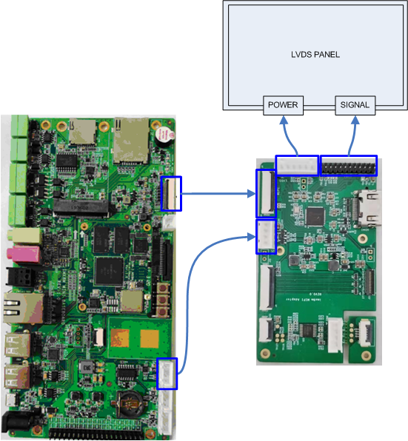
- HDMI
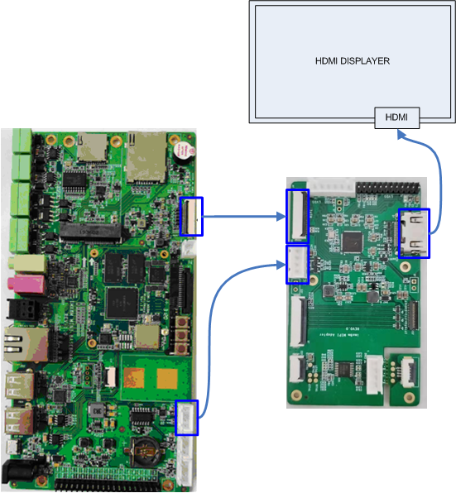
- MIPI
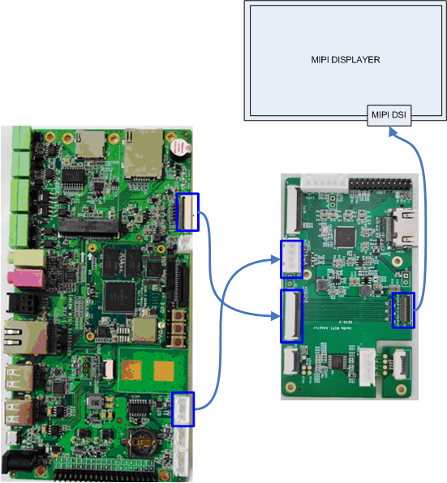
- Touch Screen
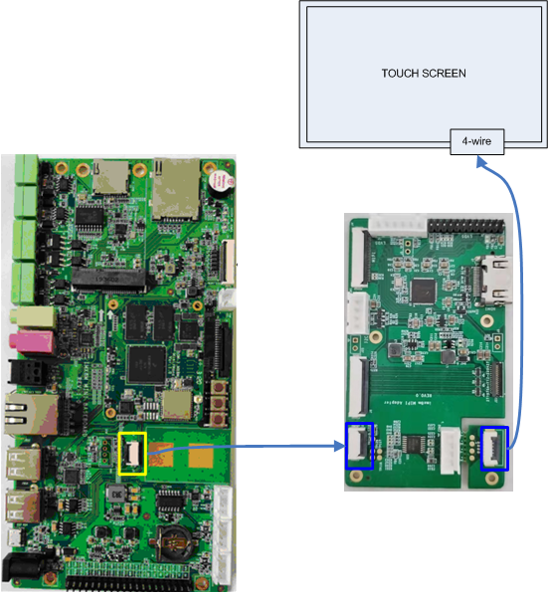

MIPI-DSI
The default configuration is tested with below devices:
TYPE | PANEL | RESOLUTION | DTB
MIPI-DSI | EK79007  VISLCD_070HYC530NCT61 | 1024 * 600 | fsl-imx8mm-demo.dtb
MIPI-DSI | VISLCD-101HYSX31P | 800 * 1280 | fsl-imx8mm-demo-vislcd-mipi.dtb
LVDS | VISLCD-101BWX1 | 1280 * 800 | fsl-imx8mm-demo-lt8912-lvds.dtb
User can modify uEnv.txt and choose the dtb file for the corresponding displayer.
Check the kernel source code:
- vi arch/arm64/boot/dts/freescale/fsl-imx8mm-demo.dts
&mipi_dsi {
status = "okay";

panel_ek79007: panel@0 {
compatible = "ronbo,rb070d30";
reg = <0>;
vcc-lcd-supply = <&dummy_reg>;
backlight = <&backlight_pwm>;
status = "okay";
};

panel_vislcd_101hysx31p: panel@1 {
compatible = "bananapi,lhr050h41", "ilitek,ili9881c";
reg = <1>;
power-supply = <&dummy_reg>;
backlight = <&backlight_pwm>;
status = "disabled";
};

panel_hdmi: port@1 {
status = "disabled";

mipi_dsi_hdmi_out: endpoint {
remote-endpoint = <&lt8912_1_in>;
attach-bridge;
};
};
};

hdmi_bridge: lt8912b@48 {
#address-cells = <1>;
#size-cells = <0>;
compatible = "lontium,lt8912";
reg = <0x48>;
lontium,dsi-lanes = <4>;
vdd1-supply = <&dummy_reg>;
no-hpd;
no-edid;
status = "disabled";

port {
lt8912_1_in: endpoint {
remote-endpoint = <&mipi_dsi_hdmi_out>;
};
};
Rebuild the kernel, generate dtb and replace the image on board.

BACKLIGHT
- vi arch/arm64/boot/dts/freescale/fsl-imx8mm-demo.dts
backlight_pwm: backlight {
compatible = "pwm-backlight";
pwms = <&pwm1 0 1250 0>;
brightness-levels = <0 1 2 3 4 5 6 7 8 9 10 11 12 13 14 15 16 17 18 19 20 21 22 23 ...... 234 235 236 237 238 239 240 241 242 243 244 245 246 247 248 249 250 251 252 253 254 255>;
default-brightness-level = <200>;
};
pwms = <&pwm1 0 1250 0>;
Sets the PWM signal period(ns):

The target frequency we set is 800KHz, so:
brightness-levels =<...>
Assign the duty cycle value.
default-brightness-level
Set the default duty cycle value after booting up.

Set the backlight:
- root@arm:~# echo 100 > /sys/class/backlight/backlight/brightness

HDMI
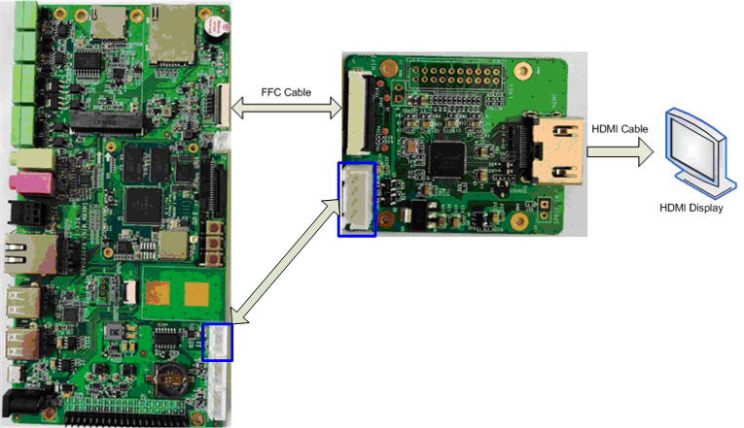
The MIPI to HDMI chip LT8912B is already tested.
Check the kernel source code:
- vi arch/arm64/boot/dts/freescale/fsl-imx8mm-demo-hdmi.dts
&hdmi_bridge {
status = "okay";
};

&display_timings {
native-mode = <&timing0>; /* 1080p */
};

&panel_ek79007 {
status = "disabled";
};

&panel_hdmi {
status = "okay";
};

Rebuild the kernel, generate dtb and replace the image on board.

The HDMI EDID feature is not supported on our board. Please choose the target resolution according to your displayer manually:
- vi arch/arm64/boot/dts/freescale/fsl-imx8mm-demo.dts
display-timings {
native-mode = <&timing0>;

/* 1920 * 1080 MIPI */
timing0: timing0 {
clock-frequency = <148500000>;
hactive = <1920>;
vactive = <1080>;
hfront-porch = <88>;
hsync-len = <44>;
hback-porch = <148>;
vfront-porch = <36>;
vsync-len = <5>;
vback-porch = <4>;
hsync-active = <0>;
vsync-active = <0>;
de-active = <0>;
pixelclk-active = <0>;
};

/* 1280 * 720 MIPI */
timing1: timing1 {
clock-frequency = <74250000>;
hactive = <1280>;
vactive = <720>;
hfront-porch = <110>;
hsync-len = <40>;
hback-porch = <220>;
vfront-porch = <5>;
vsync-len = <5>;
vback-porch = <20>;
hsync-active = <0>;
vsync-active = <0>;
de-active = <0>;
pixelclk-active = <0>;
};

/* 1280 * 800 MIPI */
timing2: timing2 {
clock-frequency = <71000000>;
hactive = <1280>;
vactive = <800>;
hfront-porch = <48>;
hsync-len = <32>;
hback-porch = <80>;
vfront-porch = <3>;
vsync-len = <6>;
vback-porch = <14>;
hsync-active = <0>;
vsync-active = <0>;
de-active = <0>;
pixelclk-active = <0>;
};
};
Modify the native-mode with value: timing0, timing1 and timing2, to set the corresponding resolution.

CAPACITIVE TOUCH PANEL GT911
Device already tested: VISLCD_070HYC530NCT61 with GT911 CTP chip.
- vi arch/arm64/boot/dts/freescale/fsl-imx8mm-demo.dts
&i2c2 {
......
touch@5d {
compatible = "goodix,gt911";
reg = <0x5d>;
pinctrl-names = "default";
pinctrl-0 = <&pinctrl_touch>;
interrupt-parent = <&gpio3>;
interrupts = <25 IRQ_TYPE_EDGE_FALLING>;
irq-gpios = <&gpio3 25 GPIO_ACTIVE_HIGH>;
reset-gpios = <&gpio5 9 GPIO_ACTIVE_LOW>;
touchscreen-inverted-x;
touchscreen-inverted-y;
panel_is_vislcd_070hyc530nct61;
};
};
- make ARCH=arm64 menuconfig
Device Drivers --->
Input device support --->
[*] Touchscreens --->
<*> Goodix I2C touchscreen
- Update driver source code: drivers/input/touchscreen/goodix.c, please refer to the latest kernel code released by Emtop Tech.
- Rebuild the kernel and get dtb files and 'Image', update them on ARM board.
- Modify uEnv.txt:
fdt_file=fsl-imx8mm-demo.dtb

- Boot the board, login and run below commands to calibrator and test touch panel:
- root@arm:~# weston-touch-calibrator
could not load cursor 'dnd-move'
could not load cursor 'dnd-copy'
could not load cursor 'dnd-none'
device "/sys/devices/platform/soc@0/soc@0:bus@30800000/30a30000.i2c/i2c-1/1-005d/input/input3/event1" - head "DSI-1"

- root@arm:~# weston-touch-calibrator /sys/devices/platform/soc@0/soc@0:bus@30800000/30a30000.i2c/i2c-1/1-005d/input/input3/event1
The LCD will display symbol +, click it four times to calibrate touch panel.

- root@arm:~# weston-flower
The LCD will display a flower figure, press it and drag within the window to check the touch point.

USB TOUCH
(To be continued)

SPDIF AUDIO
- root@arm:~# aplay -L
null
Discard all samples (playback) or generate zero samples (capture)
pulse
PulseAudio Sound Server
sysdefault:CARD=imxspdif
imx-spdif, S/PDIF PCM snd-soc-dummy-dai-0
Default Audio Device
sysdefault:CARD=wm8904audio
wm8904-audio,
Default Audio Device
Transform the digital audio to anolog voice signal with a SPDIF converter.
- root@arm:~# aplay /usr/share/sounds/alsa/*.wav
Playing WAVE '/usr/share/sounds/alsa/Front_Center.wav' : Signed 16 bit Little Eo
Playing WAVE '/usr/share/sounds/alsa/Front_Left.wav' : Signed 16 bit Little Endo
Playing WAVE '/usr/share/sounds/alsa/Front_Right.wav' : Signed 16 bit Little Eno
......

WM8904 AUDIO
Playback:
- root@arm:~# aplay -D plughw:1,0 /usr/share/sounds/alsa/*.wav
Record:
- root@arm:~# amixer -c 1 set 'Left Capture Mux' IN1L
- root@arm:~# arecord -D plughw:1,0 -t wav -f cd test.wav
Wait several seconds, Ctrl+C to terminate arecord program. Now, let's play it to check:
- root@arm:~# aplay -D plughw:1,0 test.wav

UART

Device Node | Hardware | Usage
/dev/ttymxc0 | UART1 | BLUETOOTH
/dev/ttymxc1 | UART2 | DEBUG PORT
/dev/ttymxc2 | UART3 | RS485
/dev/ttymxc3 | UART4
There is only UART4 can be tested here. Connect TXD and RXD to run loopback test:
- root@arm:~# /test/com -d /dev/ttymxc3
SEND: 1234567890
RECV: 1234567890
SEND: 1234567890
RECV: 1234567890

RS485
Connect a RS485 device, or connect 2 boards directly.
- root@arm:~# /test/com -d /dev/ttymxc2 -m rs485
SEND: 1234567890
RECV: 1234567890
SEND: 1234567890
RECV: 1234567890

POWER BUTTON
- root@arm:~# evtest /dev/input/event0
Input driver version is 1.0.1
Input device ID: bus 0x19 vendor 0x0 product 0x0 version 0x0
Input device name: "30370000.snvs:snvs-powerkey"
Supported events:
Event type 0 (EV_SYN)
Event type 1 (EV_KEY)
Event code 116 (KEY_POWER)
Properties:
Testing ... (interrupt to exit)
Event: time 1591238021.080788, type 1 (EV_KEY), code 116 (KEY_POWER), value 1
Event: time 1591238021.080788, -------------- SYN_REPORT ------------
Event: time 1591238021.144791, type 1 (EV_KEY), code 116 (KEY_POWER), value 0
Event: time 1591238021.144791, -------------- SYN_REPORT ------------
Event: time 1591238021.544772, type 1 (EV_KEY), code 116 (KEY_POWER), value 1
Event: time 1591238021.544772, -------------- SYN_REPORT ------------
Event: time 1591238021.608776, type 1 (EV_KEY), code 116 (KEY_POWER), value 0

LED
There is LED named D21, used as system running indicator under hearbeat blinking mode. But we can change its mode manually.
- root@arm:~# echo none > /sys/class/leds/sys/trigger
- root@arm:~# while test 1; do echo 1 > /sys/class/leds/sys/brightness;sleep 1;echo 0 > /sys/class/leds/sys/brightness;sleep 1;done

BUZZER
- root@arm:~# while test 1; do echo 1 > /sys/class/leds/beep/brightness;sleep 1;echo 0 > /sys/class/leds/beep/brightness;sleep 1;done

PCIe
Aready test a PCIe to USB3.0 module uPD72020x.

SPI FLASH
- root@arm:~# cat /proc/mtd
dev: size erasesize name
mtd0: 00800000 00010000 "30bb0000.spi"
Erase:
- root@arm:~# flash_erase /dev/mtd0 0 0
Format:
- root@arm:~# mkfs.ext4 /dev/mtdblock0
mke2fs 1.45.3 (14-Jul-2019)
Creating filesystem with 8192 1k blocks and 2048 inodes
Allocating group tables: done
Writing inode tables: done
Creating journal (1024 blocks): done
Writing superblocks and filesystem accounting information: done
Mount:
- root@arm:~# mount /dev/mtdblock0 /mnt
[ 2107.531052] EXT4-fs (mtdblock0): mounted filesystem with ordered data mode. )
[ 2107.539223] ext4 filesystem being mounted at /mnt supports timestamps until )
Create and write your data under directory /mnt, it will be stored in SPI FLASH.

TFCard
When booting from eMMC, the TFCard will be recognized as a removable disk device.

eMMC
eMMC is mainly used for storing system image, needless to test it manually.

Unique ID
- root@arm:~# cat /sys/devices/soc0/soc_uid
0C259209DAB3DAF3

CAN Bus
- root@arm:~# ifconfig can0
can0 Link encap:UNSPEC HWaddr 00-00-00-00-00-00-00-00-00-00-00-00-00-00-0
NOARP MTU:16 Metric:1
RX packets:0 errors:0 dropped:0 overruns:0 frame:0
TX packets:0 errors:0 dropped:0 overruns:0 carrier:0
collisions:0 txqueuelen:10
RX bytes:0 (0.0 B) TX bytes:0 (0.0 B)
Configure parameters:
- root@arm:~# ifconfig can0 down
- root@arm:~# ip link set can0 type can bitrate 125000
- root@arm:~# ip link set can0 type can restart-ms 100
- root@arm:~# ifconfig can0 up
Start to listen:
- root@arm:~# candump can0 &
Send package:
- root@arm:~# cansend can0 "5A1#1122334455667788"
For more information, please refer to project can-utils.

WIFI
- root@arm:~# ifconfig wlan0 up
If it reports message: SIOCSIFFLAGS: Operation not possible due to RF-kill, please try below command:
- root@arm:~# rfkill unblock all
Now, we can control it manually.
- root@arm:~# ifconfig wlan0 up; iw wlan0 scan
BSS f0:b0:52:70:e2:58(on wlan0)
last seen: 214.948s [boottime]
TSF: 0 usec (0d, 00:00:00)
freq: 2447
beacon interval: 100 TUs
capability: ESS Privacy ShortPreamble ShortSlotTime (0x0431)
signal: -70.00 dBm
last seen: 15156 ms ago
SSID: Embest_Guest
Supported rates: 1.0* 2.0* 5.5* 11.0*
DS Parameter set: channel 8
Country: US Environment: Indoor/Outdoor
Channels [1 - 11] @ 36 dBm
ERP: <no flags>
Extended supported rates: 6.0 9.0 12.0 18.0 24.0 36.0 48.0 54.0
HT capabilities:
Capabilities: 0x1ad
RX LDPC
HT20
SM Power Save disabled
RX HT20 SGI
TX STBC
RX STBC 1-stream
Max AMSDU length: 3839 bytes
No DSSS/CCK HT40
... ...
- root@arm:~# wpa_passphrase WIFI_AP 12345678 >> /etc/wpa_supplicant.conf
- root@arm:~# systemctl restart wpa_supplicant.service
If everything works fine, it will get IP after several seconds.
- root@arm:~# ifconfig wlan0
wlan0 Link encap:Ethernet HWaddr d0:c5:d3:d0:9c:33
inet addr:192.168.52.101 Bcast:192.168.52.255 Mask:255.255.255.0
inet6 addr: fe80::d2c5:d3ff:fed0:9c33/64 Scope:Link
UP BROADCAST RUNNING MULTICAST DYNAMIC MTU:1500 Metric:1
RX packets:60 errors:0 dropped:0 overruns:0 frame:0
TX packets:94 errors:0 dropped:0 overruns:0 carrier:0
collisions:0 txqueuelen:1000
RX bytes:7380 (7.2 KiB) TX bytes:12849 (12.5 KiB)
Now you can do some connection test.

- root@arm:~# sync; reboot
Next boot, turn it on:
- root@arm:~# rfkill unblock all; ifconfig wlan0 up
Wait a while for getting IP:
- root@arm:~# ifconfig wlan0
wlan0 Link encap:Ethernet HWaddr d0:c5:d3:d0:9c:33
inet addr:192.168.52.101 Bcast:192.168.52.255 Mask:255.255.255.0
inet6 addr: fe80::d2c5:d3ff:fed0:9c33/64 Scope:Link
UP BROADCAST RUNNING MULTICAST DYNAMIC MTU:1500 Metric:1
RX packets:60 errors:0 dropped:0 overruns:0 frame:0
TX packets:94 errors:0 dropped:0 overruns:0 carrier:0
collisions:0 txqueuelen:1000
RX bytes:7380 (7.2 KiB) TX bytes:12849 (12.5 KiB)

BLUETOOTH
- root@arm:~# hciattach /dev/ttymxc0 bcm43xx 921600
bcm43xx_init
Set Controller UART speed to 921600 bit/s
Flash firmware /etc/firmware/BCM4345C0.1MW.hcd
Set Controller UART speed to 921600 bit/s
Setting TTY to N_HCI line discipline
Device setup complete
- root@arm:~# hciconfig -a
hci0: Type: Primary Bus: UART
BD Address: D0:C5:D3:F9:60:06 ACL MTU: 1021:8 SCO MTU: 64:1
DOWN
RX bytes:708 acl:0 sco:0 events:38 errors:0
TX bytes:443 acl:0 sco:0 commands:38 errors:0
Features: 0xbf 0xfe 0xcf 0xfe 0xdb 0xff 0x7b 0x87
Packet type: DM1 DM3 DM5 DH1 DH3 DH5 HV1 HV2 HV3
Link policy: RSWITCH SNIFF
Link mode: SLAVE ACCEPT
- root@arm:~# rfkill unblock all
- root@arm:~# bluetoothctl
Agent registered
[bluetooth]# power on
Changing power on succeeded
[bluetooth]# scan on
Discovery started
[CHG] Controller D0:C5:D3:F9:60:06 Discovering: yes
[NEW] Device 63:EB:0D:5C:3D:F6 63-EB-0D-5C-3D-F6
[NEW] Device 51:02:9F:66:76:EC 51-02-9F-66-76-EC
[NEW] Device 78:C5:28:67:88:03 78-C5-28-67-88-03
[NEW] Device 7B:A2:1E:1D:15:60 7B-A2-1E-1D-15-60
.. ..
[bluetooth]# scan off
Please search bluetoothctl usage on web for more information.

4G
(To be continued)

MIPI-CSI Camera
Tested Devices: ALINX AN5641 [OV5640 inside]
Kernel Version: linux-imx-5.4.47
- Hardware Connection:
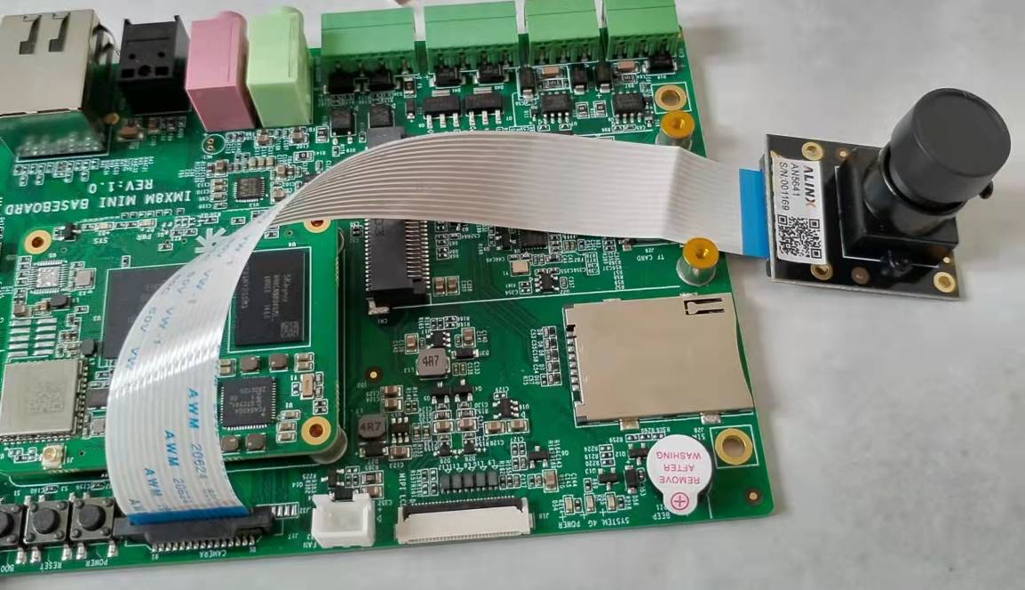

- Software Configuration:
- cd <YOUR_PATH>/linux-imx-5.4.47
- vi arch/arm64/boot/dts/freescale/fsl-imx8mm-demo.dts
&iomuxc {
pinctrl-names = "default";
pinctrl-0 = <&pinctrl_default>;
......
pinctrl_csi_pwn: csi_pwn_grp {
fsl,pins = <
MX8MM_IOMUXC_GPIO1_IO05_GPIO1_IO5 0x19
>;
};
};

&i2c3 {
clock-frequency = <100000>;
pinctrl-names = "default";
pinctrl-0 = <&pinctrl_i2c3>;
status = "okay";

......

ov5640_mipi: ov5640_mipi@3c {
compatible = "ovti,ov5640_mipi";
reg = <0x3c>;
status = "okay";
pinctrl-names = "default";
pinctrl-0 = <&pinctrl_csi_pwn>;
clocks = <&clk IMX8MM_CLK_CLKO1>;
clock-names = "csi_mclk";
assigned-clocks = <&clk IMX8MM_CLK_CLKO1>;
assigned-clock-parents = <&clk IMX8MM_CLK_24M>;
assigned-clock-rates = <24000000>;
csi_id = <0>;
pwn-gpios = <&gpio1 5 GPIO_ACTIVE_LOW>;
mclk = <24000000>;
mclk_source = <0>;
port {
ov5640_mipi1_ep: endpoint {
remote-endpoint = <&mipi1_sensor_ep>;
};
};
};
};

&csi1_bridge {
fsl,mipi-mode;
status = "okay";

port {
csi1_ep: endpoint {
remote-endpoint = <&csi1_mipi_ep>;
};
};
};

&mipi_csi_1 {
#address-cells = <1>;
#size-cells = <0>;
status = "okay";

port {
mipi1_sensor_ep: endpoint@1 {
remote-endpoint = <&ov5640_mipi1_ep>;
data-lanes = <2>;
csis-hs-settle = <13>;
csis-clk-settle = <2>;
csis-wclk;
};

csi1_mipi_ep: endpoint@2 {
remote-endpoint = <&csi1_ep>;
};
};
};

- vi drivers/media/platform/mxc/capture/ov5640_mipi_v2.c [refer to the below patch to update it]
--- a/drivers/media/platform/mxc/capture/ov5640_mipi_v2.c
+++ b/drivers/media/platform/mxc/capture/ov5640_mipi_v2.c
@@ -123,6 +123,7 @@ struct ov5640 {

void (*io_init)(struct ov5640 *);
int pwn_gpio, rst_gpio;
+ enum of_gpio_flags pwn_gpio_flags;
};

struct ov5640_res {
@@ -499,9 +500,9 @@ static inline void ov5640_power_down(struct ov5640 *sensor, int enable)
return;

if (!enable)
- gpio_set_value_cansleep(sensor->pwn_gpio, 0);
+ gpio_set_value_cansleep(sensor->pwn_gpio, !!(sensor->pwn_gpio_flags & OF_GPIO_ACTIVE_LOW));
else
- gpio_set_value_cansleep(sensor->pwn_gpio, 1);
+ gpio_set_value_cansleep(sensor->pwn_gpio, !(sensor->pwn_gpio_flags & OF_GPIO_ACTIVE_LOW));

msleep(2);
}
@@ -551,13 +552,13 @@ static void ov5640_reset(struct ov5640 *sensor)
gpio_set_value(sensor->rst_gpio, 1);

/* camera power dowmn */
- gpio_set_value(sensor->pwn_gpio, 1);
+ gpio_set_value(sensor->pwn_gpio, !(sensor->pwn_gpio_flags & OF_GPIO_ACTIVE_LOW));
msleep(5);

gpio_set_value(sensor->rst_gpio, 0);
msleep(1);

- gpio_set_value(sensor->pwn_gpio, 0);
+ gpio_set_value(sensor->pwn_gpio, !!(sensor->pwn_gpio_flags & OF_GPIO_ACTIVE_LOW));
msleep(5);

gpio_set_value(sensor->rst_gpio, 1);
@@ -1712,7 +1713,7 @@ static int ov5640_probe(struct i2c_client *client,
dev_warn(dev, "No pin available\n");

/* request power down pin */
- sensor->pwn_gpio = of_get_named_gpio(dev->of_node, "pwn-gpios", 0);
+ sensor->pwn_gpio = of_get_named_gpio_flags(dev->of_node, "pwn-gpios", 0, &(sensor->pwn_gpio_flags));
if (!gpio_is_valid(sensor->pwn_gpio))
dev_warn(dev, "No sensor pwdn pin available");
else {

- make ARCH=arm64 imx8mm_demo_defconfig
- make ARCH=arm64 menuconfig
Device Drivers --->
<*> Multimedia support --->
[*] V4L platform devices --->
<*> mxc mipi csi driver
MXC Camera/V4L2 PRP Features support --->
<*> OmniVision ov5640 camera support using mipi
- Rebuild the kernel to get dtb and Image, update them on ARM board.
- Boot and test:
- root@arm:~# gst-launch-1.0 v4l2src device=/dev/video0 ! video/x-raw,width=1920,height=1080 ! waylandsink window-width=1280 window-height=720
Setting pipeline to PAUSED ...
Pipeline is live and does not need PREROLL ...
Setting pipeline to PLAYING ...
New clock: GstSystemClock
[ 154.230969] ov5640_mipi 2-003c: s_stream: 1
Now you can see the live video captured by camera on wayland desktop.

