|  |
| --- |
| **CMSE 322 – Software Design**  **Team Project Proposal**  **PROJECT NO : 1**  **PROJECT NAME: Mobile Grade and Exam Tracking**  **PROJECT START DATE : 15 March 2017**  **PROJECT END DATE : 26 May 2017** |

A.1. Preliminary Project Information

# A.1.1

|  |  |
| --- | --- |
| **Project No** | 1 |
| **Project Name** | Mobile Grade and Exam Tracking Automation |
| **Start Date** | 15 March 2017 |
| **End Date** | 26 May 2017 |
| **Time** | 10 Weeks |

# A.1.2

|  |  |  |  |
| --- | --- | --- | --- |
| **Project Manager** | | | |
| **Name Surname** | Fikri Kurtuluş | **ID No** | 131133 |
| **Title/Role** | Project Manager/Lead System Analyst/Lead Programmer | | |
| **Address** | Famagusta/TRNC | | |
| **Phone** | +90 (533) 857 58 25 | | |
| **Email** | Fikrikurtulus53@gmail.com | | |

A.2 Group Information

# A.2.1

|  |  |  |  |
| --- | --- | --- | --- |
| **Student 1** | | | |
| **Name Surname** | Ahmet Sezen | **ID No** | 142323 |
| **Title/Role** | User Interface Designer/Tester/Network Designer | | |
| **Address** | Famagusta/TRNC | | |
| **Phone** | +90 (542) 858 17 17 | | |
| **Email** | sezenahmeet@gmail.com | | |

|  |  |  |  |
| --- | --- | --- | --- |
| **Student 2** | | | |
| **Name Surname** | Berke Muhtaroğlu | **ID No** | 133429 |
| **Title/Role** | Administrator/Programmer/Database Developer | | |
| **Address** | Famagusta/TRNC | | |
| **Phone** | +90 (533) 877 38 18 | | |
| **Email** | berkemuhtaroglu@gmail.com | | |

# A.2.2

|  |
| --- |
| **List of Completed / Ongoing Projects of Team** |
| * Software Security Term Project – C# Cypher encrypted and access control models user and file management * Software Requirements Analysis Term Project – Course scheduling system of EMU computer engineering department |

B.1 Introduction to Project

# B.1.1

|  |
| --- |
| **Summary of Project** |
| An automation/application that gives chance to track grades and exams from application. Instructors can enter exams, dates, topics, sample files and give enrollment chance to students. Students can track their exam grades (for each question), enroll any exam of their lectures. There will be available all materials uploaded by instructors. |

# B.1.2

|  |
| --- |
| **Key Words** |
| iOS, mobile, application, exam, grade, tracking, automation, exam dates, exam topics, course materials |

# B.1.3

|  |
| --- |
| **Aim of Project** |
| To ensure the best possible interaction between students and instructors, such as lecture notes, exam materials and course materials. |

# B.1.4

|  |
| --- |
| **Innovative Aspects/Contributions of Project** |
| This project is an innovative mobile-based application. Today, many student portals for students are web based. The most important innovation that distinguishes the project from its competitors is that it can run smoothly on mobile devices. Because most student portals have limited possibilities, a mobile and modular system will see more demand in the technology age. |

# B.1.5

|  |
| --- |
| **Methods to be Applied** |
| Interview (Data collection method)  Object Oriented System Development  UML Diagrams (OOSA)  Unit Testing |

# B.1.6

|  |
| --- |
| **Economic and National Outcomes** |
| Lecture notes and examination materials will be shared and will be benefited from transportation and printing costs. |

B.2 Reason of Starting the Project, Methods and R&D Stages

# B.2.1

|  |
| --- |
| **1- Explain the reason of starting this project. (Max 500 charachter)** |
| Lack of communication between instructors and students and the inability of students to get detailed information about exams, difficulties of students in finding the course materials, and inexplicable publication of exam grades are reasons why we enter this job. |

|  |
| --- |
| **2- Explain the purpose of this project.** |
| Increasing interaction between students and instructors, providing students with detailed information about exam questions, and providing students with easy access to course material.a |

|  |
| --- |
| **3- Explain**   * **output of project** * **national / international standards if exist** * **the specific objectives of the project** * **success criterias** * **realistic constraints** |
| At the end of the project we aim to work on the mobile application. Our project can be applied to any department. At the end of the project, we will make important changes in the way students find material for the course and follow the exam result. For the project to be successful, we aim to have interactive teacher and student sessions. |
| **4- Explain**   * **the methods to be applied during R&D activities** * **applications** * **technics and tools to be used** * **standards to be followed under the workflow** |
| **Which SOFTWARE PROCESS MODEL in below will you apply? Why? How? Explain.**  **\* The waterfall model?**  **\*V-model of software process?**  **\*Evolutionary development?**  **\*Component-based software engineering? Etc.**  We will use waterfall development software process model. Because, we are planning to make a mobile application. So a mobile application needs changeable features in every time of project. In Waterfall model we will plan a part of program and after this part we will go next step. This advantage of Waterfall model makes applications better with agile and step by step working model.  **Explain, Project Workflow: Waterfall Model**   1. **Feasibility and Pre-research:**   There are applications such as Keystone Exam Tracking System and Exam Professor, which are close to our project in the market. There is no application or automation for students in the full sense of what students expect. This automation will be modular, so the evolution of application is depends real students' expectations.   1. **System Design:**   The methodology will be used at system design step is Joint Application Design methodology. We did not decide to use Rapid Application Development methodology. Because, we do not have any specific end user. So we should be able to finish project with our team members. Such that, Project manager, system designer, database designer.   1. **Software development:**   With the waterfall model, we plan to do the software development part of the project with teammates. The waterfall model will enable us to achieve better results while enabling us to follow software development steps more easily by providing more convenient documentation control.   1. **Prototype implementation and testing work:**   In prototype and code implementation step, we do not have a lot of alternatives to make an application for IOS platform. We will use XCode platform of Apple to design interface and write code of application. In testing step, we will use some tools for check our codes. Our basis thoughts are using unit testing for getting more effective results.   1. **Maintenance:**   We will use some tools like “github”, “bitbucket” to see all versions of project. So when we release application to users, we will be able to storage old version and publish the next version. With these things, also the application and all services of program will be tracking periodly. If there will be any problem or any missing parts, thanks to waterfall model, the team will be able to solve problems and after testing, publish the new version. |
| **5- Explain**   * **the contribution of national/international technological development if exist** * **starting a new research and development projects within or outside the team** * **launch new applications or research studies in different technology areas**   **With whom we can cooperate?**  **Expectations:**  **Published work:**  **Can your output be an input for other similar national/international projects?** |
| For the spread of the project, it is possible to communicate with the schools/universities and establish a business association. The project can be developed within Android which is an another mobile technology. Also, this project can be developed as a web-based application other than mobile application. |

B.3 Innovative and Unique Aspects

# B.3.1

|  |
| --- |
| **1- Describe**   * **differences** * **advantages** * **superiority**   **compared to other similar projects.** |
| According to similar projects, our best advantage is to be developed according to the wishes of the users and to be perfect and modular. Other projects have a fixed pattern and everyone has to use it according to the rules of the project. In our project, changeability will be available depending on demand and needs. The results of the exam are the ones that reach the student on the basis of the question, the right to enroll in the exams, and the right to have direct access to the intructors’ share. |

# B.4.1

|  |
| --- |
| **2- Who can contribute to this project in your team?** |
| * Project Manager * System Designer * Database Developer * Interface Designer * Lead Programmer |

C.1 Gantt Chart and Work Packages

# C.1.1 Gantt Chart and PERT Analysis

**Gantt Chart:**

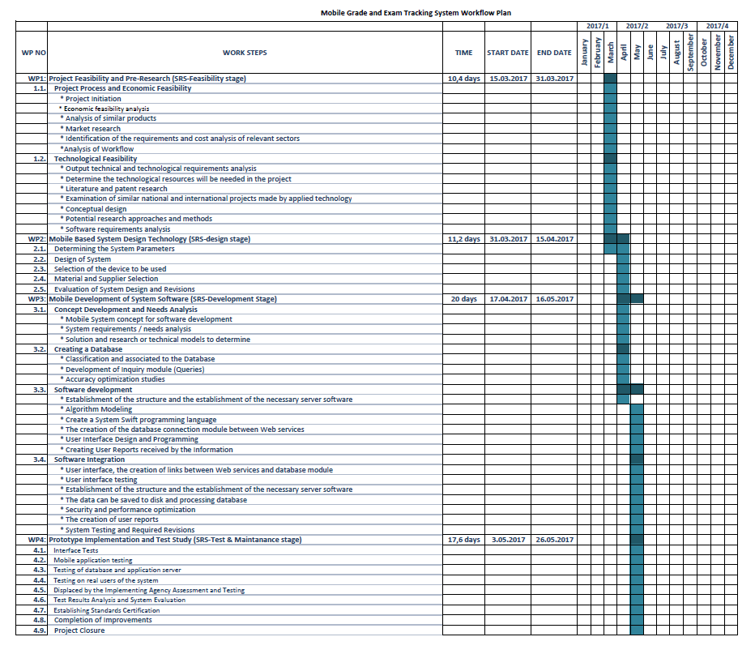

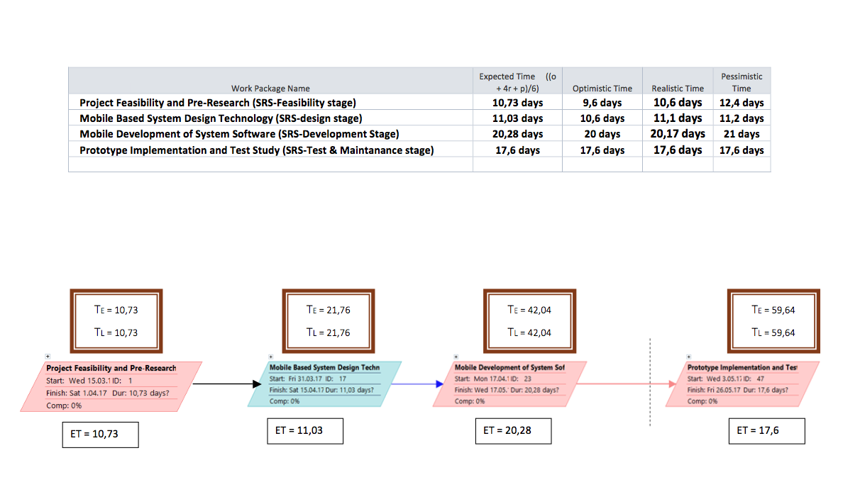**Pert Analysis and Network Diagram:**

# C.1.2 List of Work Packages

|  |  |
| --- | --- |
| **Work Package No** | 1 |
| **Work Package Name** | **Project Feasibility and Pre-Research (SRS-Feasibility stage)** |
| **Start-End Date and Time** | 15.03.17/31.03.17 2 Weeks |
| **Related Organizations** | - |

|  |
| --- |
| **1- List the activities of work packages.** |
| * 1. **Project Process and Economic Feasibility:** * **Project initiation** * **Analysis of similar products** * **Market research** * **Identification of the requirements and cost analysis of relevant sectors** * **Analysis of workflow**   1. **Technological Feasibility:** * **Output technical and technological requirements analysis** * **Determine the technological resources will be needed in the project** * **Literature and patent research** * **Examination of similar national and international projects made by applied technology** * **Conceptual design** * **Potential research approaches and methods** * **Software requirements analysis** |
| **2- Describe the methods and parameters that will be used for work package.** |
| Technical, legal, operational and schedule feasibility techniques will be used in this work package. |
| **3- List the experiments, tests and analysis in the work package.** |
| * Economic market and outcomes test * Technological requirements and users’ needs test * Project process flow test |
| **4- List the output of work package and its success criterias.** |
| **Outputs:**  The output of feasibility study will show similar projects’ marketspace and missing features  **Success Criterias:**  If current systems have little usability and features, our project will deserves to work on it. |
| **5- Explain the relation of output with other work packages** |
| Other work packages prerequisite to this feasibility work package. So, only after this work package successfully end, we can start to work on other work packages. |

|  |  |
| --- | --- |
| **Work Package No** | 2 |
| **Work Package Name** | **Mobile Based System Design Technology (SRS-design stage)** |
| **Start-End Date and Time** | 31.03.17/15.04.17 2 Weeks |
| **Related Organizations** | - |

|  |
| --- |
| **1- List the activities of work packages.** |
| * **Determining the system parameters.** * **Design of System.** * **Selection of the device to be used.** * **Material and supplier selection** * **Evaluation of system design and revisions.** |
| **2- Describe the methods and parameters that will be used for work package.** |
| * Figuring out system architecture with this work package * Research about the most useful methodologies for project |
| **3- List the experiments, tests and analysis in the work package.** |
| * Research about convenient development interface * Research about coding language * Research about application of system architecture to project |
| **4- List the output of work package and its success criterias.** |
| **Outputs:**  The most important output is fully ready system architecture for development stage.  **Success Criterias:**  Convenient models and methodologies. |
| **5- Explain the relation of output with other work packages** |
| Before starting development and implementation steps, the most important thing is system design/architecture to reach success at next steps of project. |

|  |  |
| --- | --- |
| **Work Package No** | 3 |
| **Work Package Name** | **Mobile Development of System Software (SRS-Development Stage)** |
| **Start-End Date and Time** | 17.04.17/16.05.17 3 Weeks |
| **Related Organizations** | - |

|  |
| --- |
| **1- List the activities of work packages.** |
| * **Concept development and needs analysis** * **Creating database** * **Software development** * **Software integration** |
| **2- Describe the methods and parameters that will be used for work package.** |
| * Creating relational database with ER and different diagrams * Using pre-desired software language and platform. |
| **3- List the experiments, tests and analysis in the work package.** |
| * Start time for coding * Little unit tests for strong codes * Integration with IDE, DB * Interface design with professional tools |
| **4- List the output of work package and its success criterias.** |
| **Outputs:**   * Running sample application of project * Ready to test codes   **Success Criterias:**   * Low error rate in coding step * Effective database design and implementation |
| **5- Explain the relation of output with other work packages** |
| The project is fully connected this work package because other work packages are preparatory for this step. After this work package there will be only testing and releasing steps. |

|  |  |
| --- | --- |
| **Work Package No** | 4 |
| **Work Package Name** | **Prototype Implementation and Test Study and Maintenance (SRS-Test &Maintenance stage)** |
| **Start-End Date and Time** | 03.05.17/26.05.17 2 Weeks |
| **Related Organizations** | - |

|  |
| --- |
| **1- List the activities of work packages.** |
| * **Interface tests** * **Mobile application testing** * **Testing of database and application server** * **Testing on real users of the system** * **Displaced by the implementing agency assessment and testing** * **Test results analysis and system evaluation** * **Establishing standards certification** * **Completion of improvements** * **Project closure** |
| **2- Describe the methods and parameters that will be used for work package.** |
| * Database testing * Interface testing by all team members * Testing real users’ opinions about project and usability |
| **3- List the experiments, tests and analysis in the work package.** |
| * Unit test will be completed and correctings errors if there exist. Unit test is the most important test for project release step. |
| **4- List the output of work package and its success criterias.** |
| **Outputs:**   * Reporting test results * Ready to release project   **Success Criterias:**   * The application should be passed from all test perfectly. |
| **5- Explain the relation of output with other work packages** |
| This work package is last one. So, if this work package’s steps will be perfectly completed, our project will be done. It means, the project is ready to release market and gain. |

# C.1.3 List of Milestones

|  |  |  |
| --- | --- | --- |
|  | **Description of Output** | **Expected Time Interval** |
| 1 | Feasibility Studies & Pre-Research | 15.03.2017 – 31.03.2017 |
| 2 | SRS System Design | 31.03.2017 – 15.04.2017 |
| 3 | SRS Development Stage | 17.04.2017 – 16.05.2017 |
| 4 | SRS Test & Maintance Stage | 03.05.2017 – 26.05.2017 |

# C.1.4 List of Risks

|  |  |  |  |
| --- | --- | --- | --- |
| Risk | Probability | Effects | Your Strategy |
| The time required to develop the software is underestimated. | High | Serious | Can be solved with a properly configured job distribution and continuous team meetings. |
| Software tools cannot work together in an integrated way. | High | Tolerable | Can be found new tools to use or integrated needs manually. |
| Customers fail to understand the impact of requirements changes. | Moderate | Tolerable | Change requirements with new understandable requirements dependly demands. |
| The rate of defect repair is underestimated. | Moderate | Tolerable | Replace potentially defective components with more reliable bought-in components. |
| The size of the software is underestimated. | High | Serious | Investigate buying sw components;  Investigate use of a program generator. |
| Code generated by code generation tools is inefficient. | Moderate | Insignificant | Code can be written on different compilers, different languages. |
| Key staff are ill at critical times in the project. | Moderate | Serious | Reorganize team so that there is more overlap of work and people therefore understand each other’s jobs. |
| The database used in the system cannot process as many transactions per second as expected. | Moderate | Serious | Investigate the possibility of buying a higher-performance database. |

C.2 Project Management and Organization

# C.2.1 Project Team

|  |  |  |  |  |  |  |
| --- | --- | --- | --- | --- | --- | --- |
| **Personnel Name** | **Title** | **ID** | **Education Status** | **Graduation Date** | **Date of Starting Work** | **Idea Owner** |
| Fikri Kurtuluş | Project Manager | 131133 | B.S. | 2018 | 15.03.17 |  |
| Ahmet Sezen | Database Developer | 142323 | B.S. | 2018 | 15.03.17 |  |
| Berke Muhtaroğlu | Administrator | 133429 | B.S. | 2018 | 15.03.17 |  |

# C.2.2 Organization Scheme

# Drawing1

D.1 Economic Forecasts

|  |
| --- |
| **1- Evaluate the commercialization potential of project outcomes. List possible risks here?** |
| Our project, the portal system can be preferred by those who are not enough. The portal system may not be preferred by the developed schools in terms of commercialization risk. |

|  |  |
| --- | --- |
| **2- List your expectations to your team which are come by your project** | |
| Time-to-market (month): | June |
| The expected increase in sales revenue (%): | 5 |
| The expected increase in market share (%): | 10 |
| Time to start to gain: | December 2017 |

D.2 National Outcomes

|  |
| --- |
| **1- Specify the output that may be subject to patent, utility model and industrial design registration in the project.** |
| We can adapt our project differently for each school/university. According to incoming requests, we can create different industrial designs for each school/university. |
| **2- Explain the potential of project and its outputs that may have an effect on social life, education, health and etc.** |
| This project will have an effect on education. Because the project is aimed at students, it is linked to education. In addition, the impact of the project on the students is directly proportional to the effect on the education. |
| **3- Explain the positive and negative effects of project outputs for environment and human being.** |
| * Positive effects : Instructors caninteract with the students, students can get detailed information about the their exam results and they can easily access the course materials. * Negative effects: There may be people who think that they can cause radiation diseases because it increases the use of mobile phones. |

(M013) Instrument / Equipment / Software / RELEASE PURCHASES

|  |  |  |  |  |  |  |  |  |  |  |  |
| --- | --- | --- | --- | --- | --- | --- | --- | --- | --- | --- | --- |
| **Project Name** | | **Mobile Grade and Exam Tracking Automation** | | | | | | | | | |
| **Line no** | **Instrument / Equipment / Software / Publication Name** | | **No. of Item** | **Capacity** | **Technical specification** | **Purpose of Project Activities** | **Post-Project Place of Use / Purpose** | | **Unit Price (USD)** | **Unit Price (TL)** | **Total Amount (TL)** |
| **R & D** | **Production** |
| **1** | **Macbook Pro** | | **1** |  | **Min. i5 – 8gb** | **Xcode IDE** | **Coding** | **Coding** | **1650 USD** | **6200 TL** | **6200 TL** |
| **2** | **Internet Connection** | | **1** |  | **Min. 6 Mbit** | **Connection** | **Research** | **Communication** | **100 USD** | **400 TL** | **400 TL** |
| **3** | **iPhone** | | **1** |  | **Min. İphone 5S** | **Emulation** | **Emulation** | **Test** | **400 USD** | **1600 TL** | **1600 TL** |
| **4** | **Apple Developer Account** | | **1** |  | **EU** | **Publishing Applications** | **Documentation** | **IOS App. Market** | **100 USD** | **400 TL** | **400 TL** |
| **5** | **Printer** | | **1** |  | **HP** | **Printing out** | **Documentation** | **Documentation** | **100 USD** | **400 TL** | **400 TL** |
| **6** |  | |  |  |  |  |  |  |  |  |  |
| **7** |  | |  |  |  |  |  |  |  |  |  |
| **8** |  | |  |  |  |  |  |  |  |  |  |
| **9** |  | |  |  |  |  |  |  |  |  |  |
| **10** |  | |  |  |  |  |  |  |  |  |  |
|  |  | |  |  |  |  |  |  |  | **TOTAL** | **9000 TL** |

(M030) Quarterly Estimated Cost Form (TL)

|  |  |  |  |  |
| --- | --- | --- | --- | --- |
| **Project Name : Mobile Grade and Exam Tracking Automation** | | | | |
| **Cost Item** | **2017** | | **TOTAL**  **(TL)** | **TOTAL COST RATE OF CONTENTS (%)** |
| **I** | **II** |
| **Personnel** | 54.000 | 54.000 | 108.000 | %89,2 |
| **Travel** | 3.000 | 3.000 | 6.000 | %2,8 |
| **Instrument / Equipment / Software / Publications** | 9.000 | - | 9.000 | %8 |
| **Domestic Works Made By R & D and Testing Institutions** | - | - | - | - |
| **International Works Made By R & D and Testing Institutions** | - | - | - | - |
| **Domestic Services Procurement** | - | - | - | - |
| **Overseas Service Procurement** | - | - | - | - |
| **Material** | *Depends that time’s needs | *Depends that time’s needs | - | - |
| **TOTAL COST** | 66.000 | 57.000 |  | 100 |
| **CUMULATIVE COST** |  |  | 123.000 | 100 |
| **IN THE PROJECT TOTAL MAN-MONTH** | | | 123.000 | |

APPENDIX

SCREENSHOTS FROM MICROSOFT PROJECT 2016

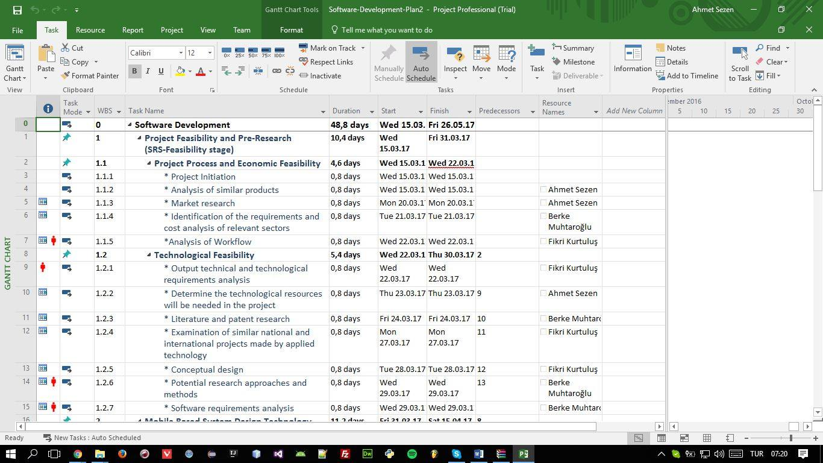

*Fig 1.* Work Packages

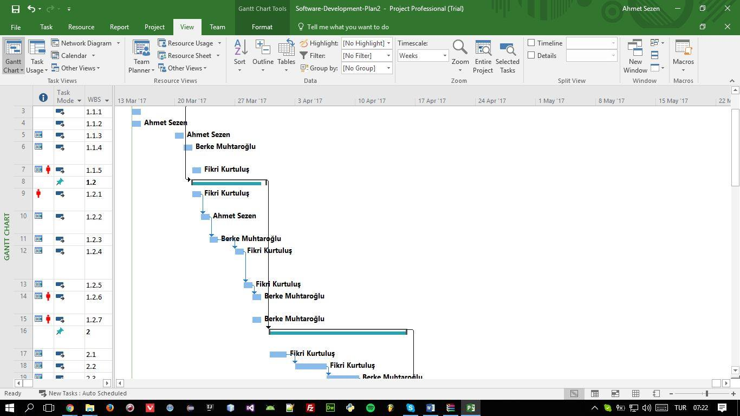

*Fig 2.* Team members’ time line sample period