

**SDS DOCUMENT FOR TAKE OUT APPLICATION**

**BY**

**Oyinbobola Owojori 128236**

**Abdulrazak Yakubu 138859**

**Zainab Sada 149190**

**Kamshinen Rotdung 138893**

**Table of Contents**

Contents

1.1Purpose 5

1.2 Scope 5

1.3 DEFINITIONS, ACRONYMS AND ABBREVIATION 5

1.4 OVERVIEW 5

2.0 DECOMPOSITION DESCRIPTION 6

2.1 Module Decomposition 6

• GUI 7

• Customer side 7

• Restaurant side 7

• SERVICES: 7

• DATABASE(DB): 7

Menu entity 8

Category entity 8

Item entity 8

2.2 CONCURRENT PROCESS DECOMPOSITION 8

Order entity 8

Order item entity 8

2.3 DATA DECOMPOSITON 8

Address entity 8

Customer entity 8

Restaurant entity 8

3.0 DEPENDENCY DESCIPTION 9

**3.**1 Inter-module dependency 9

4.0 INTERFACE DESCRIPTION 9

**4.**1 CUSTOMER USER SIDE 9

4.1.1 Register screen 9

4.1.2 LOGIN SCREEN 10

4.1.3 User Confirmation Page 11

4.1.4 Main Screen 12

4.1.4 Cart window 13

4.1.4 Favorite window 13

4.1.5 Restaurant screen 14

4.1.6 Item window 15

4.1.7 Cart window 16

4.1.8 Order status window 17

4.1.9 Search filter 18

4.1.10 Edit Profile 19

4.2 RESTAURANT USER SIDE 21

4.2.1 Registration Screen 21

4.2.2 Restaurant Setup. 22

4.2.3 Order Viewing 27

5. DETAILED DESIGN 28

5.1 Address detailed 29

5.2 Customer detailed 29

5.3 Restaurant detailed 30

5.4 Order detailed 30

5.5 Order_item 30

5.6 Menu detailed 31

5.7 Category detailed 31

5.8 Item detailed 31

6. UML DIAGRAMS 32

6.1 BPMN diagram. 32

6.2 Activity Diagram 33

6.4 Order Sequence Diagram 33

6.5 DFD DIAMGRAMS 34

6.5.1 Context diagram 34

6.5.2 Level 0 DFD Food Delivery 34

6.5.3 level 1 of System 35

7. REFERENCES 36

**List of Figures**

Figure 1 Take Out ER diagram for major parts 6

Figure 2 module decomposition 7

Figure 3 registration UI screen 9

Figure 4 user login screen 10

Figure 5 Confirmation screen 11

Figure 6 main screen 12

Figure 7 Cart window 13

Figure 8 favorites window 14

Figure 9 restaurant screen 15

Figure 10 Item window 16

Figure 11 cart window 17

Figure 12 order status window 18

Figure 13 Filtered search 19

Figure 14 Edit Profile 20

Figure 15 restaurant register screen 21

Figure 16 build restaurant screen 22

Figure 17 Contact Information 23

Figure 18 delivery Region Selection 24

Figure 19 Set Delivery time Range 25

Figure 20 Upload Logo 26

Figure 21 Build Menu Screens 27

Figure 22 Order Viewing and status 28

Figure 23 BPMN diagram 32

Figure 24 Activity diagram 33

Figure 25 Order sequence 33

Figure 26 Context Diagram 34

Figure 27 Level 0 Food Delivery 34

Figure 28 level 1 of System 35

1.0 INTRODUCTION

## 1.1Purpose

This document known as the Software Description document is mostly useful in the implementation stage, It contains the full description of the systems main components to satisfy client requirements to the fullest capability of the design and implementation team.

## 1.2 Scope

Most popular restaurants still use the traditional call and order system which works but not the best, our goal with the Take Out system is to provide an easier and more efficient meant of communication between restaurant and customer and also fix a major limitation which is the need for airtime to call and order, this fix is going to be very beneficial to mainly students but also every order person just because its saves us extra money from buying airtime.

## 1.3 DEFINITIONS, ACRONYMS AND ABBREVIATION

SRS: Software Requirements Specification

UR: User Requirement

DB: Database

I: Implementation

DP: Deployment

UML: Unified Modelling Language

## 1.4 OVERVIEW

Up to this document, Project Proposal Document, Software Project Management Plan (SPMP) and Software Requirements Specification (SRS) have been prepared. In this document, detailed design of the system with user interfaces will be described. In section 2; Decomposition of the system with module decomposition, concurrent process decomposition and data decomposition is given, in section 3; Dependency Description is given, in section 4; User Interface Description can be found and finally in section 5 Detailed Design of the system is provided.

# 2.0 DECOMPOSITION DESCRIPTION

Below is a diagram showing the view of entities of Take Out system in a hierarchical fashion, in this section a brief explanation for each entity shall be given.

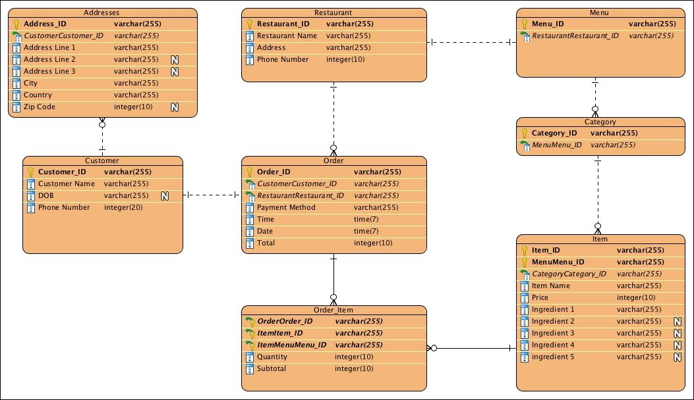

Figure 1 Take Out ER diagram for major parts

Furthermore we shall briefly give description of each entity of lunch box, in which we have divided into three categories module entities, concurrent process entities, data entities.

## 2.1 Module Decomposition

Take Out has five main modules which are GUI, customer side, restaurant side, database and services as show in the figure below.

<<Interacts>>

**DB**

**RESTAURANT SIDE**

**CUSTOMER SIDE**

**GUI**

<Manages>

<<Views>> <<stores>>

**SERVICES**

<<Inserts>>

<<Updates>>

Figure 2 module decomposition

* GUI **:** a friendly and forgiven graphical user interface that’s interact with its user types and help with viewing database contents, since Take Out has two main user types we also accordingly have two distinct GUIs, the customer GUI and restaurant GUI.

1. Customer window: this is the interaction window between customers and the system services like food viewing, placing orders, account registration ,account editing and all other use cases described in the SRS document
2. Restaurant window: this is the interface between the restaurants admin and the system giving access to interact with Take Out services available for restaurants like registration building a menu ,edit menu and all other use cases for restaurants as described by clients in the SRS document.

Detailed GUI description later on in the interface description section

* Customer side**:** this components contains entities involved with customer activities of Take Out ranging from registration down to food ordering and everything in between. More details in SRS document
* Restaurant side**:** this module is similar to the above but this focuses on the restaurant and it use cases described in the SRS document
* SERVICES:This module involves all business logic operation like the order processing feature from customer by restaurant and inserting and updating information in the DB.
* DATABASE(DB): a standing external entity responsible for storing and managing large amount of data concurrently being inserted, updated or deleted.

### Menu entity

This entity is one in which every restaurant must have and customers interact with, more details in section 5.

### Category entity

Each restaurant has one or more variety of menus distinguished by what category the menu belongs to. More details in section 5.

### Item entity

These are restaurant products like food, drinks, beverages etc. More details in section 5.

## 2.2 CONCURRENT PROCESS DECOMPOSITION

### Order entity

This is responsible of gathering all inputted information and available resources to complete order process. More details in section 5.

### Order item entity

This is as a result of the order process it deals with summing up total through a mathematical function .More details in section 5.

## 2.3 DATA DECOMPOSITON

### Address entity

This here is responsible for holding all data concerning the delivery address of each registered customer. More details in section 5.

### Customer entity

This here contains detail of every registered customer user and capabilities. More details in section 5.

### Restaurant entity

This here contains detail of every registered restaurant user and capabilities. More details in section 5.

# 3.0 DEPENDENCY DESCIPTION

## **3.**1 Inter-module dependency

**A**s seen in figure 2 the different modules have some sort of dependency on each other. The GUI view database items and also interact with both user sides depending on user type, and both user sides insert, updates and deletes item on the database and service manages both user side activities .

# 4.0 INTERFACE DESCRIPTION

Here every user interface is clearly explained with the help of screenshots.

## **4.**1 CUSTOMER USER SIDE

### 4.1.1 Register screen

This screen is the basic register screen, it will be available to all new customers who wish to register on Take Out. This screen will provide authentication procedures just in case there are wrong entries.

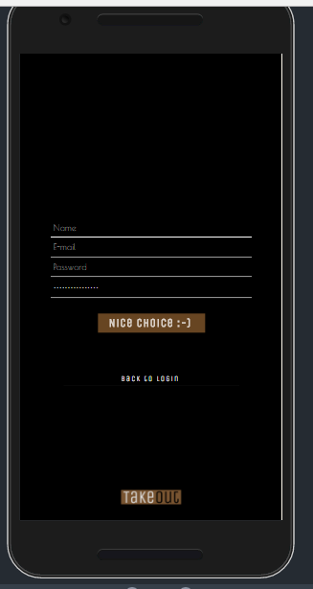

Figure 3 registration UI screen

### 4.1.2 LOGIN SCREEN

This screen here also shall be available to all customers providing authentication to registered users giving them access to Take Out.

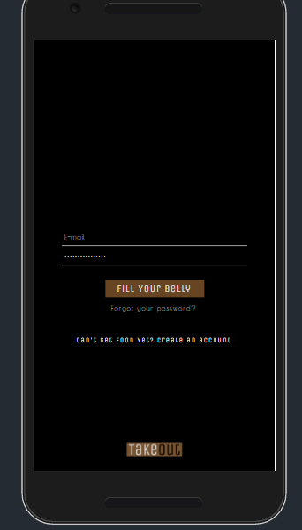

Redirects user to registration screen

Forgiving UI to allow you reset your user password

Press to submit and proceed

Figure 4 user login screen

### 4.1.3 User Confirmation Page

This shows the success of your registration as seen below in figure 5

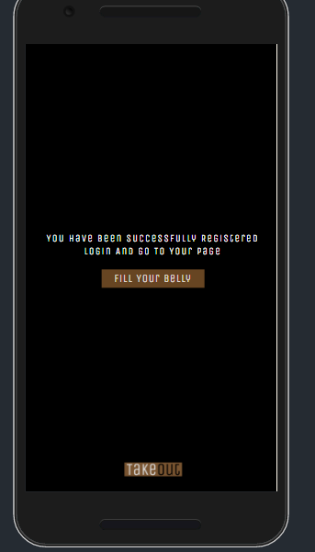

Proceed to Take Out main menu

Figure 5 Confirmation screen

### 4.1.4 Main Screen

This displays various predetermined restaurants for user to view based on nearest location, also containing tabs for search functionality, favorites, cart etc. This screen is the heart of the system as it is the major page linking all others.

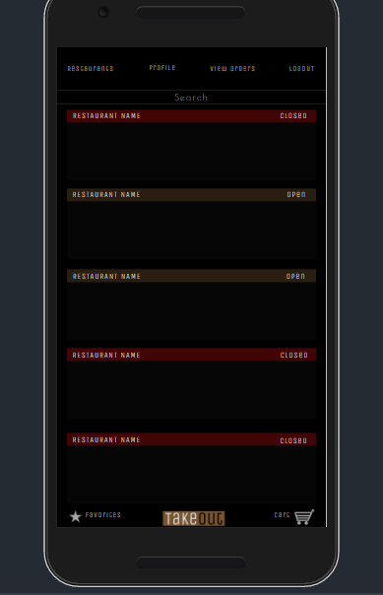

View personal profile

Search window

Log out

View favorites window

View cart screen

Figure 6 main screen

### 4.1.4 Cart window

This window gives a visual off item already in the cart and a quick access to the order placing functionality. It displays the total price and quantity of selected items to be processed.

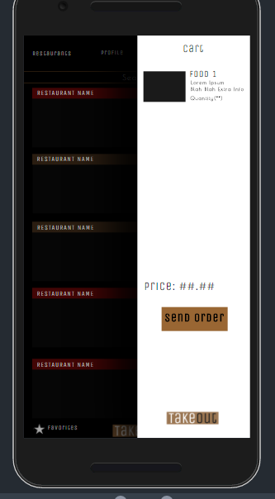

Total price to be charged

Selected food

And details

Figure 7 Cart window

### 4.1.4 Favorite window

Supplies quick access to ordering often ordered products by customer help in saving time by not having to search for same item or restaurant. The system keeps track of it for you(the customer).

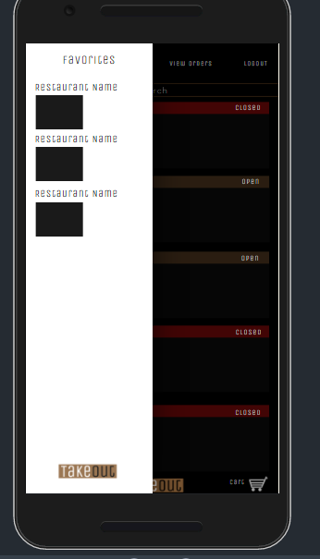

Figure 8 favorites window

### 4.1.5 Restaurant screen

Shows a single restaurant as selected by user to view its details, It displays its variety of products in categories for user to choose from as seen below.

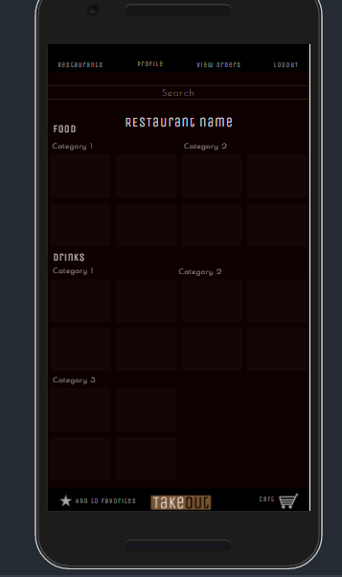

Figure 9 restaurant screen

### 4.1.6 Item window

After item has been selected these window allows you to choose how exactly you want that item prepared, you have the option to add or remove certain ingredients before adding to cart, helps with people with food allergies. It also allows you to select item quantity needed.

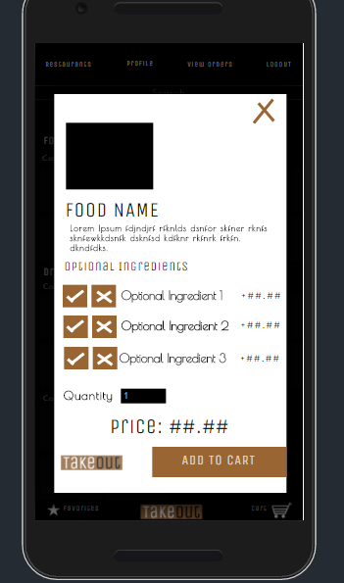

Figure 10 Item window

### 4.1.7 Cart window

This window gives you a full view of items you have previously selected, quantity and prices and also allow you to choose your ideal address and payment methods either by cash or credit. Take Out doesn’t handle transactions this information is just avoid misunderstandings during the delivery process.

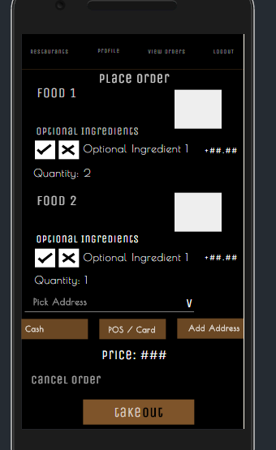

Figure 11 cart window

### 4.1.8 Order status window

This is one of two either your order has been accepted or it has been rejected. If rejected a reason is supplied an example might be insufficient ingredients or maybe underage in situation where an alcoholic item is ordered by a minor

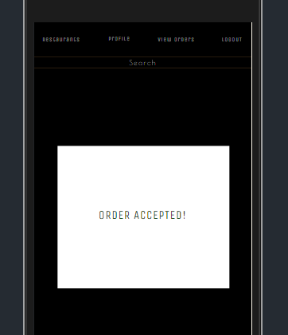 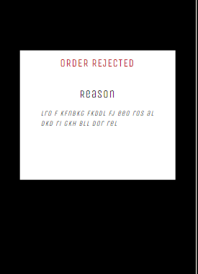

Figure 12 order status window

### 4.1.9 Search filter

Take Out narrows down your search using a timeline, results displayed are based on your orders between that timeline as seen below.

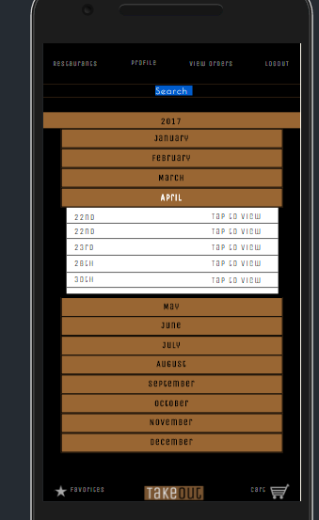 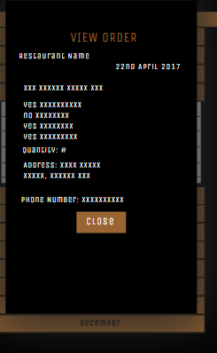

Figure 13 Filtered search

### 4.1.10 Edit Profile

This screen gives you ccess to change your profile details which will be immediately updated/deleted in the database .

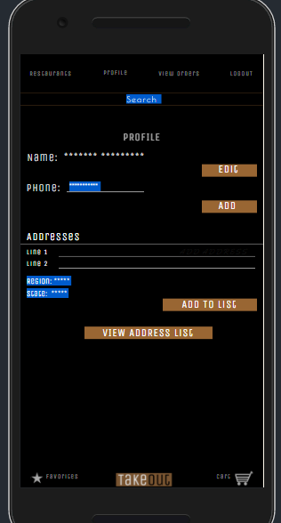

Figure 14 Edit Profile

## 4.2 RESTAURANT USER SIDE

### 4.2.1 Registration Screen

This screen is the basic register screen, it will be available to all new restaurants who wish to register on Take Out. This screen will provide authentication procedures just in case there are wrong entries. Also provides success note for successful registration.

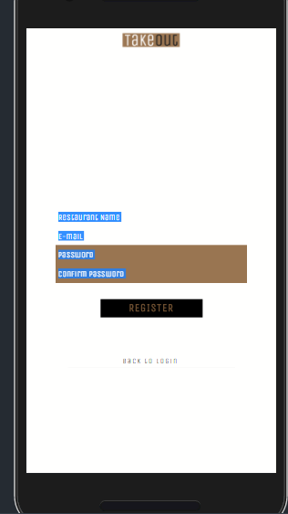 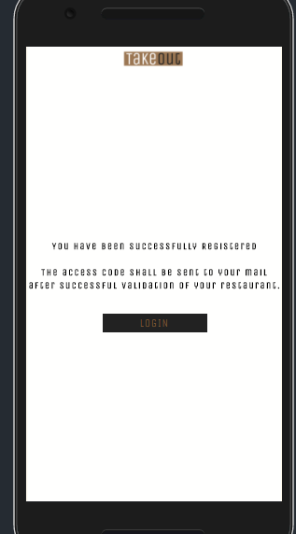

Figure 15 restaurant register screen

### 4.2.2 Restaurant Setup.

The series of images below show the step by step process involved in setting up restaurant with all required details and building digital menus to show you items which will be displayed on system when the specified restaurant comes up.

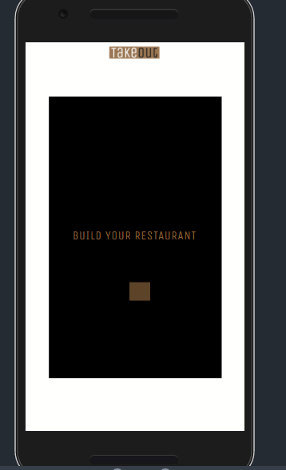

Figure 16 build restaurant screen

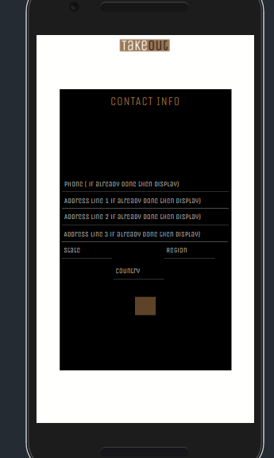

Figure 17 Contact Information

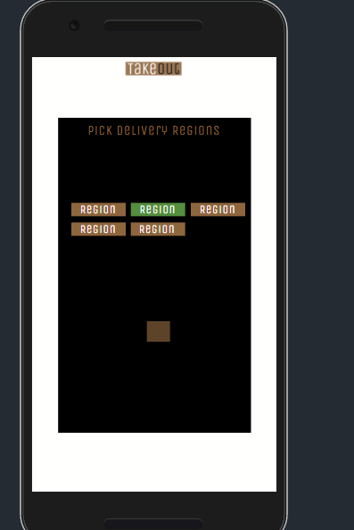

Figure 18 delivery Region Selection

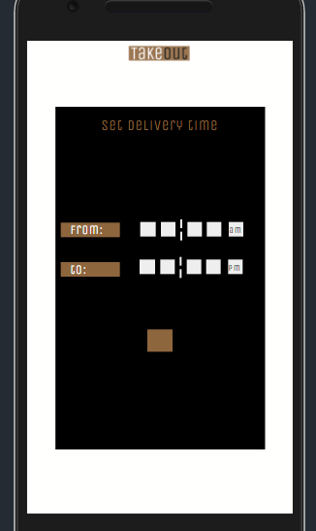

Figure 19 Set Delivery time Range

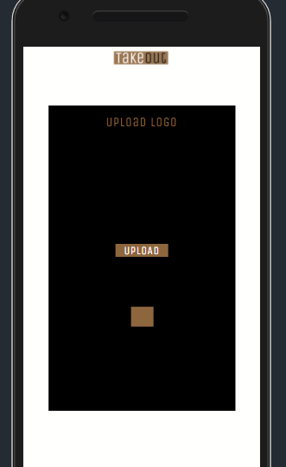

Figure 20 Upload Logo

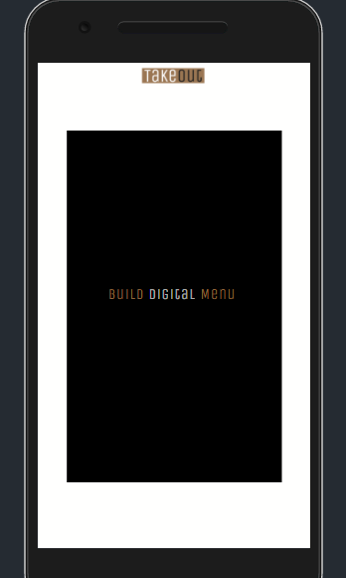 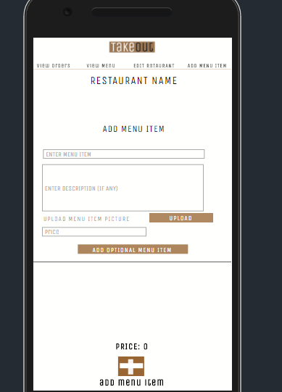

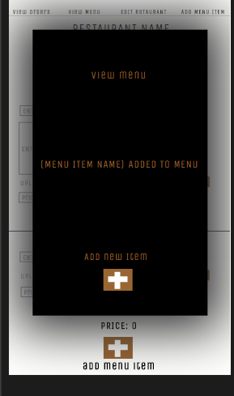

Figure 21 Build Menu Screens

### 4.2.3 Order Viewing

A view of received orders in order of arrival time to be processed by restaurant admin if it is to be accepted or rejected.

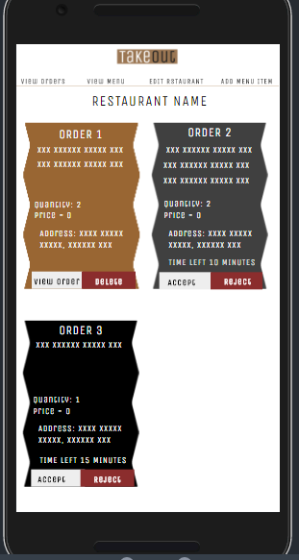 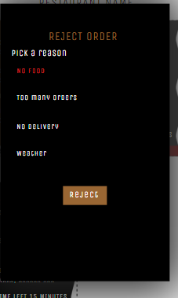

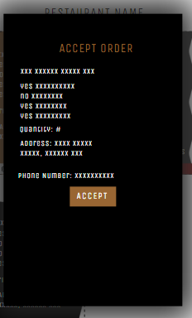

Figure 22 Order Viewing and status

# 5. DETAILED DESIGN

In this section each entity in figure 1 will be individually discussed clearly in full with respect their attributes and functions they perform or are used as inputs for.

## 5.1 Address detailed

This entity is one which hold all addresses of the customer to be stored in the database.

Attributes

* Address id this is the address unique identifier ,the primary key
* CustomerCustomer id is a reference from the customer id its responsible for matching customer to his address.
* Address Line 1-3: Three distinct address only one is needed the two are optional.
* City: a region where the system can locate in other to display nearest restaurants
* Country: The country the customer is located at the moment not customers nationality
* Zip code: series of numerical digits to show a more precise location of the customer

Functions

This entity has no predefined functions but it is used when making delivery

## 5.2 Customer detailed

This entity contains just the major details needed by the system to make its delivery functions

Attributes

* Customer id :unique customer identifier ,the primary key
* Customer name: the customers name
* DOB: customer date of birth this is needed to know if what is served is legal.
* Phone number: customer contact number

Functions

* Place order(item food, restaurant name):selected item to be ordered is being sent to the desired restaurant.
* addtoCart(item food, restaurant name):adding items to cart for further processing by customer not yet sent over.
* Editprofile(): customer address lines and/or removing .
* cancelorder(int order_id): cancelling an order within the time frame its possible.
* editOrder():add/remove ingredients from items to order.
* Search(restaurant, item): search Take Out database.

## 5.3 Restaurant detailed

This entity contains details of registered restaurants stored in the database

Attributes

* Restaurant id: unique restaurant identifier, the primary key.
* Restaurant name: the restaurant name to be displayed in the system.
* Address: where this restaurant is located.
* Phone number:the restaurant contact info.

Function

* orderstatus(): a Boolean function which returns false if order is rejected and vice versa.
* Makedelivery(): occurs after a precondition has been satisfied which is if other has been accepted.
* editmenu(): add/remove items to/from its menu .

## 5.4 Order detailed

This entity contains information about the order being made with respect to just the customer and restaurant simply.

Attributes

* Order_id .unique order identifier given as order is being made ,the primary key.
* CustomerCustomer_id: to identify which customer made the order.
* RestaurantRestaurant_id: to identify which restaurant was the order made to.
* Payment method: means of payment selected by customer.
* Time: specific time of the order.
* Date: date of the order.
* Total : total number of others received.

## 5.5 Order_item

This is a more detailed version of order entity.it contains unique details of other made including what was ordered.

Attributes

* OrderOrder_id: a foreign key to identify the order made uniquely.
* ItemItem_id: also a foreign key to identify the selected item from the menu.
* ItemMenuMenu: foreign key to identify which menu the item was ordered from
* Quantity: total distinct amount of that item was ordered.
* Subtotal: total price to be billed for that order.

## 5.6 Menu detailed

This entity holds details about the digital menu created buy each restaurant.

Attributes

* Menu_id: a unique menu id for every restaurant registered, Primary key.
* RestaurantRestaurant_id: an identifier to match restaurant to its menu

## 5.7 Category detailed

This is details about item categories like drinks, deserts etc.

Attributes

* Category_id: unique identifier for each item category available.
* MenuMenu_id: an identifier to match which menu the category was from.

## 5.8 Item detailed

This entity hold information used in order processing before making delivery.

Attributes

* Item_id: unique identifier for which item was ordered.
* MenuMenu_id:unique identifier for which menu was the order from.
* CategoryCategory_ID: identifier to match which category from which menu the order was made from.
* Item name: name of ordered item of the menu.
* Price: price of ordered item.
* Ingredient 1-5: ingredient contained in the ordered item.

# 6. UML DIAGRAMS

## 6.1 BPMN diagram.

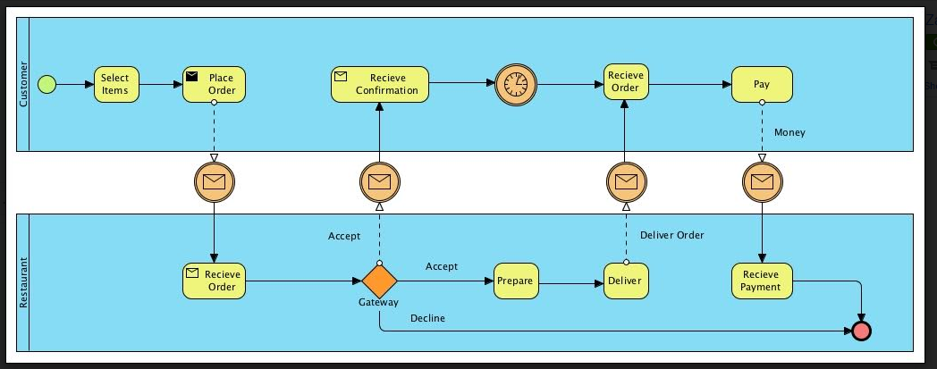

Figure 23 BPMN diagram

6.2 Activity Diagram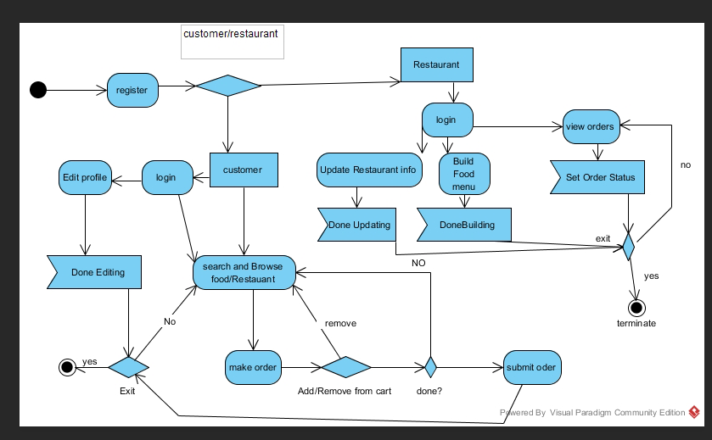

Figure 24 Activity diagram

## 6.4 Order Sequence Diagram

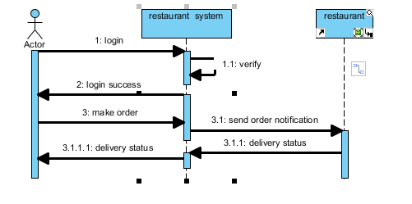

Figure 25 Order sequence

## 6.5 DFD DIAMGRAMS

### 6.5.1 Context diagram

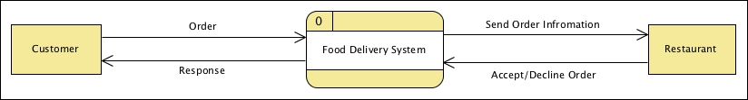

Figure 26 Context Diagram

### 6.5.2 Level 0 DFD Food Delivery

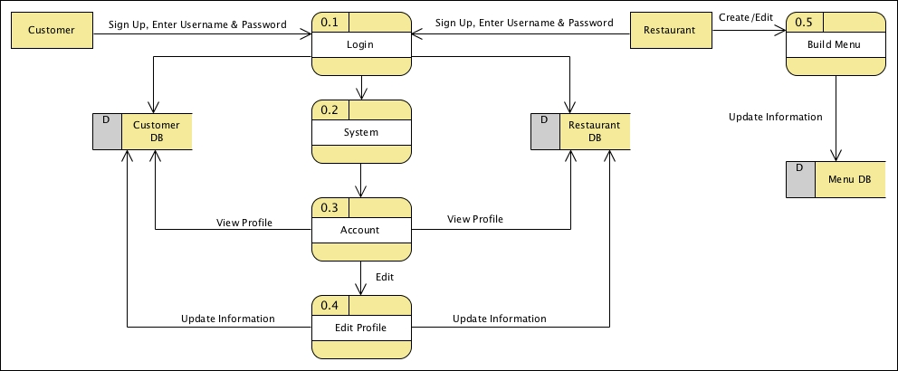

Figure 27 Level 0 Food Delivery

### 6.5.3 level 1 of System

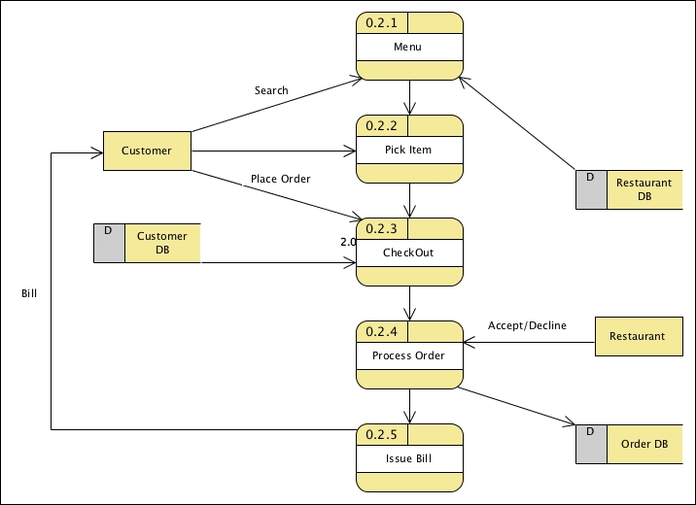

Figure 28 level 1 of System

# 7. REFERENCES

[1] Video tutorials on BPMN drawing retrieved 24th February 2017 <https://www.youtube.com/watch?v=sscOXEHVE6A>.

[2] [Software Engineering Standards Committee of the IEEE Computer Society, *“IEEE Standards for Software Project Management Plans”*, IEEE Std 1058-1998.](http://cs.bilkent.edu.tr/%7Ecagatay/cs413/1058-1998_00741937.pdf)

[3] [Software Engineering Standards Committee of the IEEE Computer Society, *“IEEE Recommended Practice for Software Design Descriptions”*, IEEE Std 1016-1998.](http://www.cs.bilkent.edu.tr/%7Ecagatay/cs413/1016-1998_00741934.pdf)