|  |
| --- |
| **PROJECT PROPOSAL FORM**  **PROJECT NO :**  **PROJECT NAME :** Food & Health application  **PROJECT START DATE : 8th March 2017**  **PROJECT END DATE :** |

A.1. Preliminary Project Information

# A.1.1

|  |  |
| --- | --- |
| **Project No** |  |
| **Project Name** | Food and Health Application |
| **Start Date** | 8th March 2017 |
| **End Date** |  |
| **Time** |  |

# A.1.2

|  |  |  |  |
| --- | --- | --- | --- |
| **Project Manager** | | | |
| **Name Surname** | Charles Brown T Dhliwayo | **ID No** | 147118 |
| **Title/Role** | Project Manager, Programmer | | |
| **Address** | Alaysia Apartment Market | | |
| **Phone** | +905338875196 | | |
| **Email** | charles.tbrown@yahoo.com | | |

A.2 Group Information

# A.2.1

|  |  |  |  |
| --- | --- | --- | --- |
| **Student 1** | | | |
| **Name Surname** | Hasan Erenus Özer | **ID No** | 131134 |
| **Title/Role** | Analysis and Testing Leader, Programmer | | |
| **Address** | Akdeniz Dormitories | | |
| **Phone** | 05338340174 | | |
| **Email** | erenus_eflatun@hotmail.com | | |

|  |  |  |  |
| --- | --- | --- | --- |
| **Student 2** | | | |
| **Name Surname** | Ivy C. Thompson | **ID No** | 148170 |
| **Title/Role** | User Interface Designer, Programmer | | |
| **Address** | Noyan 6 Apartment | | |
| **Phone** | +905338768850 | | |
| **Email** | chivy1221@gmail.com | | |

|  |  |  |  |
| --- | --- | --- | --- |
| **Student 3** | | | |
| **Name Surname** | Iurii Kabalnov | **ID No** | E1600034 |
| **Title/Role** | Database Team Leader, Database Developer | | |
| **Address** | Dau 3 | | |
| **Phone** | +7980536164 | | |
| **Email** | dicookzzz@gmail.com | | |

# A.2.2

|  |
| --- |
| **List of Completed / Ongoing Projects of Team** |
| Ivy Thompson and Charles Brown previously worked on a file system that uses authorization features- with counter mode encryption tool. |

B.1 Introduction to Project

# B.1.1

|  |
| --- |
| **Summary of Project** |
| Our project is a based on food and health guide to help consumers keep track of their diet and general well-being. The mobile application will include recipes for different cuisines, a variety of fitness regimes and information on functional foods. The application will have a variety of functionalities such as a calorie counter. |

# B.1.2

|  |
| --- |
| **Key Words** |
| Diet, food, health, recipe, mobile |

# B.1.3

|  |
| --- |
| **Aim of Project** |
| The aim of this project is to create a fully functional mobile application that can generate different diets for people with different body types and help create an eating plan with timed user notification, contain a list of various optional recipes and provide with videos that illustrate how to make them. |

# B.1.4

|  |
| --- |
| **Innovative Aspects/Contributions of Project** |
| The project brings a strict diet plan with time based alarm system that notifies the user when they should be eating their next meal.  The application will be coupled with functionalities such as of helpful recipes and instructional videos.  The application will provide interactive Health recommendation tips based on user input. |

# B.1.5

|  |
| --- |
| **Methods to be Applied** |
| Agile method has been decided as a method of software development for this project, since the project’s aim is to produce a mobile application and all of the team members are living in close proximity. |

# B.1.6

|  |
| --- |
| **Economic and National Outcomes** |
| The application will be economically viable as it can be commercialized on mobile application stores for a certain fee.  It will raise awareness to health benefits in a fun and interactive way as most people have/ use smart phones. |

B.2 Reason of Starting the Project, Methods and R&D Stages

# B.2.1

|  |
| --- |
| **1- Explain the reason of starting this project. (Max 500 charachter)** |
| The application will be a useful tool to reach the fast-rising community of technology users, helping them become aware of the benefits of functional foods and introducing them to a variety of health regimes to promote healthy living.  Also, the application markets currently are flooded with loads of in-effective or non-functional health applications hence the introduction of our product. |

|  |
| --- |
| **2- Explain the purpose of this project.** |
| The purpose of this project is to create, design, implement, test and document a fully functional Food and Health application. |

|  |
| --- |
| **3- Explain**   * **output of project** * **national / international standards if exist** * **the specific objectives of the project** * **success criterias** * **realistic constraints** |
| Output: Recipes, diet plans ,recommended calorie in-take values  National Standards:  Objectives: Create an application with a functional database containing medical research  Success Criteria: Fully functional search tools- recipe lists, specific foods. Accurate symptom diagnosis based on user inputs.  Realistic constraints: Application lags due to size of embedded videos.  Basic symptom diagnosis due to limited database of medical  information |
| **4- Explain**   * **the methods to be applied during R&D activities** * **applications** * **technics and tools to be used** * **standards to be followed under the workflow** |
| **Which SOFTWARE PROCESS MODEL in below will you apply? Why? How? Explain.**  **\* The waterfall model?**  **\*V-model of software process?**  **\*Evolutionary development?**  **\*Component-based software engineering? Etc.**  **Explain, Project Workflow:**   1. **Feasibility and Pre-research:** 2. **System Design:** 3. **Software development:** 4. **Prototype implementation and testing work:** 5. **Maintenance:** |
| **5- Explain**   * **the contribution of national/international technological development if exist** * **starting a new research and development projects within or outside the team** * **launch new applications or research studies in different technology areas**   **With whom we can cooperate?**  **Expectations:**  **Published work:**  **Can your output be an input for other similar national/international projects?** |
|  |

B.3 Innovative and Unique Aspects

# B.3.1

|  |
| --- |
| **1- Describe**   * **differences** * **advantages** * **superiority**   **compared to other similar projects.** |
| The health application will not just offer tips but it will help the user create their fitness regime according to their body types. The application offers in depth study of diseases- their symptoms, preventions, functional foods to help with the treatment. Unlike any other application, it will consists of several recipes of a wide variety of delicacies. It will also feature a calorie counter to help the user track, how many calories they are consuming or should consume. |

# B.4.1

|  |
| --- |
| **2- Who can contribute to this project in your team?** |
| Project Manager- Charles Brown  Analysis and Testing Team:   * Test Leader: Eranus Hasan * Analysts – Iurii Kabalnov,Charles Brown, Ivy Thompson   Software Team:   * User Interface Designer (Lead) – Ivy Thompson * Programmer- Charles Brown, Eranus Hasan, Iurii Kabalnov   Database Team :   * Database Team Leader- Iurii Kabalnov * Database Developers- Charles Brown, Ivy Thompson   Academic Advisor – Ms. Begum Koru |
|  |

C.1 Gantt Chart and Work Packages

# C.1.1 Gantt Chart

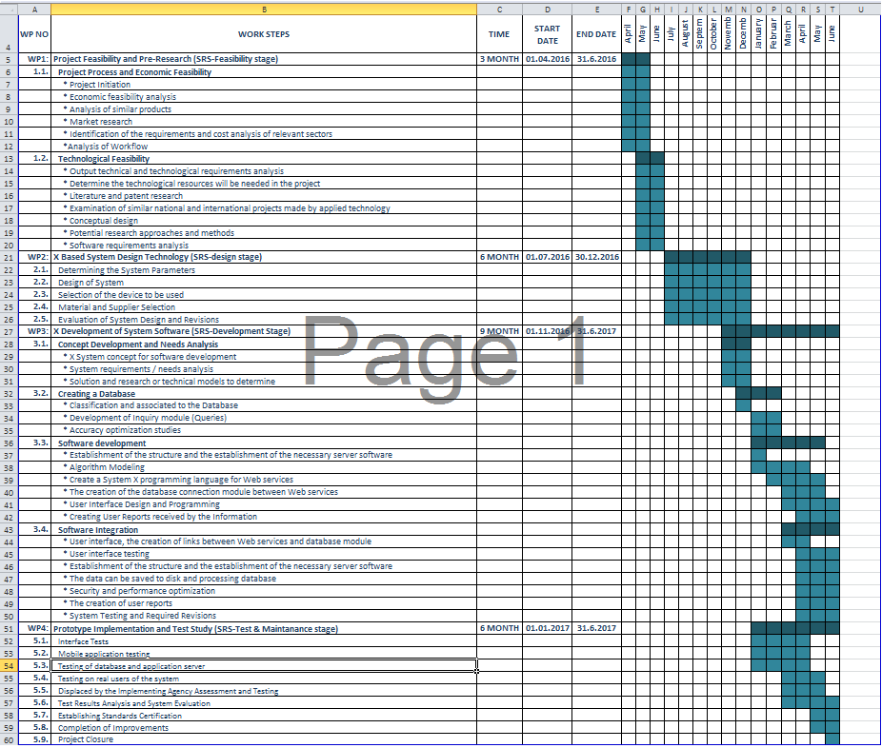

# C.1.2 List of Work Packages

|  |  |
| --- | --- |
| **Work Package No** | 1 |
| **Work Package Name** | **Project Feasibility and Pre-Research (SRS-Feasibility stage)** |
| **Start-End Date and Time** |  |
| **Related Organizations** |  |

|  |
| --- |
| **1- List the activities of work packages.** |
| **1.1 Project Process and Economic Feasibility:**  -Project Initiation  -Economic analysis- implementation cost as compared to costs of similar projects  -Analysis of similar products  -Market Research  -Identification of the requirements  -Analysis of workflow  **1.2 Technological Feasibility:**  **-**Determine Technological Resources needed for the project  -Patent and Literature Research  -Examination of similar national or international projects made  -Concept Design  -Software Requirements Analysis  -Process Modeling  - |
| **2- Describe the methods and parameters that will be used for work package.** |
| Project Feasibility: Economic Feasibility  Method: Cost- Return on Investment (ROI) for comparing overall profitability by measuring the ratio of the value of an investment to its cost.  ROI = (Estimated lifetime benefits - Estimated lifetime costs ) / Estimated lifetime costs |
| **3- List the experiments, tests and analysis in the work package.** |
| Cost-Benefit Analysis :   1. Identify costs and benefits  * Tangible and intangible, one-time and recurring * Assign values to costs and benefits  1. Determine Cash Flow   – Project costs and benefits over time, e.g. 3-5 years  – Calculate Net Present Value for all future costs/benefits  • determines future costs/benefits of the project in terms of today's dollar values |
| **4- List the output of work package and its success criteria.** |
| **Outputs:**  Ratio of the value of an investment to its cost (from ROI)  List of (possible) Operational costs and development costs compared to tangible and intangible benefits  **Success Criterias:**  The Economic feasability Solution with the highest ROI is the best alternative. Alternatively, a lower ROI with an earlier payback may be preferable.  The project benefits should outweigh the project costs. |
| **5- Explain the relation of output with other work packages** |
| A good Return on Investment (ROI) determines how good of an investment the project is, if it is then it’s advisable to advance to the next work package (the SRS development). |

|  |  |
| --- | --- |
| **Work Package No** |  |
| **Work Package Name** | **X Development of System Software (SRS-Development Stage)** |
| **Start-End Date and Time** |  |
| **Related Organizations** |  |

|  |
| --- |
| **1- List the activities of work packages.** |
|  |
| **2- Describe the methods and parameters that will be used for work package.** |
|  |
| **3- List the experiments, tests and analysis in the work package.** |
|  |
| **4- List the output of work package and its success criterias.** |
| **Outputs:**  **Success Criterias:** |
| **5- Explain the relation of output with other work packages** |
|  |

|  |  |
| --- | --- |
| **Work Package No** | 3 |
| **Work Package Name** | **Prototype Implementation and Test Study and Maintenance (SRS-Test & Maintenance stage)** |
| **Start-End Date and Time** |  |
| **Related Organizations** |  |

|  |
| --- |
| **1- List the activities of work packages.** |
|  |
| **2- Describe the methods and parameters that will be used for work package.** |
|  |
| **3- List the experiments, tests and analysis in the work package.** |
|  |
| **4- List the output of work package and its success criterias.** |
| **Outputs:**  **Success Criterias:** |
| **5- Explain the relation of output with other work packages** |
|  |

# C.1.3 List of Milestones (should be matched in the Gantt chart)

|  |  |  |
| --- | --- | --- |
|  | **Description of Output** | **Expected Time Interval** |
| ***Example:*** | ***Feasibility Studies*** | ***01.07.2014 – 30.09.2014*** |
| 1 |  |  |
| 2 |  |  |
| 3 |  |  |
| 4 |  |  |
| 5 |  |  |
| 6 |  |  |
| 7 |  |  |

# C.1.4 List of Risks (see following example, find other risks of your Project!)

|  |  |  |  |
| --- | --- | --- | --- |
| Risk | Probability | Effects | Your Strategy |
| The time required to develop the software is underestimated. | High | Serious | ? |
| Software tools cannot work together in an integrated way. | High | Tolerable | ? |
| Customers fail to understand the impact of requirements changes. | Moderate | Tolerable | ? |
| The rate of defect repair is underestimated. | Moderate | Tolerable | Replace potentially defective components with more reliable bought-in components. |
| The size of the software is underestimated. | High | Serious | Investigate buying sw components;  Investigate use of a program generator. |
| Code generated by code generation tools is inefficient. | Moderate | Insignificant |  |
| Key staff are ill at critical times in the project. | Moderate | Serious | Reorganize team so that there is more overlap of work and people therefore understand each other’s jobs. |
| The database used in the system cannot process as many transactions per second as expected. | Moderate | Serious | Investigate the possibility of buying a higher-performance database. |

C.2 Project Management and Organization

# C.2.1 Project Team

|  |  |  |  |  |  |  |
| --- | --- | --- | --- | --- | --- | --- |
| **Personnel Name** | **Title** | **ID** | **Education Status** | **Graduation Date** | **Date of Starting Work** | **Idea Owner** |
|  |  |  |  |  |  |  |
|  |  |  |  |  |  |  |
|  |  |  |  |  |  |  |
|  |  |  |  |  |  |  |
|  |  |  |  |  |  |  |
|  |  |  |  |  |  |  |

# C.2.2 Organization Scheme (an example is given below!)

PROJECT MANAGER

CHARLES BROWN

USER INTERFACE DESIGNERS

SOFTWARE TEAM LEADER Ivy Thompson

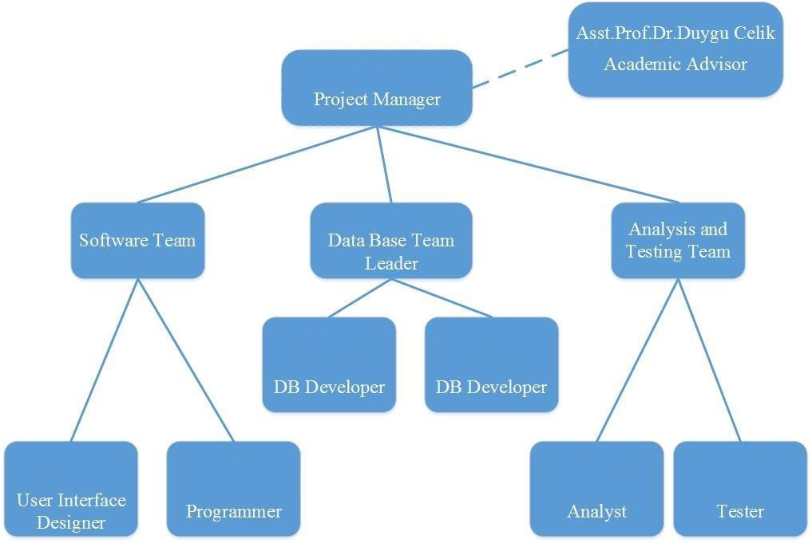

D.1 Economic Forecasts

|  |
| --- |
| **1- Evaluate the commercialization potential of project outcomes. List possible risks here?** |
| There are few phases of commercialization the product. First one is introduction the product to market. This phase will be completed when product will have a level of public value. Then product will be released to market. It will have some advertisement. Final stage will be completed when most of local people will know about the product. |

|  |  |
| --- | --- |
| **2- List your expectations to your team which are come by your project** | |
| Time-to-market (month): | 2 weeks |
| The expected increase in sales revenue (%): | 40% |
| The expected increase in market share (%): | 60% |
| Time to start to gain: | 2 months |

D.2 National Outcomes

|  |
| --- |
| **1- Specify the output that may be subject to patent, utility model and industrial design registration in the project.** |
| There are no such multifunctional products in the world. It may have great influence on people’s lives. |
| **2- Explain the potential of project and its outputs that may have an effect on social life, education, health and etc.** |
| The project could not only raise health awareness but it can help |
| **3- Explain the positive and negative effects of project outputs for environment and human being.** |
| Positives: It will increase health awareness in an increasingly technological world.  Negatives: Because its smart phone based, it will increase user’s cell phone usage which can lead to eye and hand issues/ pains. |

(M013) Instrument / Equipment / Software / RELEASE PURCHASES

|  |  |  |  |  |  |  |  |  |  |  |  |
| --- | --- | --- | --- | --- | --- | --- | --- | --- | --- | --- | --- |
| **Project Name** | |  | | | | | | | | | |
| **Line no** | **Instrument / Equipment / Software / Publication Name** | | **No. of Item** | **Capacity** | **Technical specification** | **Purpose of Project Activities** | **Post-Project Place of Use / Purpose** | | **Unit Price (USD)** | **Unit Price (TL)** | **Total Amount (TL)** |
| **R & D** | **Production** |
| **1** |  | |  |  |  |  |  |  |  |  |  |
| **2** |  | |  |  |  |  |  |  |  |  |  |
| **3** |  | |  |  |  |  |  |  |  |  |  |
| **4** |  | |  |  |  |  |  |  |  |  |  |
| **5** |  | |  |  |  |  |  |  |  |  |  |
| **6** |  | |  |  |  |  |  |  |  |  |  |
| **7** |  | |  |  |  |  |  |  |  |  |  |
| **8** |  | |  |  |  |  |  |  |  |  |  |
| **9** |  | |  |  |  |  |  |  |  |  |  |
| **10** |  | |  |  |  |  |  |  |  |  |  |
|  |  | |  |  |  |  |  |  |  | **TOTAL** | **TL** |

(M030) Quarterly Estimated Cost Form (TL)

|  |  |  |  |  |
| --- | --- | --- | --- | --- |
| **Project Name :** Food and Health Application | | | | |
| **Cost Item** | **2017** | | **TOTAL**  **(TL)** | **TOTAL COST RATE OF CONTENTS (%)** |
| **I** | **II** |
| **Personnel** | 10000 | 10000 | 20000 | 15% |
| **Travel** | 0 | 0 | 0 | 0% |
| **Instrument / Equipment / Software / Publications** | 30000 | 15000 | 45000 | 35% |
| **Domestic Works Made By R & D and Testing Institutions** | 5000 | 20000 | 25000 | 20% |
| **International Works Made By R & D and Testing Institutions** | 15000 | 25000 | 40000 | 30% |
| **Domestic Services Procurement** | 0 | 0 | 0 | 0% |
| **Overseas Service Procurement** | 0 | 0 | 0 | 0% |
| **Material** | 0 | 0 | 0 | 0% |
| **TOTAL COST** | 60000 | 70000 | 130000 | 100 |
| **CUMULATIVE COST** | 60000 | 70000 | 130000 | 100 |
| **IN THE PROJECT TOTAL MAN-MONTH** | | | 4 | |

APPENDIX