EMU Honors College

Mobile Application

Requirements Checklist and Coach

Requirements Document

Group Members:

Stefano Prezioso

Jordan Saunders

Travis Taylor

Nicole Binkowski

Edward Gurnee

Table of Contents

Table of Contents
Scope
User Population
Computing Environment
Glossary
Administrator
Advisor
Cultural Experience
Departmental Honors
Exit Interview
Handbook
Highest Honors
Honors College
Honors Contract
Honors Course
Honors Credit
Honors Director
Honors Experience
Honors Student
Leadership Experience
Requirement
Star Lecture Series
Starkweather Hall
Types of Honors Designations
University Honors
Non-Functional Requirements
The system should be portable to IOS.
The system should be easy to use.
The system should be secure.
Use Case Diagram
Use Case Specifications
1. View Requirements
2. Create Profile
3. Check-off Tasks
4. Create Handbooks
5. View Statistics
Functional Requirements
Profile Creation
Update Profile
Requirements Coaching
View In-Progress Requirements
View Expanded Requirements
View Requirement Description
View Honors’ Checklist
Completion States for Requirements
Create Handbook
Student Statistics
Walkthrough
Honors Student
Honors Staff
FAQ
Estimated Size of Program
Prototype Screen Captures

Scope
The client requires a way to more efficiently relay to the Honors students what is required of them to graduate with Honors; that need coupled with a specific desire from the client for the solution to exist in a program that is native to a mobile system such as Android or iOS. Based on the lack resources we have available to us (limited time, a collective lacking of experience developing for mobile platforms, and no developer licenses for Apple), the group has come to the consensus of creating an Android app for our client. If the Android application developed by our group is well received, then an application for the iOS platform could be developed by future students; creating an application for more than one platforms is something most certainly outside of our scope.
This system would include creating the Android application for the students to directly update their own completed requirements, a web-based administrative interface to manage requirements of a given year, and a database storing all student information of those using the application along with a collection of all requirements created by the admin.
The Android app for the students will include a checklist to help students understand the requirements to graduate with Honors; the requirements to graduate with Honors vary in the year and type of honors being pursued. This application is intended to help students understand the requirements through a checklist and coaching along the way. Each student will create a profile for initial login, including the handbook they are following. The application will give students the opportunity to view all requirements needed, check-off completed requirements, and review in-progress requirements. The application will assist students in understanding requirements in the form of prompts coaching students of the various steps needed to complete along with way.
As part of the Android application, there are select dates that are important for students to recognize as upcoming and should be prompted to take action. Prior to graduating, the students need to attend an exit interview with an Honors College advisor and the Android application should warn them of that in the semester before they intend to graduate. Additionally, the due dates of the Honors Contracts should be reminded to the students through some sort of notification.
The web-based administrative interface will include two main functions: updating requirements and viewing statistics of students using the Android application. Having the ability for the admin to create and/or update requirements for future years’ handbooks is necessary as these requirements are capable of changing between years and we cannot predict what any and all possible requirements will eventually be included. Most changes from year to year would be minor incremental changes; an administrator should be able to import a previous handbook and make changes to the requirements to reflect the new handbooks’ requirements. The second function is for the admin to view statistics of the students using the app. These statistics include the year and type of honors being pursued along with expected graduation year and major/minor.
The scope of our project dramatically changed after each and every meeting with the client; many the things that we were originally focusing on, such as social interaction, targeted event notifications based on the upcoming calendar, and an auditing system with connectivity to actual university data, have all been left behind. Given the time, ability, and motivation, the group would be interested in scoping back in those things that would be possible to finish, but the group is currently not expecting that to be possible.

User Population
This system will be interacted with by two very specific user populations: students and admins. Students will be defined as any current Honors College student that has access to an Android device and admins will be defined as any Honors College staff that would be responsible for knowing and maintaining the Honors College requirements.
Students using this application are expected to have a basic understanding of how to install an application from the Play Store, the general tech awareness that comes with college-aged people (press and hold or find the menu/question mark button for help), and will require no complex skillsets.
The admin population should have a complete or at least thorough understanding of each requirement necessary for graduating from the Honors College. As the admin population is responsible for uploading each step in the coaching process, the given admin needs to have an intimate understanding of the process on how to complete each requirement.

Computing Environment
The computing environment for this application will include the Android platform that our application will run on, the emich server and an individual’s browser will be used for the website that the admin interface will run on, and a database that the system will be connected to for data storage.
Android systems will be used to access the student side of the system; this will be where the students will have all their interactions with their self-reported data and checklist. The application will need to be tested on a variety of devices and virtual devices as Android devices are not standardized and different devices can report many different situations.
The internet interface is where the admin will be able to update handbooks and view the statistical data that the application will be able to provide. The website will be guaranteed to run on all of the major web browsers.

Glossary

Administrator
A staff member of the Honors College who will interact with the administrative side of the developed software to either create and update Honors College handbooks in the system or view usage and user statistics.

Advisor
A staff member at the Honors College who meets with Honors students to discuss or explain Honors requirements, course selection, and various other advisory related subjects.

Cultural Experience
More formally titled as Honors College Community-Based Intellectual and Cultural Activities, this is one half of the Honor Experiences requirement for University Honors students in certain Handbook years. Examples are detailed in the Handbook and may include options like studying abroad or attending three lectures of a series.

Departmental Honors
A particular Honors designation which is earned by the successful completion of at least 12 hours of Honors credit in the major or minor and developing a Senior Thesis or Project. In addition to University Honors, Honors students can pursue Departmental Honors in more than one major/minor. Successfully pursuing Departmental Honors allows them to maintain Honors privileges throughout years at EMU.

Exit Interview
To be scheduled at least two months prior to a student’s graduation date, this interview takes about 30 minutes, and it is important for several reasons: to review transcripts and verify completion of requirements; to make sure the student’s name, degree, and Honors graduation status appear correctly on the graduation certificate; to complete needed biographical information for the commencement program; and to fill out an Honors College evaluation.

Full Honors

Full Honors is a type of Honors that can be achieved only by students that have already began Honors work at particular community colleges that have articulation agreements with the EMU Honors College.

Handbook
The official document supplied by the Honors College that details the specific requirements for each of the different designations of Honors. A handbook is released for each school year. An Honors student will follow the handbook of the year they are admitted into the Honors College, or may choose to follow a newer handbook.

Highest Honors
Highest Honors marks the most distinctive recognition of academic excellence in the Honors College. Upon completion of 56 credits, but before exceeding 84 credits, students may apply for Highest Honors. Students must maintain a 3.7 or higher cumulative GPA, and complete many other specific requirements. To apply for Highest Honors, students must have completed or be in the process of completing University Honors and/or Departmental Honors.

Honors College
An institution in which students may apply for to pursue and achieve Honors designation upon completion of necessary requirements and graduation from the University.

Honors Contract
Honors contracts provide an opportunity to earn Honors credit in otherwise non-Honors courses.

Honors Course
Honors courses are taught as either special sections of regularly scheduled departmental offerings (usually as General Education classes) or as specific courses developed only for Honors students. Honors courses are available only to Honors College members, and enrollment is restricted to 20 students. Additionally, the first foreign language class a student takes can be automatically counted for University Honors credit, provided a minimum grade of B- is earned and the student submits an Honors Contract to the Honors College.

Honors Credit
Academic credit dignified by the completion of either a special Honors course or a contract with a course grade of B- or better. Honors credit cannot be earned from a class taken pass/fail. If a student is working towards University Honors, some Honors credit must be earned each semester in which a minimum of 12 credit hours is taken. If for two consecutive semesters no Honors credit is earned, Honors membership will be terminated at the end of the second semester.

Honors Director
A staff member of the Honors College whose approval is required for many processes of pursuing an Honors designation. Responsible for managing Honors College staff and programs as well as being the primary contact to University leadership.

Honors Experience
Co-curricular activities that broaden the educational experience by encouraging involvement in cultural and intellectual events/activities that promote civic engagement. They are usually a semester-long commitment. There are two types of Honors Experiences: Cultural Experience (Honors College Community-Based Intellectual and Cultural Activities) and Leadership Experience (Leadership and Civic Engagements Activities).

Honors Student
A student that has applied and been admitted into the Honors College and remains in good standing as defined by the Honors College.

Leadership Experience
More formally titled as Leadership and Civic Engagements Activities, this is one half of the Honor Experiences requirement for University Honors students. Examples are detailed in the Handbook and include options such as serving as a representative on a campus committee or serving as a New Student Orientation Assistant.

Requirement
A line item that must be completed to achieve a particular Honors designation. Requirements may include several sub-requirements or may offer multiple options to satisfy the completion of a requirement.

Star Lecture Series
A particular lecture series in which attendance is required for certain Handbook years. Attendance of additional Star Lectures can also count towards a Honors Student’s Cultural Experience requirement, as detailed in certain Handbooks.

Starkweather Hall
The building on Eastern Michigan’s campus in which the Honors College is located.

Types of Honors Designations
The Honors College has three primary types of Honors designations a student can pursue: University, Departmental, and Highest Honors.

University Honors
A particular Honors designation which is earned by the successful completion of 24 Honors credits, as well as other requirements. Of these, 18 must be in General Education, 3 must be in the major or minor, and the remaining 3 may be in either General Education or the major/minor. It is common for first-year students entering the Honors College to pursue a University Honors designation.

Non-Functional Requirements

The system should be portable to iOS.
The system should be able to move over to iOS at a later time.
Rationale: In order to reach as many students as possible it is important to have the application available on both Android and iOS platforms.
1.1 The system should be well documented.
1.2 The system should be abstractly designed.

The system should be easy to use.
The system should have a good flow to it and be intuitive. Help files and the such should not be needed for users to learn how to use the system.
Rationale: Students will not use a phone app that is clunky and takes a lot of time to figure out.
2.1 Students will be able to use the application simply by going through the application. They will understand how the application works and be able to navigate and use the application within 5-10 minutes of use.
2.2 Staff will understand how to use the admin side of the application just be viewing the options presented to them when they log in. They will understand how the admin side works and be able to navigate and use the application within 10-15 minutes of use.

The system should be secure.
The system should not allow unauthorized users to view the sensitive information being stored.
Rationale: Items such as grades and EID are stored within this system and by law should not be viewed by those who do not have permission to do so and the students the information belongs to.
3.1 The system will require a login from students.
3.2 The system will require a login from staff.

Use Case Diagram
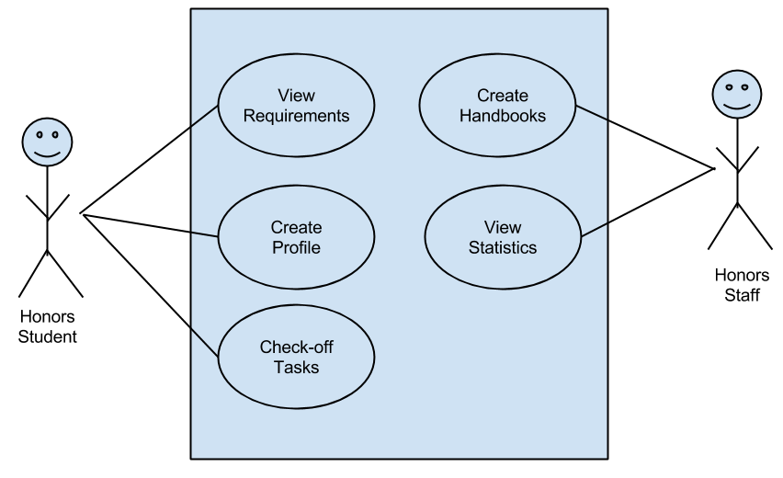

Use Case Specifications

1. View Requirements
Description: The student views completed, in progress, and not started
requirements in multiple ways.
Precondition: The student has logged in.
Main flow of events:
- Student selects which type of honors they wish to view checklist for or chooses to view only in progress requirements.
- Student selects drop down options to view the individual tasks for each main requirement.
Postcondition: None.
Exceptions:
1a. Student has selected the type “Full Honors”.
System notifies student to speak with advisor for more information.

2. Create Profile
Description: The student creates a profile to hold their information and allow them
to log in.
Precondition: None.
Main flow of events:
1. Student enters a username and password.
2. Student enters their EID.
3. Student enters their name.
4. Student selects the type(s) of honors they are pursuing.
5. Student selects which handbook they will be following.
6. Student enters their expected graduation date.
7. Student enters their major/minor.
8. Student submits profile information.
Postcondition: Student may change the type of honors, handbook, graduation date, and major/minor once the profile is created.
Exceptions:
1a. Username already exists.
System notifies student and prompts for new username.
8a. Student has not completed the full form.
System notifies student of missing information.

3. Check-off Tasks
Description: The student can check-off individual tasks for each major requirement
under each type of honors.
Precondition: The student has logged in.
Main flow of events:
1. Student selects which checklist they would like to update.
2. Student chooses which task to complete and enters requested information about task.
Postcondition: Student may edit finished tasks and remove them.
Exceptions:
2a. Student completes task but requirement is not fully complete.
System notifies student of next task.

4. Create Handbooks
Description: Staff creates new handbooks for students to follow.
Precondition: Staff has logged in.
Main flow of events:
- Staff selects older handbook to edit.
- Staff adds/deletes requirements.
- Staff saves the new handbook.
Postcondition: Staff may edit the handbook at a later time.
Exceptions:
3a. Staff does not enter all required information for a requirement.
System notifies staff.

5. View Statistics
Description: Staff searches for information about the self-reported information
students provide.
Precondition: Staff has logged in.
Main flow of events:
1. Staff chooses which information to search for.
2. Staff runs the query.
Postcondition: None.
Exceptions: None.

Functional Requirements

Profile Creation
A new student user should be able to create a new profile.
Rationale: A profile is needed to securely interact with database information.
1.1 The system will have a form to enter information.
1.2 Information is stored in the database.
1.3 The system will validate user entered information.

Update Profile
A student user is able to change and update their registered personal information.
Rationale: A student’s personal information may may change over the course of use of this system, the stored personal information needs to be able to reflect those changes.
2.1 The system will allow the user to view the currently entered personal information.
2.2 The system will give the user a form to edit personal information.
2.3 Changes made from the currently updating student will be stored in the database.

Requirements Coaching
The student user should be prompted with coaching steps upon checking off a requirement.
Rationale: To help students understand the steps necessary to complete a requirement, and help guide them through the process.
3.1 The system should prompt the user with the appropriate coaching step when the user attempts to mark off a requirement.
3.2 The system to continue to prompt the user as coaching steps are completed until all coaching steps for a requirement are complete.
3.3 The system should provide the user with a way to mark a step as completed or incomplete.

View In-Progress Requirements
The student user should be able to view their in-progress requirements separately from the checklist.
Rationale: To provide a clear location for users to view their in-progress requirements.
4.1 The system should have a separate screen that lists the current in-progress requirements.
4.2 The system should allow users to view the progress of a particular requirement that is marked as in-progress.
4.3 The user should be able to complete a requirement from the In-Progress Requirements screen.

View Expanded Requirements
The student user should be have the ability to view each sub-requirement needed to complete a given requirement, if the user desires.
Rationale: To keep the system clean for student users, the requirements are kept to a minimum size as a default; the full detail is available to the user upon request.
5.1 When the user clicks on a specific requirement, the system will display each sub-requirement as a dropdown list from below.
5.2 When the requirement is selected again, the system will hide the dropdown list.

View Requirement Description
The student should be able to view the handbook definition of a requirement.
Rationale: To give the students access to viewing the official handbook definition of a given requirement to limit potential confusion and ambiguity.
6.1 The full description will be displayed in a popup by clicking on a question mark by the requirement name.

View Honors’ Checklist
The user should be able to view each type of honors’ checklist individually.
Rationale: To provide a clear definition between different types of honors that a user is following.
7.1 The system should have different windows for each type of honors’ a user is following.
7.2 The system should allow users to check off items on each individual checklist.

Completion States for Requirements
The student user should be able to easily differentiate between completed, in-progress, and not started requirements.
Rationale: By doing this we provide a clear definition of where the student stands on their way to completing their honors requirements.
8.1 Completed requirements will be green, in-progress requirements will be yellow, and requirements not yet started will be black.
8.2 The system should have clear difference between the different types of colors used.
8.3 The colors should change when a requirement is changed from not started to in progress, and from in progress to complete.
8.4 The requirements that are located on the in progress page will also be colored yellow.

Create Handbook
The admin will be able to create new handbooks that include default choices for the student to check off. Default choices include commonly completed requirements for a particular type of honors.
Rationale: There may be new/altered requirements for a new years’ handbook.
9.1 The system will be able to import a previous handbook and edit requirements to reflect the new year; quantitative requirement changes will be altered this way.
9.2 The system will be able to handle newly introduced qualitative requirements.
9.2 The system will be able to introduce new “coaching prompts” matching the new requirements.

Student Statistics
The admin will be able search for information being documented by students.
Rationale: The admin would like to view certain statistics about the student population.
10.1 The system will be able to search the database for the number of students following a particular handbook year.
10.2 Search for the number of students pursuing a particular type of honors being pursued.
10.3 Search for the number of students declaring a particular major/minor.

Walkthrough

Honors Student
- Create Profile - When you create a profile, you will be giving the following information:
  - username and password
  - EID
  - email
  - name
  - expected graduation date
  - handbook followed
  - type of honors pursed
- Select a checklist to view. Possible options below:
  - University Honors
  - Departmental Honors
  - Highest Honors
  - In Progress
- Press the arrow to show a drop down list of detailed steps for each requirement.
- When you complete a task in a requirement you will be alerted of the next steps and the requirement you’ve started will be added to your “In Progress” page.

Honors Staff
- Login with provided username and password.
- If you wish to edit/create new handbooks:
  - Select the option to either create new handbook or edit an old handbook.
  - Edit as needed.
  - Save the handbook.
- If you wish to view student information:
  - Select the information you would like to search for.
  - Run the search.

FAQ

Q: What do I do if I forget my Password?
A: Click the Forgot Password link on the login screen.

Q: How do I turn off/on notifications?
A: Go to the settings button and edit notification settings.

Q: How do I change what Honors type and/or year?
A: Go to the settings button and edit user profile.

Q: Is this app available on iOS or the Web?
A: No this app is currently only available on Android platforms, though future support for other platforms are planned.

Q: Can I use this app on my Tablet?
A: Yes, Android tablets only.

Q: Does the college recognize this app to be official?
A: No, this is a self reporting checklist designed to assist students in understanding requirements.

Q: Will the system save my information if I get a new phone?
A: Yes, just use your initial login username and password.

Q: Where do I get the app?
A: It is currently available in the Google Play Store.

Estimated Size of Program
This system is composed of two distinct programs for the different types of users to interact with: a mobile application for the student users to interact with the stored data and be coached through the process of graduating with Honors and a web-based application for the Honors staff to input and update the requirements.
The mobile application will have a number of activities and screens; editing notification settings, updating profile information, viewing handbook, viewing checklist, logging in, and creating a user account are all modules that will need to be created. Each of those modules will need an xml make-file, the java code for the UI, the JDBC code to interact with with the database, and any image or sound files associated with the particular module. Outside of the individual modules, the application itself needs an xml file to prepare resources for loading and a main activity that maintains control of which activity is currently active.
Android application files have a size limit of 50 mb (extended Android applications have a file size limit of 4 gb), we expect our .apk to be under 10 mb.
The web-based application will be much smaller as it only exists for Honors staff to input new requirements and view statistics about the student population. There will be only four accessible .html pages for the admin interface: log in page, add new handbook page, update existing handbook page, and view statistics page. Although there will be only four front facing web pages, there will be numerous back end pages for data validation, database communication, website security, webpage generation, website styling, and resource manipulation.

Prototype Screen Captures
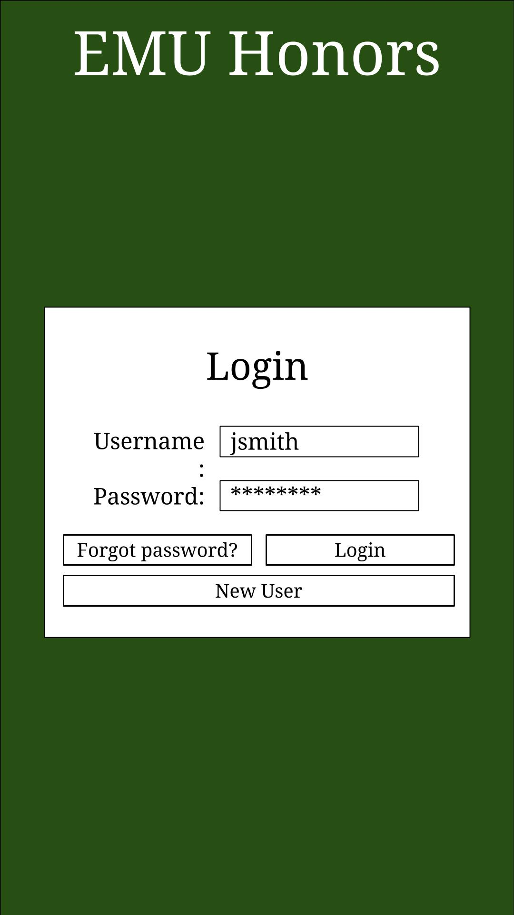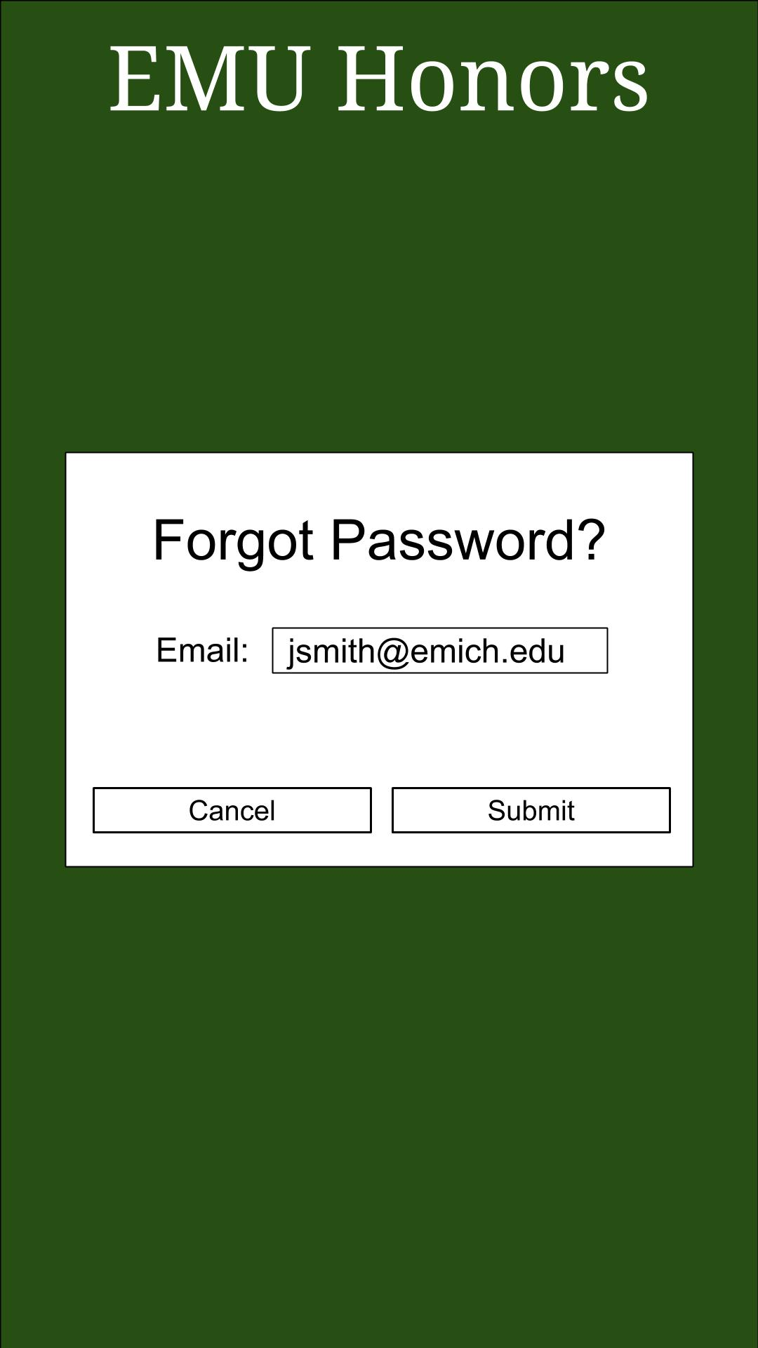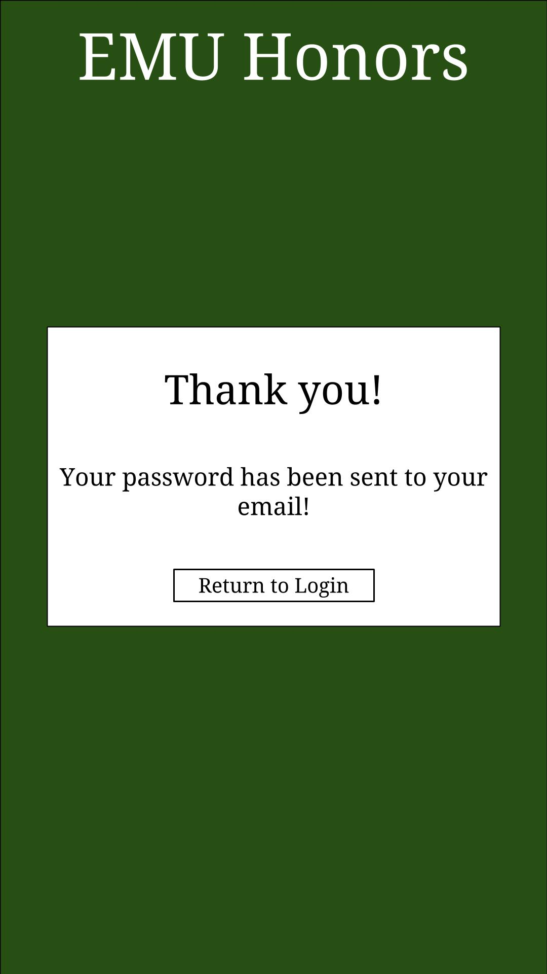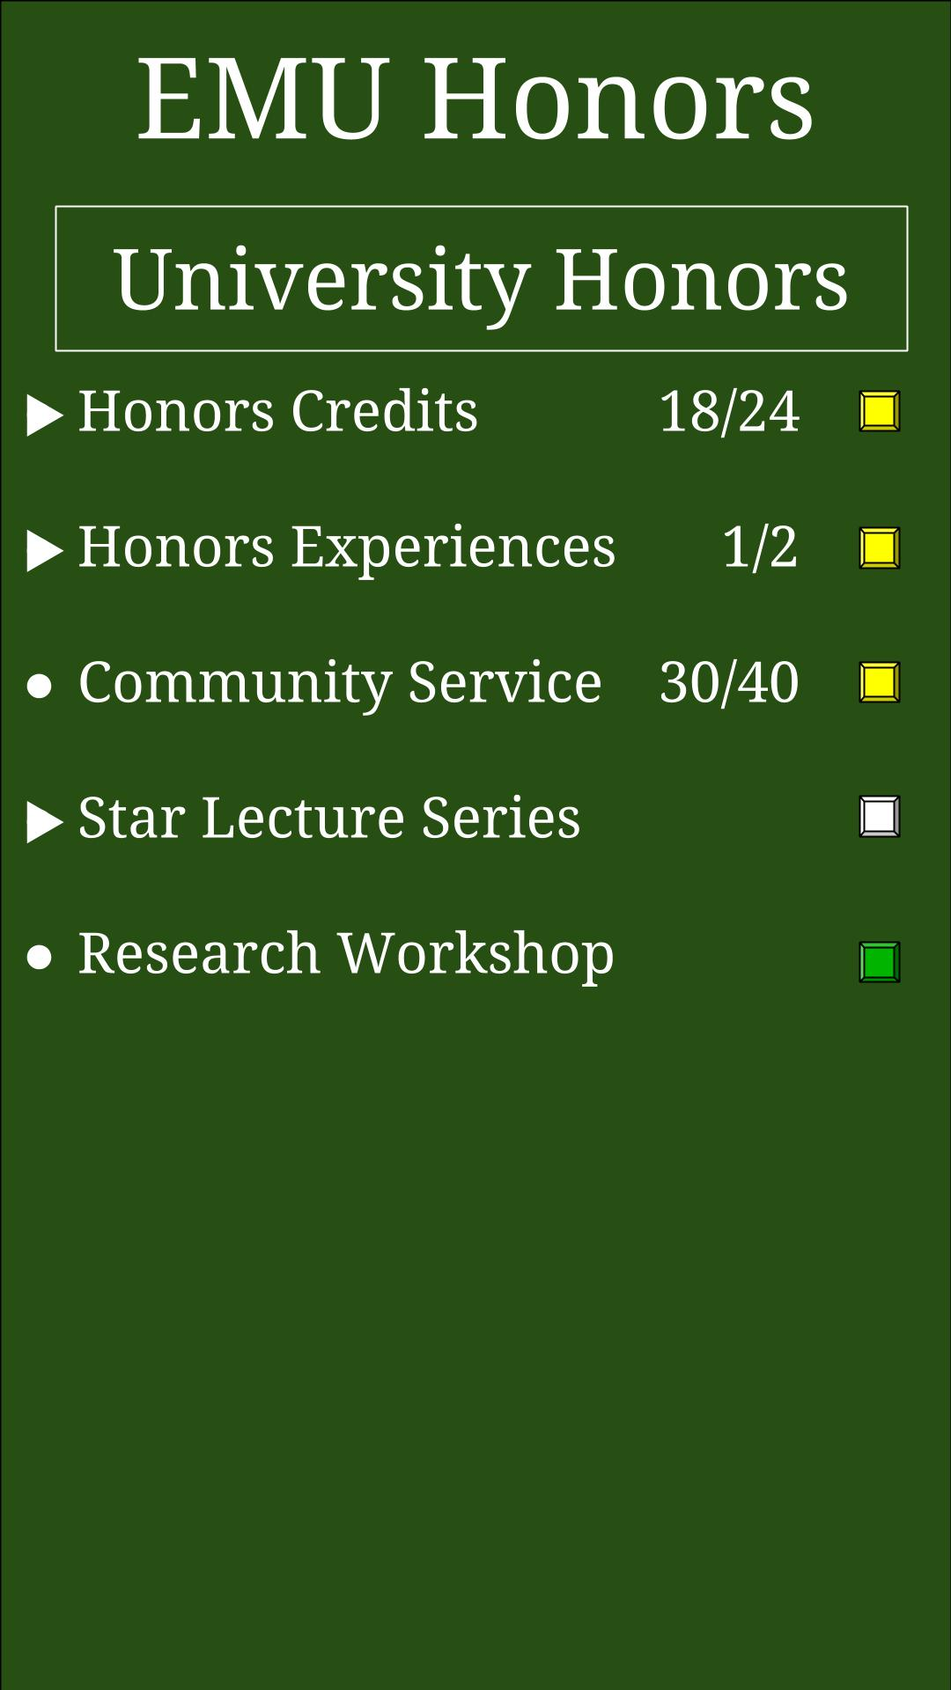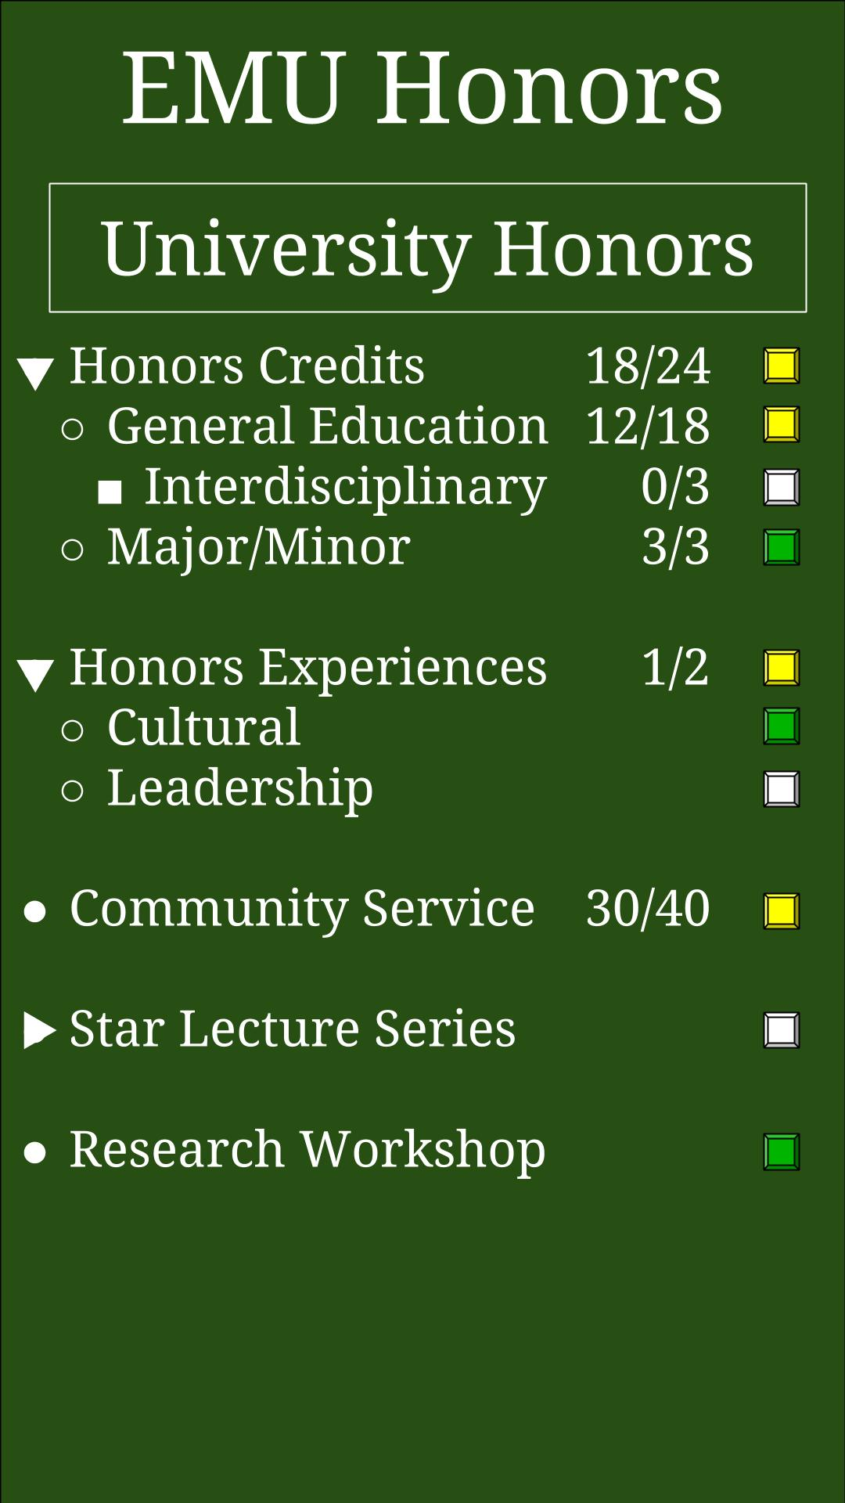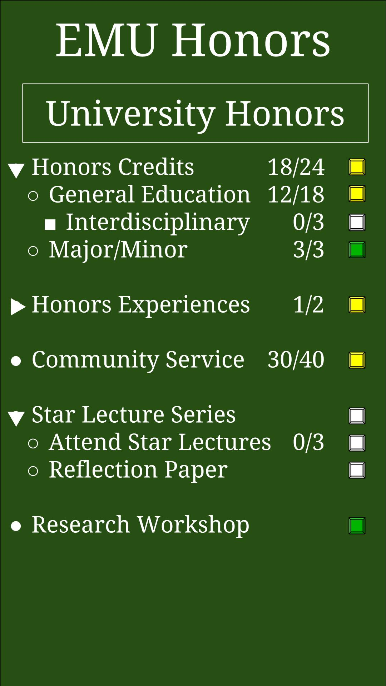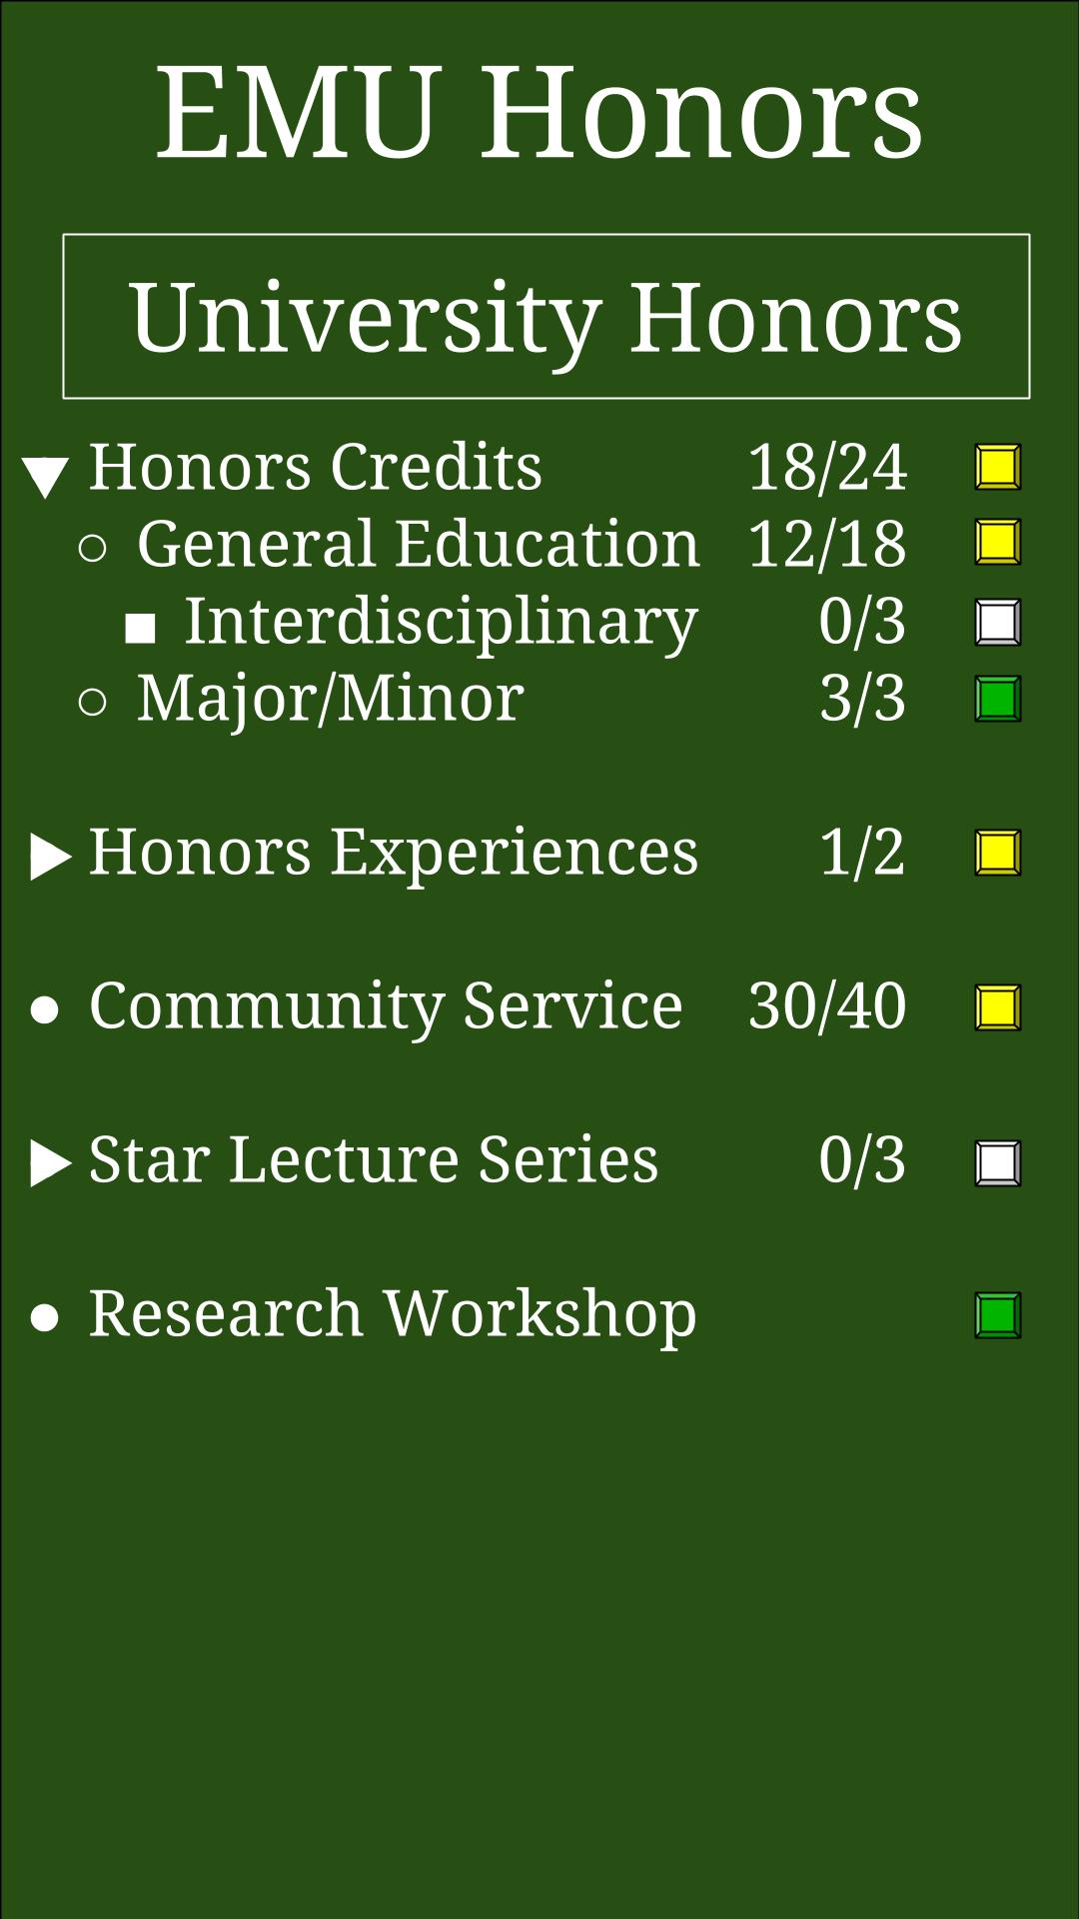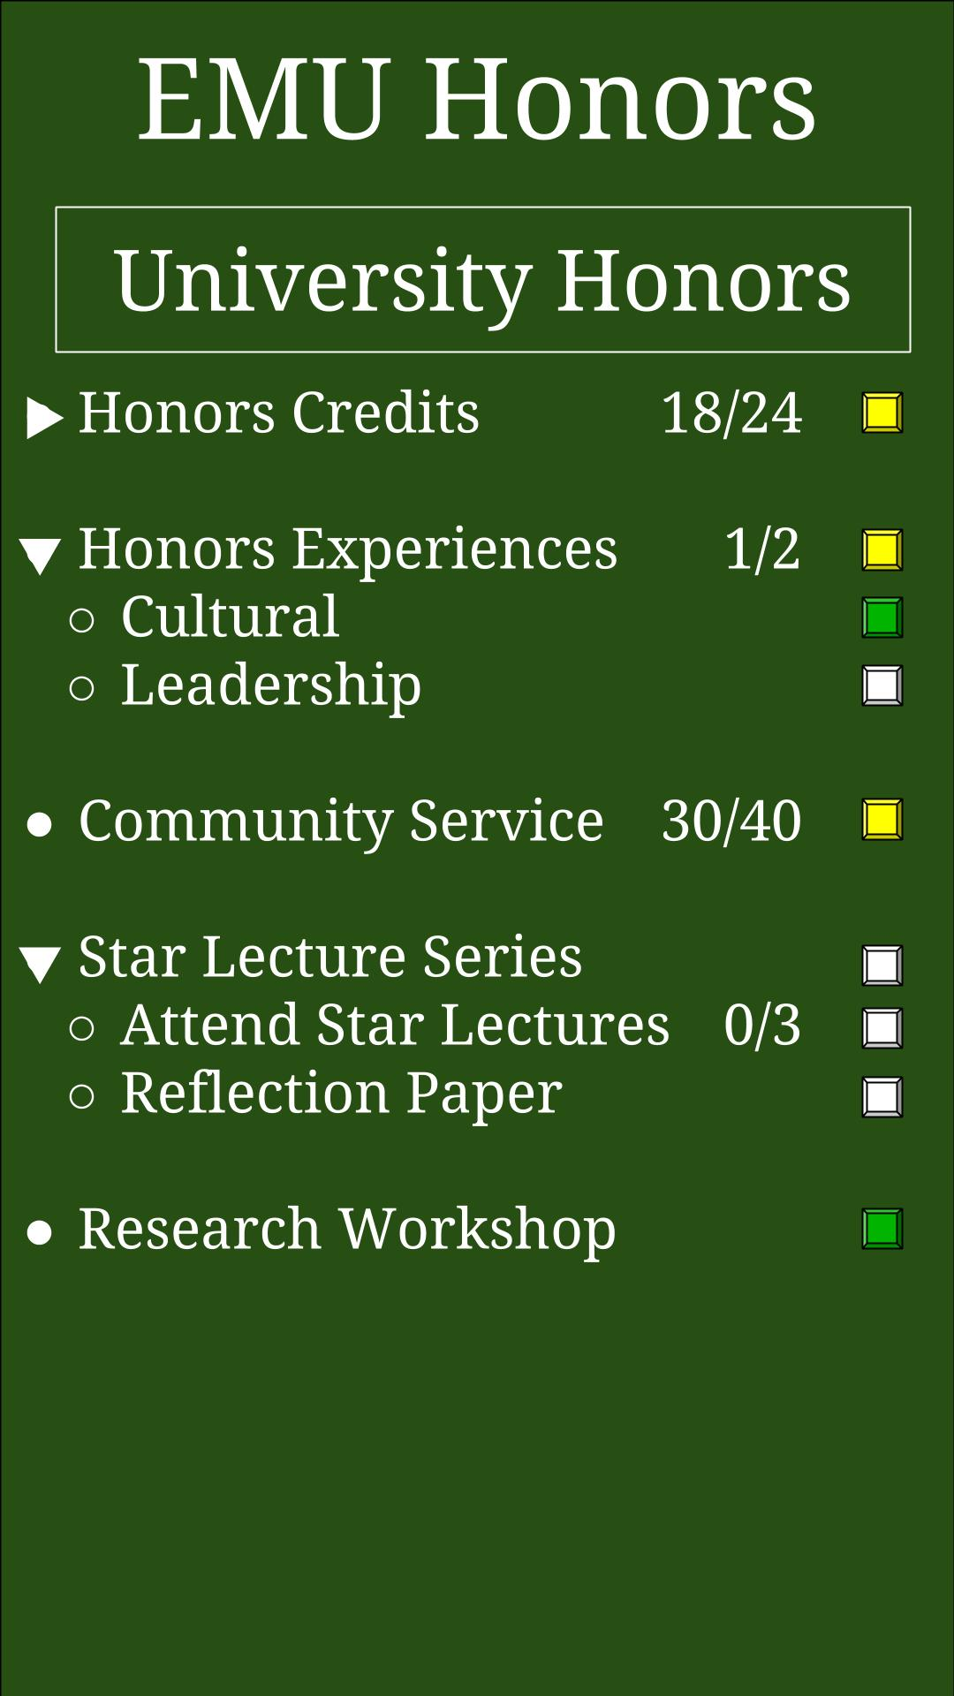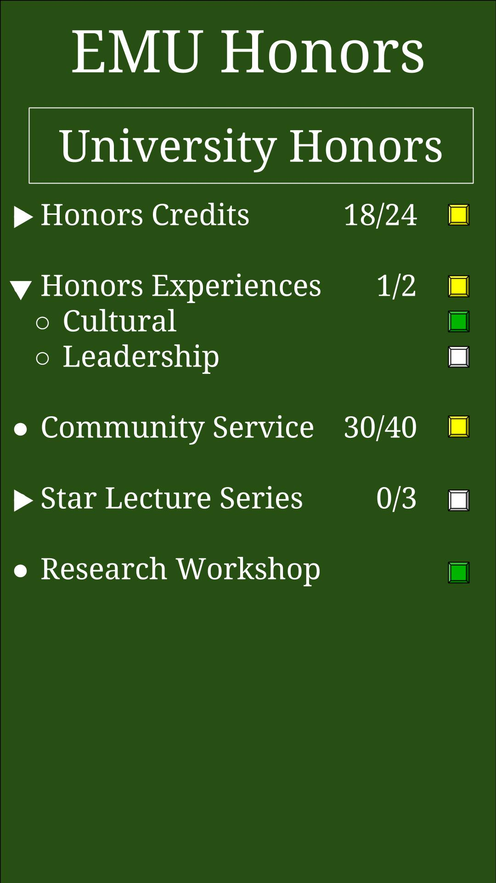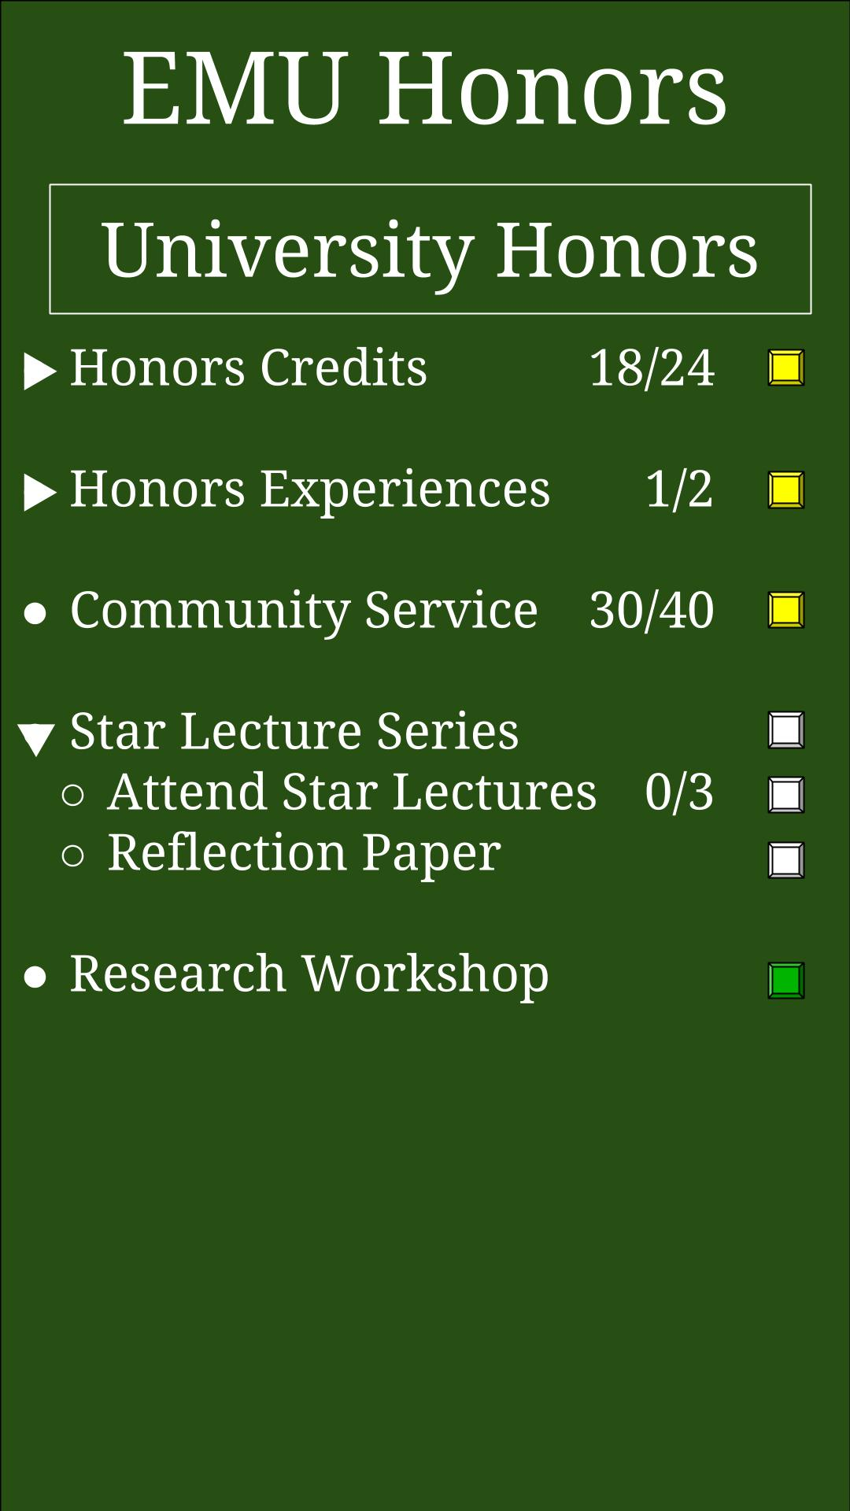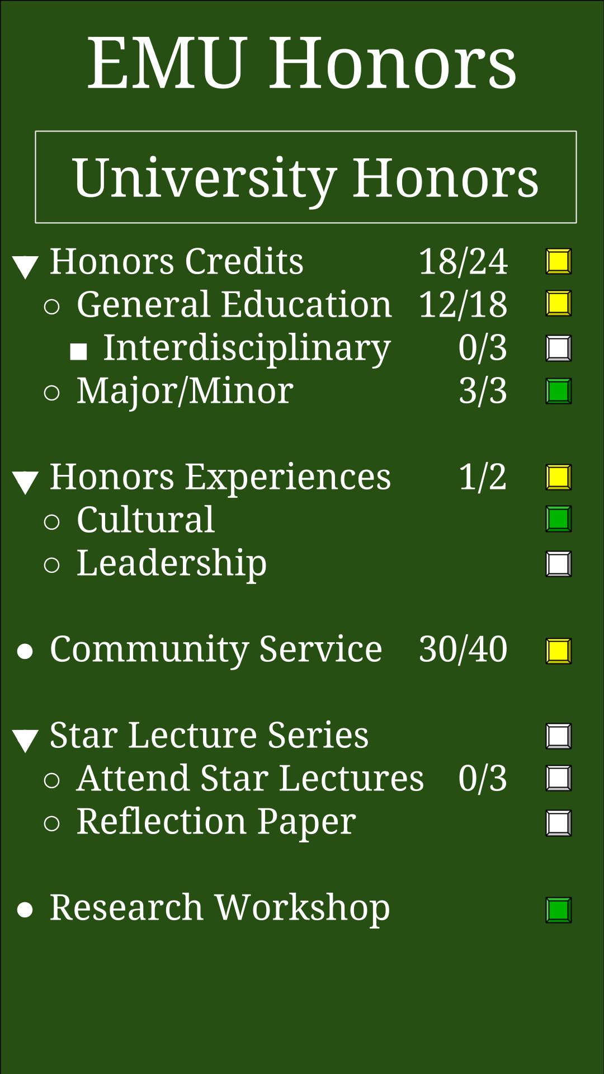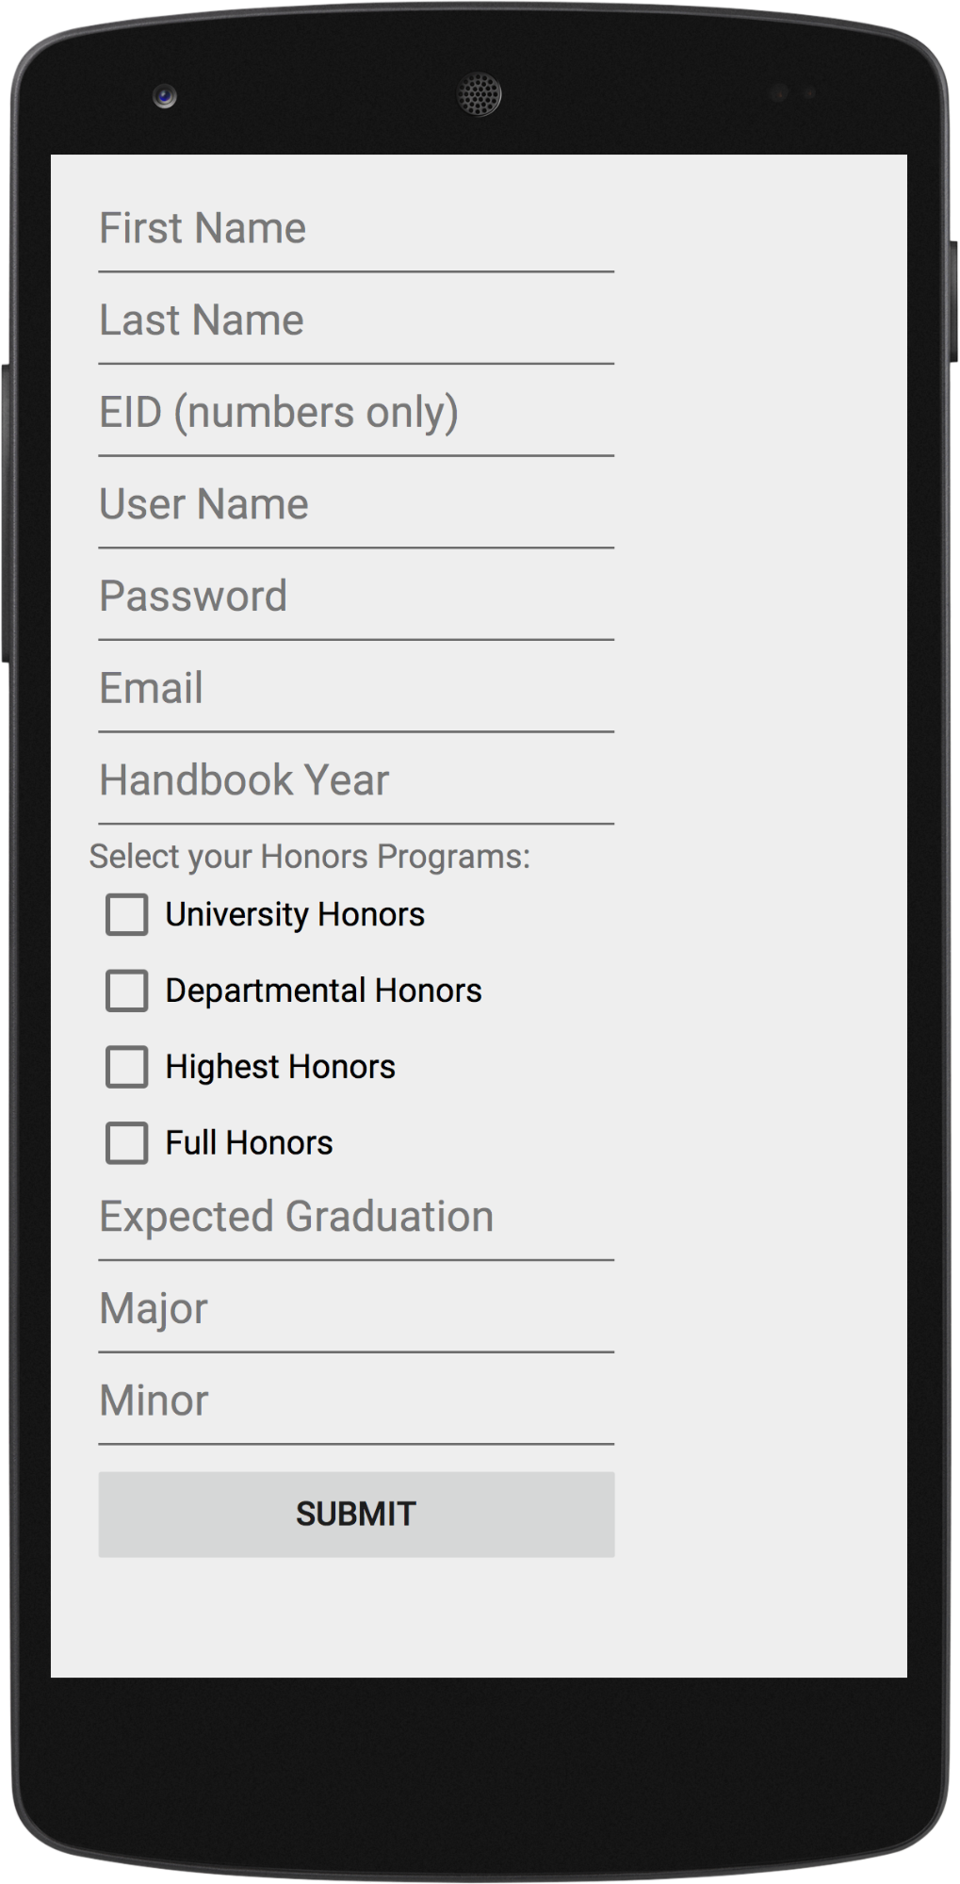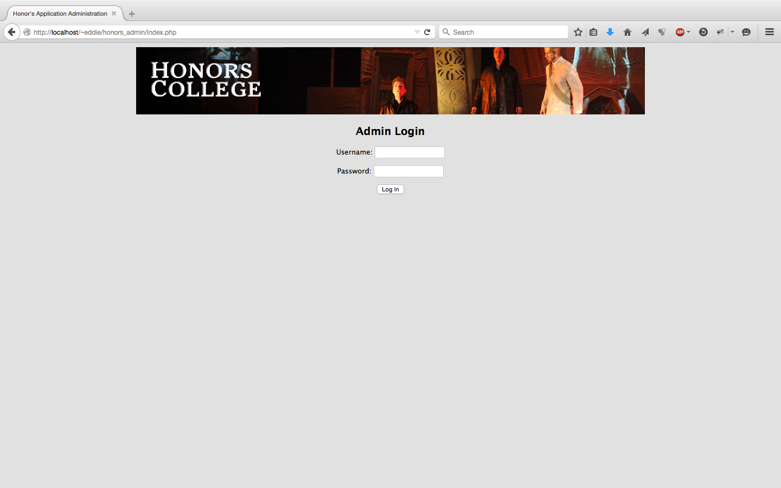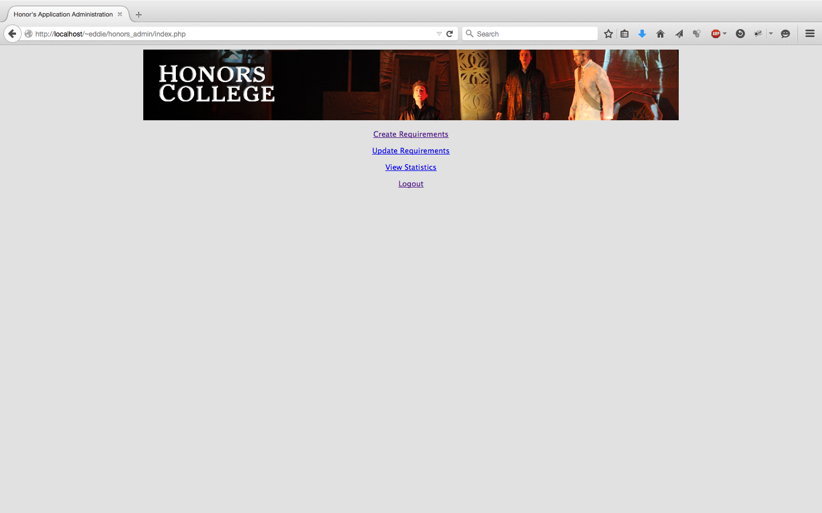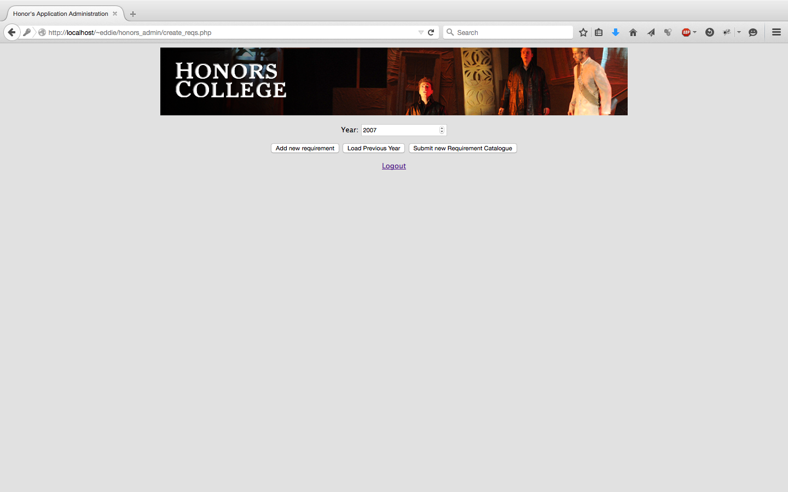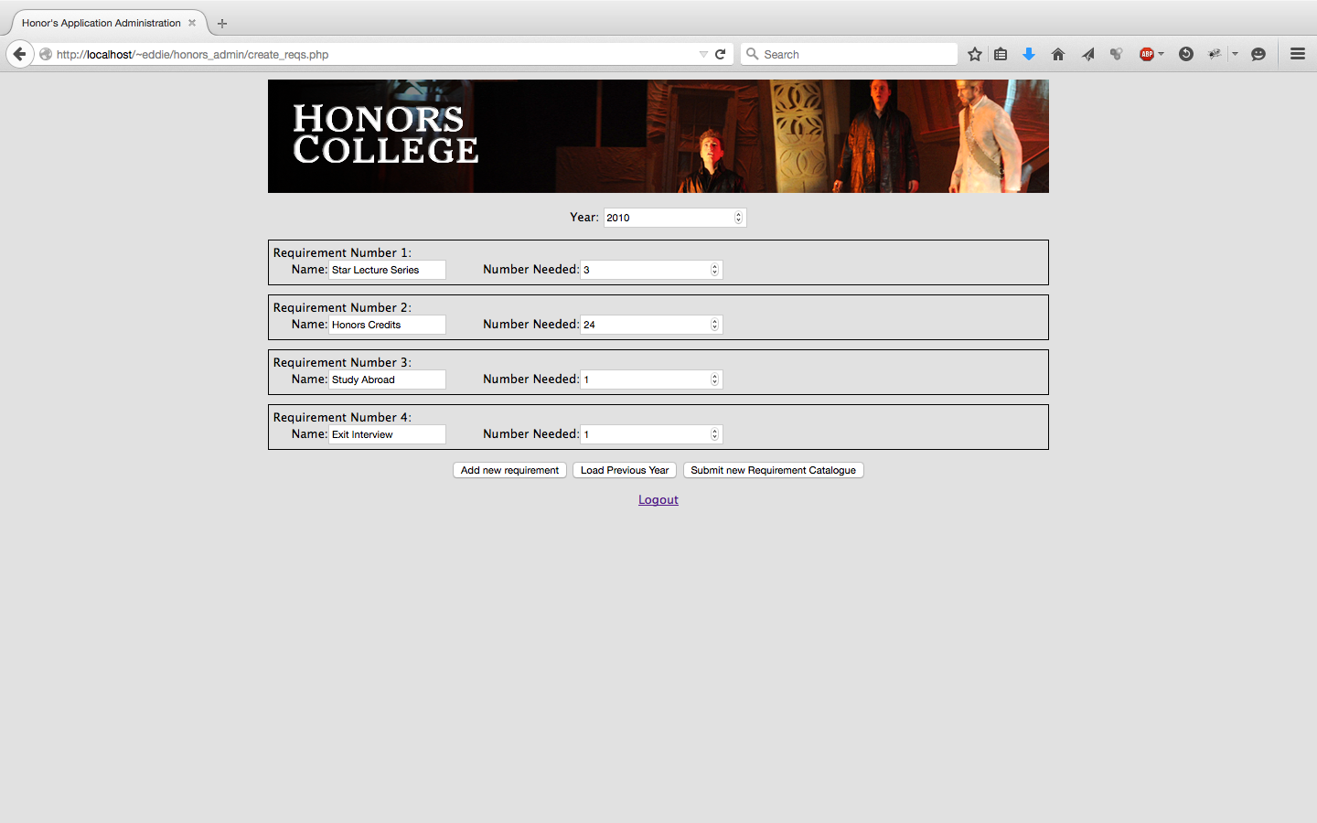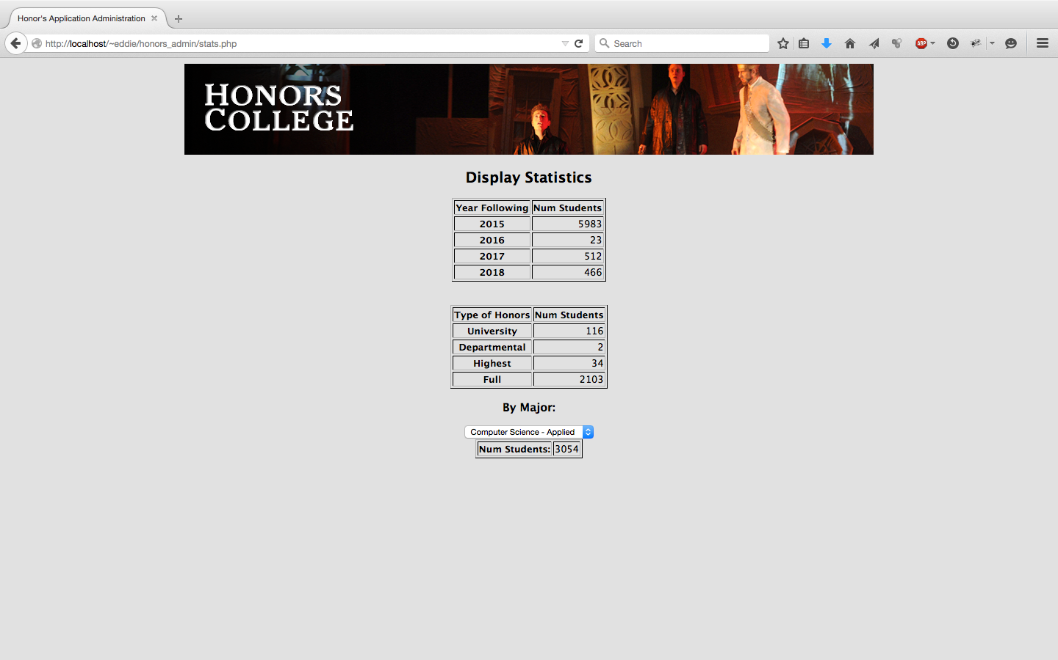

Client Validation

___ I certify that I have read this document in its entirety.

___ I certify that I am satisfied with the description of the services to be provided.

___ I certify that I wish for the project to be implemented as described in this document.

___ I certify that the requirements that the requirements presented in this document are tentative and may be subject to change due to potential scheduling constraints.

Comments:
______________________________________________________________________________________________________________________________________________________________________________________________________________________________________________________________________________________________________________________________________________________________________________________________________________________________________________________________________________________________________________________________________

Name: ______________________

Signature: ______________________ Date: _____________

Witnesses:

Name: ______________________ Name: ______________________

Signature: ______________________ Signature: ______________________
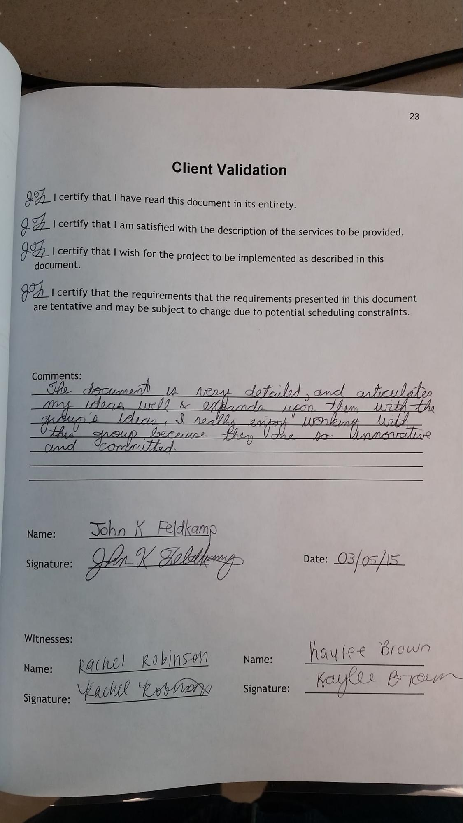Individual Contributions

Stefano
For the Requirements phase of the project, I attended a meeting with our client to determine the required functionality of our project, as well as more details about implementation and general direction. In the Requirements Document, I completed the Glossary section, helped write up a few of the Functional Requirements, created the Android Prototype in it's entirety, and helped combine and format everyone else's contributions into the final document. I also began the process of learning Android Development and started the project code base for the Android application.

Jordan
For the requirements phase of the project, I attended two meetings with our client, along with 2-3 additional meetings with our group. In the requirements Document, I contributed to the Scope, Help Files and helped write a few of the Functional Requirements. I also started learned how to use Git and the basics of Android Development.

Travis
For the requirements phase of the project, I attended two meetings with our client. I also attended two to three meetings with the group. In the Requirements Document, I completed the User Population, Computing Environment, and also contributed to the Help Files and the Functional Requirements. I also began learning how to use Android Development Software and how to use Git.

Nicole
I attended two meetings with our client and took notes. I also attended multiple meetings with the group to work on the document. I completed the Use Case diagram, the Use Case specifications and the non-functional requirements sections. I also contributed to the Help Files section and began learning Git.

Eddie
Attended several meetings with the client. Tried to rein in the client’s enthusiasm and constant idea generation that leads to serious scope creep, but was met with little success. Created the functional Admin web prototype. Wrote the Size of Program. Edited, formatted, and finalized the document, delivered hand copy to client for approval. Made immediate changes based on client’s needs and opinions. Established plans for future meetings with client. Instructed team to learn/research git and Android development.

