**Appendix A**

**Materials**

**Introduction to CCM, seen by participants of both conditions.**

“You are about to encounter information about a company called CCM, please read it over carefully because we will be asking you questions about it later.”

---

“John works as a software developer for a San Francisco based tech company called CCM.

He lives close to the headquarters, with a 20-minute commute to work. John primarily works on developing software used by companies for managing inventory and employee records. John is a talented programmer, enjoys his job, and gets along with his colleagues.

CCM was founded in 2016 and employs close to 100 people. CCM pays John a standard salary for his position and location of residence.

The following two pages briefly describe some of the perks and benefits offered to employees of CCM. Please take to time to look through both pages of this packet, it should only take a few minutes.”

**First page of promotional material displaying CCM perks, seen in both conditions.**

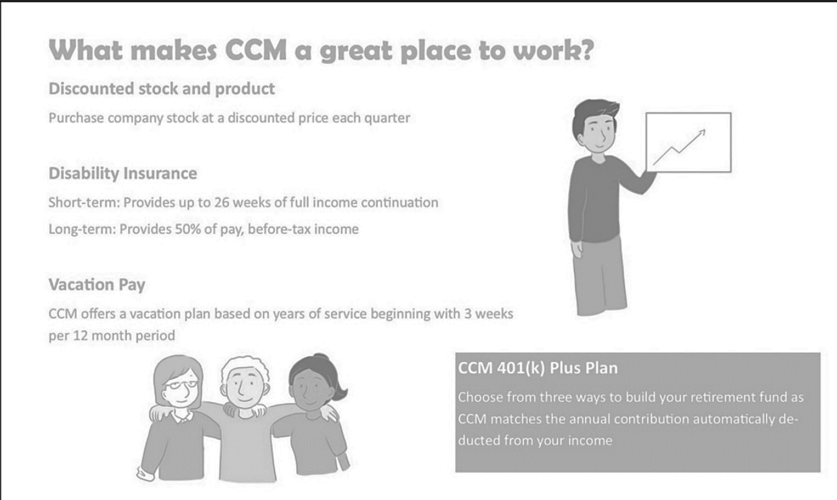

**Second page of promotional material displaying CCM perks, seen in control condition.**

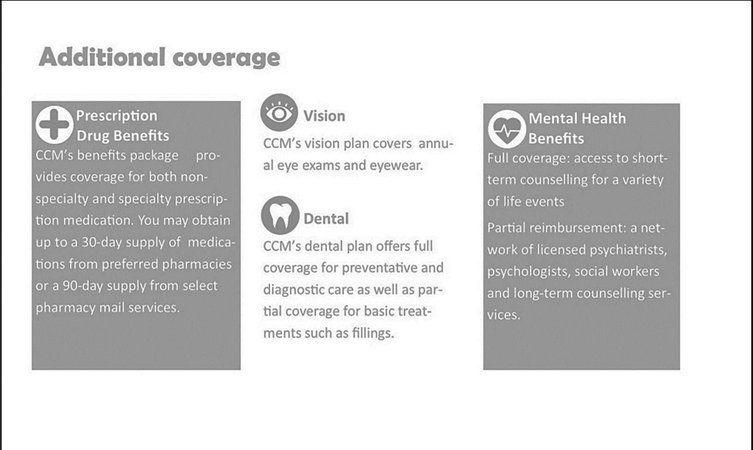

**Second page of promotional material displaying CCM perks, seen in control condition.**

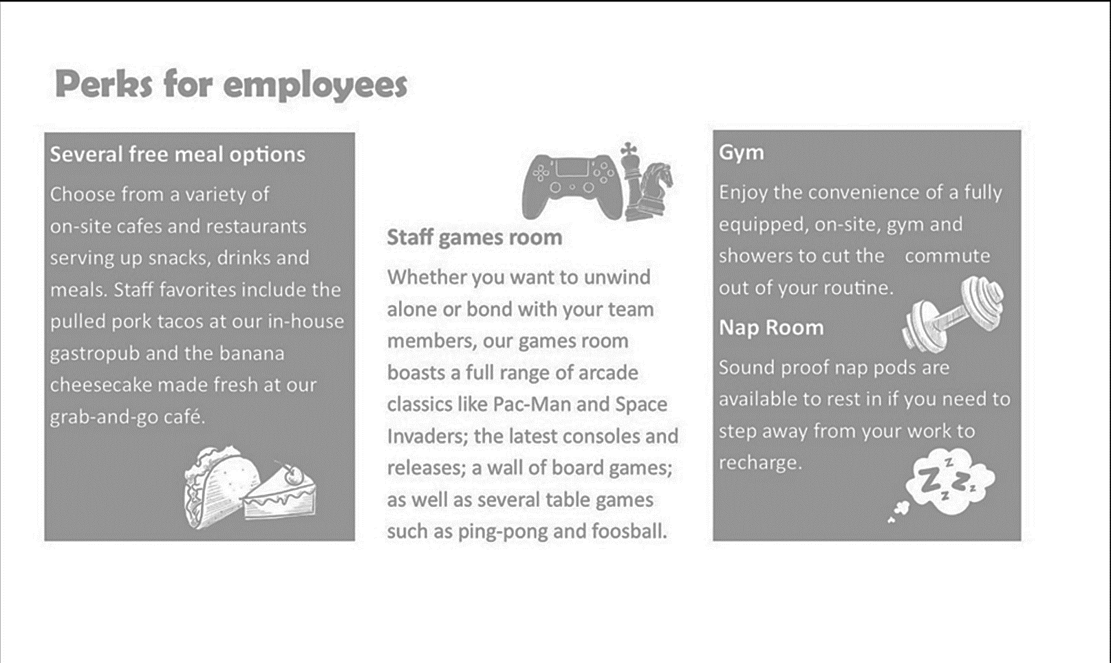

**Appendix B**

**Measures for Independent Variable and Key Outcomes**

**Exploitation Justification**

(1 = *Strongly Disagree*, 7 = *Strongly Agree*)

Please indicate how reasonable you think CCM’s actions are in the following contexts.

1. CCM is on a tight budget right now due to the economic recession. The organization needs to save money wherever they can. In response to this financial pressure, John's responsibilities increase without an offer of additional compensation.

----

CCM is reasonable for not giving John a raise given the circumstances.

1. A manager at CCM is sick, and no one from management can fill in. John is asked to take over the manager's duties until they come back so things can continue moving smoothly.

----

CCM is behaving reasonably in asking John to take over these duties temporarily without compensation.

**Expectations of Perfectionism**

(1 = *Strongly Disagree*, 7 = *Strongly Agree*)

1. After two months of working at CCM, John attends a scheduled performance review with this team lead. His lead congratulates John on meeting all of his deadlines successfully since joining the team. However, he then marks John’s performance as slightly below expectations. When John asks why he received this review, his lead explains how there is a culture amongst CCM employees of exceeding expectations. To stand out and receive positive reviews, John would need to think about taking on extra projects or submitting his work before their deadlines.

----

It is fair to expect John to go above and beyond his defined job expectations in order to receive positive performance reviews.

1. John finds that every time he submits work, it is sent back for revisions. Even when his code works, it will be sent back and not considered organized or formatted well enough.

John goes in to talk with his team lead and asks why his work is never good enough when it has always been acceptable at his previous places of work. John’s team lead tells him that the standard for employees is higher at CCM than at other companies. While he understands John’s frustration and thinks John is a great employee, he will need to raise his standards even more if he wants to fit in here.

----

It is fair that CCM holds its employee’s to higher standards than the rest of the industry.

**Mistreatment Justification**

(1 = *Strongly Disagree*, 7 = *Strongly Agree*)

Please read the following series of interactions between John and his colleagues or superiors at CCM before rating how much you agree with the behaviour exhibited by John's superiors.

1. John has been with CCM for several years and risen to the ranks of a senior developer with a team of junior developers working underneath him on an important project. Things are going well until the core software that CCM produces and distributes goes down. The error is quickly found and corrected, but CCM still received several customer complaints while the bug was being fixed. After it comes to light that John was the one who wrote the code that caused the error, he is verbally reprimanded then sent back to work. However, this error embarrassed John’s team lead, and they start to only give John tasks suitable for a newly hired junior developer to make a point.

----

The team lead’s response to John’s error is understandable

1. CCM has been struggling with a project, and everyone has been working day and night to make sure it gets completed by its deadline in 3 weeks. John booked the week before the project is due off several months prior, long before this deadline was set, to attend a family event. As his vacation draws closer, John's supervisor begins to ask John repeatedly if he can reschedule his vacation until after the deadline. When John refuses, his supervisor becomes upset with him. John's supervisor makes several remarks in front of others about how the team will suffer due to John's refusal to be a "team player." He brings up how his coworkers will be put under more stress because of John's decision.

----

It is understandable for John’s team lead to be outwardly upset with John for refusing to reschedule his time off.

**Manipulation Check**

1. From the description of CCM, I got the sense that they provide employees with considerable perks. (1 = *Strongly Disagree*, 7 = *Strongly Agree*)
2. Please briefly summarize your impression of CCM as a company.

**Appendix C**

**Measures for Exploratory Perceptions of CCM and Attitudes Towards John**

**Likelihood that John is Expected to Volunteer for Extra Work**

(1 = *Strongly Disagree*, 7 = *Strongly Agree*)

Please indicate how reasonable you think CCM's actions are in the following contexts.

1. John has a project that needs to be completed by Monday, and it's Friday. To get the job done on time, he will need to work through the weekend. He mentions this to his manager, who simply reminds him of how important this project is and says to do whatever he needs to do.

----

It is fair that John's manager expects him to work through the weekend for no extra pay to get his project done on time.

1. John finds himself needing to work more than 40 hours a week to keep up with his workload despite being an employee of average skill and time management. He goes to his manager to discuss how he feels that he is working more hours than he is compensated for. In response, his manager suggested a few techniques for getting more efficient and tells John that it's up to him to get the work done in however long it takes him.

----

It is reasonable that John is expected to work over 40 hours if he is unable to get his work done quickly enough.

**Belief that Work at CCM is a Reward in and of Itself**

(1 = *Strongly Disagree*, 7 = *Strongly Agree*)

Please answer the following questions using the response options provided.

1. John's enjoyment of his work acts as handsome compensation at CCM.
2. CCM is providing John with opportunities to enjoy his work.

**Belief that CCM Cares about its Employees Well Being**

(1 = *Strongly Disagree*, 7 = *Strongly Agree*)

Please answer the following questions using the response options provided.

1. CCM seems like an organization that values John's well-being.

**Belief that CCM is a Fun Place to Work**

(1 = *Strongly Disagree*, 7 = *Strongly Agree*)

Please answer the following questions using the response options provided.

1. CCM seems like a fun place to work.

**Belief that CCM is a Competitive Career Outcome**

(1 = *Strongly Disagree*, 7 = *Strongly Agree*)

Please rate how likely is that the following statements are accurate

1. It seems like CCM is a highly desirable employer in their field.
2. It is warranted that there are very high standards you need to meet to be considered for a promotion at CCM.

**Expectations of Company First Mentalilty from John**

(1 = *Strongly Disagree*, 7 = *Strongly Agree*)

Please rate how strongly you agree or disagree with the following statements.

1. It is reasonable to expect John to put CCM's needs ahead of his own.

**Expectations of Loyalty to CMM from John**

(1 = *Strongly Disagree*, 7 = *Strongly Agree*)

Please rate how strongly you agree or disagree with the following statements.

1. It is reasonable to expect John to be loyal to CCM and remain employed there for the next several years.

**Expectations of Gratitude Towards CMM from John**

(1 = *Strongly Disagree*, 7 = *Strongly Agree*)

Please rate how strongly you agree or disagree with the following statements.

1. John should be grateful to have his job at CCM.

**Appendix D**

**Results**

Figure D1

*Note.* A visualization of the spread and distribution of the perceived amount of perks offered by CMM between the control and experimental condition for item 1 of the manipulation check

|  |  |
| --- | --- |
| Figure D2*Text  Description automatically generatedNote*. A visualization of the spread and distribution of justification of exploitation between the control and experimental condition for item 1 | Figure D3*A screenshot of a computer  Description automatically generated with medium confidenceNote*. A visualization of the spread and distribution of justification of exploitation between the control and experimental condition for item 2 |

|  |  |
| --- | --- |
|   *Note*. A visualization of the spread and distribution of expectations of perfectionism between the control and experimental condition for item 1 | Figure D5*Text  Description automatically generatedNote*. A visualization of the spread and distribution of expectations of perfectionism between the control and experimental condition for item 2 |

|  |  |
| --- | --- |
|   *Note*. A visualization of the spread and distribution of justification of mistreatment between the control and experimental condition for item 1 | Figure D7*Text  Description automatically generatedNote*. A visualization of the spread and distribution of justification of mistreatment between the control and experimental condition for item 2 |

Figure D8

*Note*. A depiction of the means and standard deviations of degree to which participants agreed with the statement that CCM seemed like a fun place to work in the control condition and experimental condition.

Table D1

*Summary of Students t-tests, mean and standard deviations for each condition, confidence intervals and Cohen's d measures of effect size for differences of expectations for negative outcomes: extra work, expected number of hours worked, belief that work is it's own reward, expectations of company-first attitude, loyalty and gratitude, and perception that CCM is a competitive employer in the industry between control and experimental conditions.*

|  |  |  |  |  |  |  |  |
| --- | --- | --- | --- | --- | --- | --- | --- |
|  |  |  |  |  | 95% CI | |  |
|  | df | T-Statistic (p) | Ctrl M(SD) | Exp M(SD) | Lower | Upper | Cohen's d |
| Extra Work 1 | 289 | .74 (.459) | 3.35(1.67) | 3.21(1.7) | -0.242 | 0.535 | 0.09 |
| Extra Work 2 | 289 | .28 (.781) | 3.32(1.53) | 3.27(1.54) | -0.304 | 0.404 | 0.03 |
| **Work Hours 1** | **288** | **2.07 (.039)\*** | **39.73(5.39)** | **38.37(5.81)** | **-0.323** | **2.935** | **0.24** |
| Work Hours 2 | 289 | 0.07 (.941) | 43.87(11.7) | 43.77(11.63) | -2.590 | 2.793 | 0.01 |
| Work as a Reward 1 | 289 | -0.08 (.939) | 3.33(1.3) | 3.34(1.27) | -0.307 | 0.284 | 0.01 |
| Work as a Reward 2 | 288 | -1.09 (.275) | 3.11(1.4) | 3.29(1.48) | -0.516 | 0.147 | -0.13 |
| Company First | 284 | -.95 (.340) | 2.25(1.18) | 2.39(1.36) | -0.435 | 0.151 | -0.11 |
| Loyalty | 289 | 0.27 (.789) | 3.14(1.46) | 3.19(1.52) | -0.391 | 0.298 | -0.03 |
| Gratitude | 287 | -.75 (.454) | 3.79(1.21) | 3.90(1.31) | -0.402 | 0.180 | -0.09 |
| Competitive 2 | 284 | -.55 (.582) | 5.55(1.41) | 5.63(1.23) | -0.390 | 0.220 | -0.06 |

*Note.* ** p < .01 level. *  p < .05 level. Negative Mean Difference or S.D. Difference means a higher respective mean or S.D. in the experimental condition.

Table D2

*Summary of Students t-tests, mean and standard deviations for each condition, confidence intervals and Cohen's d measures of effect size for differences of expectations for perceptions of clan culture: between control and experimental conditions.*

|  |  |  |  |  |  |  |  |  |
| --- | --- | --- | --- | --- | --- | --- | --- | --- |
|  |  |  |  | |  | 95% CI | |  |
|  | df | T-Statistic (p) | Ctrl M(SD) | Exp M(SD) | | Lower | Upper | Cohen's d |
| Well-Being | 289 | -.16 (.873) | 2.39(1.32) | | 2.42(1.31) | -0.328 | 0.279 | -0.02 |
| **Fun** | **280** | **-2.49 (.013)\*** | **2.29(1.24)** | | **2.69(1.50)** | **-0.720** | **-0.084** | **-0.29** |
| Competitive 1 | 289 | 0.21 (.837) | 3.72(1.61) | | 3.68(1.62) | -0.334 | 0.412 | 0.02 |

*Note. ** p* < .01 level. *  p < .05 level. Negative Mean Difference or S.D. Difference means a higher respective mean or S.D. in the experimental condition.

Table D3

*Summary of correlations (significance) across manipulation check and all outcomes, part 1.*

|  |  |  |  |  |  |  |  |  |  |  |  |  |  |  |  |  |  |  |  |  |
| --- | --- | --- | --- | --- | --- | --- | --- | --- | --- | --- | --- | --- | --- | --- | --- | --- | --- | --- | --- | --- |
|  | 1 | | 2 | | 3 | | 4 | | 5 | | 6 | | 7 | | 8 | | 9 | | 10 | |
| 1. Manipulation | - |  |  |  |  |  |  |  |  |  |  |  |  |  |  |  |  |  |  |  |
| 2. Exploitation 1 | .01 |  | - |  |  |  |  |  |  |  |  |  |  |  |  |  |  |  |  |  |
| 3. Exploitation 2 | .08 |  | **.26** | **\*\*\*** | ­- |  |  |  |  |  |  |  |  |  |  |  |  |  |  |  |
| 4. Mistreatment 1 | -.02 |  | .09 |  | **.18** | **\*\*** | - |  |  |  |  |  |  |  |  |  |  |  |  |  |
| 5. Mistreatment 2 | .03 |  | .09 |  | **.18** | **\*\*** | **.35** | **\*\*\*** | - |  |  |  |  |  |  |  |  |  |  |  |
| 6. Perfectionism 1 | .04 |  | **.13** | **\*** | .28 |  | **.21** | **\*\*\*** | **.25** | **\*\*\*** | - |  |  |  |  |  |  |  |  |  |
| 7. Perfectionism 2 | **.26** | **\*\*\*** | .06 |  | **.04** | **\*** | -.04 |  | .05 |  | .02 |  | - |  |  |  |  |  |  |  |
| 8. Extra Work 1 | **.23** | **\*\*\*** | .10 |  | **.12** | **\*** | .06 |  | .09 |  | **.16** | **\*\*** | **.27** | **\*\*\*** | **-** |  |  |  |  |  |
| 9. Extra Work 2 | **.19** | **\*\*** | **.14** | **\*** | **.18** | **\*\*** | **.21** | **\*\*\*** | **.18** | **\*\*** | **.23** | **\*\*\*** | **.22** | **\*\*\*** | .**42** | **\*\*\*** | - |  |  |  |
| 10. Work Hours 1 | .09 |  | -.04 |  | .03 |  | **-.12** | **\*** | -.04 |  | .04 |  | **.13** | **\*** | .09 |  | **.17** | **\*\*** | - |  |
| 11. Work Hours 2 | **.21** | **\*\*\*** | .01 |  | .11 | **†** | -.08 |  | .07 |  | -.07 |  | **.15** | **\*\*** | .**15** | **\*** | **.19** | **\*\*** | **.33** | **\*\*\*** |
| 12. Competitive 1 | **.40** | **\*\*\*** | **.12** | **\*** | **.18** | **\*\*** | .**13** | **\*** | **.20** | **\*\*** | **.13** | **\*** | **.28** | **\*\*\*** | **.23** | **\*\*\*** | **.31** | **\*\*\*** | .09 |  |
| 13. Competitive 2 | **.21** | **\*\*\*** | -.03 |  | .04 |  | .03 |  | -.02 |  | .**17** | **\*\*** | **.12** | **\*\*** | **.16** | **\*\*** | **.13** | **\*** | .06 |  |
| 14. Company First | **.10** | **\*\*** | **.13** | **\*** | **.23** | **\*\*\*** | **.24** | **\*\*\*** | **.35** | **\*\*\*** | **.25** | **\*\*\*** | .06 |  | **.23** | **\*\*\*** | **.28** | **\*\*\*** | .04 |  |
| 15. Loyalty to Co | **.17** | **\*\*** | .07 |  | **.15** | **\*\*** | **.19** | **\*\*** | **.27** | **\*\*\*** | **.19** | **\*\*** | .06 |  | **.23** | **\*\*\*** | **.30** | **\*\*\*** | **.15** | **\*** |
| 16. Gratitude to Co | **.33** | **\*\*\*** | **.13** | **\*** | **.17** | **\*\*** | .**20** | **\*\*** | **.21** | **\*\*\*** | **.23** | **\*\*\*** | **.20** | **\*\*** | **.16** | **\*\*** | **.35** | **\*\*\*** | .05 |  |
| 17. Co is Fun Place | **.30** | **\*\*\*** | **.20** | **\*\*** | **.25** | **\*\*\*** | **.12** | **\*** | **.32** | **\*\*\*** | **.20** | **\*\*** | .06 |  | **.21** | **\*\*\*** | **.29** | **\*\*\*** | .11 | **†** |
| 18. Emp Well Being | **.29** | **\*\*\*** | **.13** | **\*** | **.24** | **\*\*\*** | **.14** | **\*** | **.36** | **\*\*\*** | **.28** | **\*\*\*** | .05 |  | **.24** | **\*\*\*** | **.28** | **\*\*\*** | .06 |  |
| 19. Work is Reward 1 | **.20** | **\*\*** | .04 |  | **.19** | **\*\*** | **.22** | **\*\*\*** | **.22** | **\*\*\*** | **.17** | **\*\*** | .10 | **†** | .08 |  | **.16** | **\*\*** | **.14** | **\*** |
| 20. Work is Reward 2 | **.28** | **\*\*\*** | **.12** | **\*** | **.24** | **\*\*\*** | **.16** | **\*\*** | **.31** | **\*\*\*** | **.22** | **\*\*\*** | **.13** | **\*** | **.21** | **\*\*\*** | **.19** | **\*\*** | .07 |  |

*Note.* †*p < .10, *p* < .05 level*, ** p* < .01 level, *\*\*\* p* < .001 level.

Manipulation = Manipulation Check, Exploitation = Exploitation Justification, Mistreatment = Mistreatment Justification, Perfectionism = Expectations of Perfectionism, Extra Work = Extra Work Justification, Work Hours = Work Hours, Competitive = Perception of Competitive Work Place, Company First = Company First Attitude, Loyalty to Co = Expectation of Loyalty, Gratitude to Co = Expectation of Gratitude, Co is Fun Place = Perception of Fun Workplace, Emp Well Being = Perceived Care for Employee Well Being, Work is Reward = View of Work as its own Reward.

Table D4

*Summary of correlations (significance) across manipulation check and all outcomes, part 2.*

|  |  |  |  |  |  |  |  |  |  |  |  |  |  |  |  |  |  |  |  |  |
| --- | --- | --- | --- | --- | --- | --- | --- | --- | --- | --- | --- | --- | --- | --- | --- | --- | --- | --- | --- | --- |
|  | 11 | | 12 | | 13 | | 14 | | 15 | | 16 | | 17 | | 18 | | 19 | | 20 | |
| 1. Manipulation |  |  |  |  |  |  |  |  |  |  |  |  |  |  |  |  |  |  |  |  |
| 2. Exploitation 1 |  |  |  |  |  |  |  |  |  |  |  |  |  |  |  |  |  |  |  |  |
| 3. Exploitation 2 |  |  |  |  |  |  |  |  |  |  |  |  |  |  |  |  |  |  |  |  |
| 4. Mistreatment 1 |  |  |  |  |  |  |  |  |  |  |  |  |  |  |  |  |  |  |  |  |
| 5. Mistreatment 2 |  |  |  |  |  |  |  |  |  |  |  |  |  |  |  |  |  |  |  |  |
| 6. Perfectionism 1 |  |  |  |  |  |  |  |  |  |  |  |  |  |  |  |  |  |  |  |  |
| 7. Perfectionism 2 |  |  |  |  |  |  |  |  |  |  |  |  |  |  |  |  |  |  |  |  |
| 8. Extra Work 1 |  |  |  |  |  |  |  |  |  |  |  |  |  |  |  |  |  |  |  |  |
| 9. Extra Work 2 |  |  |  |  |  |  |  |  |  |  |  |  |  |  |  |  |  |  |  |  |
| 10. Work Hours 1 |  |  |  |  |  |  |  |  |  |  |  |  |  |  |  |  |  |  |  |  |
| 11. Work Hours 2 | - |  |  |  |  |  |  |  |  |  |  |  |  |  |  |  |  |  |  |  |
| 12. Competitive 1 | **.20** | **\*\*** | - |  |  |  |  |  |  |  |  |  |  |  |  |  |  |  |  |  |
| 13. Competitive 2 | .07 |  | **.23** | **\*\*\*** | **-** |  |  |  |  |  |  |  |  |  |  |  |  |  |  |  |
| 14. Company First | **.14** | **\*** | **.20** | **\*\*** | .03 |  | **-** |  |  |  |  |  |  |  |  |  |  |  |  |  |
| 15. Loyalty to Co | **.13** | **\*** | **.22** | **\*\*\*** | .04 |  | **.44** | **\*\*\*** | **-** |  |  |  |  |  |  |  |  |  |  |  |
| 16. Gratitude to Co | **.12** | **\*** | **.36** | **\*\*\*** | **.19** | **\*\*** | **.36** | **\*\*\*** | **.47** | **\*\*\*** | **-** |  |  |  |  |  |  |  |  |  |
| 17. Co is Fun Place | **.20** | **\*\*** | **.46** | **\*\*\*** | .04 |  | **.29** | **\*\*\*** | **.35** | **\*\*\*** | **.30** | **\*\*\*** | **-** |  |  |  |  |  |  |  |
| 18. Emp Well Being | **.17** | **\*\*** | **.37** | **\*\*\*** | .06 |  | **.38** | **\*\*\*** | **.38** | **\*\*\*** | **.33** | **\*\*\*** | **.65** | **\*\*\*** | **-** |  |  |  |  |  |
| 19. Work is Reward 1 | **.18** | **\*\*** | **.31** | **\*\*\*** | **.20** | **\*\*** | **.31** | **\*\*\*** | **.33** | **\*\*\*** | **.28** | **\*\*\*** | **.28** | **\*\*\*** | **.32** | **\*\*\*** | **-** |  |  |  |
| 20. Work is Reward 2 | **.23** | **\*\*\*** | **.39** | **\*\*\*** | **.11** | **\*** | **.31** | **\*\*\*** | **.24** | **\*\*\*** | **.31** | **\*\*\*** | **.56** | **\*\*\*** | **.60** | **\*\*\*** | **.32** | **\*\*\*** | **-** |  |

*Note.* †*p < .10, *p* < .05 level*, ** p* < .01 level, *\*\*\* p* < .001 level.

Manipulation = Manipulation Check, Exploitation = Exploitation Justification, Mistreatment = Mistreatment Justification, Perfectionism = Expectations of Perfectionism, Extra Work = Extra Work Justification, Work Hours = Work Hours, Competitive = Perception of Competitive Work Place, Company First = Company First Attitude, Loyalty to Co = Expectation of Loyalty, Gratitude to Co = Expectation of Gratitude, Co is Fun Place = Perception of Fun Workplace, Emp Well Being = Perceived Care for Employee Well Being, Work is Reward = View of Work as its own Reward.