Trends in the IT Industry and how they affect my career

Ethan Marsh

Professional Practices for IT

Mr. Joe Menchefski

November 15th, 2017

The continuous fusing of our physical and digital worlds is creating more products and services that have internet connectivity, and it is changing the world around us as we speak. The coming landscape of the physical and digital worlds is going to create a myriad of advancements in the ways we do business with customers. House appliances that ran on analog hardware for decades are now being replaced with digital hardware, capable of communicating with other appliances around the house. It is called the Internet of things: a new trend that involves normally internet free items being reworked to support networking features. Many are saying that the Internet of Things is the second "Industrial Revolution". Not only is it revolutionizing the household, it is also changing the way many businesses operate on a daily basis by reworking how employees work together using the latest and greatest networking capabilities provided by the IoT, not to mention businesses are top adopter when it comes to IoT products and services. The amount of money invested into the Internet of Things by private businesses is even greater than the amount invested by the government, and consumers combined. All of these circumstances will serve to facilitate major demand for technical expertise and job growth within the IT industry. For an up and coming software developer, the popularity of the IoT means that everybody wants to make their own IoT services to cash in, and are going to need more talent to keep up with the demand. Big Data will play a very important role in the IoT movement as well. Companies are using public personal data from consumers to improve their customer experiences. With more companies increasingly relying on big data to operate their business, the demand for database expertise is going to be driven up as well. With great opportunity there are also great concerns that need to be addressed. Greater and Greater amounts of devices are being connected to the internet, which are leaving many cracks and hole that hackers could potentially slip through. Many companies realize this, which is why there is going to be an increase in demand for cyber security experts, and cyber security services in the coming years. If the IoT were to gain a bad reputation for leaving holes in customer’s networks, it would damage the bottom line, and potential sales in the near future. Businesses will either have to invest resources into developing their security technology, or they can outsource these services to other companies that specialize in cyber-security. Either way, this need for protection is going to drive up the market for cyber security products and services. These trends are creating a great many opportunities for work within the IT industry. Jobs are going to be plentiful, so newcomers have a greater chance to break into the industry. For an up and coming software developer, there is going to be plenty of work to be done. The increasing popularity of the internet of things will drive up demand for several other fields in the IT Industry including Big Data management, and cyber security. Software developers working on Internet of Things products and services are going to have to become knowledgeable on databases and security in addition to knowing how to program for the IoT.

Why is it, that the Internet of Things, out of all of the advancements and innovations made in the past couple years, was the one that made it to the top? The one that will change how businesses across the globe forever? Because the wide spread effects of the Internet of Things doesn’t stop at the IT industry. Companies coming from all kinds of different backgrounds are investing capital into IoT solutions. Everybody is using the huge networking potential of the IoT to create innovative new products and services. Businesses are learning how to integrate the internet into the customer experience even more intimately than ever before. You can order foods For example, Walmart has developed a "Savings Catcher" service: customers can scan their receipts with an in store tool that searches for lower advertised prices for the products they just bought, and gives them the money they could have saved on a gift card. However, it isn’t just about creating new products; The IoT is also helping companies expand their brands as well. Underarmor isn’t just about buying clothes for sports, with the introduction of fitness tackers, Underarmor is nudging its way into the health and fitness industry. New jobs in the IT industry aren’t just coming from companies specializing in tech anymore. Since everyone is going to find some sort of use out of the IoT, everybody is going to need the talent and expertise required to get these services up and running, which means more and more businesses, even ones that don’t usually dabble in the technological side of the general market, will be hiring software developers, database experts, and cyber-security professionals. We can actually observe this demand in action: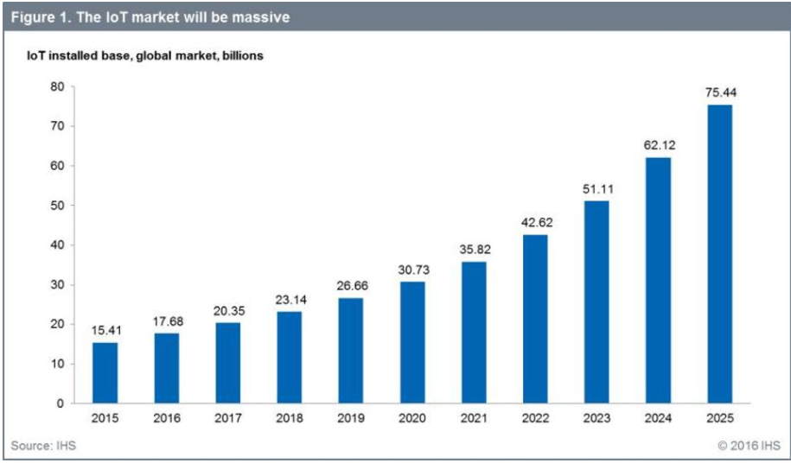 As shown in the graph above, the Internet of Things is so popular there will be almost seventy five and a half billion IoT devices installed in the entire world. In an article hosted on spiceworks.com (The data of which has been compiled in a graph on the next page), it shows us that companies are increasing their budgets and staff to meet the demand for more IoT solutions. In North America, forty six percent of companies are expecting to increase their budget. Forty six percent of companies are also expecting an increase in staff; even the US bureau of Labor statistics are saying that the software development jobs are expected to increase 24% from 2016 to 2026, and that’s just in the United States alone. The result of all this is going to be a boom in IT jobs all across North America. In 2020 Vendors selling either Internet of Things products or Internet of Things services are expecting their annual profits to top four hundred billion dollars. Optimistic estimates of the IoT market as a whole say it could generate over twelve trillion dollars in revenue in 2025.

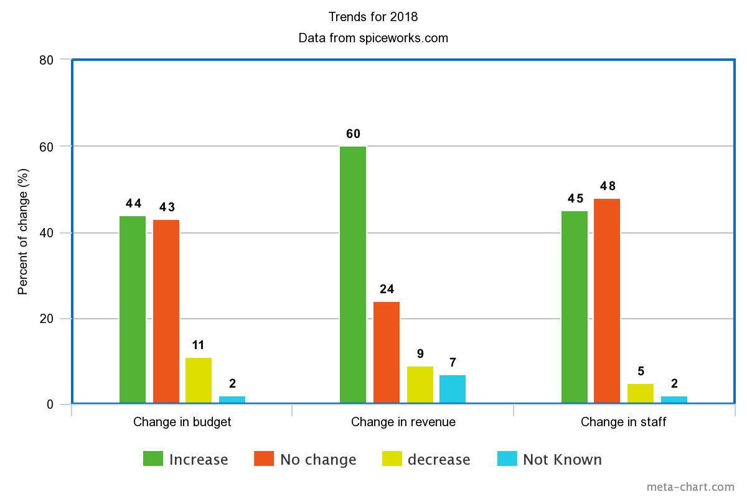

Not only is the Internet of Things generating lots of revenue, it is also capable of saving money at the same time. The advanced sensory capability of the IoT makes it possible to gather detailed information of just about every aspect of your business in real time. The IoT can use that data to micro manage every device on the system. It can strategically allocate power to every device in order to optimize power usage, and reduce electricity bills.

All of the devices around you are more likely than not recording some aspect of your life. Your preferences in movies, what places around town you like to eat at. If you so much as sneeze, chances are at least one of your devices knows about it, and has already sent the data back to headquarters. We are accumulating information at an unprecedented rate, never before witnessed by any of our ancestors. Big Data is going to be one of the biggest driving forces alongside IoT in the new Industrial Revolution. Big data is giving businesses a great variety of tools that will help them improve their strategies and techniques in ways we couldn’t have imagined even just fifteen years ago. It can be used to tailor advertisements to each individual consumer’s personal taste, research the cost of goods sold and customer demand to calculate the optimum prices for maximum profit, and it can even be used to make predictions about where the markets are going in the future. Big Data isn’t just limited to what personal information consumers are putting out there, In the case of John Deere, they had just recently started installing sensors everywhere inside all of their new machines in order to capture data about how their machines are being used, diagnosing and even predicting breakdowns in the machinery. Big Data is not only capable of greatly enhancing the customer experience, it is also able to improve the products and services companies are offering. Despite how much use we are getting out of Big Data, we aren’t even remotely close to accessing its fullest potential yet. Everyday 1 quintillion bytes of data are generated globally; according to an article by Gurjeet Singh, hosted on Gigaom.com**,** only a single percent of that reservoir of information is being researched and analyzed. Big Data is definitely not an advantage worth passing up, eventually everybody body is going to be using big data to improve their business, despite the cost to implement the adequate amount of storage and setting up proper hosting. Even considering the examples discussed prior, the fullest extent of its benefits haven’t even been touched yet. Because of the advantages of using the massive amounts of information consumers and businesses are generating, there is now a huge demand for data professionals so much that by 2020 there will be over seven hundred thousand job openings annually, despite those positions usually requiring a Masters or PhD, and are very challenging to recruit for. Today it takes an average of 53 days for a data professional position to be filled. Even if you are not a data professional, learning about the inner workings of the gratuitous amounts of data produced by the IoT will become a very valuable skill to learn in the near future, as database management will be an integral part of every IoT solution out there. Software developers will have to take into account what sorts of data can be gathered using their products, and how that data will play into the bigger picture of the market.

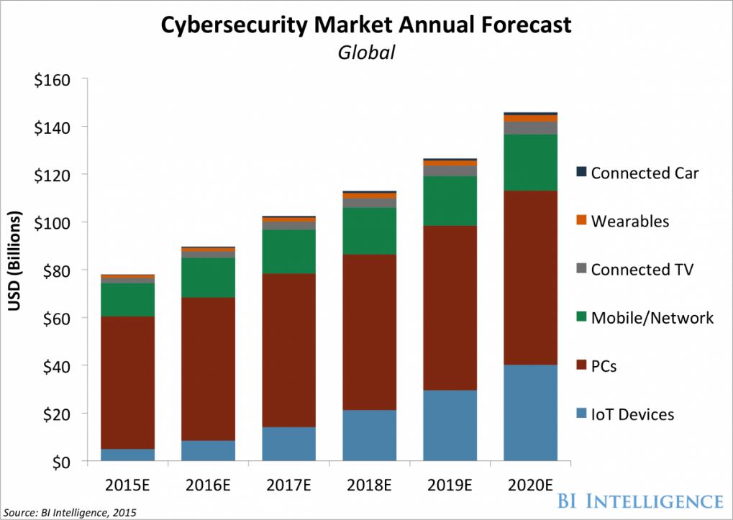 Last year, a group of Finnish hackers stole 10 gigabytes of confidential data from a casino in the United States by using the sensors of a fish tank connected to an employee's pc as a point of entry into the network. As we continue to populate our homes with appliances, and even toys that are connected to the internet, hackers are being given more and more opportunities to enter and run amok the household network. It isn’t just your computer that is vulnerable to cyber-attacks anymore, anything from your baby monitor, your fridge, and potentially even your car could be hacked, and taken control of should it be connected to the internet. Imagine having your brand new self-driving car hacked and it drives away on its own. Cyber Security is going to become an even bigger issue in 2018, especially after this year's high profile data leaks recently, such as Equifax’s data breach.

Security is going to be a major concern for the Internet of Things market, and is part of why the security sector is experiencing a surge of growth. By 2020 the annual cybersecurity market is forecasted to reach over one hundred forty billion. The demand for IT security is so dramatic that jobs in the field are going to grow 18% by 2024. Most of these new security jobs are most likely going to come from companies that specialize in cyber-security, since managing the security for hundreds of wireless devices is very difficult. AsTEKSystemssaid in an article surveying various company’s thoughts on working with the Internet of Things *“Approximately one-third of IoT project needs require support from external vendors versus internal resources. Most organizations are not highly confident in their preparedness to complete each phase of an IoT initiative in-house. Less than 4 in 10 rate their level of preparedness in each phase as excellent or very good.”* This isn’t just a problem for internet security companies to deal with, everybody in the IoT market is going to have to take many precautions when introducing their products to the market. If security standards aren’t up of snuff, and if too many people are taken advantage of while using the Internet of Things, It could potentially lead people to distrust the industry in its entirety, leading to lower the bottom line and possibly even jobs, which is why it is very important to address these issues of security in the household. Learning how to deal with security threats with in a wireless device may become a very important skillset for software developer’s to learn in the coming days. While it will be costly and difficult to manage security for the IoT, It has to be done, and if it isn’t, businesses shouldn’t expect their bottom line to go very far, or at the very least break even.

With everything that has been said about the wide spread effects of the Internet of Things, and the rippling effects it will have on the global economy, what can we learn about the effects the IoT revolution will have on your average, run of the mill software developer working with the IoT? What we know for sure, is that software developers are going to need a working knowledge of managing huge banks of information, and how to keep them safe from intruding cyber criminals. Even with professionals specialized for data or security working covering their own sections of the project, programmers are going to need an understanding of these topics in order to be able to work in tandem with them to accommodate the required systems. Grocery stores, restaurants, and even retailers are all developing digital services with the goal of enhancing the customer experience, and increasing their profit margin at the same time, which will equate to increased demand for programmers, data professionals, and cyber security experts. This demand is being driven by the growing popularity of IoT products and services. The Internet of Things became to wildly popular because the benefits it is able to provide can be applied to almost any category of business. With so many businesses discovering the benefits that come with adopting the newest technologies to take advantage of their consumer’s constant access to the internet, jobs within the IT sector are experiencing a steady growth that is forecasted to continue until 2025 at the very least. With all that has been said and done, one thing is certain. There is going to be lots of work to be done.

Citations

Primary source: Jim Deleskie, Mimir Networks

[1] Walmart’s savings catcher service

<https://corporate.walmart.com/_news_/executive-viewpoints/how-walmart-is-integrating-digital-and-physical-retail>

[2] spicework’s IT industry research

<https://www.spiceworks.com/marketing/state-of-it/report/>

[3] US borough of labor statistics

<https://www.bls.gov/ooh/computer-and-information-technology/software-developers.htm>

[4] IoT market value

<https://www.forbes.com/sites/louiscolumbus/2016/11/27/roundup-of-internet-of-things-forecasts-and-market-estimates-2016/#49dbb361292d>

[5] John Deere IoT

<https://www.networkworld.com/article/3071340/internet-of-things/john-deere-is-plowing-iot-into-its-farm-equipment.html>

[6] 1% of data

<https://gigaom.com/2013/03/10/the-big-data-world-is-operating-at-1-percent/>

[7] Underarmor’s branding

<https://readwrite.com/2016/04/25/internet-things-helps-build-brands-under-armour-vl4/>

[8] IT security growth

<http://www.modis.com/it-insights/infographics/top-it-jobs-of-2018/>

[9] TEK systems survey

<https://www.teksystems.com/en/resources/news-press/2016/state-of-the-internet-of-things>

[10] Hacked aquarium

<https://www.washingtonpost.com/news/innovations/wp/2017/07/21/how-a-fish-tank-helped-hack-a-casino/?utm_term=.3f12374e2735>

[11] How to reduce costs with the IoT

<https://www.dreamfearlessly.com/resource/how-to-reduce-costs-with-the-internet-of-things/>

[12] How the IoT impacts consumers, businesses, and government

<http://www.businessinsider.com/how-the-internet-of-things-market-will-grow-2014-10>

[13] Will demand for developers continue to increase?

<https://www.forbes.com/sites/quora/2017/01/20/will-the-demand-for-developers-continue-to-increase/#4d1ca31033ee>

[14] Top 10 IT trends of 2018 and how to prepare

<http://searchitoperations.techtarget.com/feature/Ten-IT-trends-through-2017-and-how-to-prepare>

[15] 7 ways the IoT will change business in 2017

<https://www.forbes.com/sites/jaysondemers/2017/01/11/7-ways-the-internet-of-things-will-change-businesses-in-2017/#b8ccec739e6b>

[16] How Businesses Use the IoT to Meet Consumer Demand

<http://www.commscope.com/Blog/How-Businesses-Use-the-Internet-of-Things-to-Meet-Consumer-Demand/>

[17] 5 Ways Data Analytics Powers Productivity & Profit Gains

<http://blog.crossover.com/big-data-for-business>

[18] How the IoT Can Boost Business Productivity

<https://www.liveplan.com/blog/2017/09/how-the-internet-of-things-can-boost-business-productivity/>

[19] The Internet of Things: Sizing up the opportunity

<https://www.mckinsey.com/industries/semiconductors/our-insights/the-internet-of-things-sizing-up-the-opportunity>

Graph sources

<http://voxeu.org/article/cyber-attacks-economic-policy-challenge>

<http://www.businessinsider.com/cybersecurity-report-threats-and-opportunities-2016-3>

The second graph was created by the author to compress spicework’s data into a single image