**Titanic data description**

The ship Titanic sank in 1912 with the loss of most of its passengers. Details can be obtained on 1309 passengers and crew on board the ship Titanic. The main use of this data set is Chi-squared and logistic regression with survival as the key dependent variable. Summary statistics for the categorical variables can be demonstrated and the cost of the ticket (fare) is very skewed so it can be used to demonstrate skewed data and differences between means and medians etc.

The titanic data has also been linked to numerous articles in the press including this one:

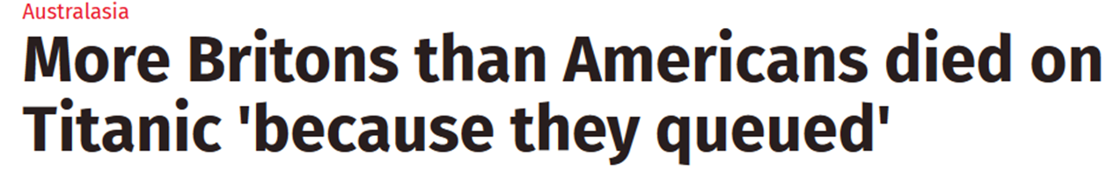

<http://www.independent.co.uk/news/world/australasia/more-britons-than-americans-died-on-titanic-because-they-queued-1452299.html>

This is a great example of misleading statistics as nationality is significant with Chi-squared but not after controlling for class in a logistic regression model. Most Americans were in 1st class which was one of the main factors influencing survival.

|  |  |  |  |
| --- | --- | --- | --- |
| Variable name | Variable label | Data type | Value labels |
| **pclass** | Class | Ordinal | 1 = 1st, 2= 2nd, 3 = 3rd |
| **survived** |  | Binary (Nominal) | 0 = Died, 1 = Survived |
| **Residence** | Country of Residence | Nominal | 0 = American, 1 = British, 2 = Other |
| **Name** |  | String |  |
| **age** |  | Scale |  |
| **sibsp** | Number of siblings/ spouses | Scale (Discrete) |  |
| **parch** | Number of parents/ children on board | Scale (discrete) |  |
| **Ticket** | Ticket number | String |  |
| **fare** | Price of ticket | Scale |  |
| **Cabin** | Cabin number | String |  |
| **Embarked** | Where passenger embarked | String |  |
| **Boat** | Boat identification (if rescued) | String |  |
| **Body** | Body number (if died) | ID |  |
| **Home.dest** | Home town | String |  |
| **Gender** | Gender | Binary (Nominal) | 0 = Male, 1=Female |

Possible research questions:

|  |  |  |  |
| --- | --- | --- | --- |
| Technique | Possible research questions | | |
| 1. Recoding variables | Identifying children | Identifying those travelling alone |  |
| 1. Bar/ pie charts | Class/gender/nationality | Class and nationality | Class and gender |
| 1. Contingency tables | Is there a relationship between class and survival | Is there a relationship between gender and survival | Is there a relationship between nationality and survival? |
| 1. Chi-squared | Is there a relationship between class and survival | Is there a relationship between gender and survival | Is there a relationship between nationality and survival? |
| 1. Logistic regression | Predicting probability of survival using any independent variables. |  |  |
| 1. Skewed data | Fare is heavily skewed. Comparisons of fare by survival/nationality demonstrate differences in mean/medians etc |  |  |
| 1. Kruskall-Wallis | Are there differences in the amount paid for tickets by nationality? |  |  |