CSC 465 Advanced Web Development

Chapter 8 & 9 – Retirement Countdown
Complete the JavaScript for the Retirement Countdown HTML page using the code. Use Ch 9’s future_value.js as an example on how to handle the data validation using JavaScript instead of HTML input attributes.
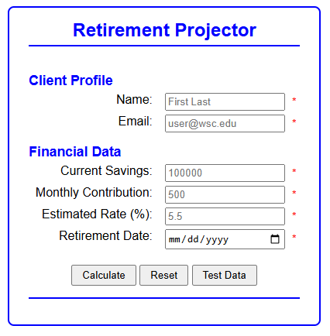
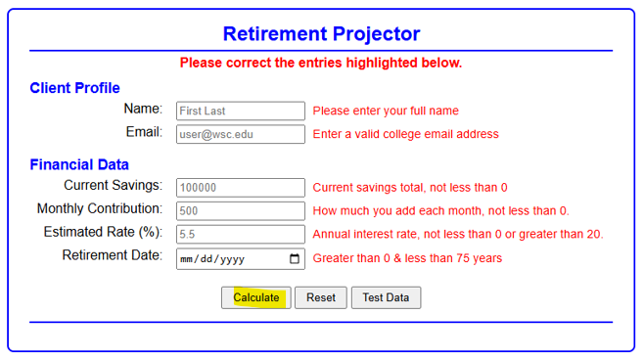
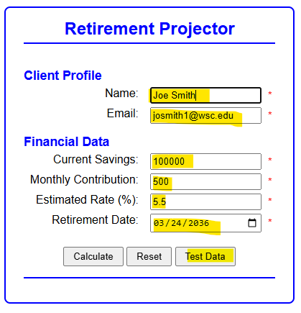
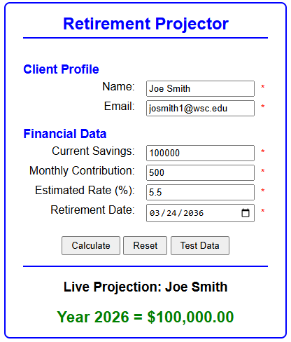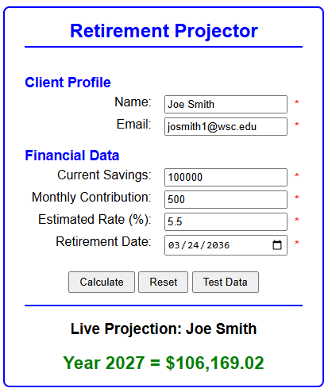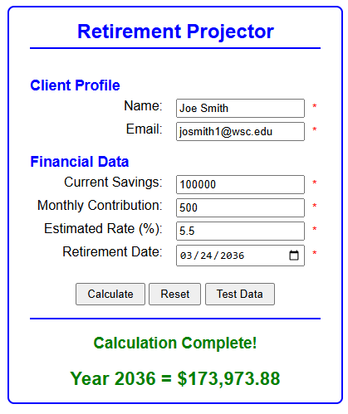
Additional requirements:
- Your goal is to NOT use AI for this assignment, but if you do, use it sparingly. If you use AI, you need to document where you used it in your code and justify your reason. I’m okay with you using it to get help, for very specific items, but not to write your code for you.
- MUST USE JSDoc: Well-documented code, including a JavaScript program header that includes a summary, author's full name, date, and GitHub repository URL
- Must use GitHub
  - Invite me to your repository (dejohns2)
  - Numerous commits which will prove who did the work
  - If working in a group, balance work across code and README
  - Professional README.md
    - Fully explain what the program does
    - Console output
-- or --
Embedded screenshots (stored in a subfolder)
Bullet point list of what new concepts were used
    - links to the author’s profiles
- PDF peer-review or self-review in a subfolder. Use the other person’s name as the file name. A peer review should focus on the person’s strengths and possibly provide helpful suggestions for future group work.
- Attach your Good, Bad, and Ugly (GBU) reflection written at a college level. IMPORTANT: Include your GitHub URL in this document.

