User Manual

Visit the site at https://www.thoughtsofjuan.me

# Landing Screen

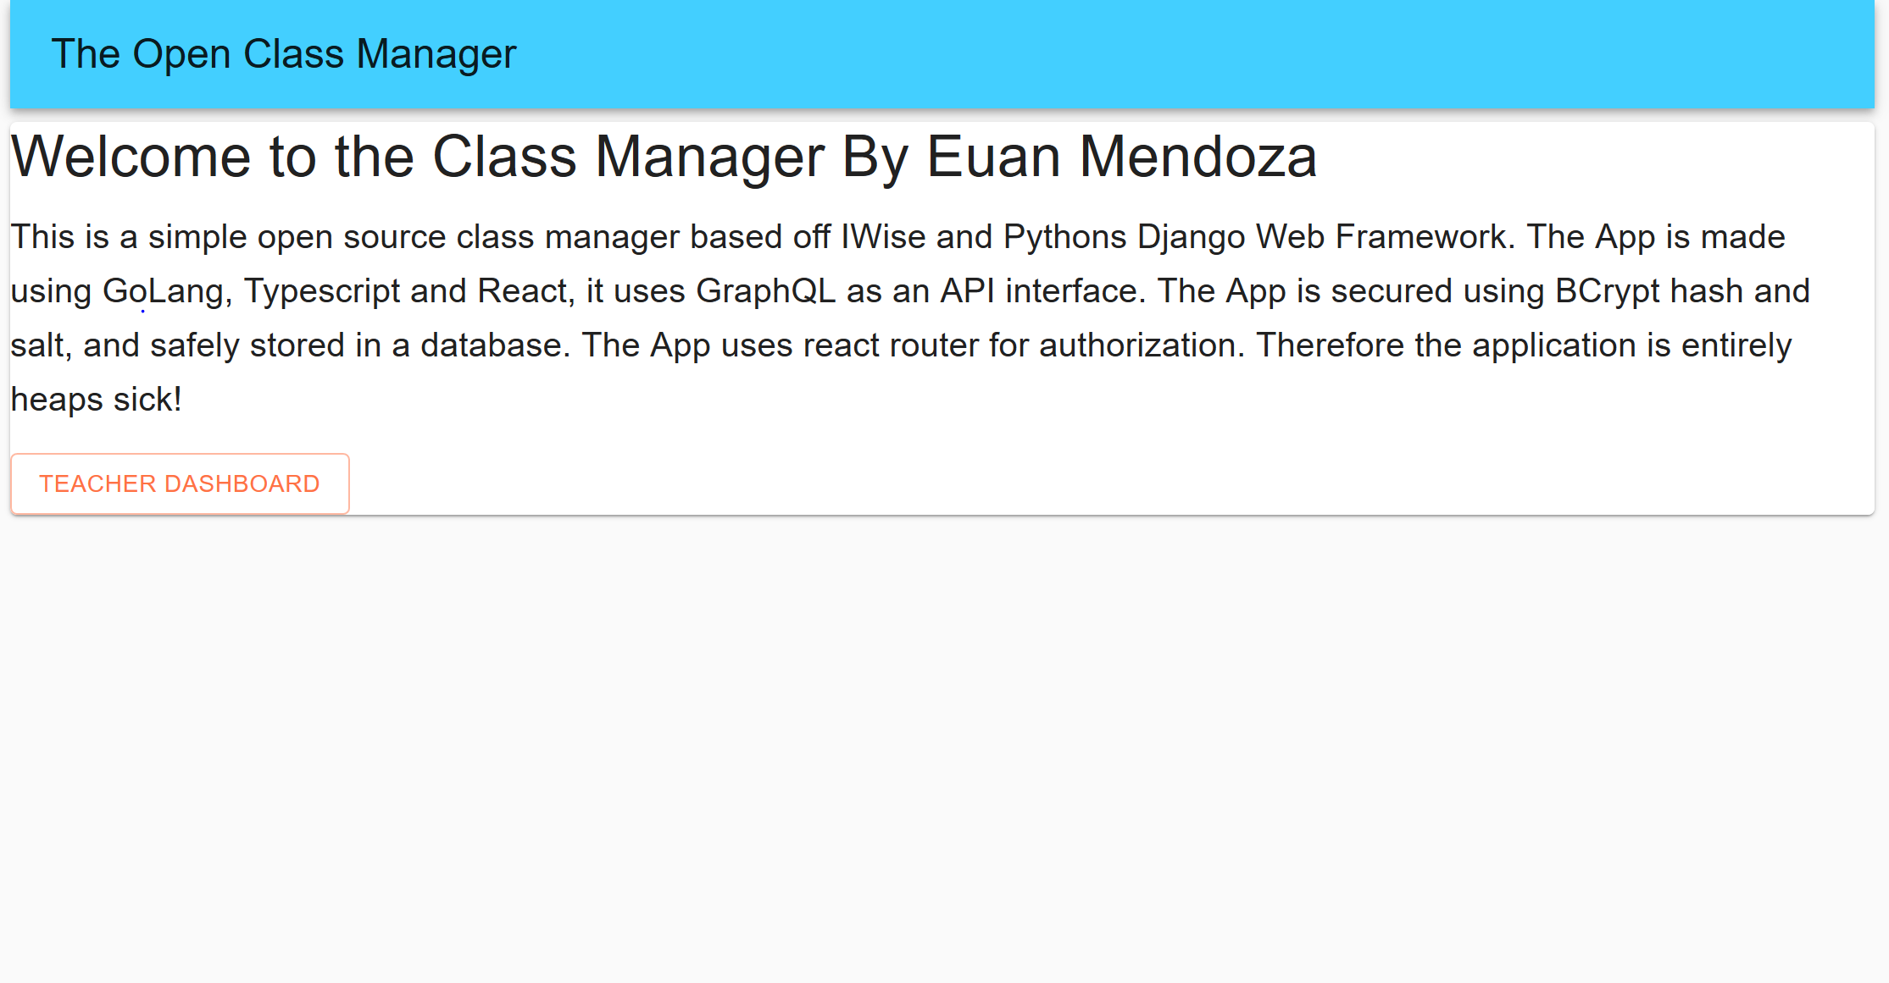

This is the landing page, it doesn’t have much of a purpose except to welcome new users

The ‘TEACHER DASHBOARD’ button in orange is a link that redirects to the teacher dashboard

# Login Screen

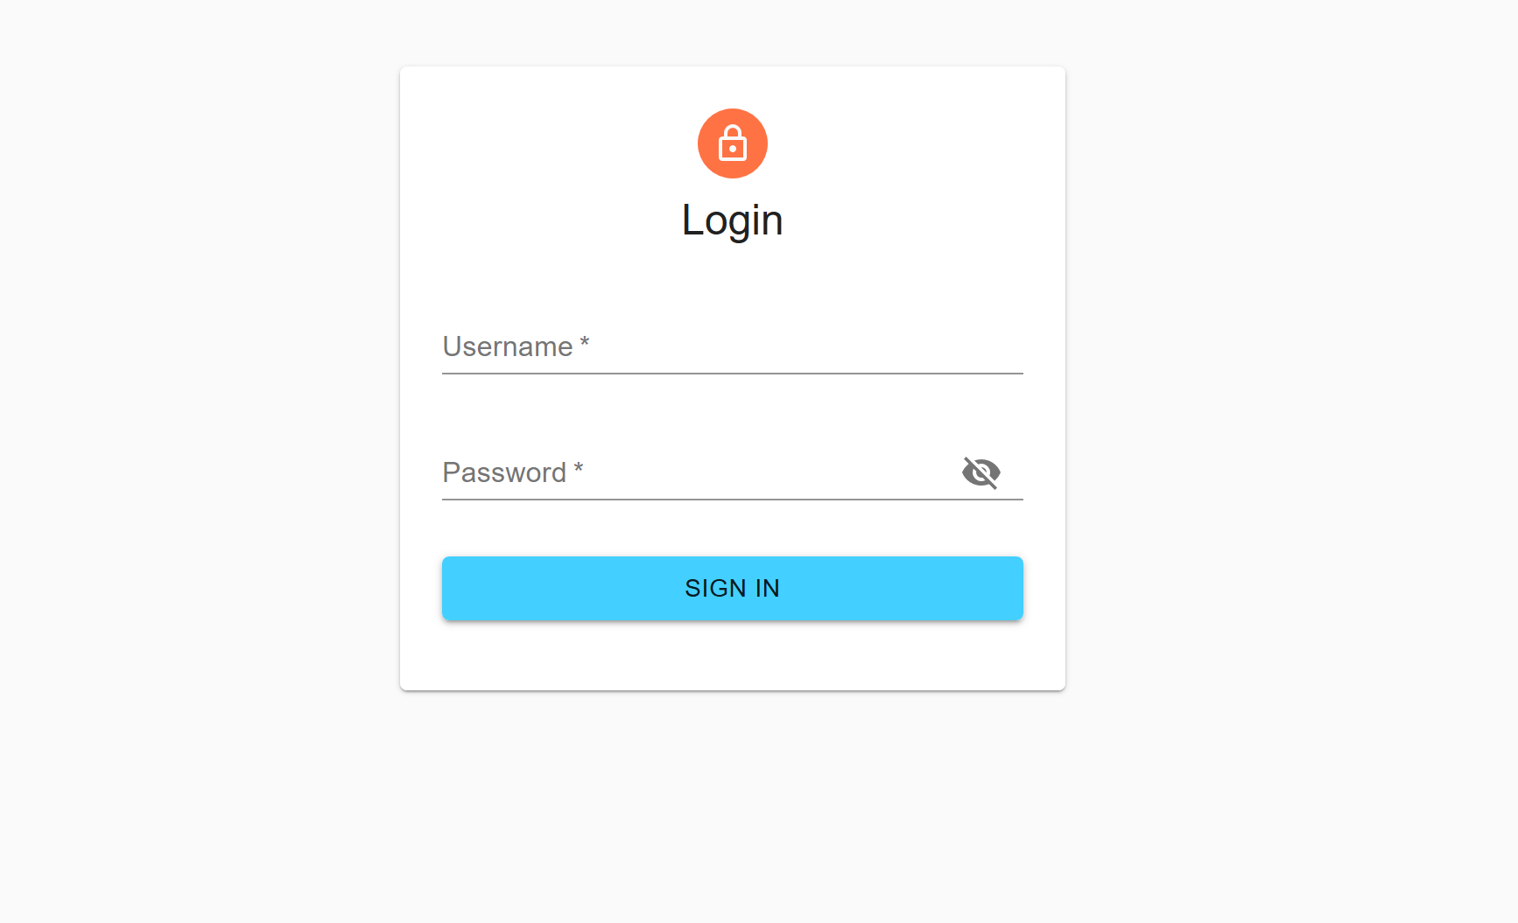

If the user is not logged in, then they can login with the panel show above

Enter username in the field named Username

Enter password in the field named Password

Click sign in to sign in

# The teacher dashboard

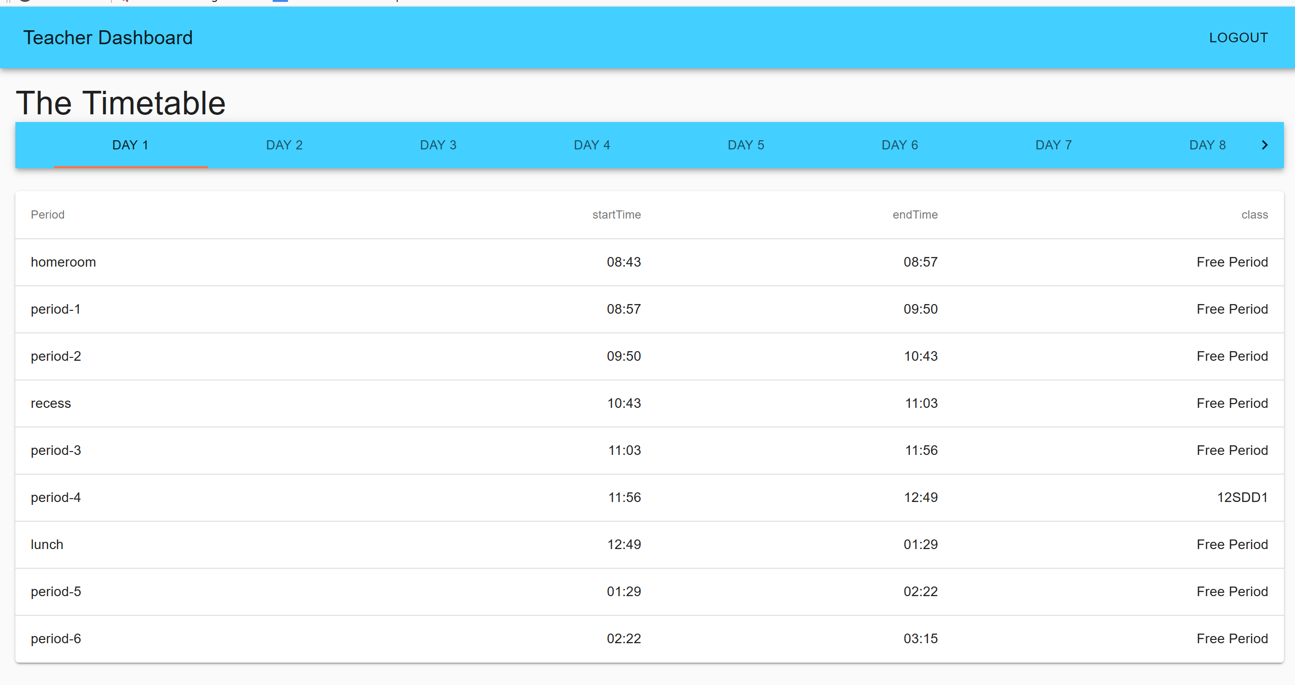

This is the dashboard and the timetable

On the top right, the logout button will logout the user

The timetable labelled timetable has a top row of tabs that a teacher can use to select the day of the week he would like to see

On the bottom there is a list of periods in the day

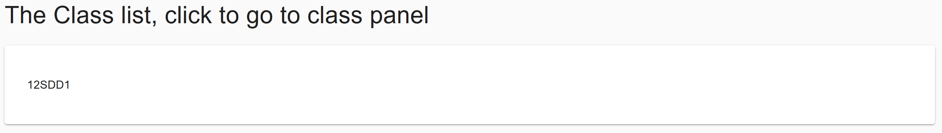

This is a list of classes,

Click a class to view the class information

# Class Panel

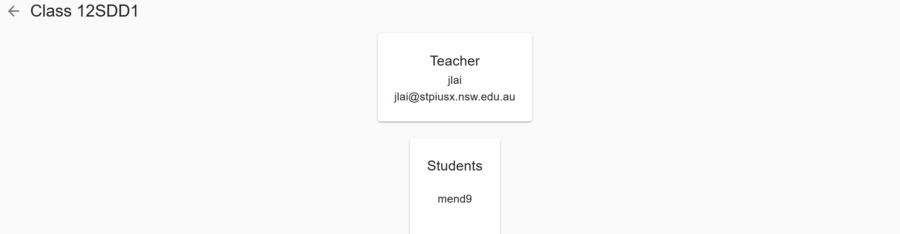

This is the class panel

On the top left, there is a button to go back to the teachers dashboard

On the top there is a card that displays the teachers information

On the bottom there is a list of students, currently this has no functionality.