Week 4 Task: Cloud Migration and Optimization Project

Migration of a legacy on-premises e-commerce application to AWS with post-migration performance, resilience and cost optimization
Scenario: 500,000 monthly active users; normal traffic ≈1,000 requests/s; peak ≈5,000 requests/s; AWS region: Mumbai (ap-south-1). These are planning assumptions for the simulation.
Evidence note: Real deployment metrics and screenshots must come from the actual AWS environment. This report does not fabricate migration results.

Executive Summary
The legacy platform is assumed to run in a single on-premises environment with a shared MySQL database, local/NAS backups and manually managed application servers. The migration objective is not simply to move servers; it is to remove the operational bottlenecks that caused peak-capacity waste, limited availability and slow recovery.
The recommended approach is a staged rehost/re-platform migration. AWS provides the target foundation, while the application becomes stateless, the database moves to managed RDS, static content moves to S3, cacheable traffic moves to CloudFront, and background work is decoupled through SQS. After migration, telemetry is used to right-size compute/database resources rather than guessing capacity.

Legacy Environment and Requirements
The hypothetical legacy environment consists of a web/application tier, MySQL database, file/NAS storage and scheduled background jobs. The business experiences variable traffic caused by promotions and campaigns. The migration must preserve application functionality while improving availability, scalability, security and cost visibility.

Area | Legacy state | Migration requirement
Compute | Manually managed servers | Horizontal autoscaling
Database | Shared MySQL | Managed RDS MySQL + backup/failover
Storage | Local/NAS | S3 for objects and backup artifacts
Traffic | Direct to application | CDN + WAF + ALB
Background work | Synchronous/host jobs | SQS + workers where appropriate
Monitoring | Limited/manual | CloudWatch metrics, logs and alarms
Recovery | Local backups | Automated backups + tested restore

Migration Strategy
A big-bang rewrite is rejected because it combines data migration, application changes and cutover risk into one event. The preferred strategy is a staged migration with a replication period and a rehearsed rollback plan.
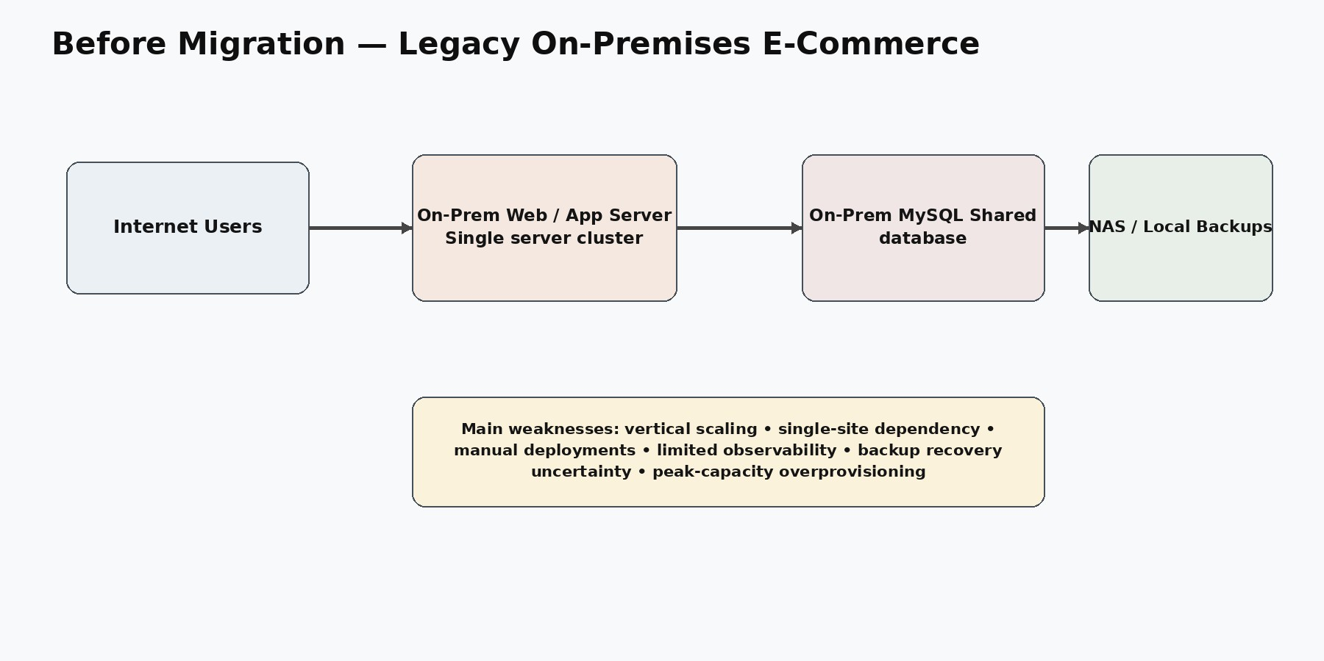
Figure 1. Simplified pre-migration architecture.

Migration waves: discovery → AWS foundation → data replication → application re-platforming → testing → cutover →
optimization.
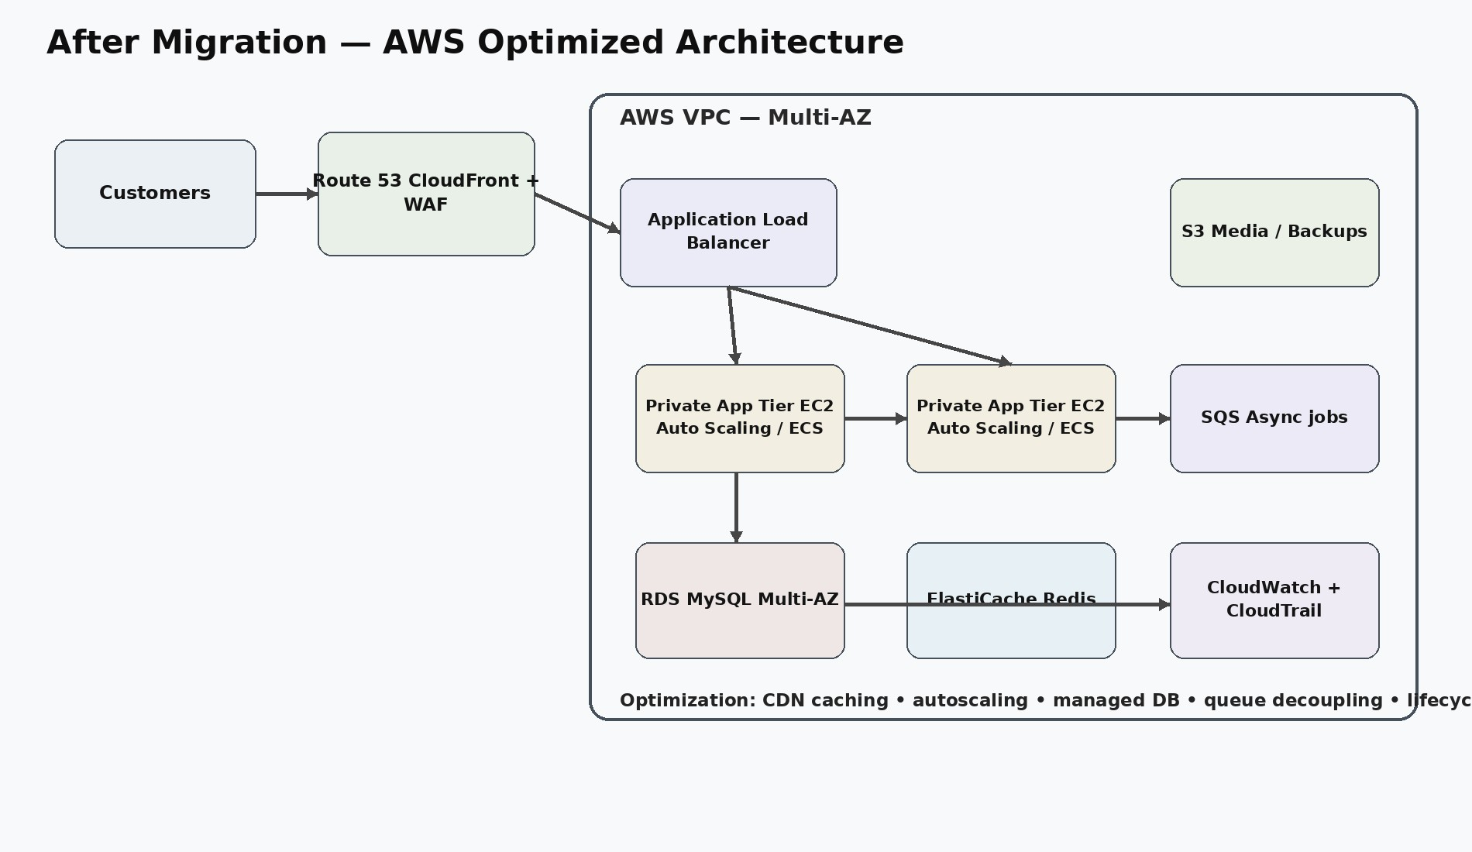
Figure 2. Target AWS architecture.

Data Migration
AWS Database Migration Service (DMS) is recommended for continuous replication from the legacy MySQL source to Amazon RDS for MySQL. The migration should begin with schema compatibility checks, followed by full load and ongoing change-data capture. Critical tables should be validated using row counts, checksums or representative record comparisons.
Before cutover, the team should confirm replication lag is acceptably low, validate application queries against the target, test backup/restore, and freeze writes during the final synchronization window if the workload requires strict consistency.

Application Re-platforming
The application should be made stateless so instances/tasks can be replaced or scaled horizontally. Sessions should move to a shared mechanism such as Redis or an external identity/session service. Product media and other large objects should move to S3. Configuration and credentials should be externalized through Secrets Manager or an equivalent configuration system.
CloudFront and WAF should sit at the edge, followed by an Application Load Balancer. The compute tier should run in private subnets. SQS should be used for workloads that do not need to block the customer's HTTP request, such as selected notification and asynchronous processing jobs.

Performance Optimization

Metric | Pre-migration planning baseline | Post-migration target | Measurement
P95 latency | 600 ms | ≤300 ms | CloudWatch/APM
P99 latency | 1,200 ms | ≤600 ms | CloudWatch/APM
5xx error rate | 1.5% | <0.5% | ALB/app metrics

Metric | Pre-migration planning baseline | Post-migration target | Measurement
Peak throughput | 5,000 req/s | 5,000+ req/s | Load test
Recovery time | ≈4 hours | ≤60 min | DR exercise
Database connections | High/uncontrolled | Pool + monitored | RDS metrics
These values are explicit simulation targets, not measured results. The assignment should only claim an improvement after the same workload is tested before and after migration.
Optimization techniques include CDN caching, Redis for hot reads, query/index tuning, asynchronous queues, connection pooling, autoscaling and compression. Load testing should use controlled stages such as 1,000, 3,000 and 5,000 requests/second and record P50/P95/P99 latency, throughput, error rate and resource saturation.

Cost Optimization

Component | Baseline INR/month | Peak/variable INR/month | Primary lever
Compute | 18,000 | 30,000 | Autoscaling + rightsizing
RDS MySQL | 20,000 | 35,000 | Right-size + storage tuning
ALB | 3,000 | 6,000 | Reduce origin traffic
CloudFront | 4,000 | 10,000 | Cache static content
Redis | 4,000 | 8,000 | Cache hot reads
S3 | 1,000 | 2,500 | Lifecycle/tiering
NAT/data transfer | 4,000 | 10,000 | Reduce unnecessary egress
Observability | 2,000 | 5,000 | Retention control
Other | 2,000 | 5,000 | Usage controls
Total | 58,000 | 111,500 | Target lower cost/request
The figures are planning ranges, not AWS quotations. The economically correct metric is not simply monthly bill; it is cost per successful order/request at an equivalent workload. Savings Plans should be considered only after the stable baseline is known. Overcommitting before migration is a weak optimization strategy.

Resilience and Security Improvements
The target application tier spans at least two Availability Zones. RDS Multi-AZ is used for managed database failover. CloudFront/WAF reduces edge attack surface and origin load. IAM follows least privilege, application credentials are externalized, and databases are not publicly exposed. Backups use automated retention and tested restoration.
A secondary region can be added for critical disaster recovery, but it should not be introduced merely for architecture aesthetics. Its cost and operational complexity should be justified by the business RTO/RPO.

Cutover and Rollback
The cutover should use a rehearsed runbook: lower DNS TTL in advance, complete replication, validate application health, freeze writes if necessary, perform final synchronization, switch traffic, and monitor. Rollback triggers are explicit: P95 latency above 2× baseline for 15 minutes, 5xx above 2% for 10 minutes, checkout/payment failure, inconsistent data, or a critical security control failure.

Migration Timeline

Phase | Duration | Deliverable
Discovery | 2–3 days | Dependency inventory + baseline
Foundation | 3–5 days | AWS network/IAM/logging
Data replication | 3–7 days | Validated DMS replication
App migration | 5–10 days | Stateless target deployment
Testing | 3–5 days | Performance/security validation
Cutover rehearsal | 1–2 days | Proven runbook + rollback
Production cutover | 1 day | Traffic moved to AWS
Optimization | 2–4 weeks | Rightsizing + cost/performance tuning

Validation and Post-Migration Evaluation
The validation script in the appendix checks endpoint availability, status codes, response headers and sample latency. For a meaningful comparison, the same test workload must be executed against the legacy and AWS environments. Results should be recorded in a table containing P50/P95/P99 latency, requests/sec, 5xx rate, CPU, database connections, cost and successful orders.

Challenges and Resolutions
Data consistency is the hardest migration problem because an application can appear healthy while the database is incomplete. Continuous replication, validation and a controlled write-freeze window address this. Another challenge is cost uncertainty: cloud pricing varies with traffic and data transfer, so the project uses a planning range and requires telemetry-driven rightsizing after migration.

Conclusion
The migration succeeds only if it improves measurable business outcomes rather than merely relocating servers. The target design reduces single-site dependency, introduces horizontal scaling and managed database operations, improves observability and creates explicit cost controls. Final claims of performance improvement must be based on actual before/after test results.

Appendices
Appendix A: migration_plan.md — detailed migration waves, cutover and rollback criteria. Appendix B: validate_migration.sh — endpoint and latency validation script. Appendix C: cost_model.csv — planning cost model. Appendix D: migration_checklist.md — execution checklist.
References: AWS documentation for AWS Database Migration Service, Amazon RDS, EC2 Auto Scaling, Elastic Load Balancing, CloudFront, AWS WAF, S3, ElastiCache, SQS and CloudWatch. Exact service pricing should be validated using AWS Pricing Calculator for the selected region and measured workload.

