EE284A Lab 1 Deliverables
Edward Bayliss
- TMP36 Datasheet
  - Package pinout
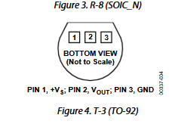
  - Operating voltage range
  - Output-voltage-vs-temperature graph
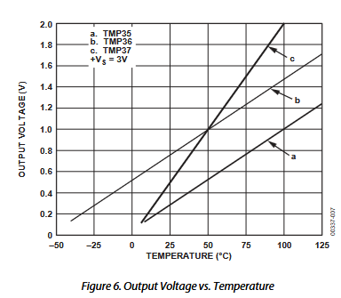
  - Scaling table
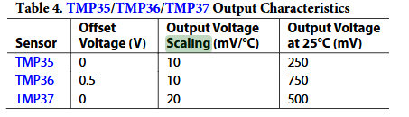

- TMP36 wiring
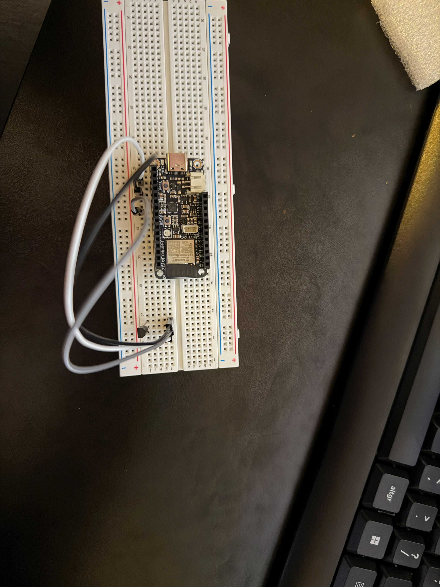
- Temperature equation
Output from Temp Sensor
y=mx + b; m = 0.010 (V/C); b = 0.5 (V); Where x is degrees C and y is Volts
y = 0.01 * x + 0.5
Therefore Temperature formula is:
x = (y – 0.5)/0.01 = 100 * (y – 0.5)

