EE284A Lab 1 Deliverables
Edward Bayliss

Section 4: Analog Temperature Sensor

Deliverable 1: TMP36 Datasheet Screenshots
TO-92 package pinout
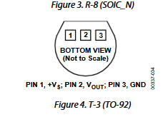
Operating voltage range
Output voltage vs temperature graph
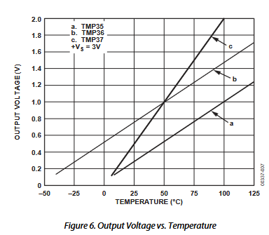
Scaling table
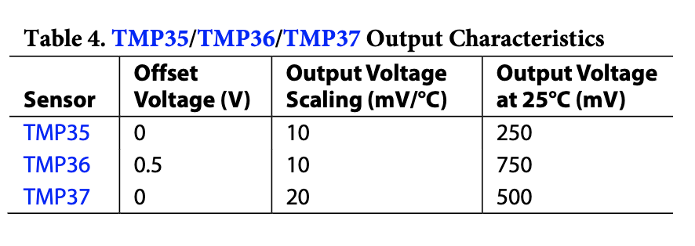

Deliverable 2: TMP36 Wiring Photo

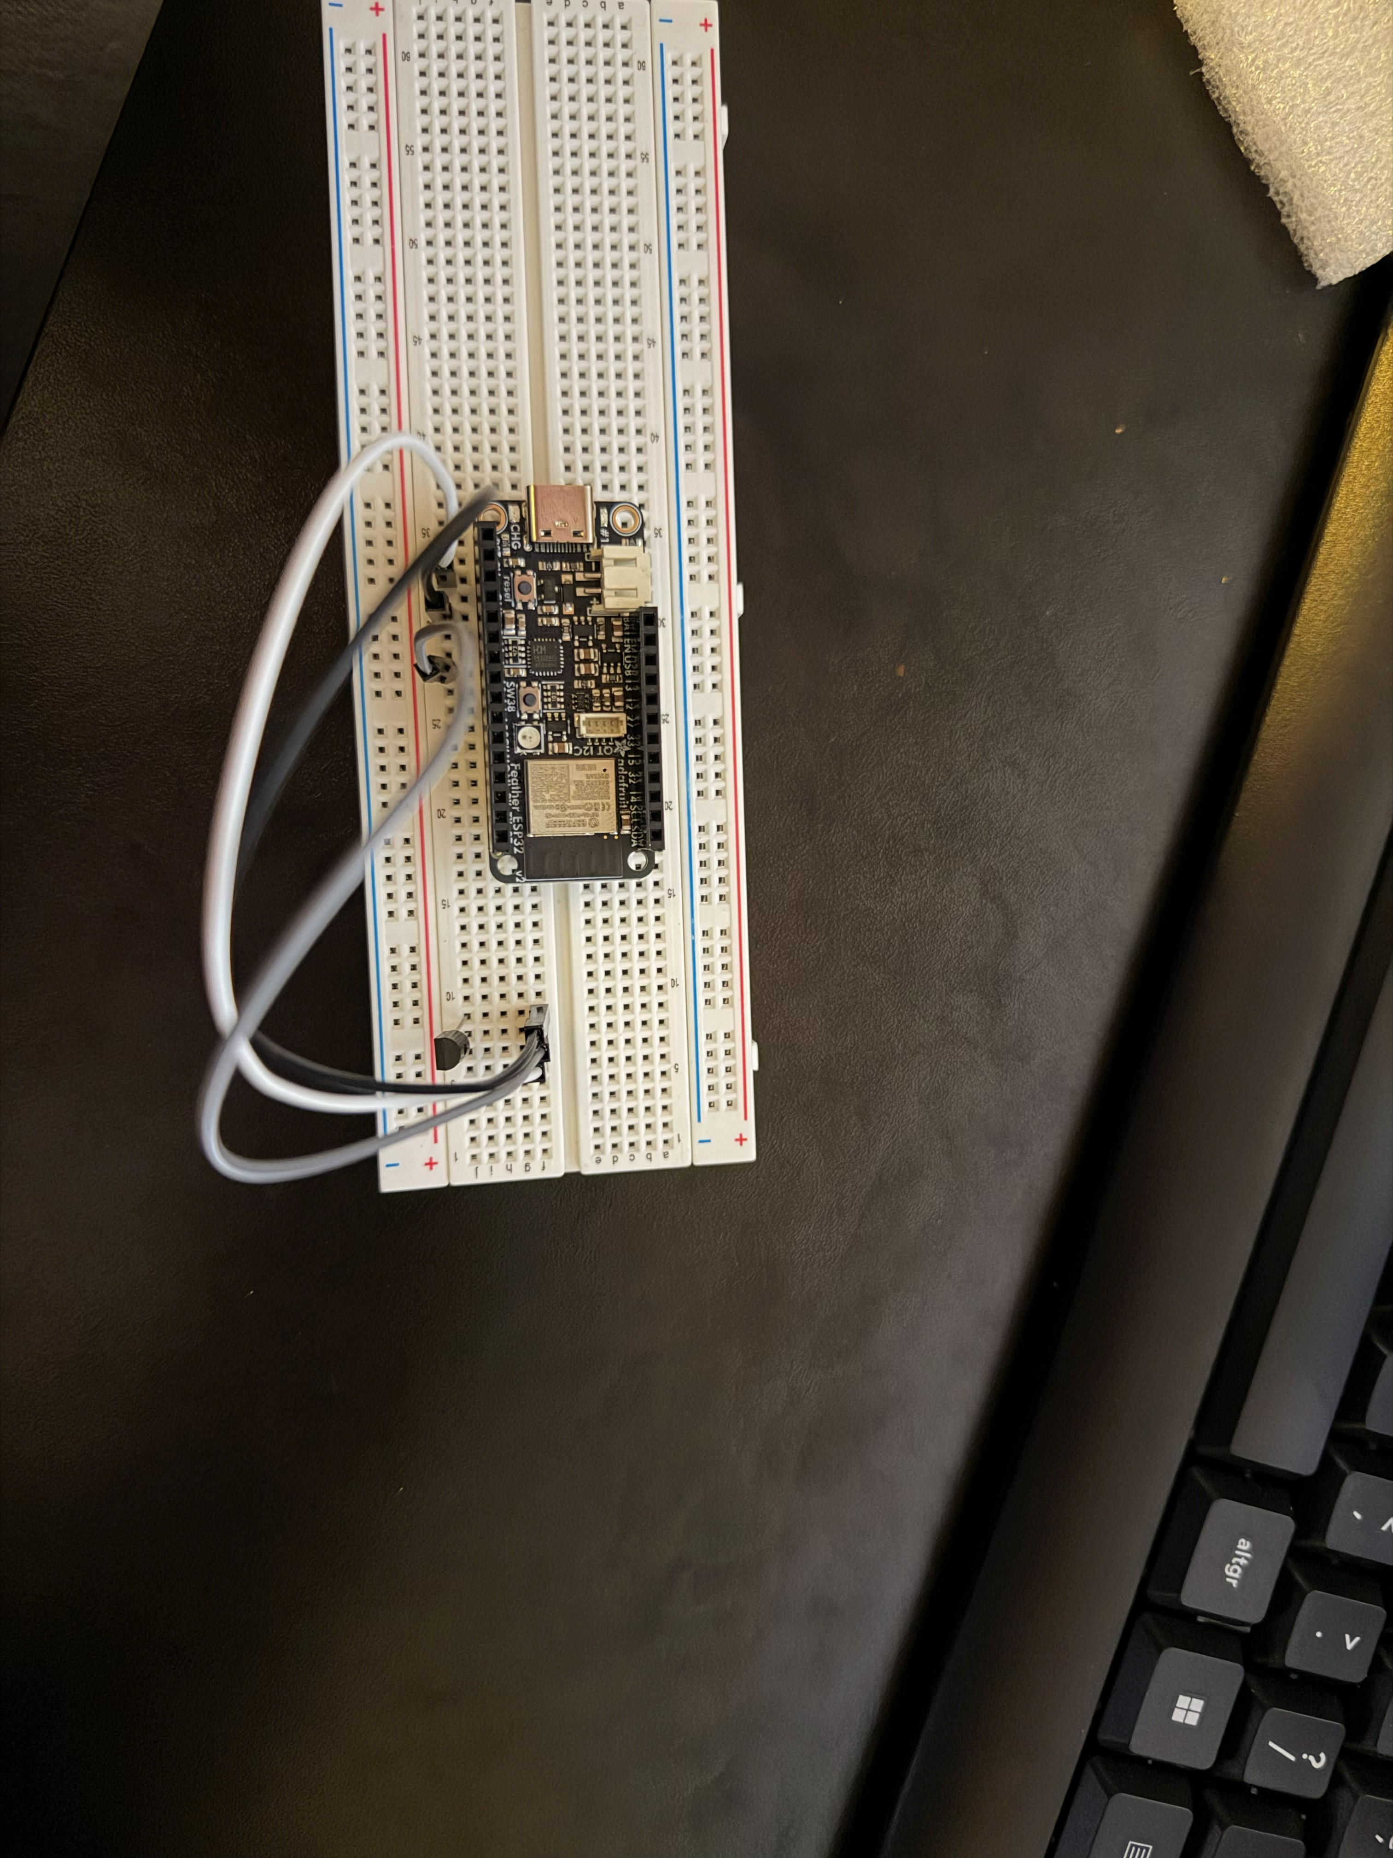

Deliverable 3: Temperature Conversion Equation
The ESP32 ADC is 12-bit with Vref = 2.1V at 6dB attenuation, giving values from 0 to 4095.
DN to voltage:
V = (DN / 4095) * 2.1
Voltage to temperature (from TMP36 datasheet: 750mV at 25 degrees Celsius, 10mV/degree scale):
T(C) = (V - 0.5) / 0.010
Combined:
T(C) = ( (DN / 4095) * 2.1 - 0.5 ) / 0.010

Deliverable 4: Serial Output Screenshots
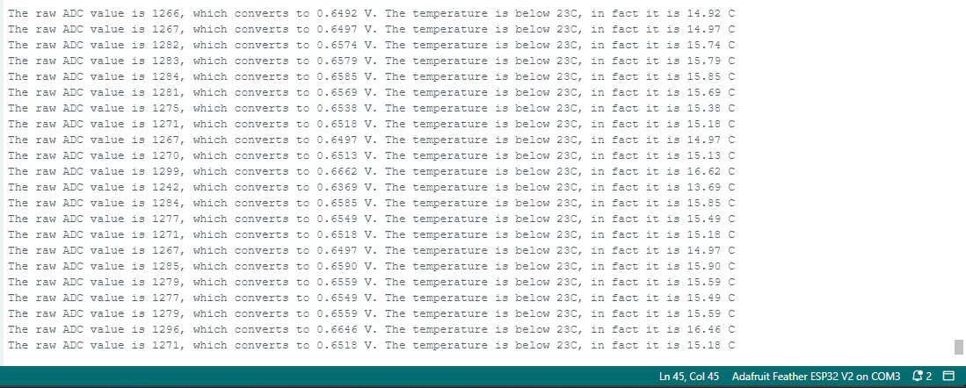

Deliverable 5: Complete TMP36 Arduino Script
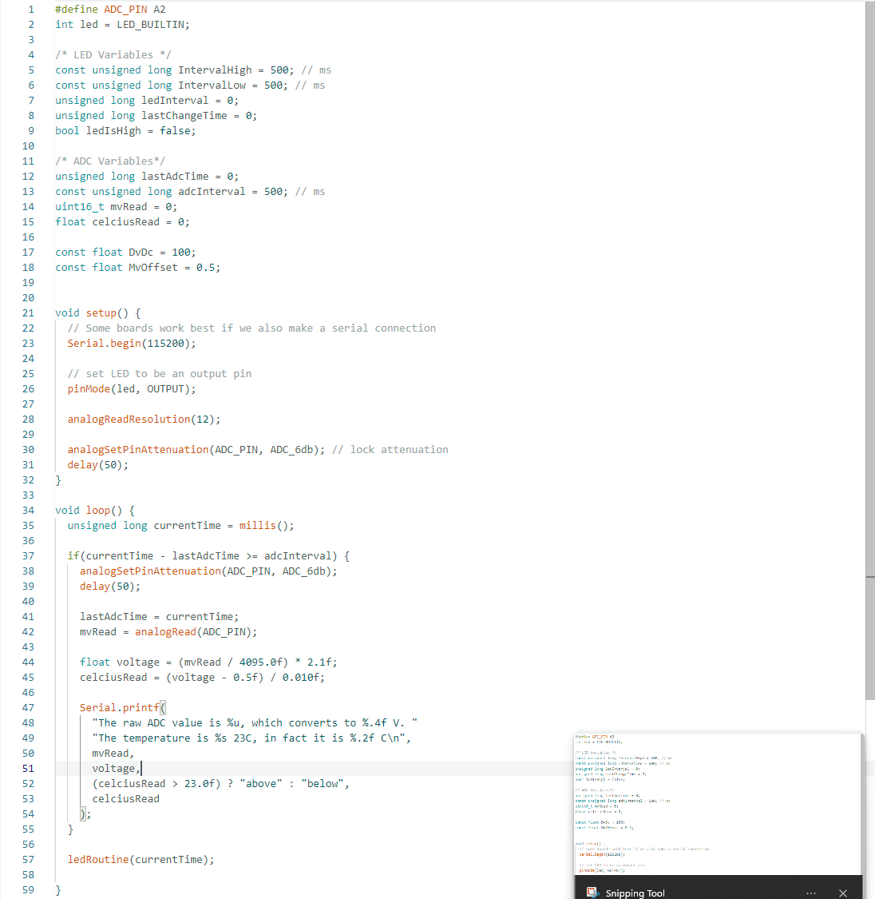

Deliverable 6: Max, Min, and Delta Temperature over 1 Minute
The maximum temperature was 16.41 degrees Celsius and the minimum temperature was 16.12 degrees Celsius, with a delta of 0.29 degrees Celsius.

Deliverable 7: Another Temperature Sensor Type
Thermocouple (Type K)
When two dissimilar metals are joined at a junction, a temperature-dependent voltage of ~41uV/degree Celsius is generated via the Seebeck effect. This voltage is too small for an ADC to read directly, so an amplifier IC (e.g. MAX31855) boosts it and does cold-junction compensation before sending the result to the MCU over SPI. The main advantage over the TMP36 is its range of -200 to 1350 degrees Celsius vs -40 to 125 degrees Celsius, which makes thermocouples the standard choice for high-temperature applications like furnaces and engines.

Section 5: I2C and SPI

Deliverable 8: I2C Wiring and Serial Output
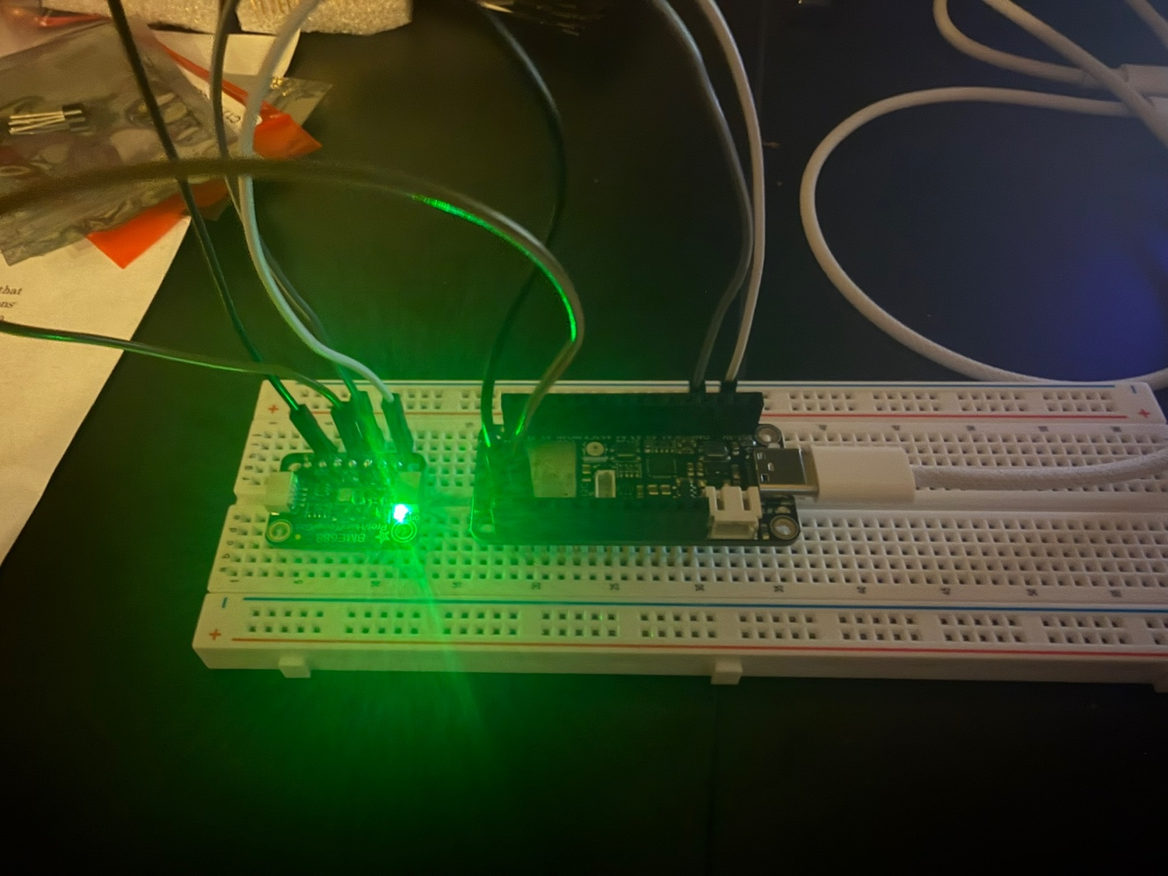
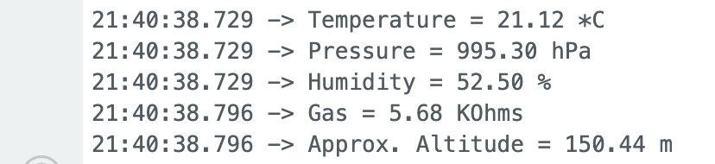

Deliverable 9: SPI Wiring and Serial Output
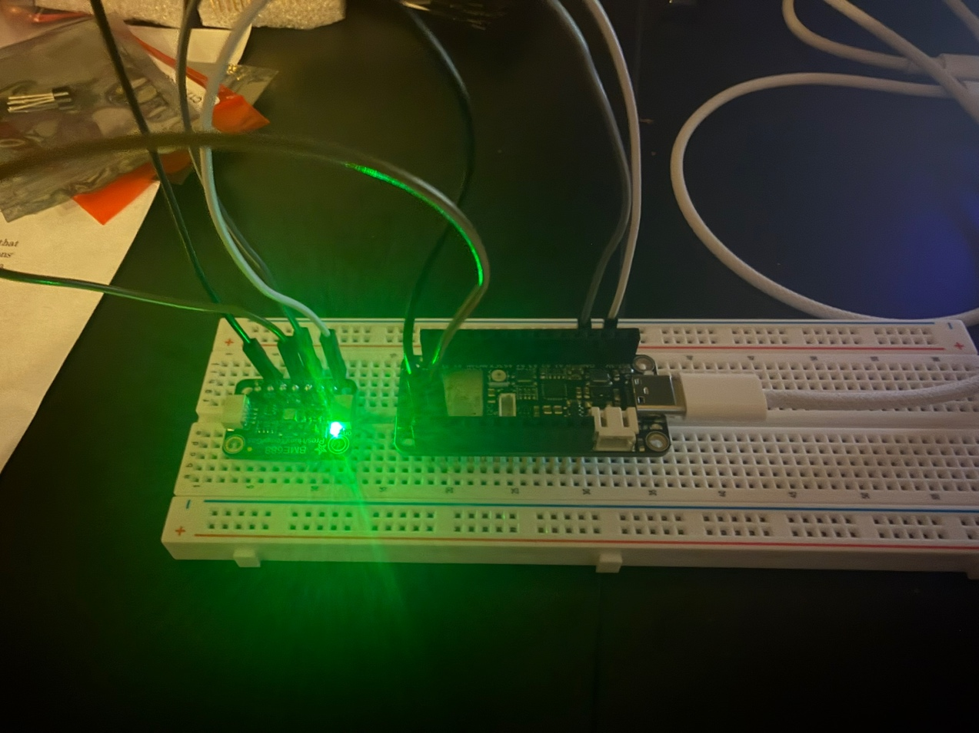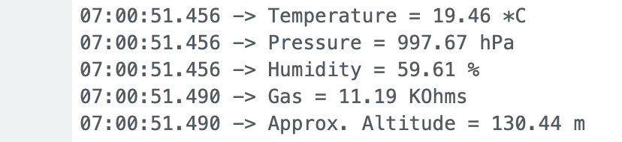
The data over SPI looked the same as over I2C. Both protocols are reading from the same sensor registers so the temperature, humidity, pressure and gas values were consistent. Any small differences between readings were just sensor noise between samples.

Deliverable 10: I2C vs SPI Transaction Order
I2C uses two wires (SDA and SCL) and supports multiple devices on the same bus using addressing:
- Master pulls SDA low while SCL is high to signal a START
- Master sends the 7-bit device address and a read/write bit
- The addressed device pulls SDA low to ACK
- Data bytes transfer one at a time, each followed by an ACK
- Master signals STOP by letting SDA go high while SCL is high

SPI uses four wires (MOSI, MISO, SCK, CS) and is faster but point-to-point:
- Master pulls CS low to select the device
- Master toggles SCK to clock data
- Data transfers in both directions at once: master out on MOSI, device out on MISO, one bit per clock edge
- Master pulls CS high to end the transaction

The main difference is that I2C is half-duplex and uses ACKs to confirm each byte, while SPI is full-duplex with no acknowledgement. SPI is faster but needs an extra CS wire for each device. I2C can share two wires across many devices using addressing.

Deliverable 11: BME688 Max and Min Temperature over 1 Minute
The maximum and minimum temperatures observed over 1 minute were 19.63 and 19.46 degrees Celsius, with a delta of 0.17 degrees Celsius. This delta is smaller than the TMP36's delta of 0.29 degrees Celsius. The BME688 has a built-in ADC with finer resolution and lower noise than the ESP32's general-purpose ADC used by the TMP36, which accounts for the difference.

Section 6: Signal Processing

Deliverable 12: Filter Implementation Screenshots with BME688 via SPI
Moving average filter code
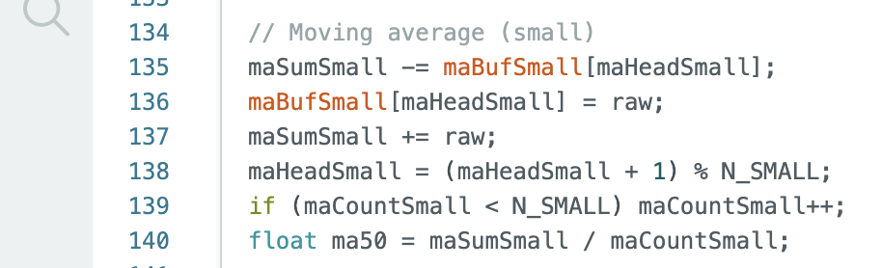Moving median filter code
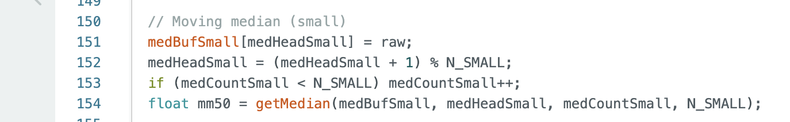
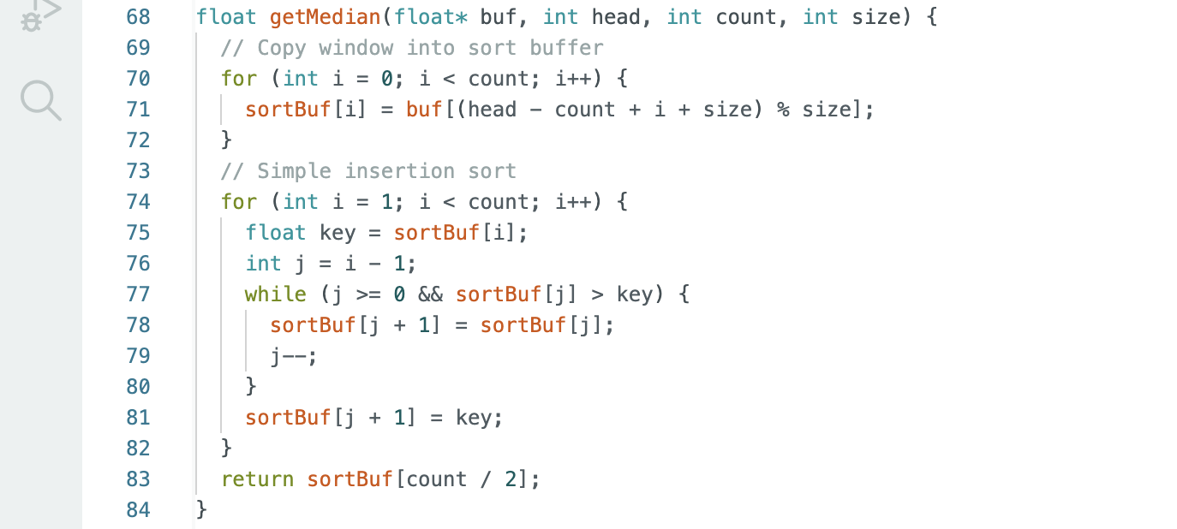Exponential moving average code
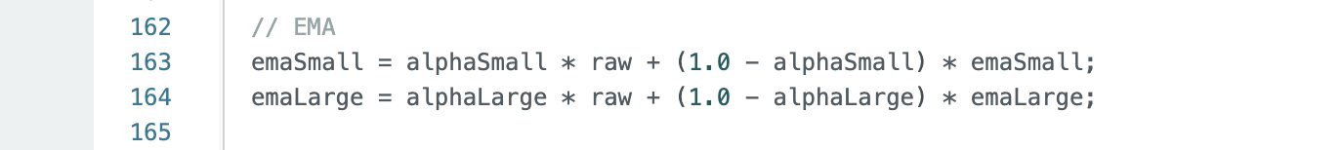

Deliverable 13: Filter Comparison Table (5000 samples)
Method | Min (°C) | Max (°C) | Mean (°C) | StdDev (°C)
Raw | 19.278 | 21.622 | 19.713 | 0.2594
MovAvg N=50 | 19.285 | 21.622 | 19.712 | 0.2681
MovAvg N=500 | 19.304 | 21.622 | 19.679 | 0.2608
MovMed N=50 | 19.283 | 21.622 | 19.711 | 0.2593
MovMed N=500 | 19.288 | 21.622 | 19.674 | 0.2611
EMA α=2/51 | 19.292 | 21.622 | 19.721 | 0.2728
EMA α=2/501 | 19.430 | 21.622 | 19.789 | 0.3249

Deliverable 14: Observations on Metric Changes
The mean stayed stable across all methods as expected, ranging from 19.67 to 19.79 degrees Celsius. The minimum converged toward the mean as N increased, most noticeably for EMA N=500 which had the highest minimum at 19.430 degrees Celsius vs 19.278 for raw.

The max of 21.622 was identical across every method, which points to a spike early in the run before any filter buffer had enough samples to suppress it.
Standard deviation didn't decrease with filtering as expected. The moving median at N=50 was the only method to marginally beat raw (0.2593 vs 0.2594). EMA at N=500 was actually the worst at 0.3249, likely because the slow-moving large window introduces drift that shows up as variance rather than reducing it.

Deliverable 15: Advantages and Disadvantages of Each Method
Moving Average: Simple to implement and effective at reducing Gaussian noise. The downside is lag: at N=500 the output trails real changes by up to 500 samples. Higher N means lower noise but more lag and more memory for the buffer.

Moving Median: Better at handling spikes and outliers than the moving average since one bad ADC reading can't skew the result the way it would an average. The tradeoff is computation cost. Sorting 500 values every sample is noticeably slower and you can see the loop time increase at N=500. Good choice when occasional glitches are expected.

Exponential Moving Average: Only needs two floats of state so memory use is minimal. Responds faster to real changes than a moving average of equivalent N because recent samples are weighted more. The downside is old data is never fully forgotten. In theory higher N should give smoother output, but in practice the N=500 EMA had higher standard deviation than N=50 (0.3249 vs 0.2728), suggesting the slow-moving large window can introduce drift that shows up as additional variance.

A higher N is worth choosing when the signal changes slowly and you want a cleaner reading. The downsides are more lag, more memory for the moving average and median, and the risk of missing fast real changes in the signal.

Section 7: Basic Actuators

Deliverable 16: LED Forward Voltage
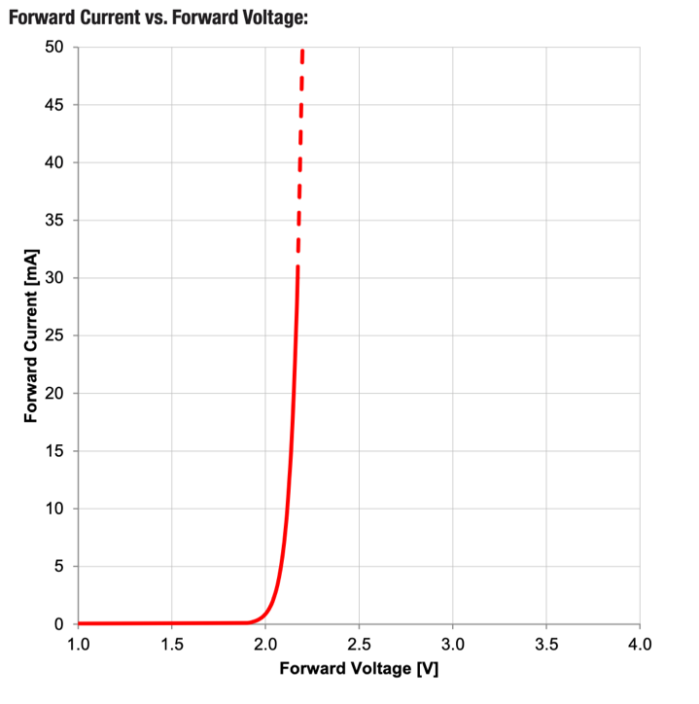
From the datasheet curve the forward voltage at around 10-20mA is approximately 2.0-2.1V. What stands out on the curve is how steeply the current rises for small increases in voltage. This is the diode's exponential I-V characteristic, which is why a current-limiting resistor is needed to prevent the LED from drawing too much current.

Deliverable 17: ESP32 GPIO Current Limits
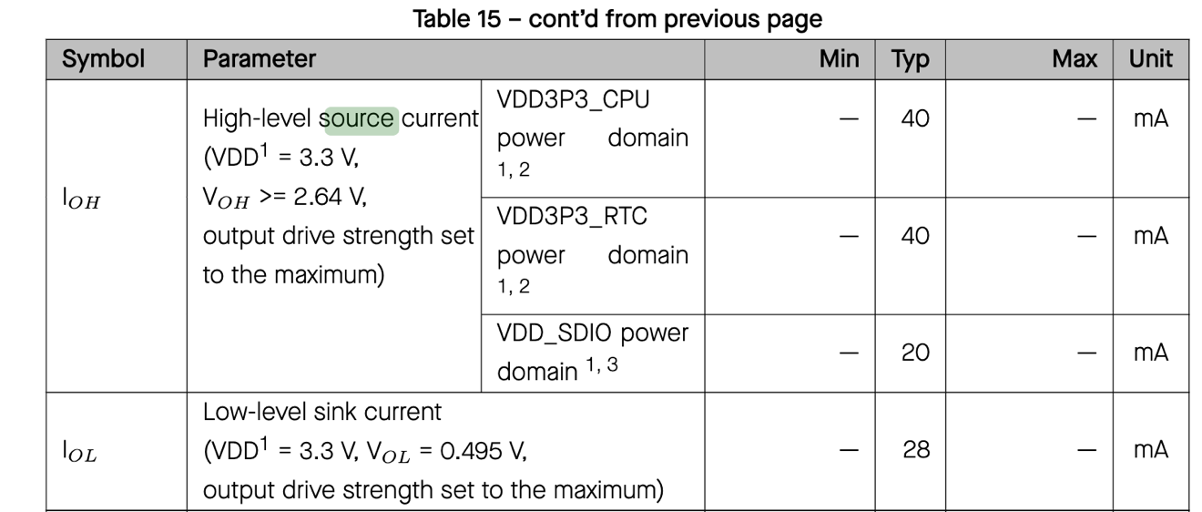
The GPIO pins can source and sink up to 40mA. With a 330 ohm resistor the LED draws about 3.6mA (1.2V drop across the resistor at 330 ohms), well within the limit. Without the resistor the GPIO pin would try to supply far more than 40mA and would likely be damaged or destroyed.

Deliverable 18: LEDs 1 and 3 On, LED 2 Off
Screenshot of serial monitor with input 101
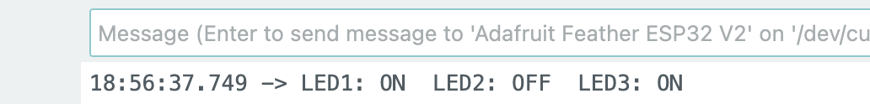
Photo of breadboard showing LED 1 and LED 3 on, LED 2 off
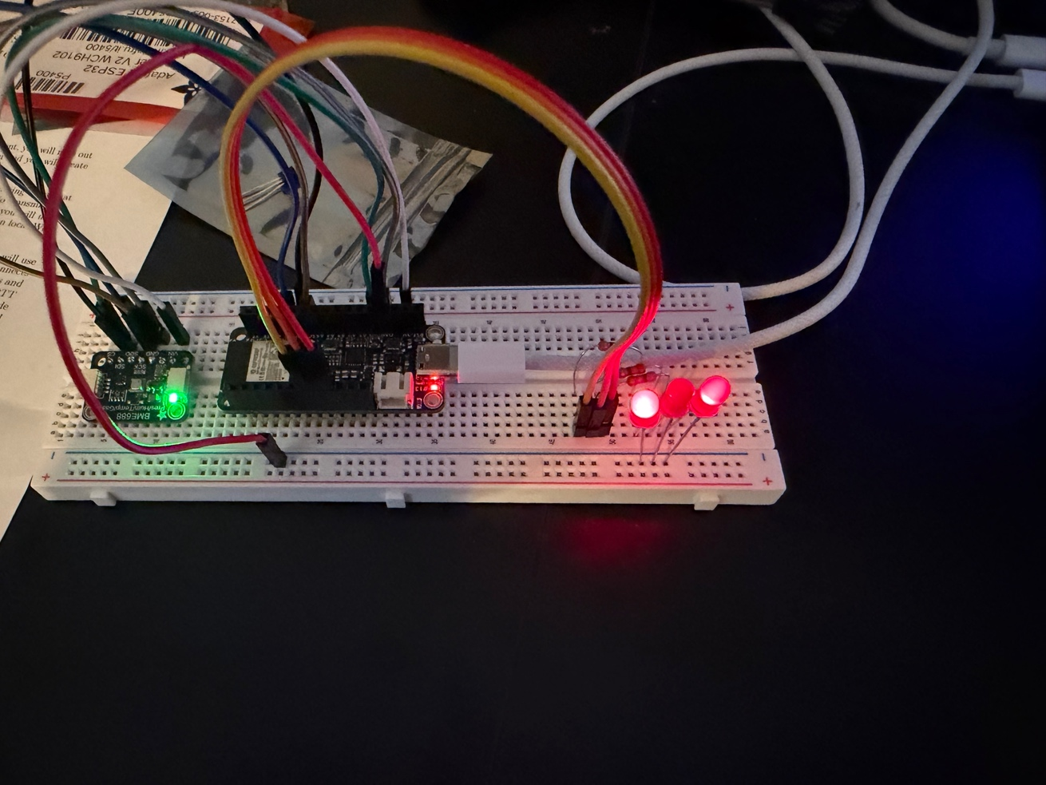

Section 9: Making Decisions and Taking Action

Deliverable 19: Complete System Code
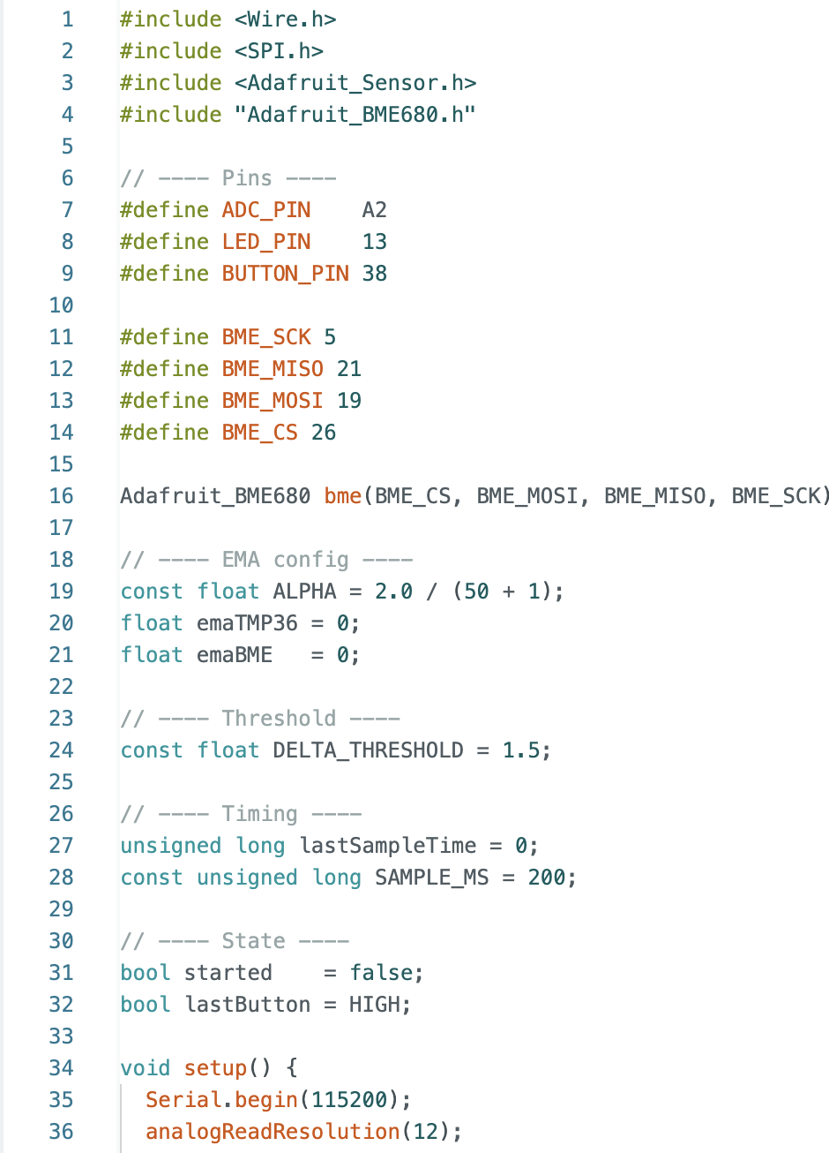
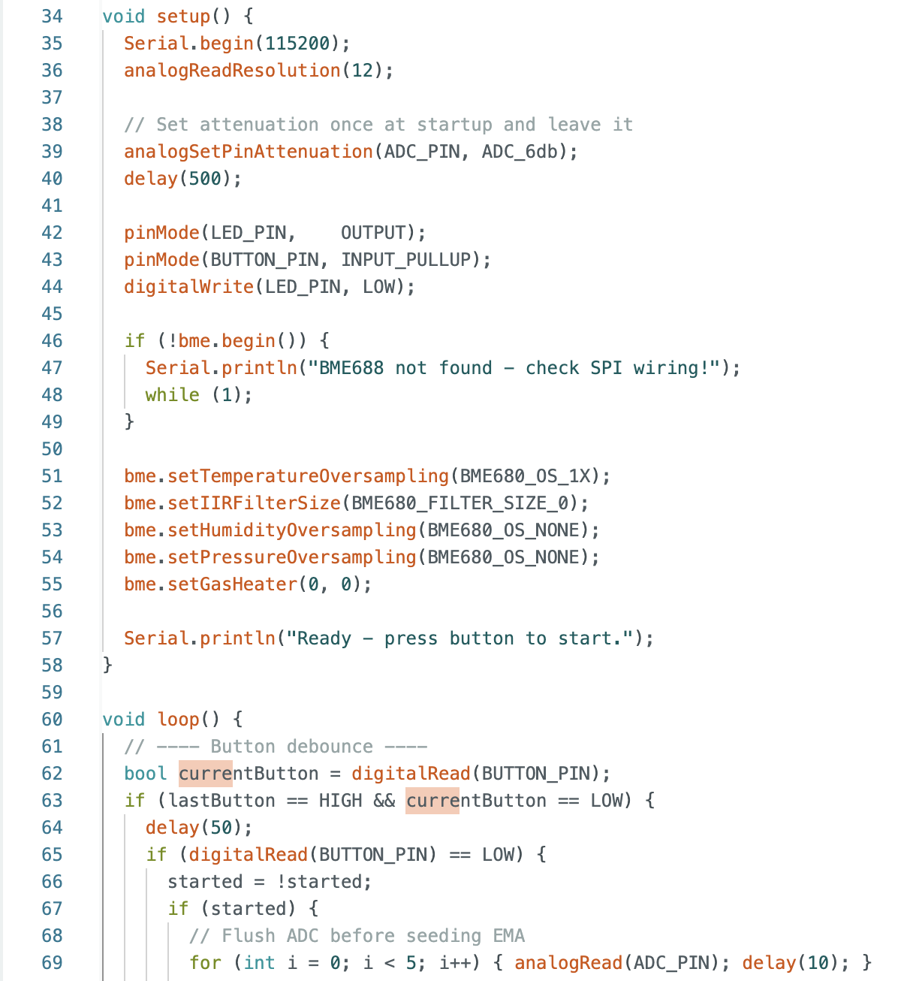
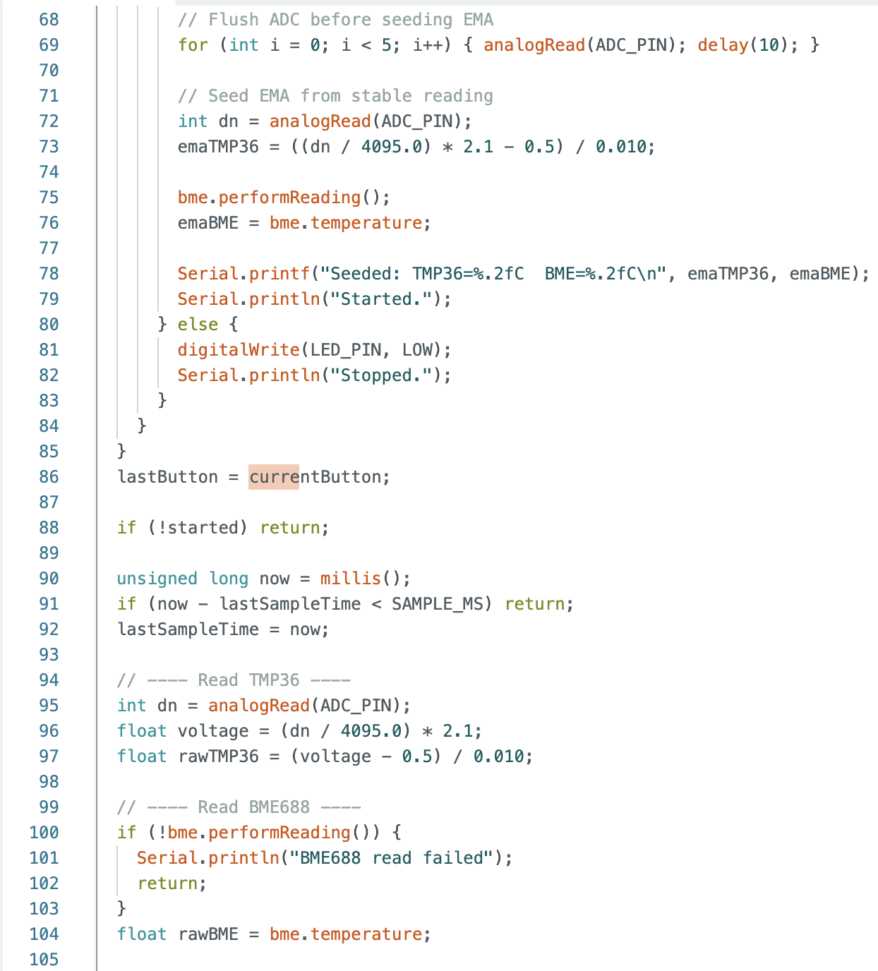
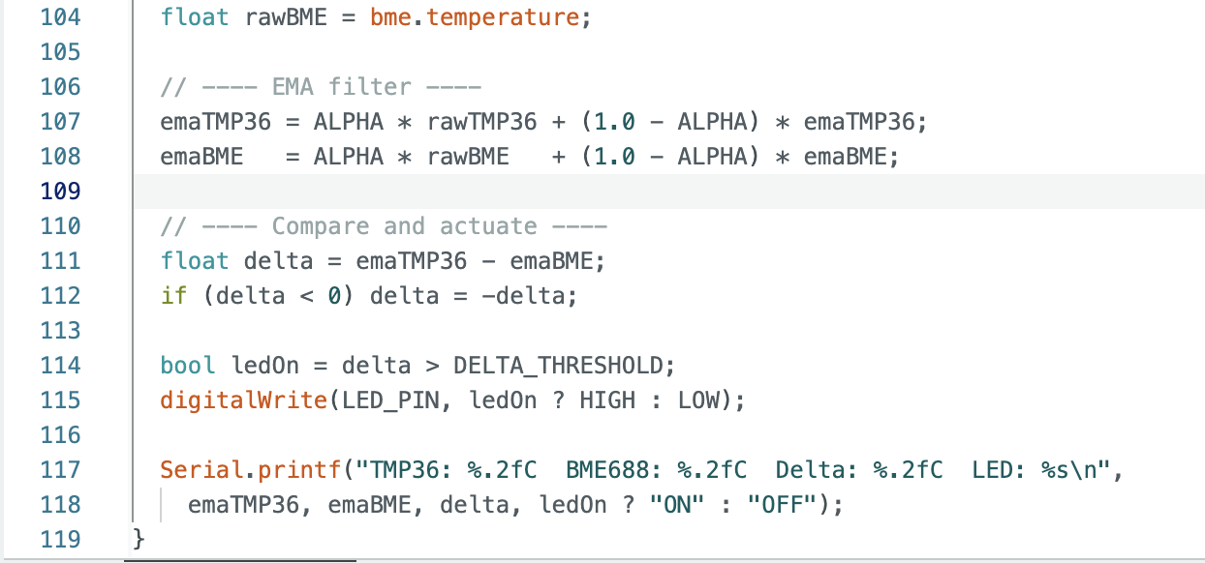

Deliverable 20: System with LED Off
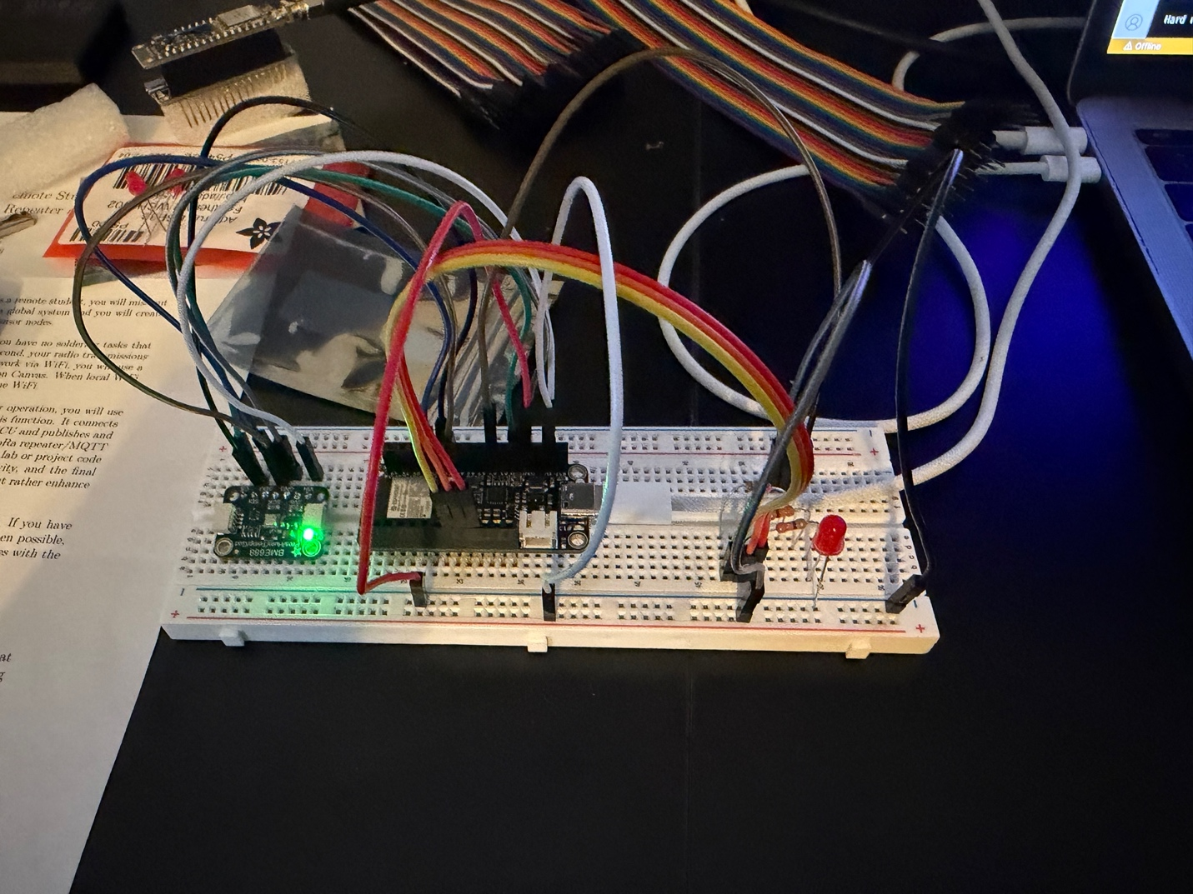

Deliverable 21: System with LED On
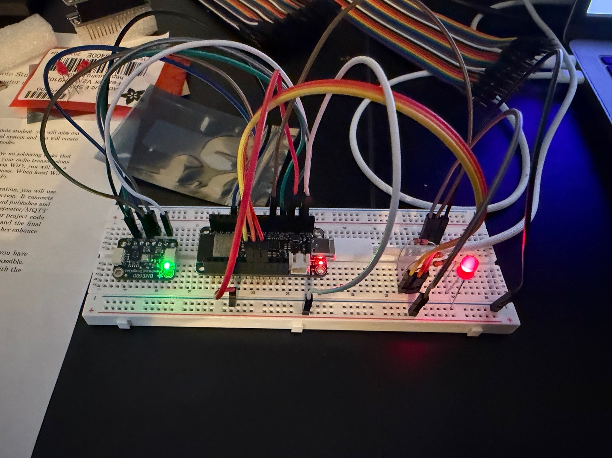
To trigger the LED I held a finger on the TMP36 to warm it up. Once the filtered temperature delta between the TMP36 and BME688 exceeded the 1.5 degree threshold the LED turned on.

Deliverable 22: Temperature Delta Between Sensors at Room Temperature
Yes, there was a small offset between the two sensors at room temperature. This is most likely because the BME688 sits close to the ESP32 chip which generates heat during operation, causing it to read slightly warmer than the TMP36. The two sensors also have different calibration tolerances (TMP36 +/-2 degrees, BME688 +/-1 degree) so some systematic offset between them is expected even in the same environment.

Deliverable 23: Design Decisions

I used SPI for the BME688 since it was already wired that way from Section 5.

For signal processing I used an EMA with alpha = 2/(50+1). It only needs two float variables, responds faster than an equivalent moving average, and provides enough smoothing to prevent ADC noise from triggering false LED events.

Sensors were sampled alternately each loop iteration. The BME688 takes around 100ms per reading so there's no benefit to batching, and alternating keeps the two timestamps close together.

analogSetPinAttenuation was called once in setup() with a 500ms settle delay rather than each loop iteration. The EMA was then seeded explicitly in the button handler after a short flush sequence, so the filter starts from a stable value rather than a potentially noisy first reading.

The delta threshold was set to 1.5 degrees Celsius which was above the natural offset between the sensors at room temperature but easy to trigger by touching one sensor.

Section 10: Sensor and Actuation in a Closed Loop

Deliverable 24: IR Sensor Setup
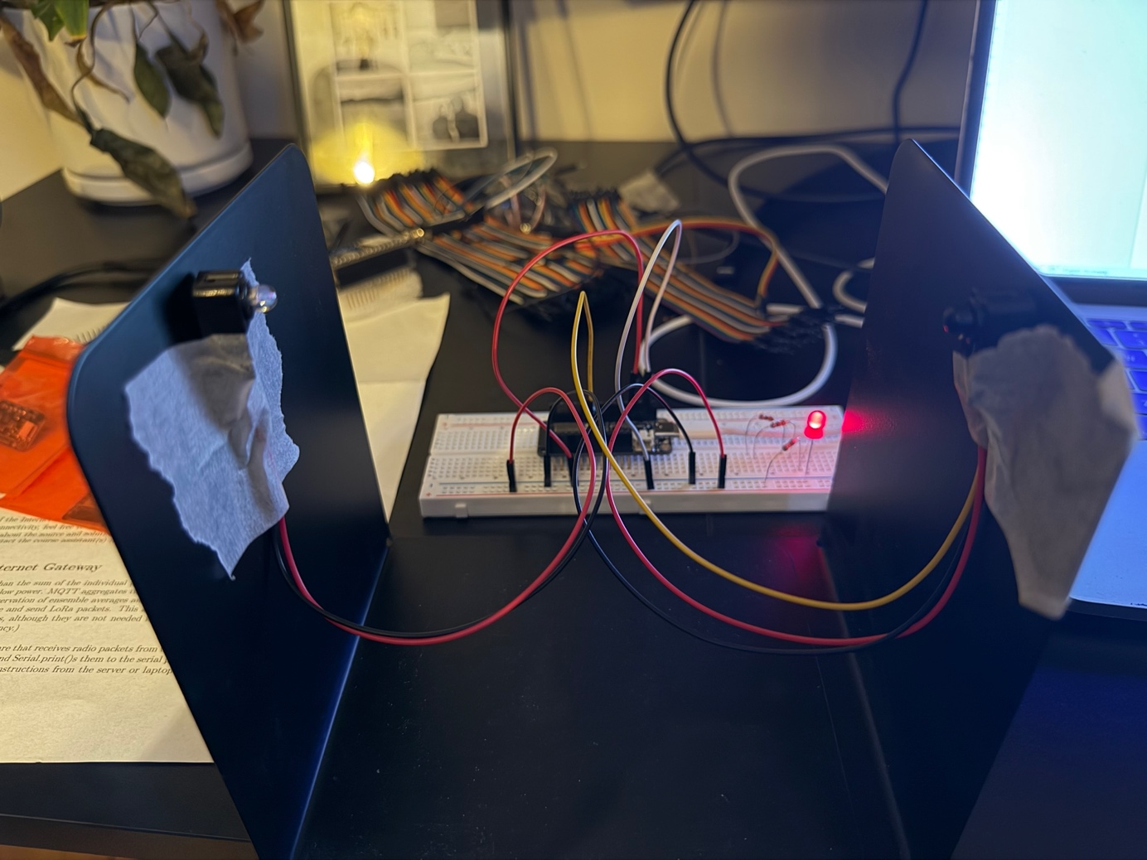
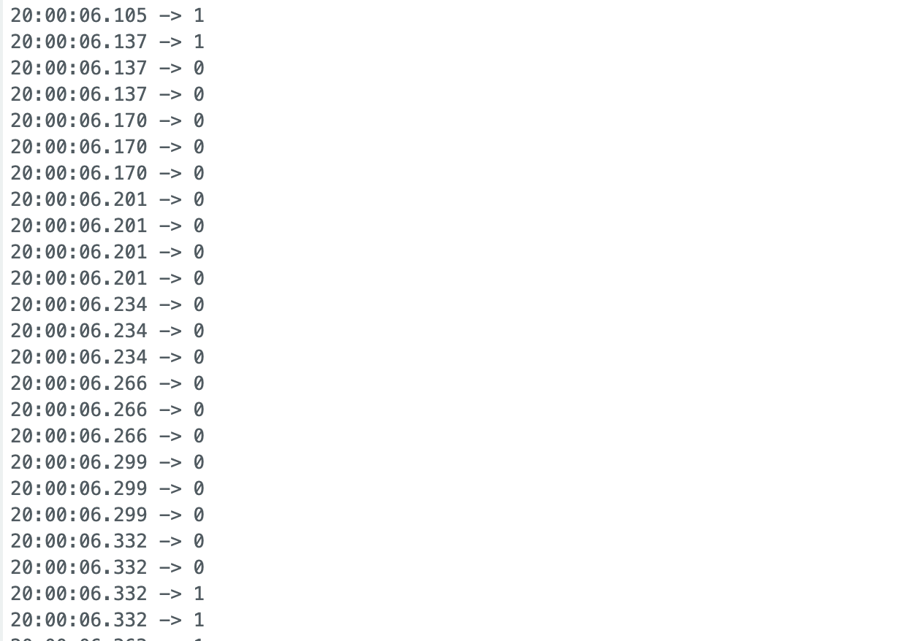

Deliverable 25: Role of the 470uF Capacitor
The capacitor acts as a local energy buffer on the 5V rail. When the servo starts or changes speed it draws a large current spike that the USB supply can't deliver fast enough on its own. Without the capacitor this causes the 5V rail to droop and can reset or destabilise the ESP32. The capacitor absorbs the spike and keeps the supply stable. Removing it causes erratic ESP32 behaviour or unexpected resets when the motor moves.

Deliverable 26: Estimated RPM for Three Pulse Widths
Pulse Width (us) | Estimated RPM
1550 (min) | 19.0
1650 (mid) | 50.0
1750 (max) | 65.5

RPM was calculated from the time between falling edges on the IR sensor using: RPM = 60 x 10^6 / interval_us

Deliverable 27: Closed-Loop Controller Design
I implemented a proportional controller. On each beam interrupt the interval between falling edges is converted to RPM using RPM = 60 x 10^6 / interval_us. The error is computed as e = 60 - rpmMeasured and the pulse width is updated by Kp x e microseconds with Kp = 2.0. The pulse is clamped to [1550, 1750] us after each update. Kp = 2.0 gave stable convergence without oscillation. Higher gains caused the RPM to overshoot and hunt around the target. Since the controller only updates on beam interrupts, its update rate naturally slows down at low speeds which helps keep it stable.

Deliverable 28: Video
Video:

Code: https://github.com/ENBayliss44/EE284aLab1

