ENCARDIO-RITE
METASENSING FOR MEGA STRUCTURES
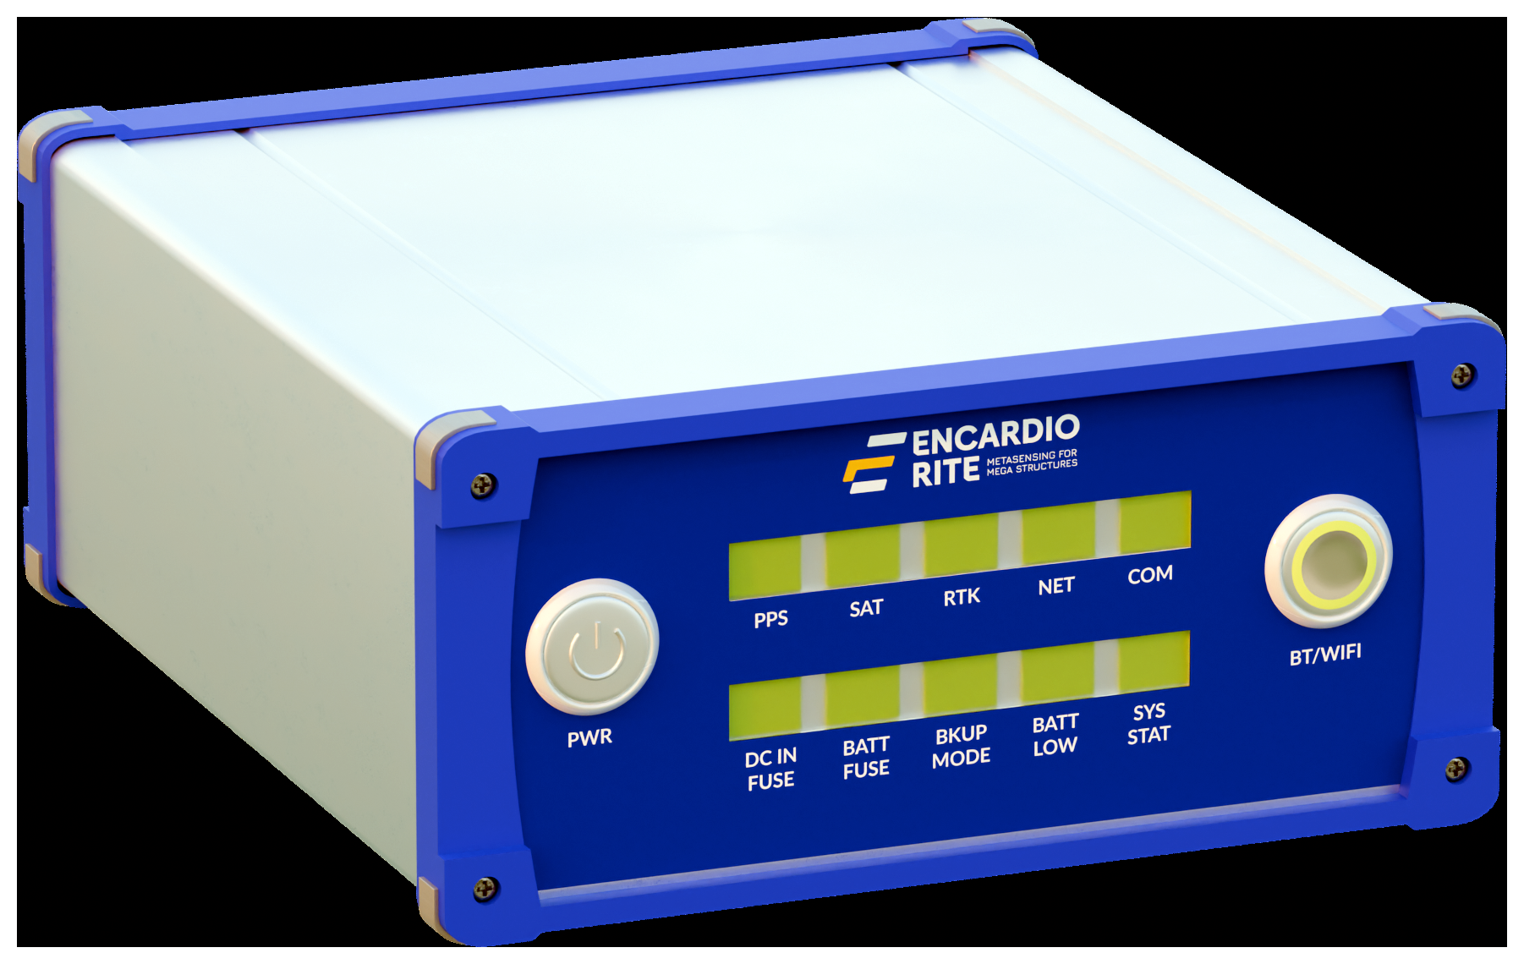
GNSS Receiver
Base & Rover Configuration
USER MANUAL
Web-based Configuration Interface
Doc. # WI 6002.xxx Rev. 00
September 2026
Encardio-Rite Electronics Pvt. Ltd. | Lucknow, India | www.encardio.com

Contents

1 Introduction

1.1 About this manual
This manual explains how to configure the Encardio-Rite GNSS receiver as a Base station or as a Rover using its built-in web configuration interface. It covers connecting to the receiver, logging in, and setting every parameter required for reliable RTK operation and data reporting.
The receiver is configured entirely through a web browser — no separate PC software needs to be installed.

1.2 System overview
A typical deployment uses at least one Base receiver and one or more Rover receivers:
- The BASE is installed over a known, stable point. It computes (or is given) its own precise position and streams RTK correction data (RTCM) to an NTRIP caster.
- Each ROVER connects to the caster, applies the corrections, and computes its own position to centimetre-level accuracy. It then reports position/deviation data and uploads log files to an FTP server.
Both receiver types are set up from the same web interface; the on-screen options change according to the selected Receiver Type.

1.3 Conventions used in this manual
- Bold text refers to an on-screen label, button, or field name — for example, Save Configuration.
- Values shown in the screenshots (IP addresses, ports, IDs) are examples only. Replace them with the values for your site.
NOTE The receiver clock and all logging times use UTC. Enter Scan Start Time in UTC, not local time.

2 Front Panel Overview
The front panel carries the power button, two rows of status LEDs, and a Bluetooth/Wi-Fi indicator.
Fig. 2.1 GNSS receiver front panel

2.1 Controls
Control | Function
PWR | Power on / off button. Press to switch the receiver on; press and hold to switch off.
BT / WIFI | Bluetooth / Wi-Fi indicator and activation. Indicates when the wireless interface is active for local access.

2.2 Status indicators (top row)
LED | Indication
PPS | Pulse-Per-Second from the GNSS engine. A steady blink indicates the receiver has valid satellite timing.
SAT | Satellite tracking. Lit / blinking when the receiver is tracking a sufficient number of satellites.
RTK | RTK solution status. Indicates when a fixed RTK (centimetre-level) solution is achieved.
NET | Network / NTRIP link. Lit when the receiver is connected to the network / caster.
COM | Communication activity between the GNSS module and the on-board computer.

2.3 Power & system indicators (bottom row)
LED | Indication
DC IN FUSE | Health of the DC-input fuse. Lit = external DC supply present and fuse healthy.
BATT FUSE | Health of the battery fuse.
BKUP MODE | Backup mode. Lit when the unit is running from the internal / backup battery.
BATT LOW | Battery low warning. Lit when the battery voltage is below the safe threshold.
SYS STAT | Overall system status / heartbeat.
NOTE LED colours and blink patterns are indicative. Use the web interface (Section 6) to confirm exact status.

3 Accessing the Configuration Interface

3.1 Physical setup
- Mount the GNSS antenna on a stable structure with a clear, obstruction-free view of the sky, and connect the antenna cable to the receiver.
- Connect power: use a 12 V DC adapter on the DC-input connector, or a battery source.
- Connect the receiver to the configuring PC with an Ethernet cable and switch the receiver on with the PWR button.

3.2 Set the PC network address
The PC must be on the same subnet as the receiver. If the receiver address is 192.168.10.100, set the PC to a free address on that subnet, for example 192.168.10.50.
- Open Control Panel → Network and Sharing Center → Change adapter settings.
- Right-click the Ethernet connection → Properties → Internet Protocol Version 4 (TCP/IPv4) → Properties.
- Select Use the following IP address and enter, for example, IP 192.168.10.50 and Subnet mask 255.255.255.0. Click OK.

3.3 Log in to the web interface
- Open a web browser and go to the receiver address, for example http://192.168.10.100
- Enter the Username and Password and click Login (default credentials are provided with the device).
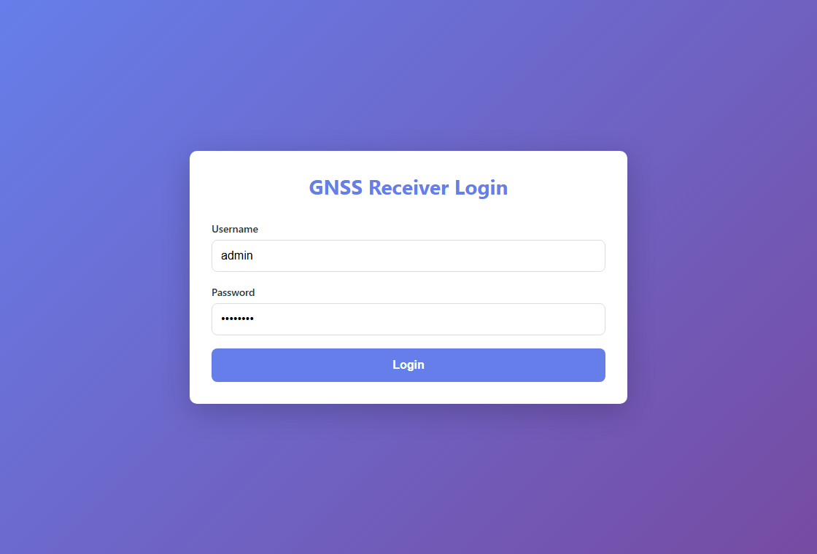
Fig. 3.1 Login screen
After logging in, the GNSS Receiver Setup page opens. The first setting, Receiver Type, determines whether the unit is configured as a Base or a Rover.

4 Configuring the Receiver as a BASE
Select BASE under Receiver Type. The Base Co-ordinates options appear. A base can either determine its own position automatically (Auto Fix) or use coordinates you enter manually.

4.1 Base coordinates – Auto Fix
In Auto Fix mode the base averages its own position over a chosen period and then locks that value as its reference coordinate.
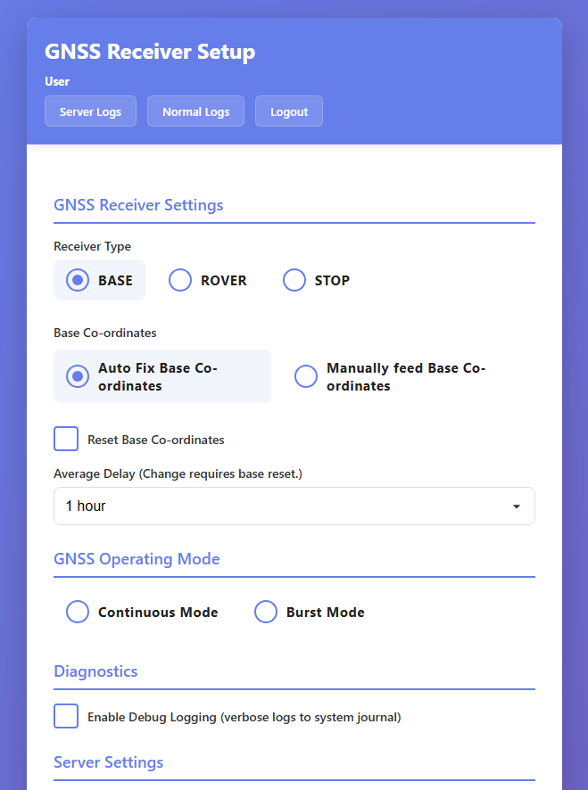
Fig. 4.1 BASE – Auto Fix coordinates and operating mode
- Select BASE, then choose Auto Fix Base Co-ordinates.
- Set Average Delay – the averaging duration (1–72 hours). A longer period gives a more accurate fixed position.
- Tick Reset Base Co-ordinates only when you want the base to discard its stored position and re-average a fresh one.
NOTE Changing the Average Delay takes effect only after a base reset (tick Reset Base Co-ordinates). Once the base has locked a position, changing the delay alone has no effect until it is reset.

4.2 Base coordinates – Manual
If the exact coordinates of the monument are already known (from a survey), enter them directly.
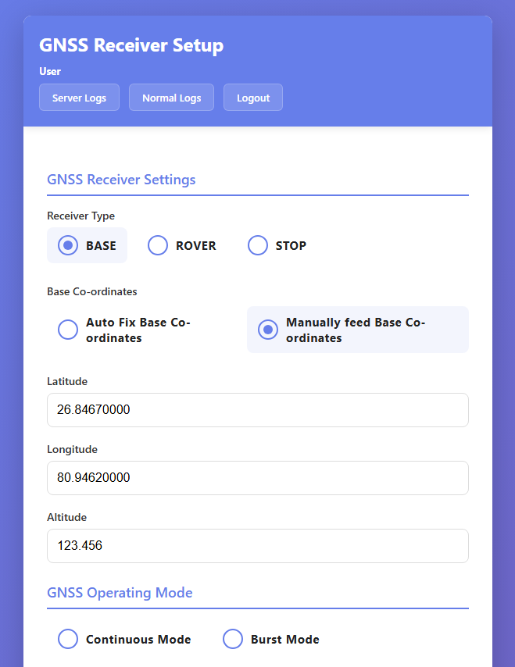
Fig. 4.2 BASE – Manually fed coordinates
- Select Manually feed Base Co-ordinates.
- Enter Latitude, Longitude and Altitude for the base monument.

4.3 Operating mode
Choose how the receiver runs:
- Continuous Mode – the receiver stays powered and streams / logs data continuously.
- Burst Mode – the receiver wakes on a schedule, operates for a set window, then sleeps to save power. Set the burst window and interval when this mode is selected.

4.4 Server (NTRIP caster) settings
These settings tell the base where to publish its RTCM correction stream.
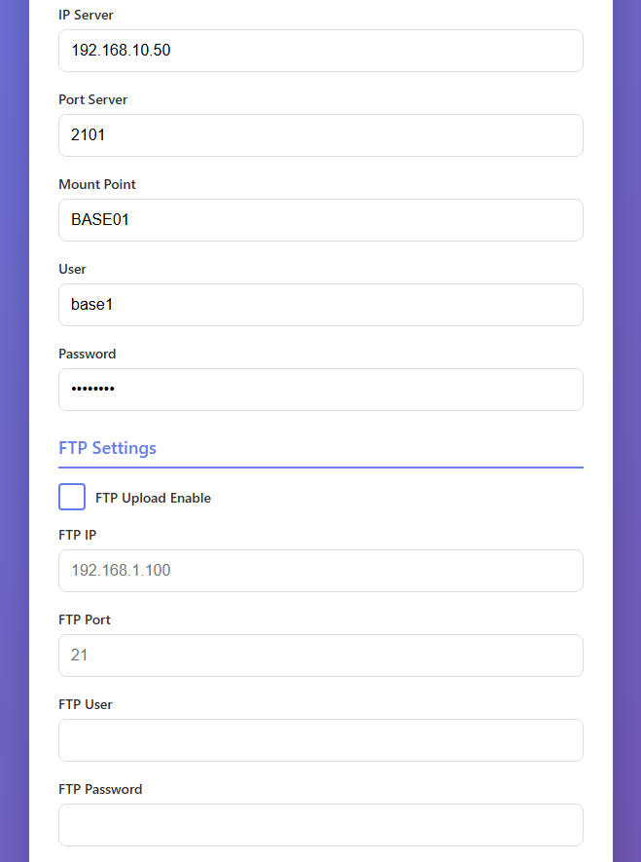
Fig. 4.3 BASE – Server and FTP settings
Field | Description | Example
IP Server | IP address of the NTRIP caster the base streams to. | 192.168.10.50
Port Server | Caster port. | 2101
Mount Point | Mount point name the base publishes on. | BASE01
User | Caster user name for the base. | base1
Password | Caster password. | ••••••

4.5 FTP settings
When enabled, the base uploads its configuration backup to the FTP server so it can be restored to replacement hardware.
Field | Description
FTP Upload Enable | Turn FTP upload on / off.
FTP IP | FTP server address.
FTP Port | FTP server port (typically 21).
FTP User / Password | FTP account credentials.

4.6 Save and finish
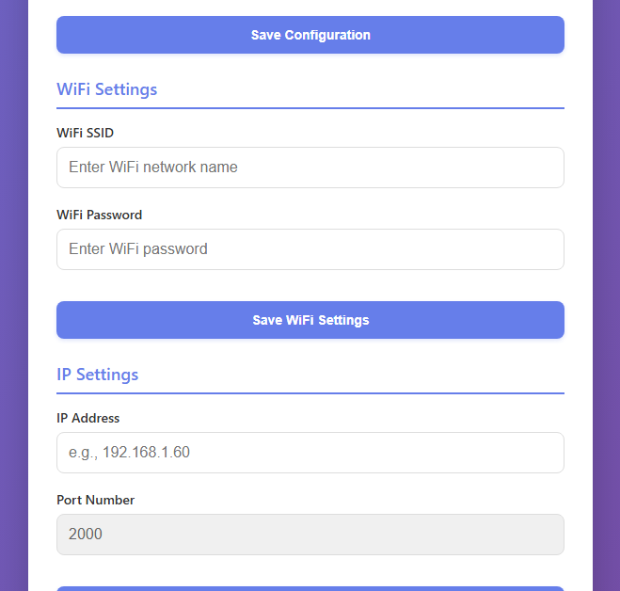
Fig. 4.4 Save, Wi-Fi and IP settings
- Click Save Configuration to apply the base settings.
- Optionally configure Wi-Fi Settings (SSID / password) for wireless access and click Save WiFi Settings.
- Optionally change the receiver IP Settings and click Save IP Settings. The receiver will then use the new address.

5 Configuring the Receiver as a ROVER
Select ROVER under Receiver Type. The Rover Settings, Data Storage and Reporting options appear.

5.1 Receiver type, operating mode and server settings
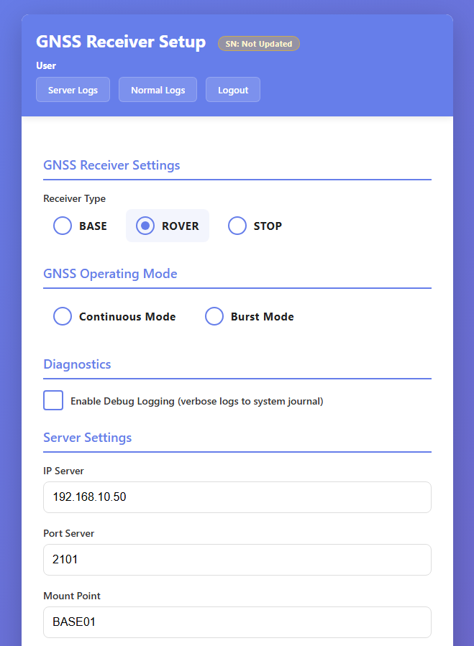
Fig. 5.1 ROVER – receiver type, operating mode and server settings
- Select ROVER.
- Choose the Operating Mode (Continuous or Burst) as described in Section 4.3.
- Under Server Settings, enter the NTRIP caster the rover receives corrections from:
Field | Description | Example
IP Server | NTRIP caster IP address. | 192.168.10.50
Port Server | Caster port. | 2101
Mount Point | Mount point of the base to receive corrections from. | BASE01
User / Password | Caster credentials for the rover. | rover1 / •••

5.2 FTP and rover settings
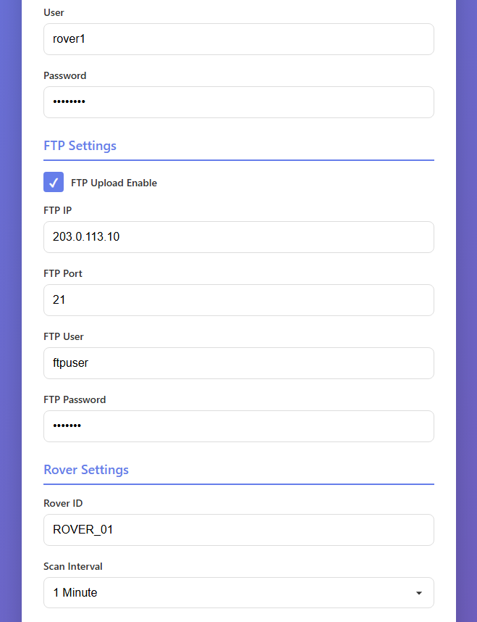
Fig. 5.2 ROVER – FTP and rover settings
Under FTP Settings, enable upload and enter the FTP server details so the rover can upload its logged data files.
Field | Description | Example
Rover ID | Unique identifier for this rover; used in data file names. | ROVER_01
Scan Interval | How often a data record is logged / reported. | 1 Minute

5.3 Scan time, deviation axis, storage and reporting
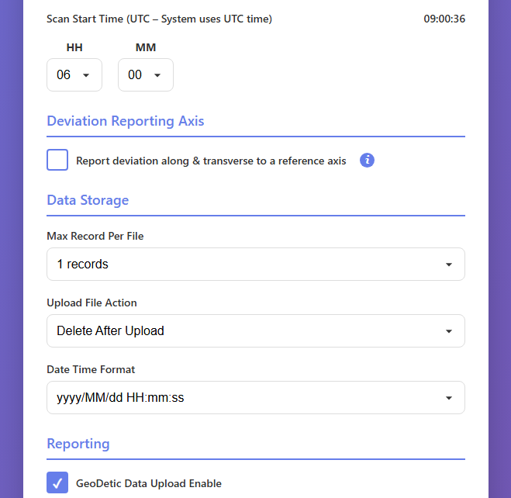
Fig. 5.3 ROVER – scan start, deviation axis, storage and reporting
Field | Description
Scan Start Time (UTC) | Time of day (HH:MM, UTC) from which logging is scheduled.
Deviation Reporting Axis | When enabled, deviation is reported along and transverse to a reference axis; enter the axis azimuth.
Max Record Per File | Number of records stored in each data file before a new file is started.
Upload File Action | What to do with a file after successful FTP upload – Delete or Archive.
Date Time Format | Timestamp format used in data files (e.g. yyyy/MM/dd HH:mm:ss).
GeoDetic Data Upload Enable | Include geodetic (lat/lon/height) values in the uploaded data.
Deviation Unit | Unit for reported deviation values (e.g. mm).

5.4 Save
- Click Save Configuration to apply the rover settings. Configure Wi-Fi and IP settings if required, as in Section 4.6.

6 Verifying Operation
After saving, confirm the receiver is working correctly:
- On the front panel, check that SAT indicates satellite tracking and, for RTK operation, that RTK shows a fixed solution and NET shows a caster connection.
- In the web interface, open Server Logs or Normal Logs (top-right of the setup page) to review recent activity and confirm data is being logged and uploaded.

7 Troubleshooting
Symptom | Checks / action
Cannot open the web page | Confirm the PC IP is on the receiver's subnet (Section 3.2), the Ethernet cable is connected, and the receiver is powered on.
No RTK fix on the rover | Check Server Settings (caster IP/port/mount/credentials) and that the base is streaming; confirm satellite visibility.
No data on the FTP server | Confirm FTP Upload is enabled and the FTP IP/port/credentials are correct; check the logs for upload errors.
Base position keeps changing | Ensure Reset Base Co-ordinates is not left ticked; once a good position is locked, untick it.
Weak / intermittent signal | Check the antenna mounting, cable and sky visibility; relocate the antenna away from obstructions.

8 Safety & Support
- Use only the specified DC supply and a correctly rated battery.
- Install the antenna and mast safely; observe site electrical-safety rules and keep clear of overhead power lines.
- Protect the receiver from water ingress beyond its rated protection and from extreme temperatures.
For support, contact Encardio-Rite: geotech@encardio.com | www.encardio.com

