ARAB AMERICAN UNIVERSITY OF PALESTINE

A HOTEL DATABASE

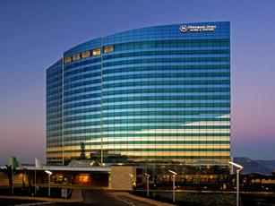

MADE BY:-

SHOROUQ ABU-ALROB , 201712443

THEKRA AAMAR ,201712366

SHIMAA OMARIA , 201810907

MOHAMAD JALODE , 201810787

**Contents:**

**1:the description …………………………………………………………………………………………………………page 3**

**2: ER diagram……………………………………………………………………………………………………………….page 5**

**3: schema…………………………………………………………………………………………………………………….page 6**

**4: Questions…………………………………………………………………………………………………………………page 7**

**5: creat table……………………………………………………………………………………………………………….page 10**

**6:**  **insertion of the data…………………………………………………………………………………………………page 21**

**7:** **Conclusion……………………………………………………………………………………………………………….page 26**

**8:** **References……………………………………………………………………………………………………………….page 26**

**THE DESCRIBTION:-**

**From fantastic amenities to excellent service, the luxury hotels are more than just a place to rest your head. You can expect modern conveniences combined with comfortable guestrooms when BOOKING IN OUR HOTEL.**

**The best hotel is the hotel which consists of several rooms, suites, restaurant and others.**

**To make sure that you have a comfortable time in our hotel we will record the information of every guest to complete our registration process, Then we will show them information about our hotel such as type of rooms which is rooms single, double, and quad and its position , the price of the room depend on the type of room and the days he will stay .The payment method either cash or by card .**

**In this hotel works many employees, and every worker has it SSN , hire- date , first_ name, last_ name ,and job_id. Employees are classified into a part time employee and each of them has a salary and work hour ,and full time employee and each of them has a salary and experiences years. These employees must belong to one department. Employees are also classified to managers, restaurant_employees, room_service_employees, and receptionist. Each rest_emp has role_type , service_employee has rating , managers has team, and receptionist has access_type.**

**Our departments can be classified reception, restaurant, room service, and adminstration department . Each department must have a department_ num and department_name.**

**Reception department has hotel_offers that contain offer_name , offer_type, duration. Reception department require recorded information about rooms, transaction, guest and receptionist. Each room has room_id, room_type, room_code, and amount. Each transaction has trans_no, guest_id, start_date, end_date, total_payment, payment_type, rec_id, and room_id. Each guest has guest_id, first_name, last_name, ssn, and number.**

**Restaurant department require recorded information about order, item. Each order has order_num, order_name, price and quantity. Each item has item_no, item_name, quantity.**

**Room services department will receive request_from_customer, request_from_reception, tools. Each request_from_customer must request_type, cust_id, room_id, date_of_request .Each request_from_reception must contain room_id, cust_id, request_type, date_of_request. Each tools has name, tool_num, and quantity.**

**Adminstration department has managers with that are related to certain teams. Each team will be responsible on a department and has team_id , team_name, .**

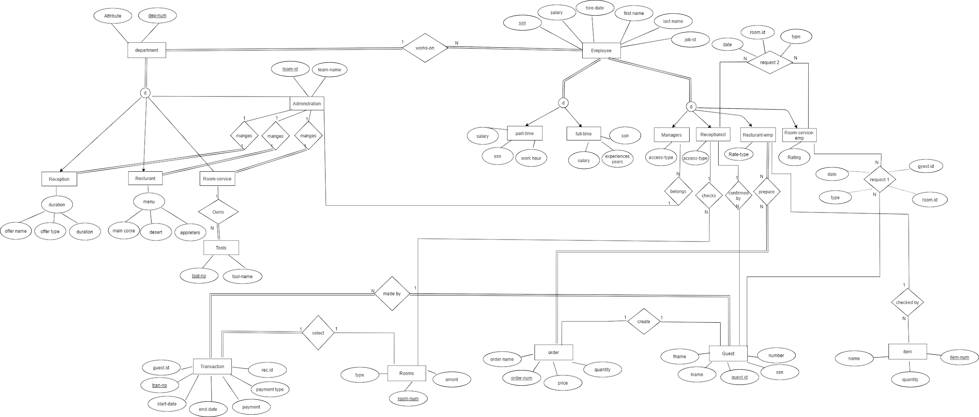

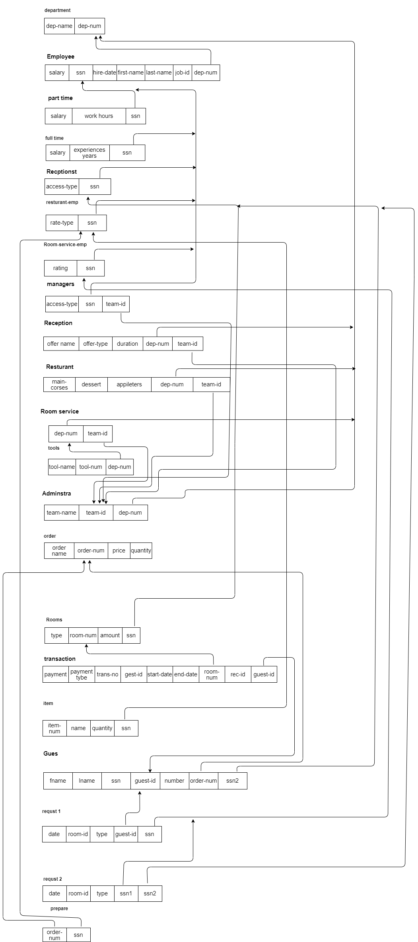

**Our ER-Diagram answered for these Questions:**

* **what is the name and id for the guest who has the maximum order in our hotel ?**

**select fname, lname ,guest_id**

**from guest join order1 using(order_num)**

**where quantity = (select max(quantity) from order1);**

* **what is the name of the manger in team id 4 their name starts with letter entered by user ?**

**select first_name,last_name**

**from department d join adminstration a on (d.dnumber = a.department_num)**

**join Employees e on (e.department_num = d.dnumber)**

**where team_id = 4 and first_name like '&name';**

* **what is the department name and number for the employee his hire_date entered by user ?**

**select dnumber , dname**

**from department d join Employees a on (d.dnumber = a.department_num)**

**where hire_date like '&date';**

* **which room the guest prefers for each type ?**

**select max(amount),max(room_num) as "room_num",type**

**from rooms**

**group by type;**

* **the names of Staff that there salary equal the minimum salary ?**

**select first_name,last_name,salary**

**from Staff**

**where salary = (**

**select min(salary)**

**from Staff);**

* **the highest salary in each department?**

**select max(salary), dname**

**from Employees e join department d on (e.department_num = d.dnumber)**

**group by dname;**

* **what is the team id that manages restaurant ?**

**select team_id**

**from adminstration a join department d on ( d.dnumber = a.department_num)**

**where dname = 'restaurant';**

* **the most order that was ordered in restaurant?**

**select order_name**

**from order1**

**where quantity = (select max(quantity) from order1);**

* **how many part time employee the hotel have?**

**select count(distinct (ssn))**

**from part_time;**

* **The most expensive room in the hotel ?**

**Select room_num**

**From rooms join transactions using(room_num)**

**Where payment = ( select max(payment) from transactions);**

* **HOW MANY ROOM WAS RENTED IN MARCH?**

**select count(room_num)**

**from transactions**

**where start_date like '%MAR%';**

* **What the number of rooms that was rented between 12-3-2019 and 1-12-2021 ?**

**select room_num**

**from rooms join transactions using(room_num)**

**where start_date between '12-mar-2019' and '1-dec-2021' ;**

* **WHICH employee HAS THE HIGHEST SALARY IN room service department ?**
* **THE SUM OF PAID RENT in year 2019?**

**select sum(payment)**

**from transactions**

**where start_date like '%19';**

* **What is the average of the benefits in year 2020?**

**select avg(payment)**

**from transactions**

**where start_date like '%20';**

* **THE MOST EXPERIENCED EMPLOYEE WE HAVE?**

**select first_name,last_name**

**from full_time join Employees using(ssn)**

**where experiences_years = ( select max(experiences_years) from full_time);**

* **the name of employee start with the letter a?**

**select first_name,last_name**

**from Employees**

**where first_name like 'a%';**

**creat table:-**

**SQL> create table employeess(First_Name varchar(15) not null,**

**Last_name varchar(15),**

**Department_ID int not null,**

**SSN char(9),**

**Date_Hire date,**

**primary key (SSN),mang_id int );**

**SQL> create table PartTime (SSN char(9),**

**work_hour int ,**

**salary decimal(10,2),**

**primary key (SSN));**

**SQL> create table FullTime (SSN char(9),**

**salary decimal(10,2),**

**experiences varchar(20),**

**primary key (SSN));**

**SQL> create table Department (Department_id int ,**

**min_salary decimal(10,2),**

**manager_id int ,**

**attribute varchar(15),**

**primary key (Department_id));**

**SQL> create table garden (max_salary decimal(10,2),**

**Departm_id int );**

**SQL> alter table garden add check( departm_id=4);**

**SQL> Alter table garden add (constraint departm_id_const foreign key(departm_id) references department(department_id));**

**SQL> create table RoomService (max_salary decimal(10,2),**

**hour_of_service int,**

**Depar_id int);**

**SQL>alter table roomservice add check( depar_id=1);**

**SQL> Alter table roomservice add (constraint depar_id_const foreign key(depar_id) references department(department_id));**

**SQL> create table Restaurant (max_salary decimal(10,2),**

**desert varchar(20),**

**appetizers varchar(20),**

**main_course varchar(20),**

**Department_id int);**

**SQL> alter table restaurant add check( department_id=1);**

**SQL> Alter table restaurant add (constraint department_id_const foreign key(department_id) references department(department_id));**

**SQL> create table other (max_salary decimal(10,2),**

**Dep_id int ,**

**type varchar(20));**

**SQL> alter table other add check( dep_id=2);**

**SQL> Alter table other add (constraint dep_id_const foreign key(dep_id) references department(department_id));**

**SQL> create table gym (max_salary decimal(10,2),**

**D_id int ,**

**sign_in_date date);**

**SQL> alter table gym add check( d_id=5);**

**SQL> Alter table gym add (constraint d_id_const foreign key(d_id) references department(department_id));**

**SQL> create table card(card_num char(9),**

**card_place varchar(30),t**

**ype varchar(20),**

**primary key(card_num));**

**SQL>create table guest (guest_number char(500),first_name varchar(50),l**

**ast_name varchar(50),birth_place varchar(20),**

**religion varchar(20),card_num char(9),nationality varchar(30),**

**primary key(guest_number);**

**SQL>Alter table guest add (constraint card_num_const foreign key(card_num) references card(card_num));**

**SQL>create table rommates (num char(500),guest_number char(500),**

**name varchar(30),releationship varchar(30),**

**general_information varchAR(30),birth_date date,**

**nationality varchar(30),primary key(num));**

**SQL>Alter table roommates add (constraint guest_number_const foreign key(guest_number) references guest(guest_number));**

**SQL> create table room(room_number char(500),**

**rent_price_monthly number ,room_position varchar(30),**

**rent_price number,rent_type varchar(20)not null,**

**room_type varchar(20),primary key(room_number));**

**SQL> create table registration (num char(500),guest_num char(500),**

**room_number char(50),amount char(365),**

**come_date date,leave_date date,**

**status varchar(10),primary key(num),**

**foreign key(room_number,come_date );**

**SQL> alter table registration add check( status=1 or status=0);**

**SQL> Alter table registration add (constraint guest_num_const foreign key(guest_num) references guest(guest_number));**

**SQL> Alter table registration add (constraint room_number_const foreign key(room_number) references room(room_number));**

**create table Employees**

**(first_name varchar(10),**

**last_name varchar(10),**

**ssn char (9) ,**

**hire_date date,**

**job_id varchar(20) ,**

**salary int,**

**department_num char(10),**

**primary key(ssn));**

**create table department**

**(department_name varchar(20),**

**department_num char(10),**

**primary key (department_num));**

**create table part_time (**

**salary int,**

**work_hour int check(work_hour<7 and work_hour>0),**

**ssn char(9));**

**create table full_time**

**(salary int,**

**experiences_years int,**

**ssn char(9));**

**create table receptionist**

**(access_type varchar(20),**

**ssn char(9),**

**primary key (ssn));**

**create table resturant_emp**

**(rate_type int check(rate_type<6),**

**ssn char(9),**

**primary key (ssn));**

**create table room_service_emp**

**(rating int check(rating<6),**

**ssn char(9),**

**primary key(ssn));**

**create table manager**

**(access_type varchar(15),**

**ssn char(9),**

**team_id int);**

**create table reception**

**(offer_name varchar(20),**

**offer_type varchar(15),**

**duration int,**

**department_num char(10),**

**team_id int );**

**create table restaurant**

**(main_course varchar(25),**

**appetizers varchar(20),**

**dessert varchar(20),**

**department_num char(10),**

**team_id int);**

**create table room_service**

**(department_num char(10),**

**team_id int,**

**primary key (department_num));**

**create table tools**

**(tool_name varchar(20),**

**tool_num int,**

**department_num char(10));**

**create table adminstration**

**(team_name varchar(20),**

**team_id int,**

**department_num char(10),**

**primary key (team_id));**

**create table order1**

**(order_name varchar(15),**

**order_num int,**

**price int,**

**quantity int,**

**primary key(order_num));**

**create table rooms**

**(type varchar(10),**

**room_num int ,**

**amount int,**

**ssn char(9),**

**primary key (room_num));**

**create table transactions**

**(payment int,**

**payment_type varchar(10),**

**trans_no int,**

**start_date date,**

**end_date date,**

**room_num int,**

**rec_id int,**

**guest_id int);**

**create table items**

**(item_num int,**

**name varchar(15),**

**quantity int,**

**ssn char(9));**

**create table guest**

**(fname varchar(10),**

**lname varchar(10),**

**ssn char(9),**

**guest_id int,**

**numberG int,**

**order_num int,**

**ssn2 char(9),**

**primary key (guest_id));**

**create table request1**

**(dateR1 date,**

**room_id int,**

**type varchar(20),**

**guest_id int,**

**ssn char(9));**

**create table request2**

**(dateR2 date,**

**room_id int,**

**type varchar(20),**

**ssn char(9),**

**ssn2 char(9));**

**create table prepare**

**(order_num int,**

**ssn char(9));**

**Alter table Employees add (constraint dep1_const foreign key(department_num)**

**references department (department_num) on delete set null);**

**Alter table part_time add (constraint ssn1_const foreign key(ssn)**

**references Employees(ssn)on delete set null);**

**Alter table full_time add constraint ssn2_const foreign key(ssn)**

**references Employees(ssn) on delete set null;**

**Alter table receptionist add constraint ssn3_const foreign key(ssn)**

**references Employees(ssn) on delete set null;**

**Alter table resturant_emp add constraint ssn4_const foreign key(ssn)**

**references Employees(ssn) on delete set null;**

**Alter table room_service_emp add constraint ssn5_const foreign key(ssn)**

**references Employees(ssn) on delete set null;**

**Alter table manager add constraint ssn6_const foreign key(ssn)**

**references Employees(ssn) on delete set null;**

**Alter table manager add constraint team1_const foreign key(team_id)**

**references adminstration(team_id) on delete set null;**

**Alter table reception add constraint Dep2_const foreign key(department_num)**

**references department(department_num) on delete set null;**

**Alter table reception add constraint team2_const foreign key(team_id)**

**references adminstration (team_id) on delete set null;**

**Alter table restaurant add constraint Dep3_const foreign key(department_num)**

**references department(department_num) on delete set null;**

**Alter table restaurant add constraint team3_const foreign key(team_id)**

**references adminstration(team_id) on delete set null;**

**Alter table room_service add constraint Dep4_const foreign key(department_num)**

**references department(department_num) on delete set null;**

**Alter table room_service add constraint team4_const foreign key(team_id)**

**references adminstration(team_id) on delete set null;**

**Alter table tools add constraint Dep5_const foreign key(department_num)**

**references room_service(department_num) on delete set null;**

**Alter table adminstration add constraint Dep6_const foreign key(department_num)**

**references department(department_num) on delete set null;**

**Alter table rooms add constraint ssn7_const foreign key(ssn)**

**references Employees(ssn) on delete set null;**

**Alter table transactions add constraint room_const foreign key(room_num)**

**references rooms(room_num) on delete set null;**

**Alter table transactions add constraint guest1_const foreign key(guest_id)**

**references guest(guest_id) on delete set null;**

**Alter table items add constraint ssn8_const foreign key(ssn)**

**references resturant_emp(ssn) on delete set null;**

**Alter table guest add constraint ssn9_const foreign key(ssn2)**

**references receptionist (ssn) on delete set null;**

**Alter table guest add constraint order1_const foreign key(order_num)**

**references order1 (order_num) on delete set null;**

**Alter table request1 add constraint guest2_const foreign key(guest_id)**

**References guest(guest_id) on delete set null;**

**Alter table request1 add constraint ssn10_const foreign key(ssn)**

**References room_service_emp(ssn) on delete set null;**

**Alter table request2 add constraint ssn11_const foreign key(ssn)**

**references room_service_emp (ssn) on delete set null;**

**Alter table request2 add constraint ssn12_const foreign key(ssn2)**

**references receptionist (ssn) on delete set null;**

**Alter table prepare add constraint order2_const foreign key(order_num)**

**references order1 (order_num) on delete set null;**

**Alter table prepare add constraint ssn13_const foreign key(ssn)**

**references resturant_emp (ssn) on delete set null;**

**THE INSERTION OF THE DATA:-**

**insert into department values ('reception','1122334455');**

**insert into department values ('restaurant','1122445566');**

**insert into department values ('room_service','122556677');**

**insert into department values ('adminstration','1122667788');**

**insert into Employees values ('sara','emad','887799664','1-jan-2018', 'rec', 2200,'1122334455');**

**insert into Employees values ('marya','ahmad','778866224','21-apr-2018', 'rec', 2200,'1122334455');**

**insert into Employees values ('noora','mansor','223344882','15-aug-2019', 'res', 2000,'1122445566');**

**insert into Employees values ('alia','noor','776611558','4-jul-2018', 'room', 1500,'1122556677');**

**insert into Employees values ('ahmad','hamad','885544662','16-jul-2018', 'adm', 2500,'1122667788');**

**insert into Employees values ('mahmoud ','aziz','772266554','8-jul-2019', 'res', 1800,'1122445566');**

**insert into Employees values ('ali','belal','996633881','2-jan-2018', 'rec', 1500,'1122334455');**

**insert into Employees values ('noor','alaa','885522771','20-may-2018', 'adm', 2500,'122667788');**

**insert into Employees values ('shahd','ahmad','774411881','3-apr-2019', 'room', 2000,'1122556677');**

**insert into Employees values ('mohamad','izz','225588771','26-mar-2019', 'res', 2200,'1122445566');**

**insert into Employees values ('sami','wael','114477881','25-oct-2020', 'rec', 2200,'1122334455');**

**insert into part_time values (1500,'5', '776611558');**

**insert into part_time values (1800,'4', '772266554');**

**insert into part_time values (2000,'6', '223344882');**

**insert into part_time values (2000,'6', '774411881');**

**insert into part_time values (2200,'5', '114477881');**

**insert into full_time values (2200,'4', '887799664');**

**insert into full_time values (2200,'5', '778866224');**

**insert into full_time values (2500,'7', '885544662');**

**insert into full_time values (2500,'6', '885522771');**

**insert into full_time values (2200,'4', '225588771');**

**insert into receptionist values ('full access', '114477881');**

**insert into receptionist values ('Part access', '996633881');**

**insert into receptionist values ('Part access', '778866224');**

**insert into receptionist values ('full access', '887799664');**

**insert into tools values ('broom','1', '1122556677');**

**insert into tools values ('bucket','2', '1122556677');**

**insert into tools values ('cleaner','3', '1122556677');**

**insert into manager values ('full','885544662',1);**

**insert into manager values ('part','885522771',1);**

**insert into Room_service_emp values (4,'776611558');**

**insert into Room_service_emp values (3,'774411881');**

**insert into Resturant_emp values (3,'225588771');**

**insert into Resturant_emp values (4,'772266554');**

**insert into Resturant_emp values (5,'223344882');**

**insert into rooms values ('quad',0033,70,'778866224');**

**insert into rooms values ('single',3300,200,'114477881');**

**insert into rooms values ('single',1002,48,'778866224');**

**insert into rooms values ('double',0001,110,'114477881');**

**insert into rooms values ('single',0020,30,'887799664');**

**insert into order1 values ('pizza',12456,20,3);**

**insert into order1 values ('Cheesecake',12341,9,2);**

**insert into order1 values ('potato',12388,10,3);**

**insert into order1 values ('Chicken burger',34442,25,2);**

**insert into order1 values ('Beef burger',43231,30,3);**

**insert into Room_service values ('1122556677',3);**

**insert into Room_service values ('1122556677',3);**

**insert into Room_service values ('1122556677',3);**

**insert into Room_service values ('1122556677',3);**

**insert into Room_service values ('1122556677',3);**

**insert into Room_service values ('1122556677',3);**

**insert into restaurant values ('pizza','chips','konofa','1122445566',2);**

**insert into restaurant values ('prots','canape', Baklava ,'1122445566',2);**

**insert into restaurant values ('shawarma','salads','fatayer','1122445566',2);**

**insert into restaurant values ('fenttuccino','dips','cake','1122445566',2);**

**insert into restaurant values ('potate','cocktails','choclate','1122445566',2);**

**alter table reception modify ( duration varchar(100));**

**alter table reception modify(OFFER_NAME varchar(100) );**

**insert into reception values ('summer offers winter offers 3in1 -15day','2in1','15 day','1122334455','1');**

**insert into reception values ('spring shows','2in1','5 day','1122334455','1');**

**insert into reception values ('autumn spring','2in1','5 day','1122334455','1');**

**insert into guest values ('ahmad','zoher', '123456789', '1','0569782032', '12456', '114477881');**

**insert into guest values ('magd','bassam', '112233445', '2','0569782033', '12341', '996633881');**

**insert into guest values ('mohamad','awne', '123123123', '3','0569782034', '12388', '887799664');**

**insert into guest values ('osama','nadi', '111222333', '4','0569782035', '34442', '778866224');**

**insert into guest values ('ehab','abufarha', '222333444', '5','0569782036', '43231', '114477881');**

**insert into items values ('1','bread', '5', '225588771');**

**insert into items values ('2','meat', '10', '772266554');**

**insert into items values ('3','apple', '15', '772266554');**

**insert into transactions values (5000,'cash','1','11-dec-2019', '20-dec-2019','0001', '114477881', '1');**

**insert into transactions values (6000,'card','2','10-nov-2019', '26-nov-2019','0020', '996633881', '2');**

**insert into transactions values (7000,'cash','3','9-mar-2019', '25-mar-2019','0033', '887799664', '3');**

**insert into transactions values (8000,'card','4', '2-feb-2020' , '24-feb-2020', '3300', '778866224', '4');**

**insert into transactions values (9000,'cash','5', '4-may-2020', '11-may-2020','1002', '996633881', '5');**

**insert into prepare values ('43231','772266554');**

**insert into prepare values ('34442','225588771');**

**insert into prepare values ('12388','772266554');**

**insert into prepare values ('12456','772266554');**

**insert into prepare values ('12341','225588771');**

**insert into Request1 values ('2/jan/2019', '0001', 'cleaning', '1', '776611558');**

**insert into Request1 values ('2/feb/2020', '0033', 'cleaning', '5', '776611558');**

**insert into Request1 values ('1/aug/2019', '0020', 'food', '3', '774411881' );**

**insert into Request1 values ('2/mar/2018', '0020', 'food', '2', '774411881' );**

**insert into Request1 values ('14/jan/2018', '0020', 'food', '4', '774411881' );**

**insert into Request2 values ('12-feb-2020','0001', 'Food', '776611558','114477881');**

**insert into Request2 values ('14-jan-2021','0020', 'Clean' , '774411881', '996633881');**

**insert into Request2 values ('7-jan-2021', '0033', 'Food', '776611558', '887799664');**

**insert into Request2 values (' 3-dec-2020', '3300', 'Clean', '774411881', '778866224');**

**insert into Request2 values ('9-nov-2019', '1002', 'food' ,'776611558','996633881');**

**Conclusion :**

**It is clear from studying this research that the tourism sector is the most attractive sector in any country, which in turn contributes to the development of several economic sectors, such as increasing foreign and domestic investments, and providing jobs, and. Trying to move away from the reliable bitmap dependency in some countries.**

**We built a very good design schema for hotel in 3`rd normal form ,where we built er-diagram that answer all questions asked ,then we made mapping this ER into tables , wrote DDL command and inserted the data, and finally built queries to ask the questions asked.**

**We hope that this topic was useful and won your admiration.**

**References :**

[**https://www.giata.com/en/products-services/multilingual-hotel-guide/?utm_term=%2Bhotel%20%2Bdescriptions&utm_campaign=Giata+Products&utm_source=adwords&utm_medium=ppc&hsa_acc=6728182427&hsa_cam=948938793&hsa_grp=49936431273&hsa_ad=232945565186&hsa_src=g&hsa_tgt=kwd-298527199422&hsa_kw=%2Bhotel%20%2Bdescriptions&hsa_mt=b&hsa_net=adwords&hsa_ver=3&gclid=Cj0KCQiAmfmABhCHARIsACwPRACbqak4eCPTeq-ynSbY-B5smhZzMcSvaCDzzfGN3MaxI3dl4MPsLnkaAoi3EALw_wcB**](https://www.giata.com/en/products-services/multilingual-hotel-guide/?utm_term=%2Bhotel%20%2Bdescriptions&utm_campaign=Giata+Products&utm_source=adwords&utm_medium=ppc&hsa_acc=6728182427&hsa_cam=948938793&hsa_grp=49936431273&hsa_ad=232945565186&hsa_src=g&hsa_tgt=kwd-298527199422&hsa_kw=%2Bhotel%20%2Bdescriptions&hsa_mt=b&hsa_net=adwords&hsa_ver=3&gclid=Cj0KCQiAmfmABhCHARIsACwPRACbqak4eCPTeq-ynSbY-B5smhZzMcSvaCDzzfGN3MaxI3dl4MPsLnkaAoi3EALw_wcB)