Exercice 3 : Connect to a remote share with command line.
- What does ls /home/$USER/datasource shows ?
It shows what is inside the dir datasource in our case it shows all the images and a pytohn
- What does ls /home/$USER/datasource shows?
Nothing becasue we rebooted the vm

Exercise 4: Make the mount persistent

Exercice 6 : Lychee API.
Token :
Tu reçois un message d’erreur en JSON indiquant que la session a expiré.
wMeOLxFThaLzoLEUvGgmDg==

Exercice 6b : API in python
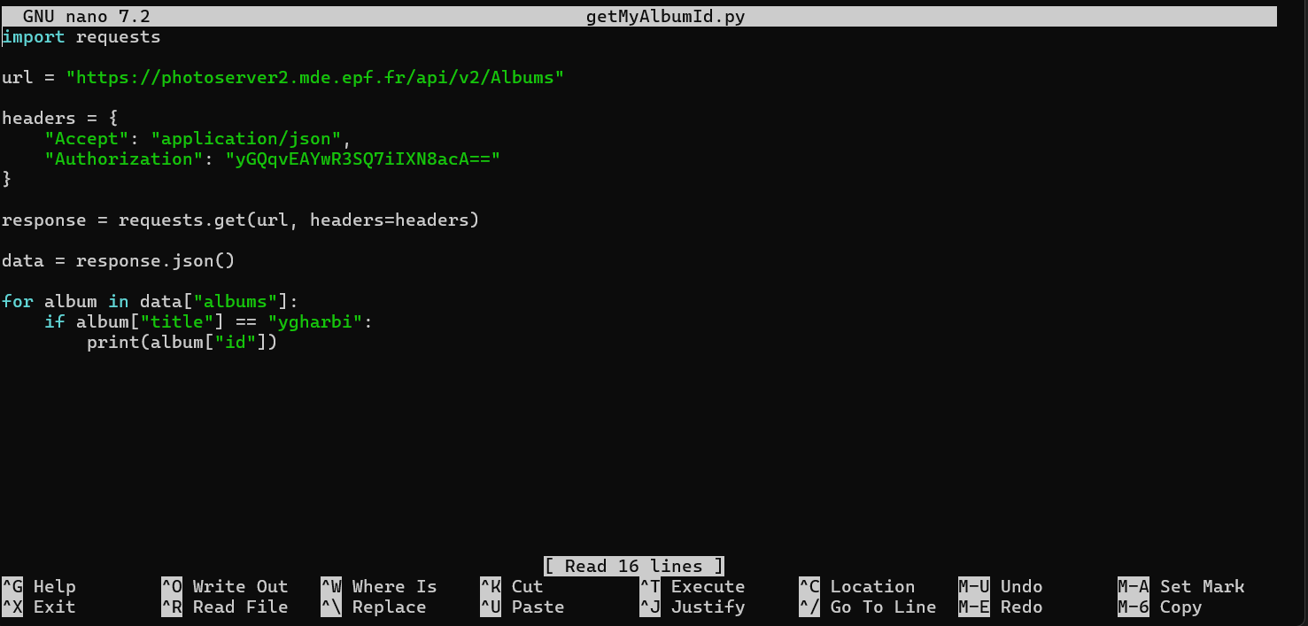
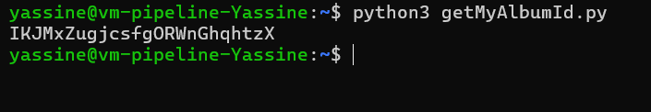

DIR="/home/yassine/datasource"
ALBUM_ID="IKJMxZugjcsfgORWnGhqhtzX"

curl --request PATCH --url https://photoserver2.mde.epf.
fr/api/v2/Photo::tags --header 'Accept: application/json' --header 'Content-Type: application/json' --header "Authorization: $API_TOKEN" --data "{\"shall_override\": true, \"photo_ids\": [\"$PHOTO_ID\"]
, \"tags\": [\"Black\"]}"

